Makers Mark: Wallace Detroit Guitars Lets Customers 'Build Their Own Guitar' from Anywhere in the World

Using its brand new configurator tool, customers can create their own Detroit classic using reclaimed wood from the City's past, customized hardware and other aesthetic options

Detroit, September 7, 2017— Wallace Detroit Guitars, a Detroit-based guitar manufacturer that creates unique and timeless instruments out of reclaimed wood from local landmarks, wants everyone to share in the joy of crafting their own custom-made guitars. Effective immediately, the environmentally responsible company invites customers around the world to log on to its website at wallacedetroitguitars.com to create their own musical masterpiece.

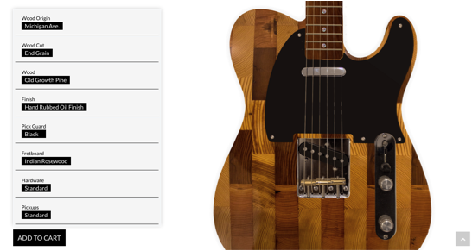
The company's 'Build Your Own Guitar' configurator allows users to create their own unique instrument by choosing from options such as wood selections from a range of original Detroit landmarks, body style, hardware, and pickups — all without having to incur exorbitant additional fees for customization. Each guitar ships with its own custom made unique case and information about the specific Detroit landmark from which the wood was sourced.

“We are proud of this powerful new feature, which takes our one-of-a-kind instruments and brings them to the ultimate personalized level,” Wallace explained. “Now, our customers from anywhere in the world can tap into our little corner of the world and create beautiful, bespoke instruments that are meaningful to the city of Detroit, yet speak to each customer's own creativity and vision.”
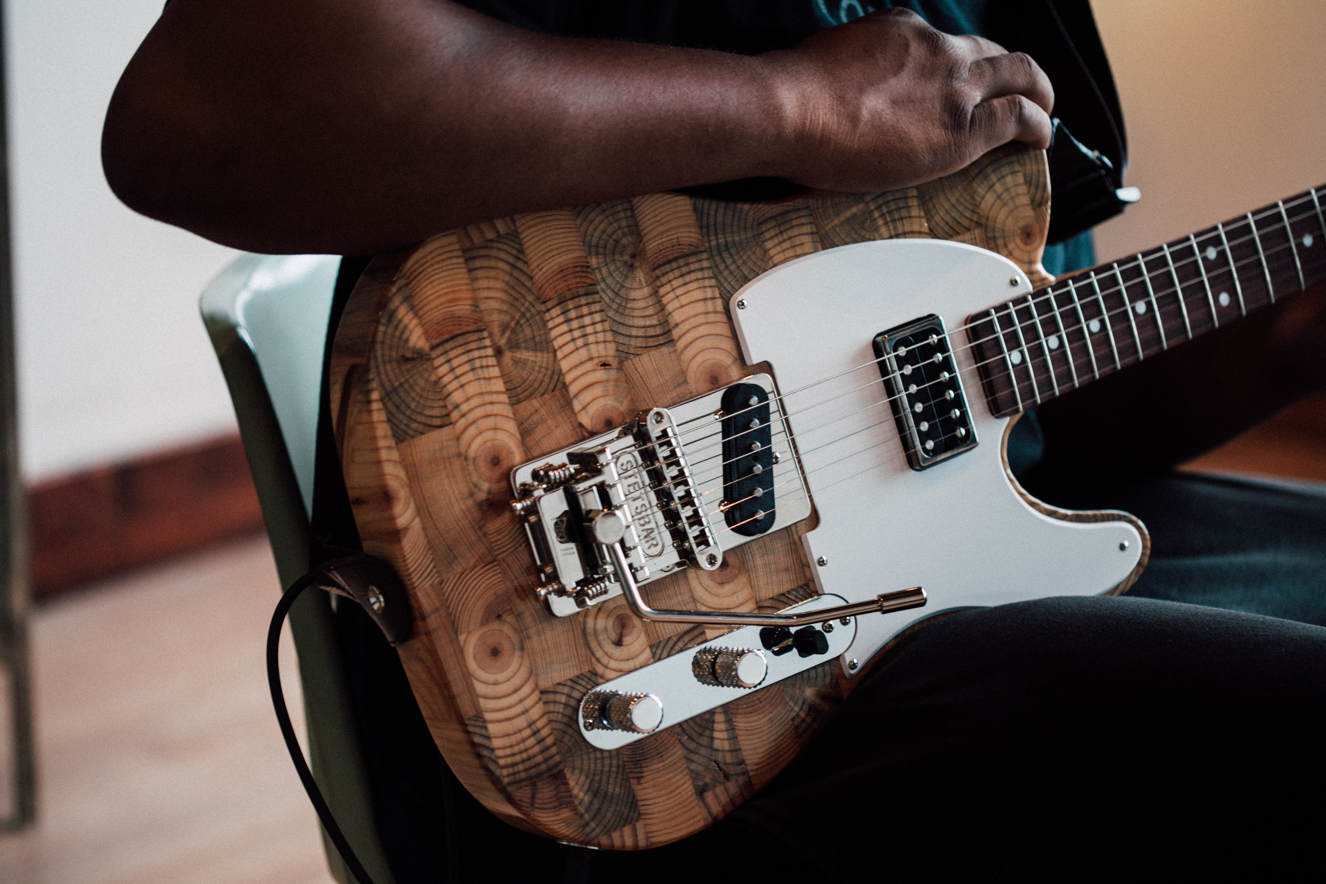
Each Detroit Wallace Guitar speaks to the city's past, while possessing a unique tone from old growth wood that has been naturally aged and cut to perfection. Using the new online custom guitar configurator, customers can select wood from Detroit’s Michigan Avenue, or salvaged old growth pine and maple from the floorboards of the former Detroit Fire Department Headquarters — the city's original firehouse. Customers can also choose maple taken directly from the benches of the Brewster Wheeler Recreation Center — training home to boxing legend Joe Louis, and also frequented by some of Motown’s biggest stars such as Diana Ross and the Supremes.
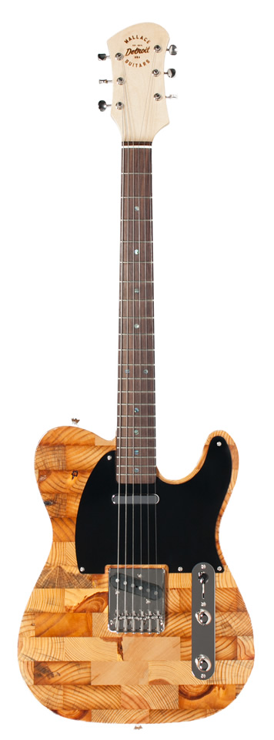
“Owning a guitar should be an extremely personalized lifestyle choice," Wallace added. "We want each of these guitars to inspire their owners and bring appreciation of their instrument to a new level. What they choose to create with these special guitars is entirely up to them!"

In addition to making custom wood selections, customers can also choose from several body styles and unique custom finishes, including hand-rubbed oil, sunburst nitrocellulose lacquer or high gloss nitrocellulose lacquer. Pickguards come in any color, and standard, antique and Bigsby hardware options are also available. For fretboards, customers can select Rosewood, ebony or maple and choose among pickup options include P90’s and humbuckers.

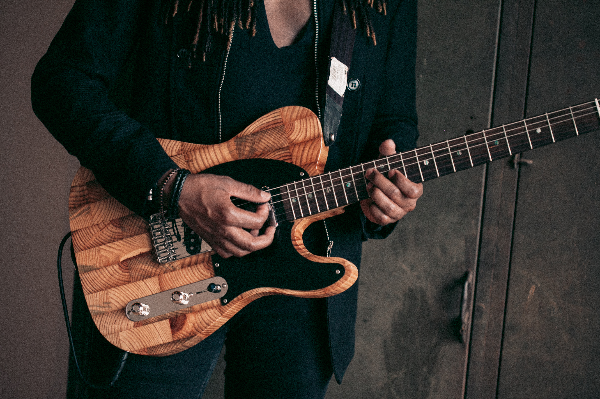
Every Wallace Detroit Guitars instrument sold features a certificate of authenticity and ships with a one-of-a-kind handmade guitar strap fashioned out of reclaimed car upholstery and a hard-shell leather case.
For more information or to place your customer order please visit: wallacedetroitguitars.com/build-your-own-guitar/configure/6748/

About Wallace Detroit Guitars
Founded by Mark Wallace in 2014, Wallace Detroit Guitars breathes new life into reclaimed wood from Detroit buildings by shaping it into some of finest American guitars on the market. Their instruments acknowledge not only Detroit’s architectural history, but also its proud tradition of both great craftsmanship and great music. With superior construction, premium components, and a great story, each guitar delivers a truly timeless playing experience.
Contact Information:
Jeff Touzeau
Public Relations
Hummingbird Media, Inc.
(914) 602-2913
jeff@hummingbirdmedia.com

