Get through the day, not in the way.
The new ACCENTUM Open is a refreshingly simple way to stay connected
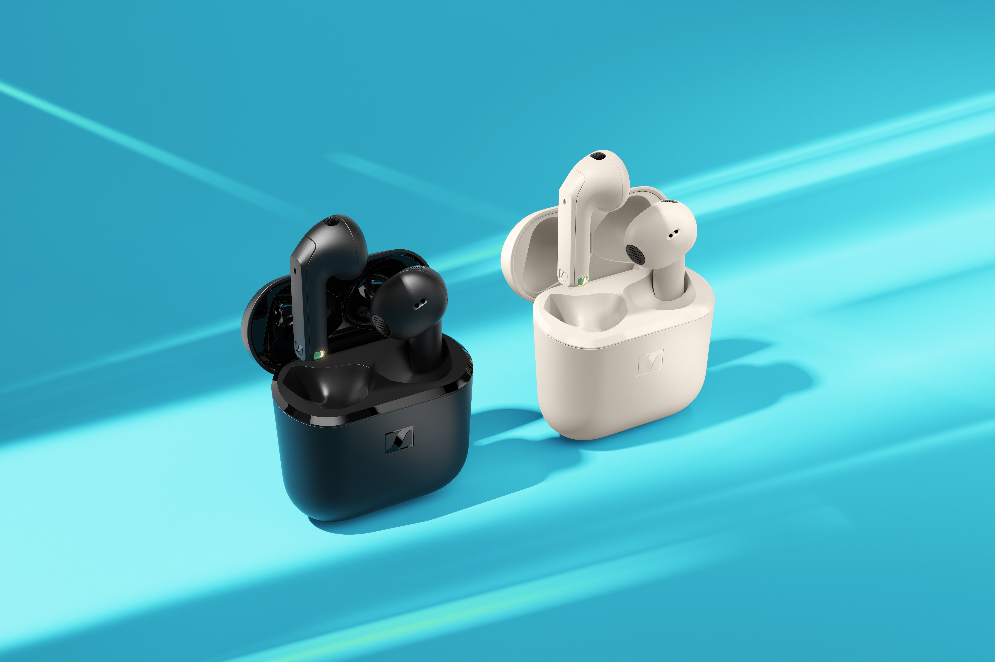
Marlow, UK – May 7th, 2025 – The Sennheiser brand today announces ACCENTUM Open, a true wireless open earbud for staying connected to your entertainment and the outside world on the simplest of terms. Combining the audio brand’s renowned sound tuning with an open fit (non-occlusive), ACCENTUM Open is made for multitaskers that want satisfying sound without a fuss.
“ACCENTUM Open was designed to complement your busy life—not complicate it,” said Friederike Menking, Product Manager. “Whether you are listening to music, catching up on a podcast at your desk or checking in with your friends on your way to the train, the ease of use is second only to the sound.”
Fidelity with freedom
At the heart of ACCENTUM Open is an 11mm dynamic transducer, seated just outside of the ear canal. Due to the open nature of the earbud, the fit does away with ear fatigue while providing awareness of your surroundings. The universal design is second nature to wear, eliminating the need for ear adapters or clips.
With Bluetooth 5.3 and multipoint connectivity, users can seamlessly switch between multiple devices, such as taking a work call on a laptop before instantly returning to a music playlist on their smartphone. The dual beamforming microphones ensure dependable hands-free call quality, filtering out background noise for additional speech intelligibility.

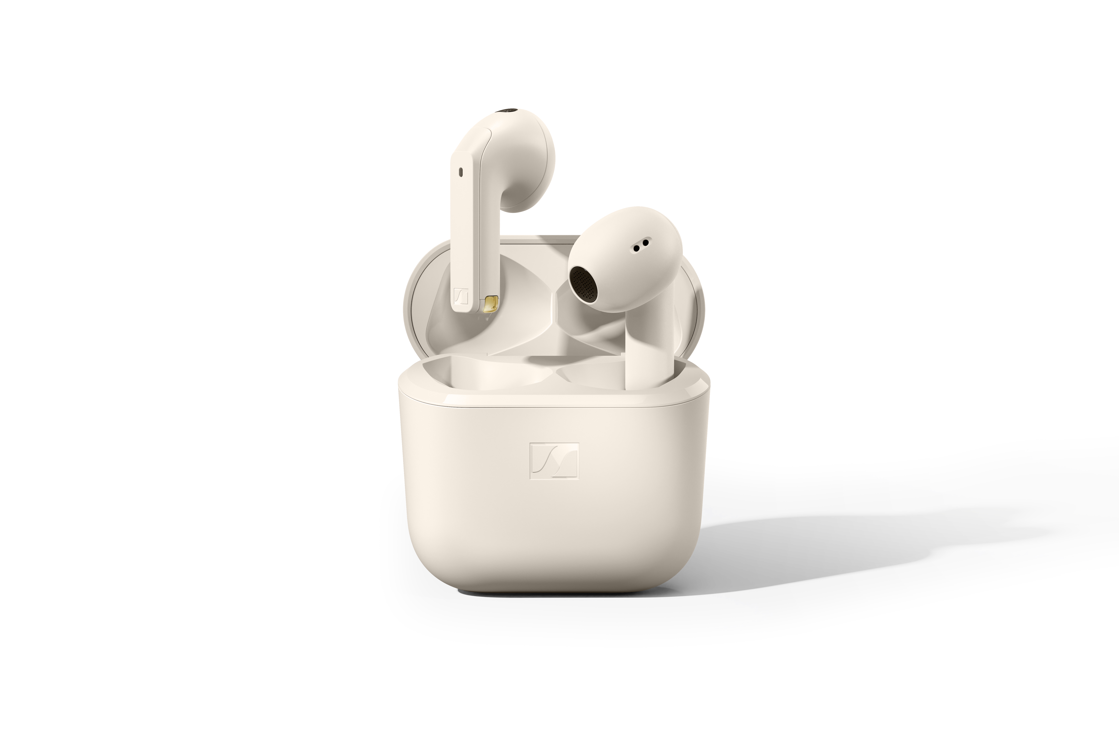
Light as air
The combination of an open earbud and ultralight stem with touch controls makes ACCENTUM Open liberating to use. Each weigh just 4.4 grams — about the same as a playing card — and is effortless to remove — for the evening or just a moment. The earbuds offer up to 6.5 hours of playback on a single charge, and a total of 28 hours when recharged with the compact case. With fast-charge capability, just 10 minutes of charging from a USB cable delivers up to 1.5 hours of listening time — perfect for bringing an extra episode or two of your favourite new show.

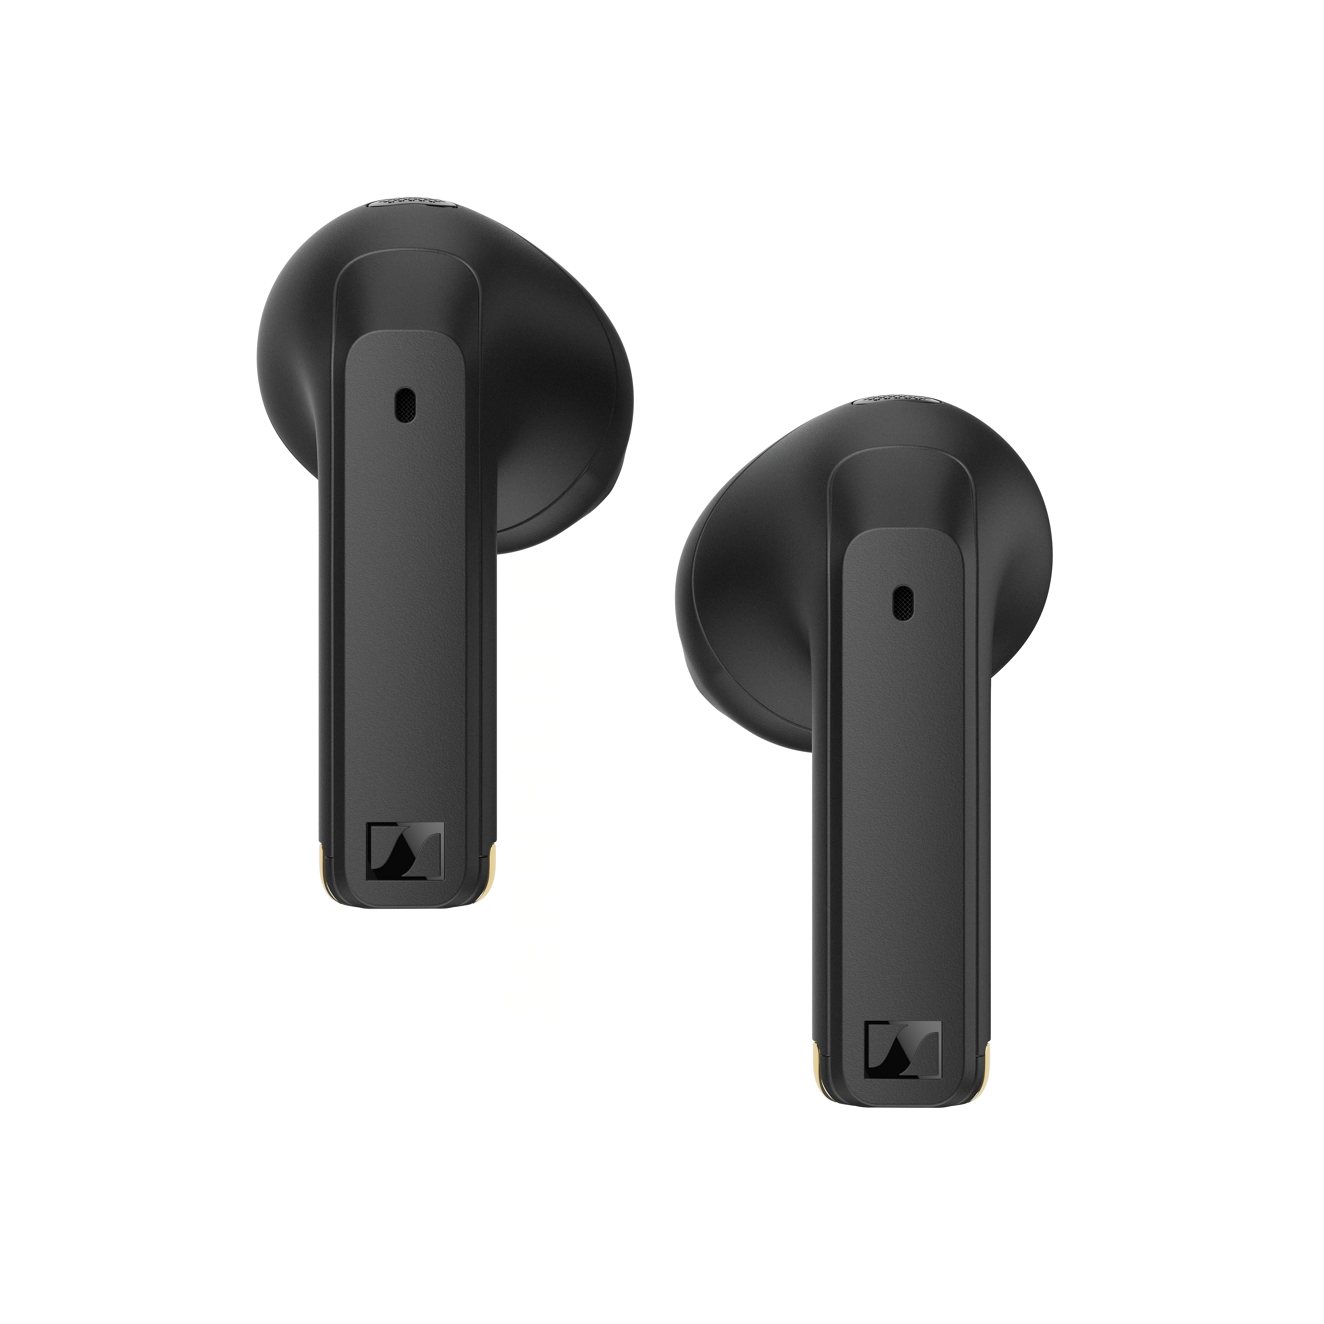

Availability
ACCENTUM Open is available in cream and black colourways from today, with an MSRP of £69.99/€89.90.

About the Sennheiser brand
We live and breathe audio. We are driven by the passion to create audio solutions that make a difference. Building the future of audio and bringing remarkable sound experiences to our customers – this is what the Sennheiser brand has represented for more than 75 years. While professional audio solutions such as microphones, meeting solutions, streaming technologies and monitoring systems are part of the business of Sennheiser electronic GmbH & Co. KG, the business with consumer devices such as headphones, soundbars and speech-enhanced hearables became part of the Sonova Holding AG group of companies in 2022, who have licensed the Sennheiser trademark for this purpose.

www.sennheiser.com
www.sennheiser-hearing.com

About Sonova Consumer Hearing
Sonova Consumer Hearing offers premium headphones and hearables – primarily in the true wireless segment – as well as audiophile headphones, hearing solutions and soundbars under the Sennheiser brand. The business is part of the Sonova Group, a global leader in innovative hearing care solutions with headquarters in Switzerland and more than 17,000 employees worldwide.

Press contact
Sonova Consumer Hearing GmbH
Kate Smart
EMEA PR and Influencer Manager
T +447909729925
Kate.smart@sonova.com

