Sennheiser – 80 years of innovation in broadcasting

Wedemark/Amsterdam, September 2025 – With Sennheiser having turned 80 in June, IBC is the ideal opportunity to go time-travelling and take a look at the company’s greatest broadcast-relevant products and inventions, from the first shotgun microphone to today’s Spectera bidirectional wideband wireless ecosystem. Join us on a ride through the decades.

1945 – Founding
 | Dr.-Ing. Fritz Sennheiser founds “Laboratorium Wennebostel” (Laboratory Wennebostel), or “Labor W” (Lab W) for short, in the village of Wennebostel, north of Hanover, Germany. Lab W first focused on building measuring devices, but soon expanded its portfolio to include microphones.

1953 – The MD 21, a new standard in ruggedness
 | Robustness and a long service life were the hallmarks of the omnidirectional MD 21 at a time when microphones had to be treated with care. The MD 21 excelled as a broadcast mic and was Sennheiser’s first microphone with a metal die-cast housing – the breakthrough to mass production was made.

1954 – First shotgun mic
At a 1954 tradeshow, the company showed the MD 81, the first interference tube shotgun microphone for the TV and film industry. | 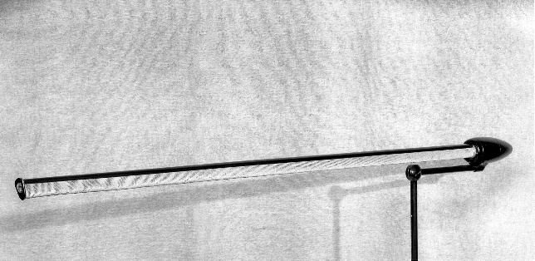

1957 – A wireless microphone for TV use
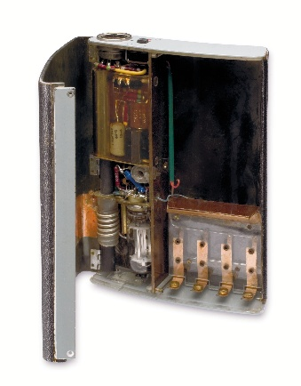 | In August 1957, Labor W showed its first wireless microphone at a tradeshow in Frankfurt. It had been developed together with broadcaster NDR and had, under ideal conditions, a range of up to 100 m and an operating time of up to five hours. Pictured is the wireless transmitter, which still used a tube and consequently needed five batteries. A handheld microphone was plugged in at the transmitter top.

1958 – Lab W is renamed Sennheiser electronic
The advertisement translates as “We have a new company sign and a new name. Our old name, ‘Laboratorium Wennebostel’, often led to misunderstandings. We have long since stopped being a laboratory; rather, we are the manufacturing facility for microphones, transformers, amplifiers, miniature headphones and measuring devices that you have come to know.” | 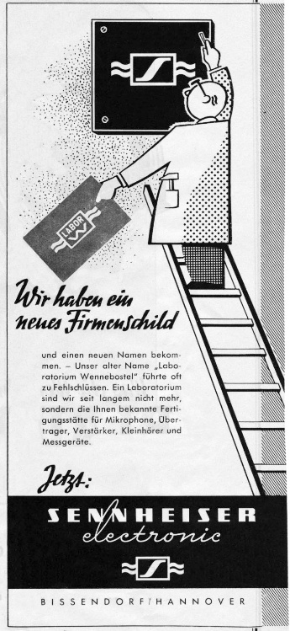

1960 – The MD 421 is launched…
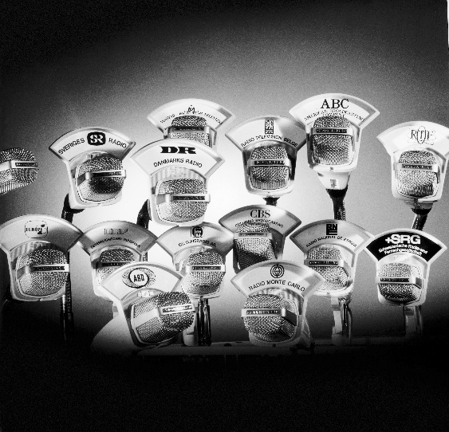 | …and goes on to become a broadcast and studio classic! The cardioid microphone quickly became a standard for broadcasters across the globe.

1962 – Birth of the famous MKH series RF condenser microphone
At a 1961 tradeshow, Sennheiser showed its first RF condenser microphones. Series production started in the following year with the MKH 104/105 – the birth of the MKH series. The picture shows the redesigned and improved 1963 MKH 104. In 1964, Sennheiser’s long gun mics (MKH 804/805) followed. | 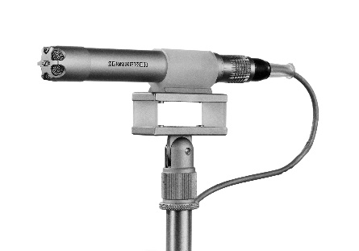

1963 – Equipment for outside broadcasting
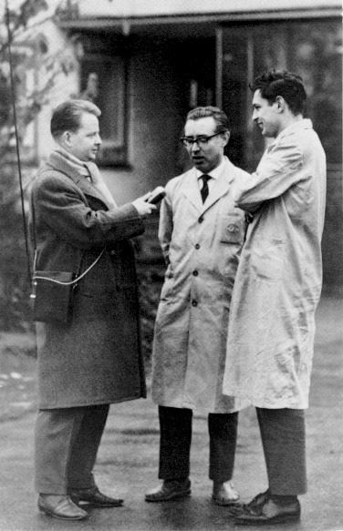 | Showcased as prototypes at the 1962 Industrial Fair, the portable SER 1 reporter transmitter and associated ER 1 receiver became available in 1963. Covering a distance of 10 kms, with longer ranges possible when using several transmitters and receivers as relay stations, the SER 1 and ER1 hit the market at the right time, when broadcasting companies needed an alternative to the services of the postal authorities.

1966 – The first ‘one-piece’ wireless
In 1966, Sennheiser debuted the SK 1008, its first wireless transmitter with interchangeable mic heads. The omnidirectional MD 1008 plug-on head was followed by the cardioid MD 4008 a year later. | 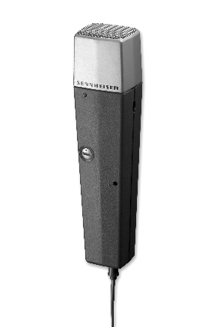

1971 – A dynamic with the sound of a condenser: The MD 441
Company rumour has it that the innovative and stylish MD 441 is the result of a bet between the heads of two Sennheiser development departments: The dynamic microphone was to have a sound that is as good as that of a condenser microphone. The engineers succeeded in creating a directional dynamic mic with excellent sensitivity across the wide frequency response range of 30 – 20,000 Hz. With a capsule system that is spring-suspended in all directions, built-in pop protection and brilliance (treble) and bass switches, the MD 441 has been a must-have studio microphone for more than 50 years. | 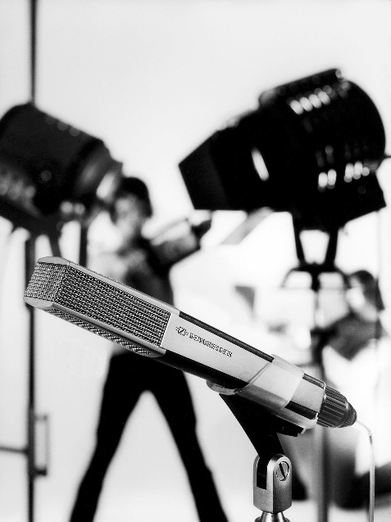

1975 – The legendary MKH 416 P48
The phantom-powered MKH 416 has become Sennheiser’s most popular MKH microphone, and a go-to microphone for on camera use and voiceover artists. | 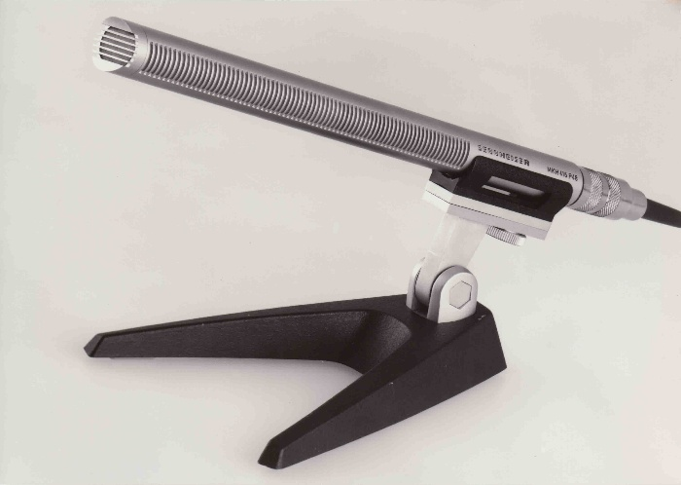
1982/1983 – Sennheiser innovates RF wireless microphone technology
The new wireless generation is launched, with the EM 1036 multi-channel receiver and SKM 4031 handheld transmitter being the stand-out products. The HiDyn compander system had been developed three years earlier, and the usual VHF systems were now complemented by the more reliable UHF models with much shorter antennas. | 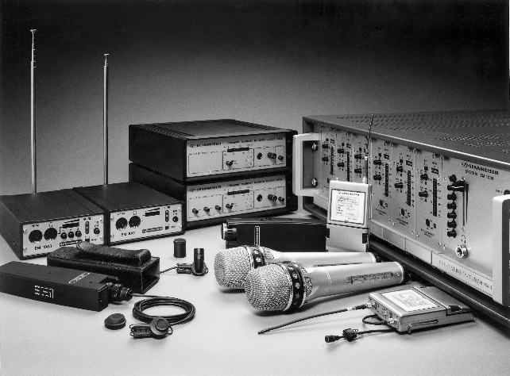

1988 – A monitoring classic: The HD 25
The HD 25 monitoring headphones have had quite a career – from broadcast monitoring to field recording and the DJ stage. They were the first Sennheiser model to use neodymium-ferrous magnets. | 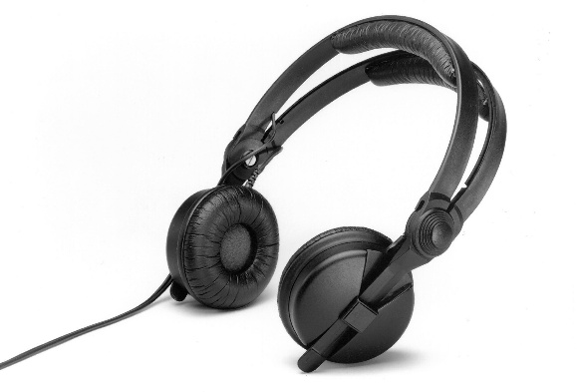

1992/1993 – The EM 1046, SKM 5000 and SK 50
At the beginning of the 1990s, Sennheiser debuted the new professional wireless generation with synthesizer technology. The EM 1046 multichannel receiver, SK 50 and SK 250 bodypack transmitters and SKM 5000 handheld represented the best in wireless technology available at the time. For the first time, a microprocessor was used to monitor all analogue functions of a receiver, and the HiDyn plus compander improved noise reduction further. Sennheiser wireless was used for the most spectacular broadcasts, such as the live transmission of the ascent of the Eiger North Face. | 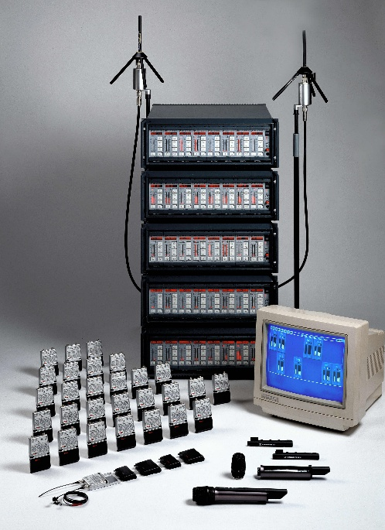

1999 – The advent of evolution wireless
Sennheiser’s best-selling wireless range ever, which made professional wireless affordable for more users than ever before. Right from the start, the series also included camera systems. | 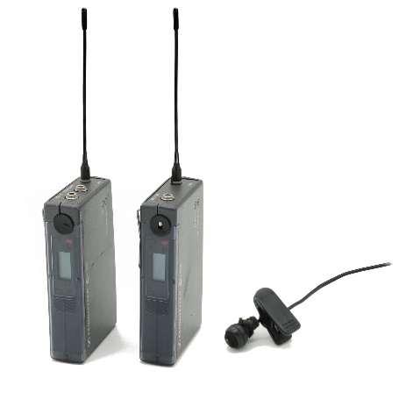

2001 – SK 5012
Transmitter miniaturisation continued with the SK 5012 bodypack – it was the same size as the battery pack of the SK 250 launched in 1993! | 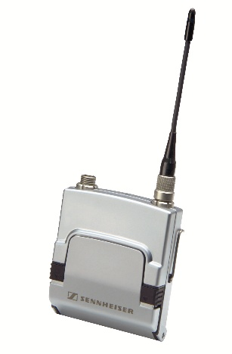

2011 – The MKH 8000 series shotgun microphones
The MKH 8060 short gun (pictured) and MKH 8070 long gun microphone were launched as part of the modular Sennheiser MKH 8000 series. Their RF condenser principle makes them rugged and weather-resistant field microphones. | 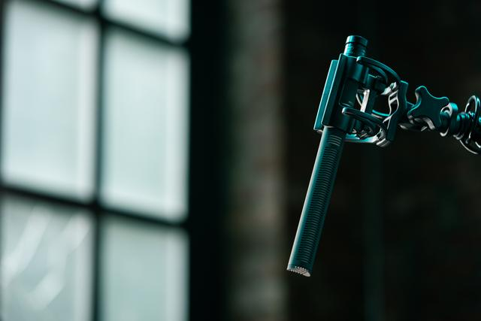

2012 – Digital 9000
Digital 9000 is Sennheiser’s first digital wireless system for broadcasters and other highly professional applications. It’s still the world’s only digital wireless which can transmit codec-free. | 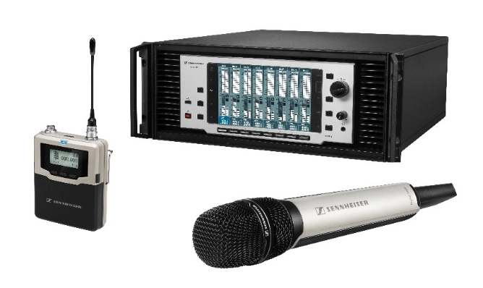

2016 – The EK 6042
The EK 6042 – part of the Digital 6000 Series announced in the same year – handles both digital and analogue transmitters – ideal for the long-lasting gear produced by Sennheiser! | 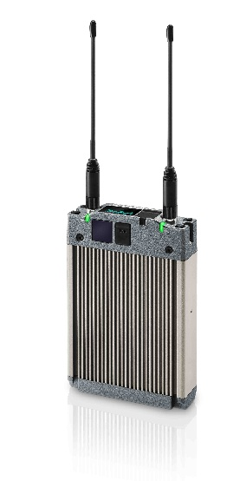

2022/2023 – evolution wireless goes digital: EW-DP and EW-DX series
The new Evolution Wireless Digital family is expanded by the EW-DX professional rackmount systems and by the portable EW-DP systems (pictured) for camera-mount ENG applications.

2024 – Spectera
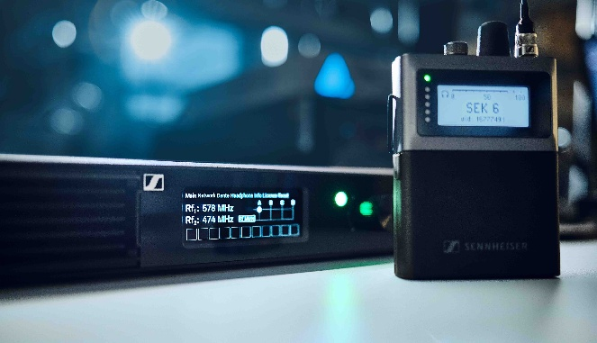 | At IBC 2024, Spectera, the world’s first wideband wireless, is unveiled. After seven decades of narrowband wireless, Spectera’s innovative bidirectional wideband technology brings numerous advantages for broadcasters and other professional wireless users.

2025 – MKH 8018
The MKH 8018 stereo shotgun microphone completes Sennheiser’s MKH 8000 series. Switchable between MS stereo and internally matrixed wide and narrow XY stereo, short dimensions and lightweight aluminium housing, the 8018 is an ideal on-camera mic for broadcasters. | 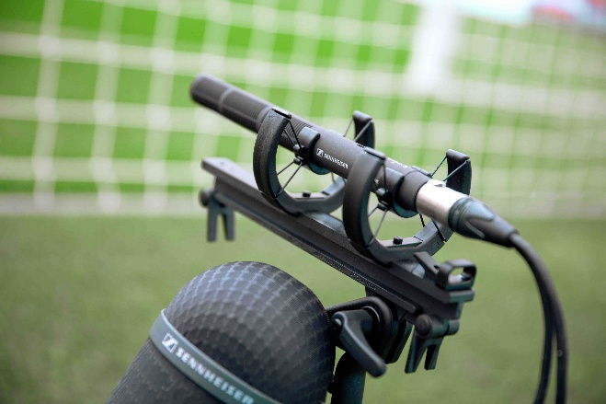
(Ends)

The high-resolution images accompanying this media release can be downloaded here.

About the Sennheiser Brand – 80 Years of Building the Future of Audio
We live and breathe audio. We are driven by the passion to create audio solutions that make a difference. This passion has taken us from the world’s greatest stages to the quietest listening rooms – and made Sennheiser the name behind audio that doesn’t just sound good: It feels true. In 2025, the Sennheiser brand celebrates its 80th anniversary. Since 1945, we have stood for building the future of audio and bringing remarkable sound experiences to our customers. While professional audio solutions such as microphones, meeting solutions, streaming technologies and monitoring systems are part of the business of Sennheiser electronic SE & Co. KG, the business with consumer devices such as headphones, soundbars and speech-enhanced hearables is operated by Sonova Holding AG under the license of Sennheiser.
www.sennheiser.com
www.sennheiser-hearing.com

Global Pro Audio Press Contact
Stephanie Schmidt
stephanie.schmidt@sennheiser.com
+49 (5130) 600 – 1275

