MEDIA RELEASE
ISSUED UNDER STRICT EMBARGO OF 20:30 ON 11 NOVEMBER 2025

A BOLD NEW CHAPTER FOR SEACOM AS THE AFRICAN
CONNECTIVITY PIONEER REBRANDS
Johannesburg, 12 November 2025 (embargo on 11/11/2025 at 20:30) — Seacom, Africa's original digital fibre backbone infrastructure and trusted partner for future business growth, today unveiled a refreshed brand identity at AfricaCom 2025 in Cape Town. Seacom is the provider of secure, services, connecting the continent and beyond. The brand refresh marks a bold new chapter in the company's history and reaffirms its commitment to innovation, client focus, and digital leadership.
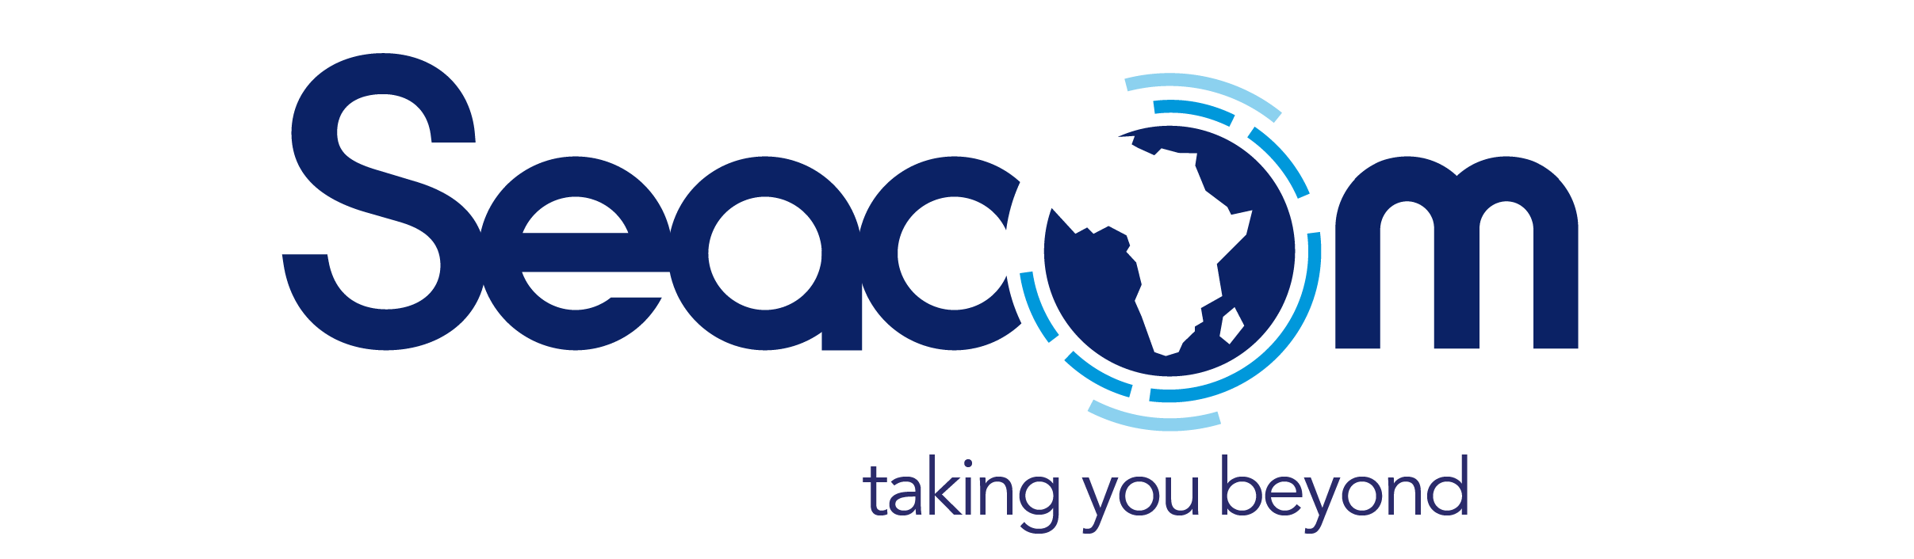
The rebrand marks a strategic leap for Seacom, showcasing its expanded capabilities, renewed purpose, and ambitious vision for Africa's digital future. "Our new brand embodies the energy, innovation and growth we are driving across the continent and beyond ," said Alpheus Mangale, Seacom Group CEO.
"This is about more than design, it's about purpose. We are a dynamic, forward-thinking company deeply connected to Africa's growth story, ready to power the next wave of digital progress across the continent," adds Mandisa Ntloko-Petersen, Seacom Group Chief Marketing Officer.
"The new refreshed brand representation with its strong tagline supports the client-centric approach of Seacom, always guiding, partnering and accompanying the client on their digital journey. The new tagline of taking you beyond acts as an intensifier beyond the present, unleashing the business potential that a relationship with Seacom can bring beyond the present," adds Ntoko-Petersen.
Founded in 2009, Seacom made history by connecting East Africa to the world with the region's first subsea fibre cable. This milestone bridged the digital divide and ignited a wave of growth across the continent. Since then, Seacom has evolved into a continental-scale technology partner, operating one of Africa's most extensive networks that supports millions of users and enterprises across every primary industry.
"The announcement of the brand refresh follows the recent presentation of the Seacom 2.0 project, a next-generation subsea cable system that will transform connectivity across Africa, the Middle East, and Asia. Together, these milestones signal the start of a new era for Seacom, its clients, and Africa's digital future," says Mangale. "The refreshed brand represents how Seacom opens up Africa to the world and the world to Africa, enabling business growth from the tip of the continent to the rest of the world," adds Mangale.
Seacom created Africa's original digital backbone and continues to partner with enterprises at scale. By integrating cloud, security and managed services on the same foundation, Seacom delivers growth through integrated solutions and a clearer path to value. Seacom operates through two focused divisions:
- Digital Infrastructure: Delivering the backbone, subsea cables, terrestrial fibre, and data centres that keep Africa connected.
- Digital Services: Building on that foundation with enterprise cloud computing solutions, advanced security services, and managed IT offerings that help businesses grow without complexity.
The company serves content providers, carriers, service providers, and enterprises across key sectors, including finance, hospitality, and mining. "With our new refreshed brand, Seacom focuses on empowering Africa's digital future through innovation and partnership," concludes Mangale.
Visit www.seacom.com to see the refreshed look and feel incorporated in our new website.
ENDS
>493 words<

EDITORS’ NOTES:
ABOUT SEACOM
Seacom made history by bringing the first subsea fibre cables to East Africa in 2009, sparking economic growth and setting the stage for a digitally connected continent. That pioneering role made Seacom Africa's original digital backbone. The company now operates at scale, with infrastructure that spans borders and connects millions of people and businesses. On this foundation, Seacom built an integrated portfolio of cloud, security and managed services that perform reliably – precisely because they run on its own network. With 35,000 km of fibre, six diverse subsea cables and more than 4,000 enterprise clients, Seacom combines scale with client-level care. The company helps enterprises lead Africa's connected future.
PRIMARY EDITORS' CONTACTS:
- Mandisa Ntloko-Petersen of Seacom on mandisa.petersen@Seacom.com or +27832000279
- Willem Eksteen of Stone on willem@stone.consulting or +27832726304

