Waygate Technologies Launches Major Upgrade for Krautkrämer USM 100, Adding Industry-First Features

Pro edition of flagship conventional ultrasonic flaw detector now available with B/C Scan capability, improved connectivity features and an app to add contextual information to inspection data

HUERTH, Germany, Feb. 22, 2023 – Waygate Technologies, a Baker Hughes business and market leader in non-destructive testing (NDT) for industrial inspection, has developed a new upgrade for its flagship portable ultrasonic flaw detector Krautkrämer USM 100, designed for the energy, petrochemicals, rail, and automotive industries. In addition to its superior ergonomics, user interface and connectivity, the upgraded Krautkrämer USM 100 Pro edition boasts multiple new features. Notably, it is the first portable flaw detector with B/C scanning capability at the price point of a standard conventional device.

“As a company, it is important for us to constantly explore new solutions to industry challenges and to continuously improve and advance our products,” said Miao Wang, general manager of Ultrasound at Waygate Technologies in Huerth. “Our Krautkrämer USM 100 is a conventional flaw detector that sets new standards in ergonomics, connectivity and robustness. We are proud to now introduce a Pro upgrade that offers more customizable, industry-unique options, enabling faster decision-making and greater efficiency for our customers.”

Industry-First Advancements

The newly available upgrade adds features that raise inspection standards and can perform more demanding tasks, such as B/C Scan. This function, an industry first for portable conventional inspection equipment, enables an effective two- and three-dimensional visualization and rapid quantification of ultrasonic data in real time. B/C Scan can visualize larger amounts of data and identify multiple defects in an object – such as corrosion, lamination and inclusions – in a single, comprehensive image. In addition to the B/C Scan capabilities, A-scans are enhanced with real-time averaging eliminating noise signals while interface echo tracking and consistent TOF (Time-of-Flight) measurements are provided. These additions help enable comprehensive and accurate inspections of industrial equipment suitable for an interconnected world.

Advanced Connectivity, Analytics and Customizability

The Krautkrämer USM 100 Pro edition increases operator confidence in results and helps improve asset management and predictive maintenance. The new Enrich smartphone app enables the creation of more detailed inspection reports and better traceability of data by adding contextual information such as images of the inspected part, its geographic location, notes about the part and comments.

In addition, the USM 100 PC Live software uses the processing power of a tablet or PC to operate the Krautkrämer USM 100 remotely. When the device is connected to a PC, laptop or tablet, customers benefit from the added convenience and speed of working on a large screen. The additional computing power also enables much faster data capture and analysis. Larger data sets are captured and processed more quickly. In turn, this data is stored directly on the device and can thus be easily shared with other applications and third parties.

With the Pro upgrade, the instrument's user interface can be further customized to meet specific needs. With the available Create desktop software, inspection apps may be created and tailored for individual inspection procedures, industry applications and experience levels. Customizable filters also allow users to configure filter settings to optimize the signal-to-noise ratio for the best possible results.

Overall, the Pro upgrade available now and provides a comprehensive expansion of the device's capabilities to scale up to more demanding tasks and generate more revenue.

Learn more and contact Waygate Technologies:
- Learn more about Krautkrämer USM 100 and the Pro upgrade in the web
- Waygate Technologies corporate website: waygate-tech.com
- Waygate Technologies LinkedIn Channel
- Waygate Technologies YouTube Channel

###
Images


The Krautkrämer USM 100 Pro edition is the first portable ultrasonic flaw detector with B/C scan function.
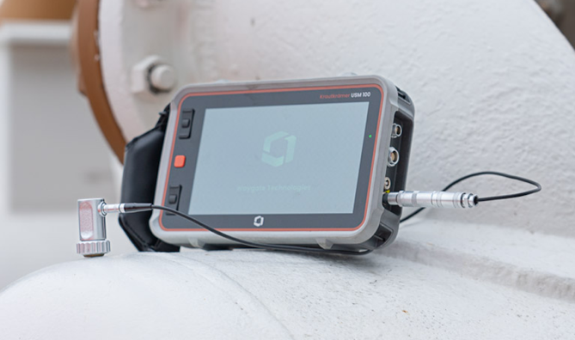
The Krautkrämer USM 100 becomes even more versatile with the Pro update.

About Waygate Technologies
Waygate Technologies, a Baker Hughes business, is an industrial inspection solutions provider and the world leader in nondestructive testing (NDT) ensuring safety, quality and productivity. We combine more than 125 years of experience and a collection of heritage brands including Krautkrämer, phoenix|x-ray, Seifert, Everest and Agfa NDT. Today, hundreds of brands in the automotive, aviation, space exploration, electronics, energy, battery and additive industries trust our technologies. We drive digital transformation through a broad portfolio of award-winning hardware and software solutions in industrial radiography and computed tomography (CT), remote visual inspection (RVI), ultrasound (UT), eddy current, robotic inspection, and data management. Headquartered in Germany, Waygate Technologies is part of the Industrial & Energy Technology segment of Baker Hughes (NASDAQ: BKR). Inspection starts here: waygate-tech.com

Media Contact

Henning Juknat
Global Communications Leader
Waygate Technologies
+49 2233 601272
henning.juknat@bakerhughes.com

