For more information, please contact Marta de Paco
On +34 670 780 664 or email press@comunicahair.com

Important:
These images are only available for editorial content.
Credits must be included.
Notification of their publication is expected.

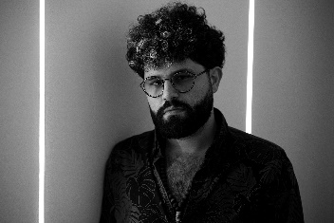
JAVIER GOMAR
UPRISING Collection

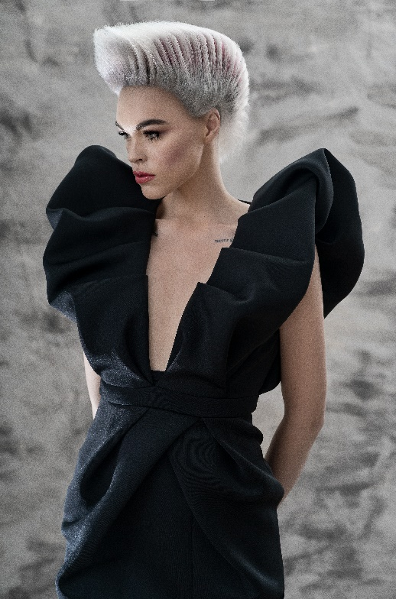
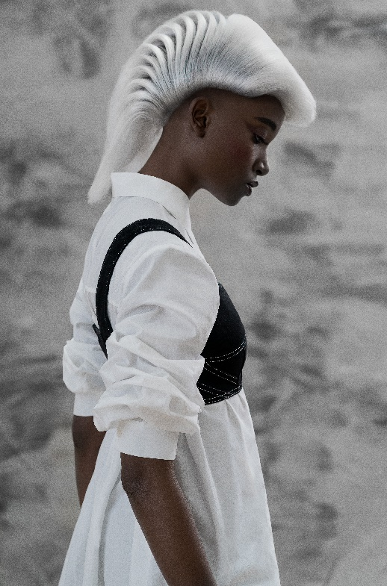
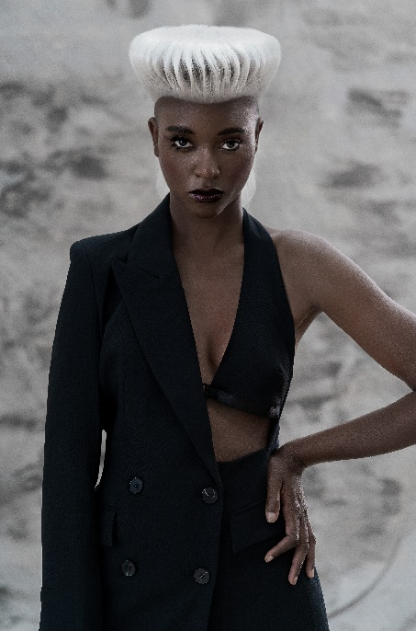
Finalist Newcomer of The Year at Fígaro Awards 2020
Finalist International Visionary Awards 2020
Finalist AIPP Awards 2020-2021
Hair: Javier Gomar - Javier Blade’s
Hair Instagram: @javiergomar4
Hair Assistant: Nestor Riera @nestorirerad
Photography: David Arnal
Photography Instagram: @davidarnalteam
MUA: Anna González
MUA Instagram: @iamlaflaca
Styling: Eunnis Mesa
Styling Instagram: @eunnismesa
Models: Irina Bon y Karol Maestre
Modelos Instagram: @irinabon @day_kiri

JAVIER GOMAR
UPRISING Collection

Uprising is a puzzle in which all the details are previously thought so each piece fits perfectly and works within the whole. Color, with its contrasts and with its subtle gradations; the haircut, with a line drawn to be precisely positioned on hair, and; lastly, drying, which is what gives life and confirms that all pieces are correctly positioned. This is the only way to achieve this architectural and geometric result, in which hair explores its own margins creating surprising silhouettes, unusual textures reinforced by the effect of color and an image that blends hair and hairdressing with art.

