EMBARGOED UNTIL Thursday, August 20, 2026, at 12:00 PM CEST (UTC+2)

Introducing Sennheiser MOMENTUM True Wireless 5: The Flagship MOMENTUM Experience in Your Pocket
Ultra-portable powerhouse arrives with high-resolution sound, user-replaceable batteries, Dolby Atmos® optimized head tracking, and more.

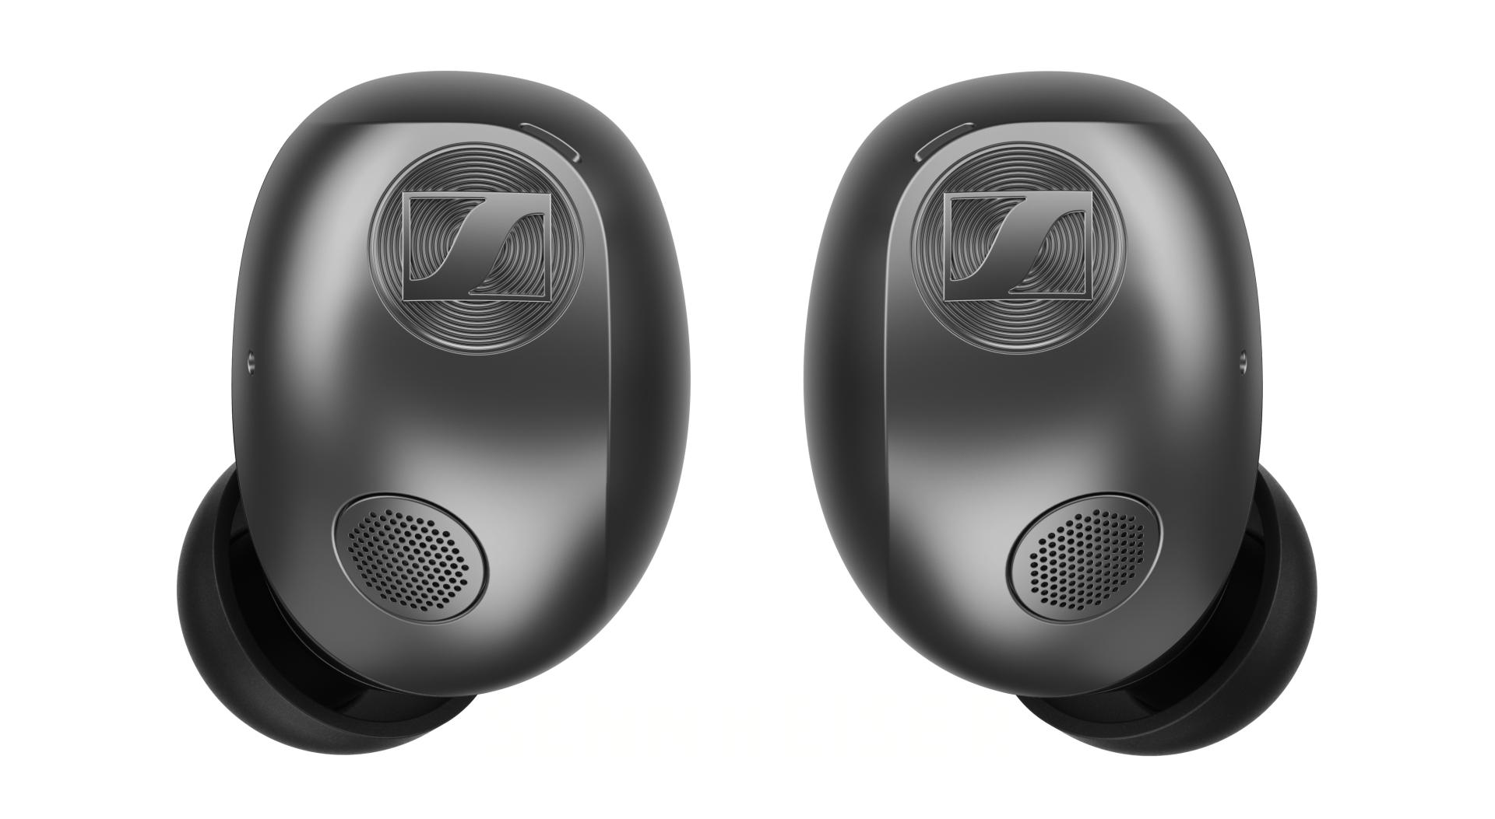

Hanover, Germany – August 20, 2026 – The Sennheiser brand today announces MOMENTUM True Wireless 5, its most advanced true wireless earbuds yet, engineered for an uncompromising listening experience wherever life takes you. Reimagined from the inside-out, they combine intelligent innovation with the inspired engineering of their full-size MOMENTUM 5 Wireless counterpart, bringing flagship performance into a beautifully compact design.

“We set out to bring the larger-than-life sound and connected technology of the MOMENTUM series into a remarkably compact format,” said Frank Foppe, Product Manager. “From its exquisite audio reproduction to the advanced hardware powering it all, MOMENTUM True Wireless 5 represents our most advanced integration of audio technology in an earbud.”

Key Highlights:
- All-new design – Improved comfort, stability, and portability
- User-replaceable batteries – Easily refresh your run-time even years from now
- Optimized for Dolby Atmos® – Head-tracking unlocks immersive entertainment
- Improved voice calls & ANC – Voice accelerometer, expanded mic array, and AI speech enhancement
- Bluetooth® 6.0 – Prioritizes fast and stable connections
- Smart Control Plus – a new 8-band EQ highlights an assortment of customizable features in the free app
Get Your Sound Revelation
The heart of the earbuds is the same sound-first DNA that powers the recently released fifth-gen MOMENTUM headphones, letting listeners choose their preferred wearing style for listening without compromise. It all starts with the brand’s signature 7mm TrueResponse dynamic transducer, capable of balancing remarkable detail with full-bodied, bass-driven tuning. Meticulously developed at the brand’s production facility in Tullamore, Ireland, each transducer is manufactured and tested for exceptional precision, clarity and dynamics. Bluetooth 6.0 with aptX Adaptive codec support provides stable wireless freedom for a crystal-clear hi-res audio pathway up to 24-bit and 96 kHz, including aptX Lossless for bit-perfect transmission on supported audio sources.

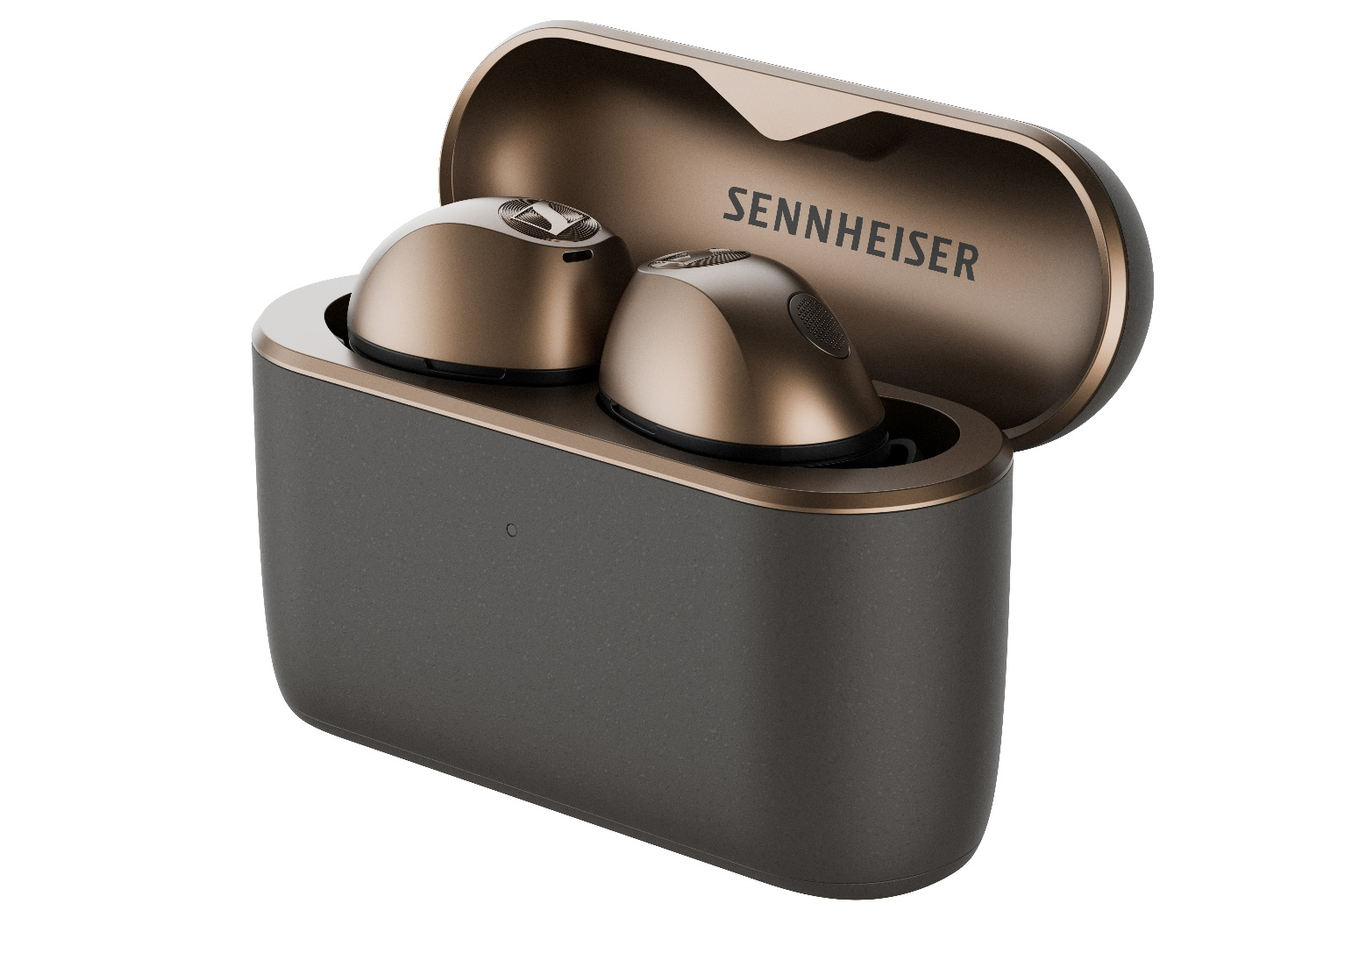

Sennheiser MOMENTUM True Wireless 5 pairs signature sound with user-replaceable earbud & case batteries
The bar for acoustic performance is raised once again, highlighted by the revised adaptive hybrid active noise cancellation (ANC) system and automatic anti-wind mode. A redesigned ear tip works in tandem with a dedicated four-microphone array to maximize noise cancelling performance while delivering the series’ most natural-sounding, real-time transparency mode to date. For pristine voice capture, the earbuds engage all eight system sensors—combining six microphones and two bone-conduction voice accelerometers with an AI speech-extraction algorithm to isolate the voice in chaotic environments.

Inheriting the spatial audio prowess of the over-ear model, MOMENTUM True Wireless 5 is fully optimized for Dolby Atmos® with interactive head-tracking capability¹, projecting an immersive, theater-like spatial audio field that you can take anywhere.



Eco-Conscious Endurance
MOMENTUM True Wireless 5 is built to last, introducing a user-replaceable battery system in both the earbuds and wireless charging case, letting users easily refresh the power cells in mere minutes. Sharing the same ethos as the brand’s flagship MOMENTUM 5 headphones, customers can safeguard their technology and retain the earbuds' longevity far beyond standard battery degradation using only a compact screwdriver.

Designed for all-day listening, the earbuds further improve their endurance over the prior generation with 12 hours of continuous playback per charge, and over two additional replenishments stored in the Qi-enabled wireless charging case for up to 40 total hours of run time. The quick charge capability extends listening up to 1 hour from just an 8-minute top-up.

“Balancing compact size, our signature high-fidelity acoustics, and a replaceable battery is a major breakthrough,” added Lilika Beck, President of Sennheiser Consumer Hearing. “With MOMENTUM True Wireless 5, we are proving that cutting-edge performance does not have to sacrifice longevity.”

Ergonomic Evolution
To achieve their "barely there" fit, the earbud housing features an elegant new aerodynamic silhouette sculpted using data derived from thousands of unique ear models. The earbuds’ fin-less shape was rated more comfortable than the prior generation by 73% of testers, and is rated IP54 for dust, sweat and splash resistance, A micro-perforated acoustic mic plate mitigates wind turbulence, protecting both voice capture and ANC stability from aerodynamic interference. The companion charging case has also been re-engineered with a narrower, pocket-friendly aspect ratio and a low-friction finish for seamless ingress and egress from tight pockets.

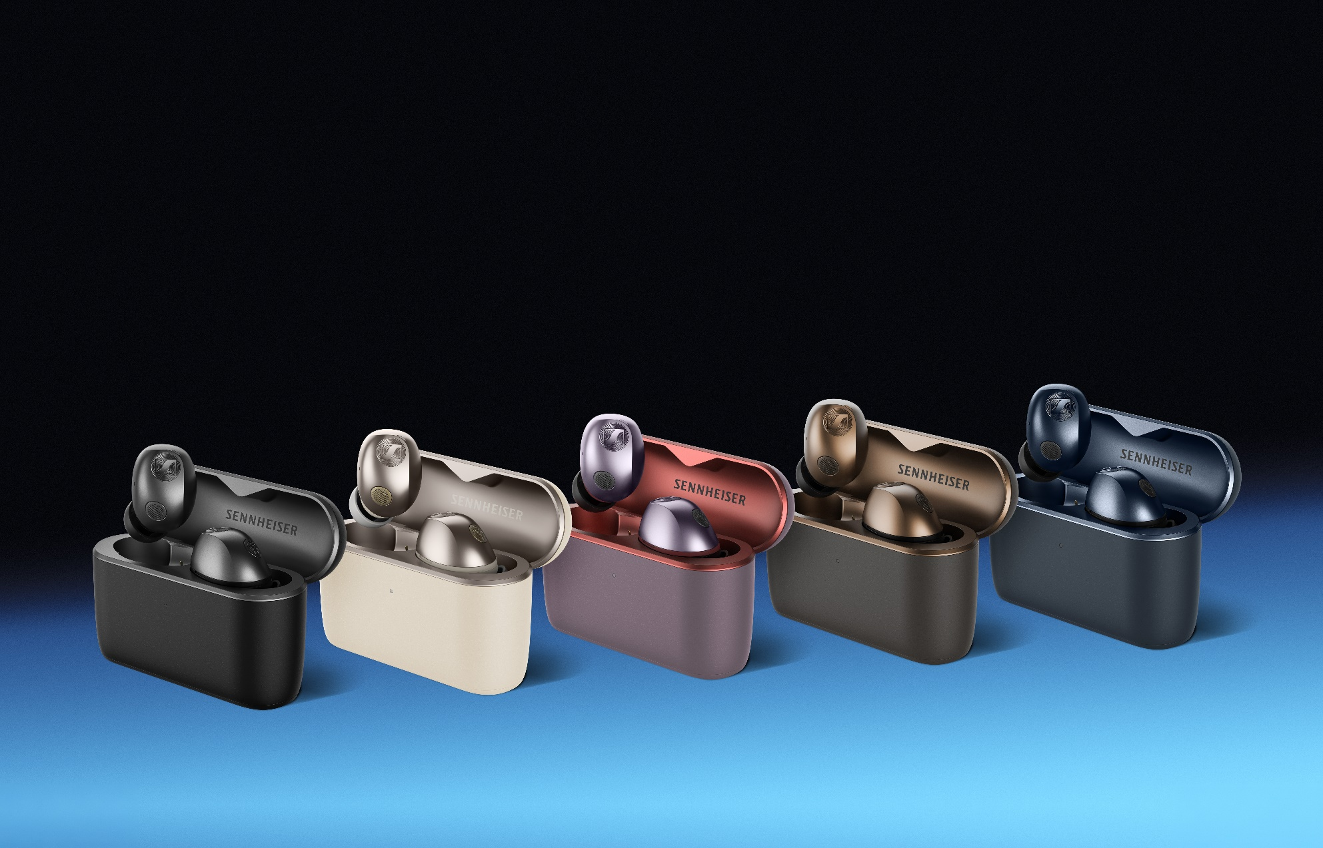
Sennheiser MOMENTUM True Wireless 5 sports a top-to-bottom redesign to enhance both portability and function

Ready for the Future Today
MOMENTUM True Wireless 5 is a connectivity king, bringing a frictionless experience to a wide range of audio sources:

- Next-Gen Bluetooth 6.0 with native support for Google Fast Pair, Microsoft Swift Pair, and multipoint switching
- Resilient RF Antenna with a selectable "robust mode” designed to maintain rock-solid signal integrity even in crowded RF environments
- Powered by Snapdragon Sound™ for bit-perfect, high-resolution wireless streaming up to aptX Lossless, alongside a low-latency mode for pulse-pounding gaming
- Smart Control Plus app integration provides an 8-band EQ, prompt-guided interactive Sound Personalization and granular setting customization—doubling as a platform to expand performance capabilities over time

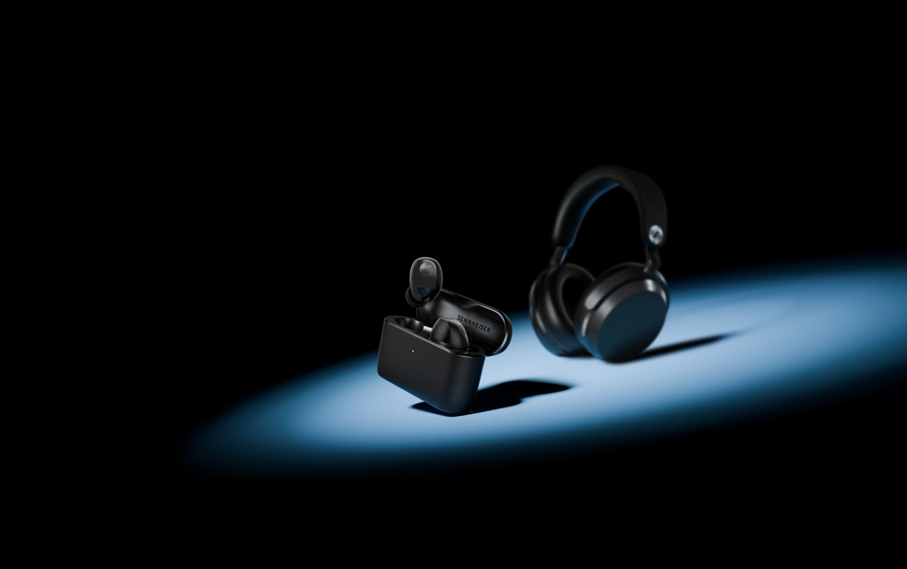
The MOMENTUM series offers a flagship experience in two different wearing styles

Pricing and Availability
MOMENTUM True Wireless 5 will be available in five luxurious metallic colorways: Graphite, Cream, Graphite, Copper, Denim, and Lavender. The earbuds will begin shipping on September 3rd from sennheiser-hearing.com and select retailers at an MSRP of $299.95 USD.

¹Head-tracking feature is optimized for Dolby Atmos-enabled sources and also available for use with all other audio content. The Bluetooth® word mark and logos are registered trademarks owned by Bluetooth SIG, Inc. and any use of such marks by Sonova Consumer Hearing is under license. Android is a trademark of Google LLC. iOS is a trademark or registered trademark of Cisco in the U.S. and other countries and is used under license by Apple Inc. Snapdragon Sound and aptX are trademarks or registered trademarks of Qualcomm Technologies, Inc. and/or its subsidiaries. aptX is a product of Qualcomm Technologies, Inc. and/or its subsidiaries. Dolby, Dolby Atmos, and the double-D symbol are registered trademarks of Dolby Laboratories Licensing Corporation. All other company and product names mentioned herein may be trademarks of their respective companies.

About the Sennheiser Brand – 80 Years of Building the Future of Audio
We live and breathe audio. We are driven by the passion to create audio solutions that make a difference. This passion has taken us from the world’s greatest stages to the quietest listening rooms – and made Sennheiser the name behind audio that doesn’t just sound good: It feels true. In 2025, the Sennheiser brand celebrated its 80th anniversary. Since 1945, we have stood for building the future of audio and bringing remarkable sound experiences to our customers. While professional audio solutions such as microphones, meeting solutions, streaming technologies and monitoring systems are part of the business of Sennheiser electronic SE & Co. KG, the business with consumer devices such as headphones, soundbars and speech-enhanced hearables is operated by Sonova Holding AG under the license of Sennheiser.

sennheiser.com
sennheiser-hearing.com

About Sonova Consumer Hearing
Sonova Consumer Hearing offers premium headphones and hearables – primarily in the true wireless segment – as well as audiophile headphones, hearing solutions and soundbars under the Sennheiser brand. The business is part of the Sonova Group, a global leader in innovative hearing care solutions with headquarters in Switzerland and more than 17,000 employees worldwide.

Press contact
Eric Palonen
PR Manager | Americas
Sonova Consumer Hearing USA
T +1 860 908 1210
eric.palonen@sonova.com

