For immediate distribution

Adrian Gurvitz: Recording Andra Day and ‘The Best Vocal Chain on the Planet”
With a multi-decade / multi-continental career as an artist, writer, producer and talent scout, Gurvitz go-to signal path in the studio is as sophisticated as it is simple, including the BAE 1073 DMP

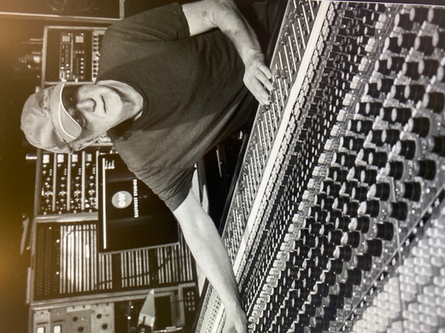
Tarzana, CA – March xx 2021 — Adrian Gurvitz career is the stuff of rock ‘n’ roll lore. Having achieved his first hit single in the UK at the tender age of 16, he has since racked up no less than 17 of his own albums, has penned several top 10 singles and has worked with a vast array of artists including Journey, REO Speedwagon, Chicago, The Moody Blues, the list goes on. Gurvitz, who remains incredibly prolific to this day, currently runs LONMAN Records, which he set up to identify and cultivate musical artists.
After decades of success as an artist with the likes of Buddy Miles, Ginger Baker and indeed as a solo artist, Gurvitz moved from the UK to the U.S., where he began shifting his career from front-line, touring performer to working with, and cultivating, artists behind the scenes. “I came to the States after I got the number one with Eddie [Money] around 1988, and I started writing for everybody,” he recalls. “I was moving more towards production and was mostly interested in finding and producing acts at that point, focused on writing, producing, and working as a talent scout.”
BAE and mic pres over tea
After Gurvitz moved to southern California, he met Mark Loughman of BAE Audio in a serendipitous moment. “I went to BAE’s offices to get a mic pre, which I still have to this day,” he recalls. “When I went into the office, there was a guy just sitting there who never spoke, soldering things. You were lucky if he said two words to you.” That guy was then-intern, now President of BAE, Mark Loughman. “I ended up getting to know him a bit better over time, because I ended up buying about 20 of their mic pres.” One day, many years later at a NAMM Show, the two reunited over a cup of tea at the BAE booth and soon became friends.
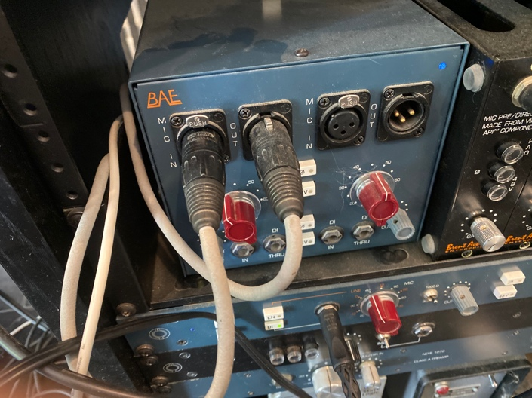
One of Gurvitz most recent successes is his work with superstar singer / songwriter / actress Andra Day, whose album Cheers to the Fall skyrocketed up the charts and whose single “Rise Up” received a Grammy nomination for Best R&B Performance. Most recently, Day portrayed Billie Holiday in the film The United States vs. Billy Holiday and subsequently won a Golden Globe Award for Best Actress in a Motion Picture and received a nomination for Best Original Song. Gurvitz began working closely with Day around 2010 as a producer and collaborator.
A sense for the song
Interestingly, while he has so many album credits to his name as a producer, Gurvitz admits he has very little engineering skills — nor has he ever needed them. “I’ve never really been technical, although I have a ton of gear in the studio,” he explains. “I make a record, and I end up making that record sound exactly the way I want it to sound. When working in the large studios like Oceanway or Sunset Sound, I work with engineers who help me get the sound I want — whether it’s drums, piano or orchestration.”
A singular mainstay in his signal chain is the BAE Audio 1073 mic pre, which he used on Andra Day’s vocal tracks on the The United States vs. Billy Holiday soundtrack. “I use these preamps all the time,” he says. “To me, they are fantastic and make everything sound great — whether I am mic’cing up a drum track, a vocal, bass guitar, it all goes through the 1073.”
While Gurvitz will often record basic tracks at a larger studio, he will then bring these tracks back to his well-appointed home studio in Tarzana to complete vocals and various overdubs. Indeed, the vocals for Day’s anthem “Rise Up” — which received a Grammy nomination — was recorded through a BAE 1073 DMP. “I’ve got the best vocal chain on the planet,” he enthuses. “I use a vintage Telefunken, then into a Universal Audio compressor and then into the BAE 1073 straight into Pro Tools. The vocal sound is incredible.”
Sound design and more
His private studio also is home to several modern and vintage synthesizers, which he also patches into the BAE 1073: “I am very into sound design, so I have the Mellotrons, the Moog Voyagers, the Mother32s and OB6s and more,” he says. “I put the Mother32 through the Big Sky Reverb, and dial in all sorts of different effects — it sounds really trippy and amazing. And then to cap it off, I go into the BAE 1073s.”
With a stellar signal chain in place and always at the ready, Gurvitz can remain focused on the production and delivery of the song rather than on engineering nuances: “The BAE 1073s are the best, and don’t need anything else. They are wide, deep and just make everything sound like a great record.”
To learn more about BAE Audio, please visit http://www.baeaudio.com.

About BAE Audio
BAE Audio is a U.S.-based manufacturer of high-end microphone preamp and equalizers, all of which are faithful to vintage designs of the seventies and before. The company is committed to the vintage philosophy of hand wiring and hand soldering all of its components to achieve a high quality and authentically vintage sound. For more information on BAE Audio, please visit our website at www.baeaudio.com.

Media contact
Jeff Touzeau
Public Relations
Hummingbird Media
+1 (914) 602 2913
jeff@hummingbirdmedia.com

