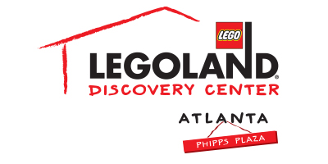

For more information:
Katie Clark
BRAVE Public Relations
404.233.3993
kclark@bravepublicrelations.com

**MEDIA ADVISORY**

LEGOLAND® Discovery Center Atlanta to host
Homeschool Week on February 5 – 9
Phipps Plaza attraction welcomes homeschool students for a week of educational fun

ATLANTA (January 12, 2018) – LEGOLAND® Discovery Center Atlanta invites homeschoolers to participate in its Homeschool Week on February 5 – 9! A week filled with free LEGO® Education Workshops and activities that address Common Core standards, local homeschoolers and their teachers will have the chance to learn while having fun in a different kind of classroom setting.

Local homeschools can reserve a field trip by visiting bit.ly/HomeschoolWeekFebruary and completing the registration form. Homeschools must send the registration form and declaration of intent via fax to 404.848.9591 or email at LDCATL.Groupsales@LEGOLANDDiscoveryCenter.com prior to visiting.

WHAT: Homeschool Week
Local homeschoolers will enjoy a week filled with LEGO Education Workshops and activities to gear up for the school year!

WHEN: February 5 – 9
Monday – Friday: 10 a.m. – 7 p.m.
Saturday: 10 a.m. – 9 p.m.
Sunday: 10 a.m. – 7 p.m.
*Last admission is two hours before closing

WHERE: LEGOLAND Discovery Center Atlanta
Third Floor, Phipps Plaza | 3500 Peachtree Road in Buckhead

HOW: Homeschool Week is FREE for teachers and $7.00 per student. Local homeschools can reserve a field trip by visiting bit.ly/HomeschoolWeekFebruary and completing the registration form. Homeschools must send the registration form and declaration of intent via fax to 404.848.9591 or email at LDCATL.Groupsales@LEGOLANDDiscoveryCenter.com prior to visiting.

For more information, visit facebook.com/LDCatlanta
or atlanta.legolanddiscoverycenter.com.

###

