PRESS FILE 2016
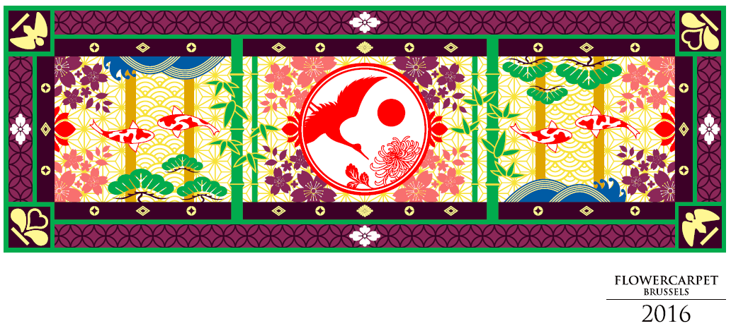
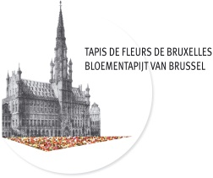
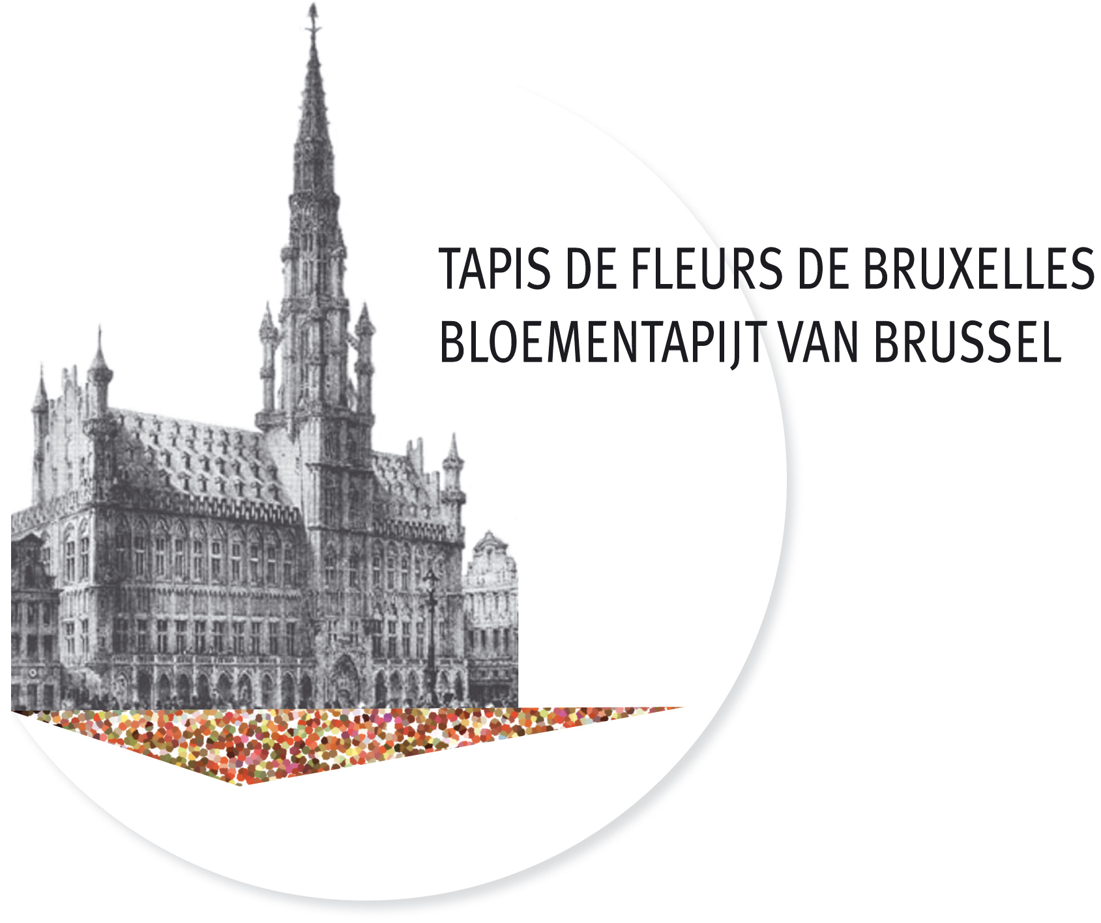

“This year, Japan and Belgium are celebrating their 150th anniversary of friendly relations, established in 1866 with the Treaty of Amity, Commerce and Navigation. On this special year, Japan has been given the honour to be invited as guest country to the world-famous Flower Carpet in Grand Place.
The 2016 Flower Carpet is showcasing nature in Japanese tradition with its numerous good luck talismans: flowers, birds, the wind and the moon are symbols of the natural beauty (Kacho-fugetsu); Koi (Japanese carps) represent strength and growth; pine trees and bamboos are signs of good omen; and the cherry blossoms, of course.Please enjoy!”
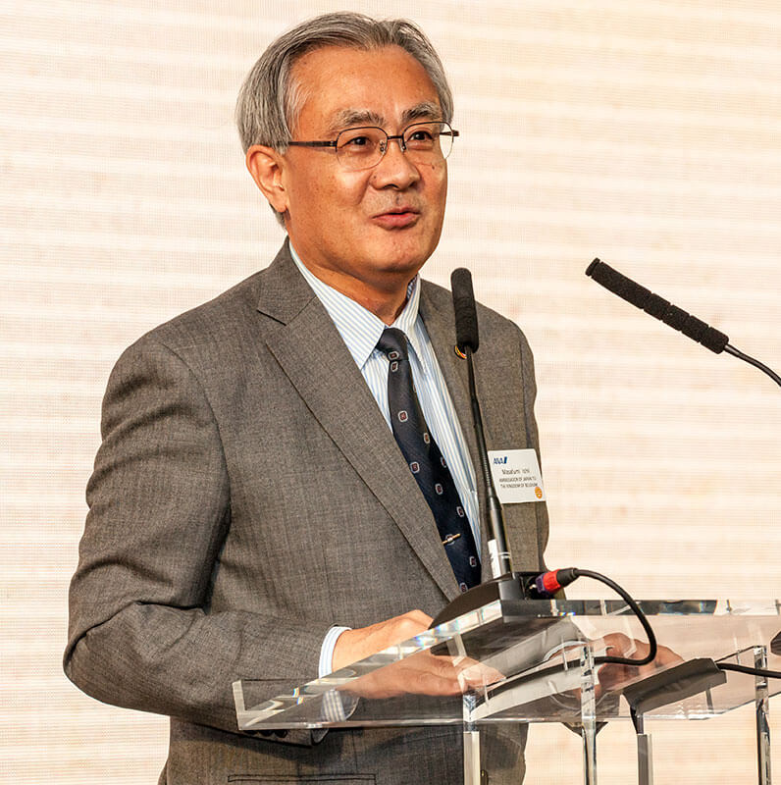
Masafumi Ishii
Ambassador of Japan to Belgium

"Along with the Ommegang, each of our Communities' feast days and certain other prestigious concerts, the Flower Carpet is a staple on Brussels' calendar, the difference being that it is the most cosmopolitan event held in the Grand Place. The Flower Carpet is culturally inclusive and, as a result, attracts a broad range of visitors, far beyond just flower enthusiasts and local residents, with foreign tourists travelling from far and wide to enjoy the exceptional view from the balcony of Brussels' Town Hall. During the last Flower Carpet event in 2014, the hotel occupancy rate in the city reached a record 95%.
Practically the entire city will delight in and, I hope, be bathed in the delicious scent of the Flower Carpet. Now in its 20th year, the carpet will be decorated in the colours of Japan to celebrate its expertise in floral art. A complete joy!"
Philippe Close
Councillor for Tourism
Vice-President of the Brussels Flower Carpet Organisation

“The Grand-Place has always been an ideal setting for the Flower Carpet. Every two years, in the middle of August, this tapestry of stone-weaved lace perfectly complements the splendid floral patterns. This ephemeral fusion contributes to the repute of our Capital, which reaches well beyond its borders. Artists, craftspersons and volunteers have all strived to draw, sow, harvest, organise and arrange hundreds of thousands of flowers.Without their dedicated contribution, such a masterpiece could not exist. The City of Brussels is eternally grateful to them. We welcome you to the Grand-Place, to admire a work of art that will, I am sure, illuminate the anniversary celebrations of 150 years of Belgo-Japanese friendship.”
Yvan Mayeur
Magistrate of the City of Brussels
President of the Brussels Flower Carpet Organisation

CONTENT

PRESS RELEASE 5
150 YEARS OF BELGO-JAPANESE FRIENDSHIP 7
FLOWERS IN JAPANESE CULTURE 8
BRUSSELS CITY HALL IN IKEBANA 9
ONE FLOWER CARPET, TWO DESIGNERS 10
MAKING A FLOWER CARPET 12
FLEMISH BEGONIA : UNIQUE IN THE WORLD 13
A BRIEF HISTORY OF THE FLOWER CARPET 14
TWO FLOWER CARPETS IN TOKYO ON THE THEME OF ART NOUVEAU 16
THE OPENING SHOW, MUSICAL NOTES 17
2016 FLOWER CARPET: AGENDA 18
PRESS CONTACTS 19
ACKNOWLEDGEMENT 20

PRESS RELEASE
Now in its 20th year, the 2016 Flower Carpet is celebrating 150 years of Belgo-Japanese friendship
The 20th Flower Carpet, set up in Brussels' Grand Place, will be adorned in a Japanese designed to celebrate 150 years of Belgo-Japanese friendship. This ephemeral tapestry will be made up of 1,800 m² of begonias, drawing inspiration from Japanese representations of flowers, birds, the wind and the moon to depict the beauty of nature.
Visitors will be able to admire this stunning creation from 12 to 15 August 2016 in its every detail, whether from floor level or from up high on the balcony of the Brussels Town Hall.
A flourishing Belgo-Japonese friendship
On 1 August 1866, the two countries signed their first Treaty of Friendship, Commerce and Navigation. This event marked the birth of a long history between the two nations. Since then, Belgium and Japan have maintained amicable, rich and solid diplomatic and commercial relations.
A common heritage, shared values, prosperous trade, close relationships between the Japanese Imperial family and the Belgian royal family, and a mutual source of inspiration and cultural admiration are just some of the ties that have existed between these two nations for 150 years, and the reason why the Flower Carpet selection committee has chosen this theme as a means of paying homage to a wonderful friendship!
Flowers in Japanese culture
Enjoying a temperate climate, Japan has four very distinct seasons that allow an exceptionally varied flora to thrive. The seasons represent a central theme in Japanese culture, with flowers symbolising the changing of the seasons and the passage of time.
This fleeting, seasonal beauty has long inspired admiration and contemplation among the Japanese, as evidenced by their countless artistic representations of flowers.
"Hanami" is a traditional Japanese custom that involves enjoying the beauty of flowers. It is particularly popular with the arrival of spring, when the Sakura (cherry trees) come into bloom. As for the "Hanakotoba", it is the Japanese form of the language of flowers and is used to express one's emotions without words.
A few figures
The flower carpet is 75 m long and 24 m wide - that's more than 1,800 m² of begonias! It takes two years of work to get the Flower Carpet ready: the team has to reserve the hundreds of thousands of cut flowers it needs a very long time in advance. The Flower Carpet is a huge challenge both aesthetically and logistically. The weather conditions, the number of visitors, the route through the Town Hall, and the schedule all play a vital role in ensuring its success.
The flowers need to stay fresh and radiant for four whole days. So how is this done? Just before it is unveiled to the public, 100 volunteers create the carpet's design on the ground in the Grand Place. They are guided by a life-size design laid out over the Grand Place's cobblestones. The design is drawn on a micro-perforated plastic sheet that is fixed to the ground on top of a thin layer of sand.
This year the Flower Carpet will be composed of 600,000 begonias as well as dahlias, grasses, and strips of tinted bark which will come together to create a fleeting tapestry inspired by Japanese elegance.
The first Flower Carpet event took place in the Grand Place in 1971. This year will bring the number of carpets created to 20 - something that is done solely for the pleasure of millions of tourists and visitors from all over the world!
A multi-sensory experience
The opening ceremony will take place on 12 August 2016. A sound and light show, accompanied by the Italian opera "Madame Butterfly" by composer Giacomo Puccini, will completely transform the Grand Place!
Practical info
The Grand Place in Brussels will be dressed in its Flower Carpet on 12, 13, 14 and 15 August 2016. The public will be able to access it on 12 August from 1 pm to 5:30 pm and on 13, 14 and 15 August from 10 am to 10 pm.
The opening ceremony, fireworks and sound and light show will take place on 12 August at 10 pm.
If you want to admire the carpet as a whole, don't miss the panoramic view from the balcony of the Town Hall. Visits will be available from 10 am to 10 pm (last entry at 9:30 pm).
Entry price: €5.
Children under 10 get in free.
www.flowercarpet.brussels

150 YEARS OF BELGO-JAPANESE FRIENDSHIP
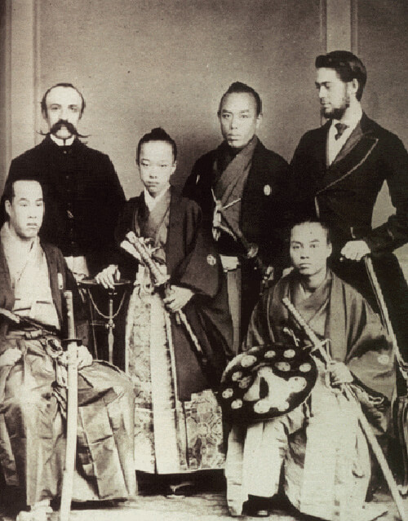
This year Belgium and Japan are celebrating 150 years of friendship and diplomatic relations.
On 1 August 1866, the two countries signed their first Treaty of Friendship, Commerce and Navigation. Belgium was still a fledgling independent state hoping to broaden its horizons, while Japan, still governed by Shogun Tokugawa, was just beginning to open its doors to the outside world
The Meiji Restoration that took place in Japan two years later led to flamboyant modernisation. The second half of the 19th century saw a period of fruitful exchanges with each nation proving a source of inspiration to the other: Japan was inspired by the Belgian institutional system while Japanese works of art fuelled the imagination of numerous Belgian artists.
Tokugawa Akitake mission is received by King Leopold II - first official contact by a Japanese representative with the government of Belgium - 1867
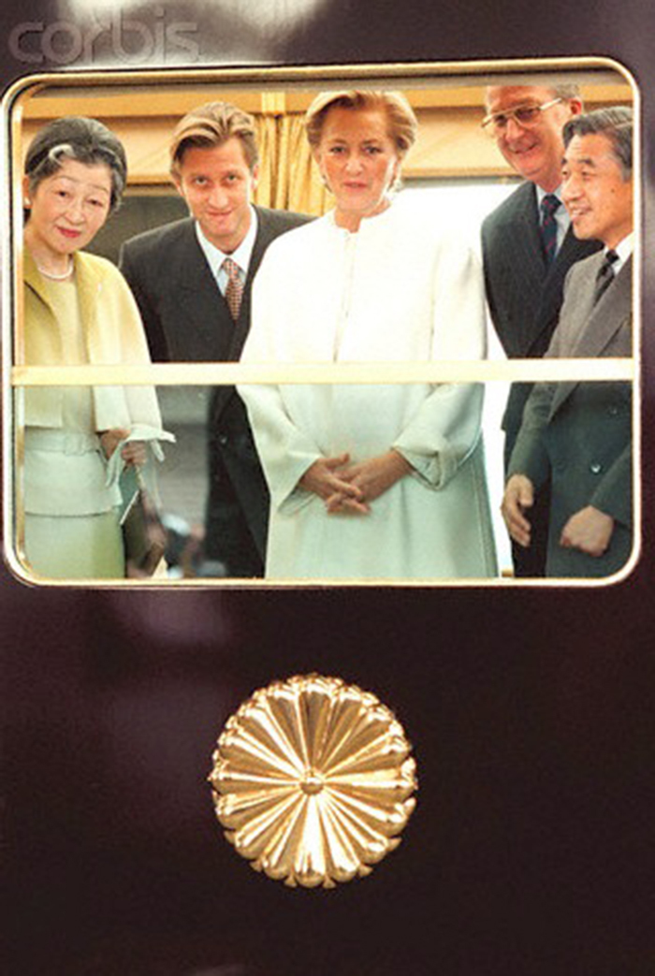
After the Second World War, relations between Belgium and Japan gathered momentum in tandem with Japan's booming economic recovery during the 50s and 60s. The first Japanese factory to be exported abroad was built by Honda in Belgium in 1962, with numerous other companies following suit. Major personal, political and economic visits contributed to tightening links between the two countries and the two royal families.
Since then, hundreds of Belgian and Japanese students have benefited from exchange programmes. Japanese culture is present in Belgian everyday life through manga comics, fabulous Japanese cuisine, decor, etc. while the Japanese keenly associate Belgium with its quality beers, chocolate, waffles, and even its football team.
The famous Manneken Pis, the emblem of Brussels' independent spirit, illustrates this long tradition of friendship through its wardrobe which contains 17 traditional Japanese costumes including samurai, Daimyo and Kintaro outfits. The oldest dates from 1928 while the most recent was introduced in 2003.
State visit to Japan by King Albert II and Queen Paola - 1996
Source: http://belgiumjapan150.jp/en/

FLOWERS IN JAPANESE CULTURE
Love of flowers is universal. The culture of a nation is often identified by the ways how flowers are used for artistic expressions: they have inspired artists throughout the centuries. Belgium and Japan are leading countries in flower arts and in festivals celebrating the beauty of nature. In both cultures, flowers are given a prominent, symbolic role in the social as well as in the spiritual life.
Japan and flowers
An island country spanning from the sub-tropical Okinawa to the freezing cold of Hokkaido, Japan has distinctive four seasons that give it a remarkably rich variety in vegetation. The flowers’ transient, seasonal beauty evokes admiration as well as pathos. From ancient times, the Japanese culture has evolved to capture their beauty of impermanence in various artistic forms.
Of the 4500 short poems of Man-yo-shu, the first collection of poems in Japan compiled in the 8th century, a third use plants or flowers to express the author’s feelings of love, hope, anguish and nostalgia. The roots of today’s Hanami, marking the arrival of spring and often celebrated with cheerful sake drinking under the Sakura in bloom (cherry blossoms), can be traced back to more than one thousand years ago. In Japan, Hanami is regarded as the cradle of many artistic forms; poems were created and Kabuki and Noh (Japanese plays) were performed with the elegant fall of white cherry petals as background. Ikebana, bonsai culture, gardening and other forms of flower arrangements demonstrate the importance of horticulture in Japanese daily life.
Chrysanthemum festivals in autumn are popular cultural entertainments since several centuries, often with ornamental displays of the flower such as in the shape of ships and dolls. The crest of the imperial family is based on chrysanthemum. His Majesty the Emperor organizes spring and autumn garden parties and invites guests.
By the Ambassador of Japan to Belgium, Masafumi Ishii

BRUSSELS CITY HALL IN IKEBANA
The Brussels City Hall will also be decorated in Ikebana on the occasion of this special Flower Carpet edition. Three Belgian Ikebana schools, each of which has its own style, will adorn the City Hall and Grand-Place in collaboration with Ghent Floralies and VLAM (Flanders’ Agricultural Marketing Board).
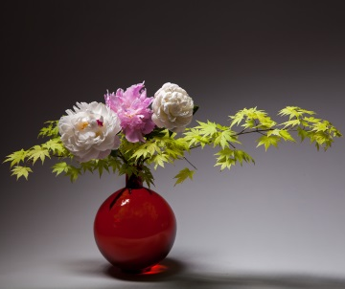
Ikebana is the well-known Japanese art of flower arrangement that is deeply rooted in Eastern tradition. Flowers offered to Buddha form the foundation for Ikebana. The art of flower arrangement reflects an art of living and a frame of mind indicative of simplicity and respect. Ikebana attempts to serenely and poetically provide a small-scale representation of nature.
©Ben Huybrechts

Ikebana schools
Four Ikebana study groups, each of which performs a different branch of this art of flower arrangement, are active in Belgium: Ikenobo, Sogetsu, Ohara and Saga. This year, the first three study groups, each of which has its own characteristics, are celebrating their 25th anniversary in Belgium and are assuming responsibility for decorating the Brussels City Hall:
- Ikenobo is characterized by clarity and purity. Respect for both the plant and water, which is the source of life, is of prime importance. Arrangements are three-dimensional, whereby both the empty and filled spaces have meaning. The vase or base plate and the natural materials used in the arrangements combine to form one harmonious unit.
- Sogetsu adheres to the traditional Ikebana rules for basic arrangements but it also offers more options to the arranger to express individual originality and creativity.
- Ohara, where observing nature is extremely important. The school attaches much importance to seasonal characteristics and nature’s growth processes.
Bonsaï, which literally means ‘tree in a pot’, will also feature in the Brussels City Hall. This type of tree, which exudes age and character, will totally submerge the visitor in the atmosphere of the country of the rising sun.
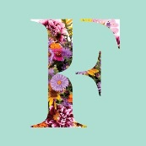
Info on Ghent Floralies - The organization behind Ghent Floralies, the Koninklijke Maatschappij voor Landbouw- en Plantkunde (KMLP), (Royal Society for Agriculture and Botany of Ghent) was established 207 years ago. The very first flower and plant exhibition was held in a tavern in Ghent in 1809 and has since then experienced spectacular growth and evolution. In 2016, the Floralies left the Flanders Expo exhibition halls and returned to the city. K.M.L.P. is partner to the Brussels Flower Carpet.

ONE FLOWER CARPET, TWO DESIGNERS
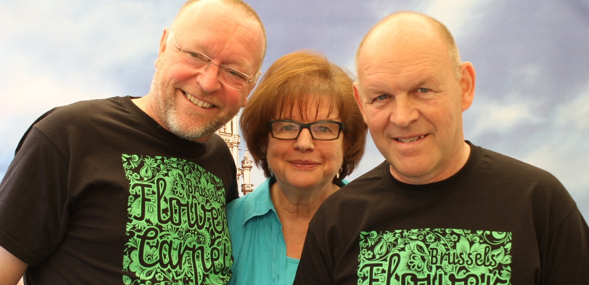
MARK SCHAUTTEET: BELGIAN GRAPHIC DESIGNER
In the 1970s, he started working for Etienne Stautemas (pioneer of the begonia carpets) producing various begonia carpets.
Together they created begonia carpets in Brussels, Columbus-Ohio, Vienna and The Hague. These carpets confirmed their major international appeal.
When Etienne Stautemas passed away in 1998, Mark decided to carry on his mentor’s pioneering work and further it through promoting the begonia as an export product, using the flower carpets, in association with the begonia committee.
Koen Vondenbusch, Annette Katz, Mark Schautteet
Between our borders many market squares have already been transformed with a stunning colourful begonia carpet designed by Mark Schautteet.
Achievements abroad in recent years should also not be overlooked:
In Belgium: Brussels, Tongeren, Seneffe, Koksijde, Leuven, Oudenaarde, Zaventem, Zottegem, Genk
International: Frankfurt, Haarlem, Tel Aviv, Tenerife, Warsaw, Prague, Barcelona, Bern, Shanghai, New Delhi, Tokyo
FUJIE SUZUKI: A TALENTED YOUNG JAPANESE DESIGNER
Having graduated from the Sapporo School of the Arts in 2001, Fujie Suzuki has worked at NOMURA Co., Ltd. since April 2001. The designer began her short yet brilliant career creating visual projects for museums and exhibitions. Today she is involved in many visual identity (VI) design and graphic design projects for corporate events and showrooms.
This talented artist’s creative strengths lie in giving shape to abstract brand concepts and messages. She is also skilled in focusing attention on the user’s perspective and creating designs that evoke warmth and emotional reassurance.

References:
Photo 1: FUJIKO F. FUJIO 80th Anniversary Exhibition, Advertising design (Tokyo, 2013), ©Fujiko-Pro
Photo 2: FUJIKO F. FUJIO Hometown Art Gallery in Takaoka City, Advertising design (Toyama, 2015), ©Fujiko-Pro
Photos 3 & 4: MAYOTERRACE (Kewpie), Graphic design, sign design (Tokyo, 2014)
Photo 5: My Margaret Exhibition (Mori Arts Center Gallery), Graphic design (Tokyo, Sep 2014)
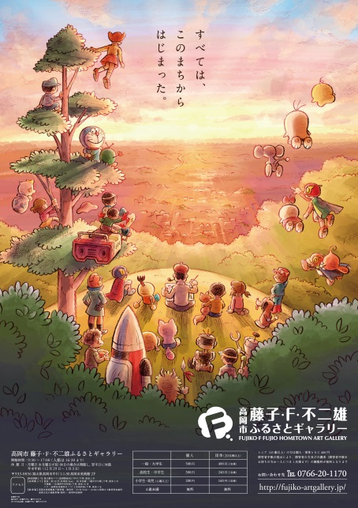
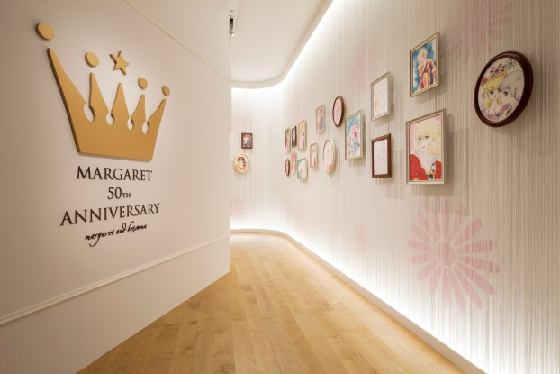
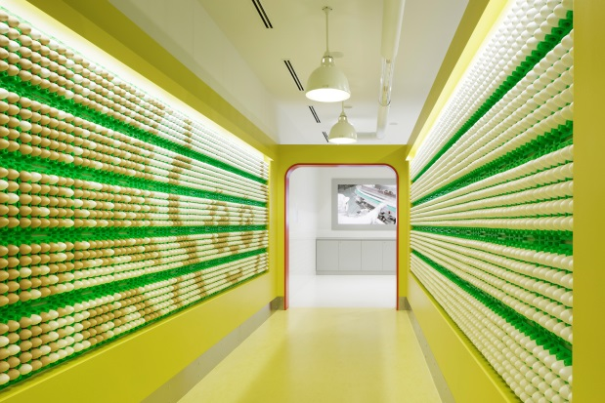
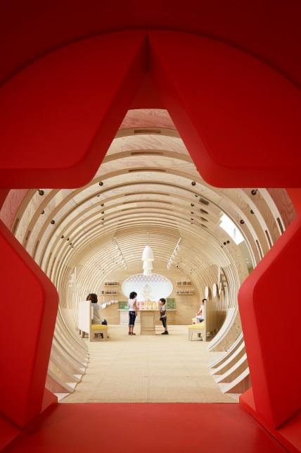
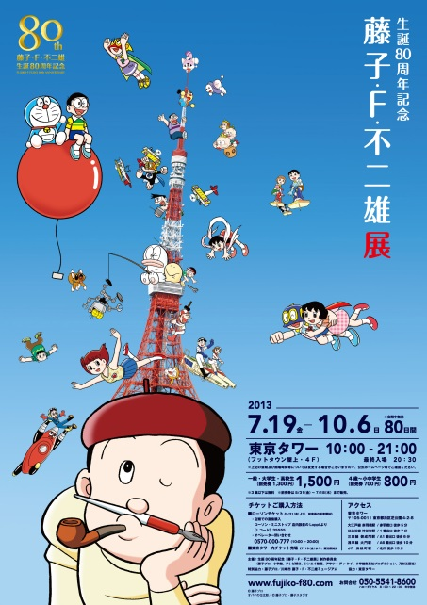

“Watching the 2014 Flower Carpet’s documentary on flower growers, I was drawn to the warmth in the eyes of the people growing the flowers. The love many flower growers have for the flowers they cultivate was evident, and I wanted my design to give them a sense of pride and accomplishment in their work and their flowers.
In Japanese we have the expression 'kacho fugetsu', which consists of the kanji characters for flower, bird, wind, and moon. It translates into English as 'the beauties of nature' and is used to describe the beauty of animals and natural landscapes captured in artistic works. The phrase also indicates a love and respect for nature.
I intend to communicate the beauty of Japanese nature through the natural beauty of flowers lovingly cultivated in Belgium and displayed in its central square, considered one of the most beautiful in the world. Through the theme of the beauty of nature and natural landscapes shared by Belgium and Japan, my design expresses the deep friendship cultivated between Belgium and Japan over 150 years of diplomacy and the shared wish for a bright future for both countries."

Fujie Suzuki
Graphic Designer

MAKING A FLOWER CARPET
Two years of patience and preparation is what it takes to conceive and create the four magical, colourful days of the Brussels Flower Carpet. If there's one thing this thousand-year-old site has, it's patience. The stones have all the time in the world.
The team behind the event has to choose the theme, design the project, and assess just how to grow the right number of begonias while taking into account the variety of colours. Around 600,000 flowers are required, sitting shoulder to shoulder in order to create the patterns, texture and nuances of a carpet unlike any other.
Precise and delicate coordination
The begonia fields are located close together in a single region of Flanders. For several months, twenty-odd flower producers will plant and cultivate their begonias in order to obtain the exact colours and quantities needed to bring the Flower Carpet to life. When the time comes, these horticulturists will pack and transport the flowers as quickly as possible so as to ensure that they last the length of the event.
A hundred volunteers in action
On the day itself, the life-size design will be transferred onto a transparent, micro-perforated plastic sheet. It will then be up to the 100 volunteers to perform an extremely delicate task: "colouring in" this giant image with the right shades of begonias and placing them as close as possible to one another. They will create a microclimate with a constant humidity in order to guarantee the freshness and variation in colour of these typical Belgian flowers.
All of this work will be carried out in the few days leading up to the Flower Carpet event, which will open on 12 August. This fleeting masterpiece will be on show to the general public for four nights and four days.

FLEMISH BEGONIA: UNIQUE IN THE WORLD
With its long flowering period, broad range of colours, variety of shapes and suitability for borders and patios alike, the Flemish begonia has many strengths, which are the result of years of tradition and craftsmanship. No wonder that the Flemish begonia is a success as far away as Japan and America.
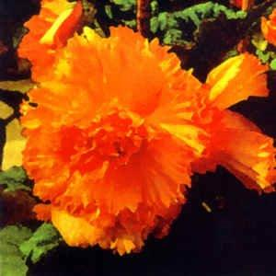
Tradition and craftsmanship
Flanders is the world’s leading producer of tuberous begonias, thanks to a rich tradition of seed selection and tuber production. Every year, over 30 million tubers are exported to Europe, North America and Japan.
Begonia cultivation is chiefly concentrated in East Flanders, and more specifically in the region around Ghent. Selection companies are continuously looking for new colours and flower shapes. The most popular types are the double begonias and the hanging varieties.
The immense Belgian flower carpets of tuberous begonias present an alluring picture and enjoy international renown. The begonias are perfectly showcased in all their colourful splendour.
Flower spectacle for the garden and the patio
Tuberous begonias are the perfect choice for anyone who loves striking colours. Colours range from white to yellow and orange to red, as well as a whole spectrum of pinks; and flowers can be single, hanging or double. The begonia range offers a wide selection, meaning that there will always be a begonia to suit every taste, and to complement the rest of your plant arrangement. With its abundant and long-lasting flowering period, it will provide colour from early July right up to the first frost. Furthermore, tuberous begonias are extremely versatile, as they can be used for balconies, in hanging baskets, on patios, or as bedding plants. They require little maintenance and also have the benefit of being allergy friendly, as they do not cause hay fever.

A BRIEF HISTORY OF THE FLOWER CARPET
Officially, the first Flower Carpet as its present-day form was created in 1971 on the Grand-Place by the landscape architect Etienne Stautemas, but, in fact, it was the culmination of a whole series created in various towns in Flanders.
Etienne Stautemas, who was born in Zottegem, and graduated from the Ghent Horticultural College, had been experimenting since the early 50's making simple small carpets, more like rugs, mainly consisting of begonias (in Knokke, Oudenaarde, Sint-Niklaas, Lille…).
He very quickly realised that floral carpets would be an excellent vehicle for the promotion of his beloved begonias which he had always worked with, technically, economically and aesthetically. After years of attempts and calculations, this architect, who was inventive and imaginative, and knew how to make the most of the numerous resources of begonias, became an expert in the creation of superb floral carpets with sophisticated colours and complicated designs.
His fame spread and he was asked to make carpets not only in Belgium (Ghent, Bruges, Antwerp, Ypres, Courtrai, Hasselt, Tongres, Mons, Durbuy…) but worldwide (Cologne, Hamburg, Luxemburg, Paris, London, Breda, Amsterdam, The Hague, Vienna, Valencia, and as far afield as Buenos Aires and Colombus, Ohio). Since his disappearance, the landscape architect Mark Schautteet has taken over with talent. The carpets of Brussels’ lace and the Gardens of Versailles have enchanted thousands of visitors since the year 2000.
Some of these carpets were bigger than the ones created in Brussels (77 x 24 m), like the 1973 masterpiece at Sint-Pietersplein, Ghent that reached a gigantic 164 x 42 m. However, as E. Stautemas himself says: "Nowhere is the carpet more beautiful and distinguished than in the unique, ancient surroundings of the Grand-Place in Brussels."
Themes of the carpets :
- 1971: 1st Flower Carpet in Brussels: a garden
- 1976: Year of the Landscapes, Parks and Gardens
- 1979: Brussels Millenium
- 1980: Celebration of Belgium's 150 anniversary
- 1986: Coat of Arms of the City of Brussels
- 1988: A Chinese Carpet, inspired by the carpets of the Chinese province of Sinkiang
- 1990: Year of Mozart
- 1992: Brussels, Capital of Europe
- 1994: 50th anniversary of the Liberation of Brussels
- 1996: A garden "à la française"
- 1998: A carpet inspired by the semi-nomadic tribes living today in NE of Turkey
- 2000: Brussels' lace
- 2002: Versailles
- 2004: Art Nouveau
- 2006: Middle Ages
- 2008: Savonnerie
- 2010: Europe
- 2012: The African continent
- 2014: Anatolian carpet on the occasion of the 50th anniversary of the Turkish and Moroccan immigration in Belgium
- 2016: 150 years of belgo-japanese friendship
On the occasion of its twentieth edition, the public can “plunge” into the story of the Flower Carpet. A retrospective exhibition offers to its audience an absolute visual feast! Giant photographs of the nineteen Flower Carpets and the drawing of the 2016 Flower Carpet are displayed from July 15 to August 31, 2016 in the splendid Royal Galleries St-Hubert in Brussels.
People who are not able to visit the exhibition, can always discover the history of the Flower Carpet with the book dedicated to the beautiful ephemeral tapestries.
The book can be bought during the event in three languages (French, Dutch and English).

TWO FLOWER CARPETS IN TOKYO ON THE THEME OF ART NOUVEAU
The city of Tokyo hosted the 11th "Brussels Days" from 16 to 20 May 2016. Over the course of a few days, business leaders, managers and politicians visited the Japanese capital in order to forge economic and commercial links between Brussels and Tokyo and to celebrate 150 years of diplomatic relations between Japan and Belgium.
To mark the occasion, two flower carpets graced the city of Tokyo. The style of these two temporary tapestries was inspired by the inventiveness, rhythms, colours and curves of Art Nouveau. This art movement, born of the creativity of famous architect Victor Horta, previously served as inspiration for the 2004 Brussels Flower Carpet.
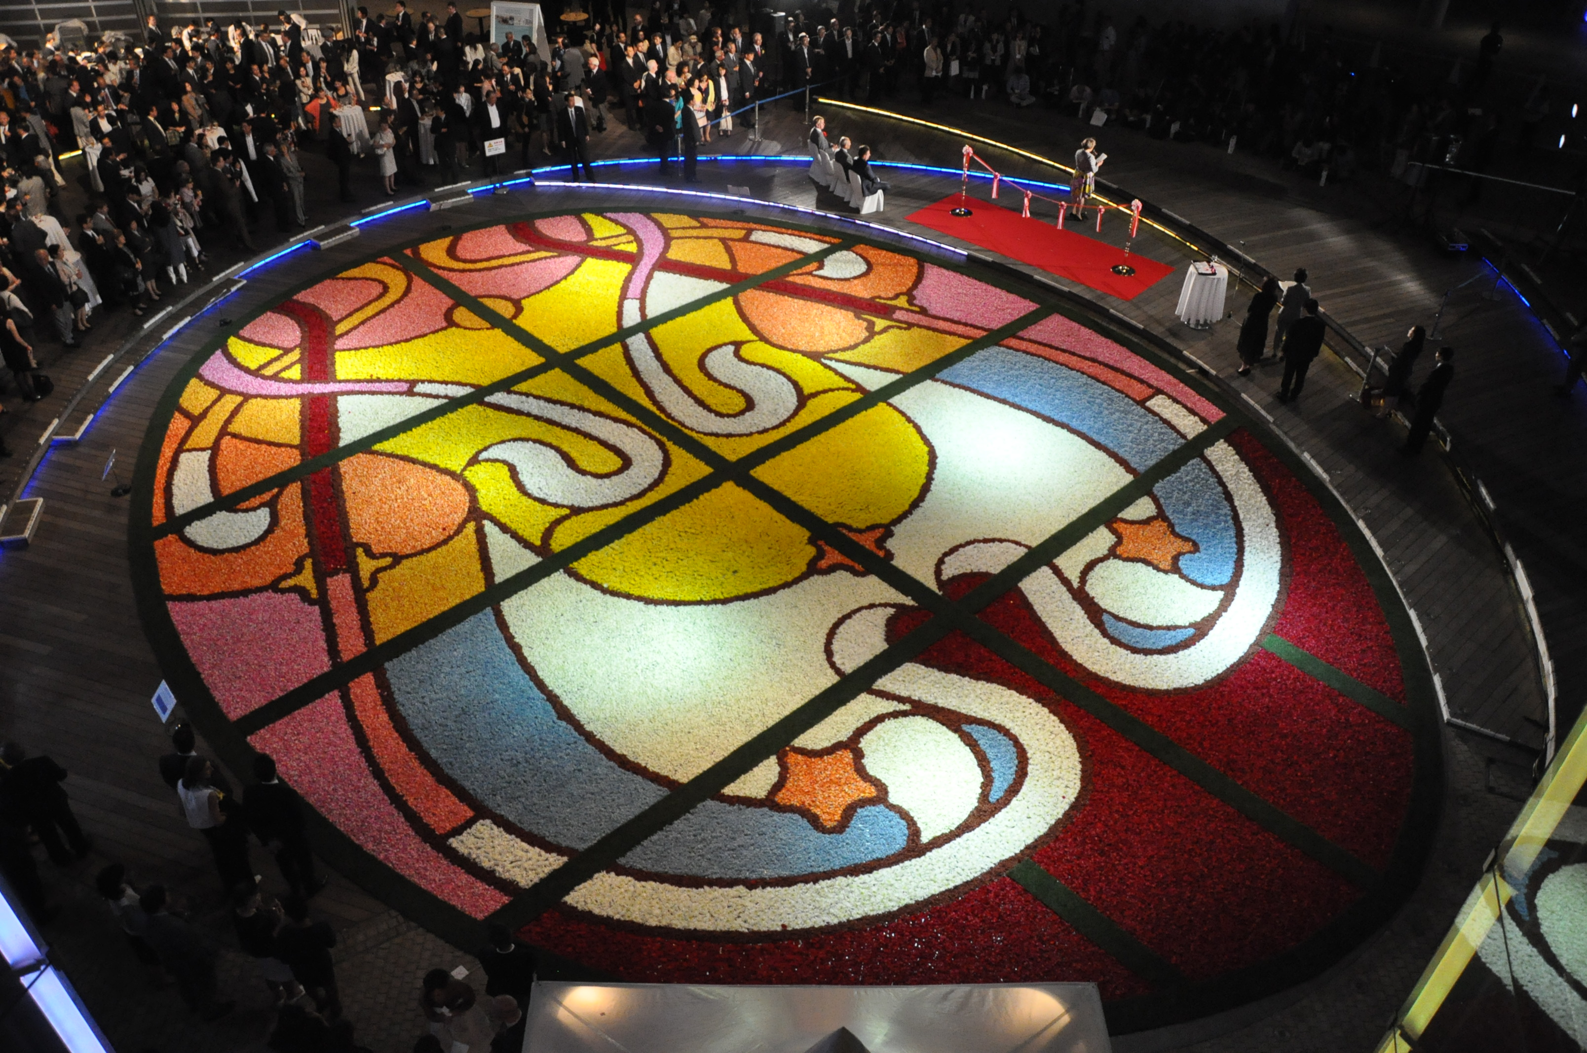

Roppongi Hills
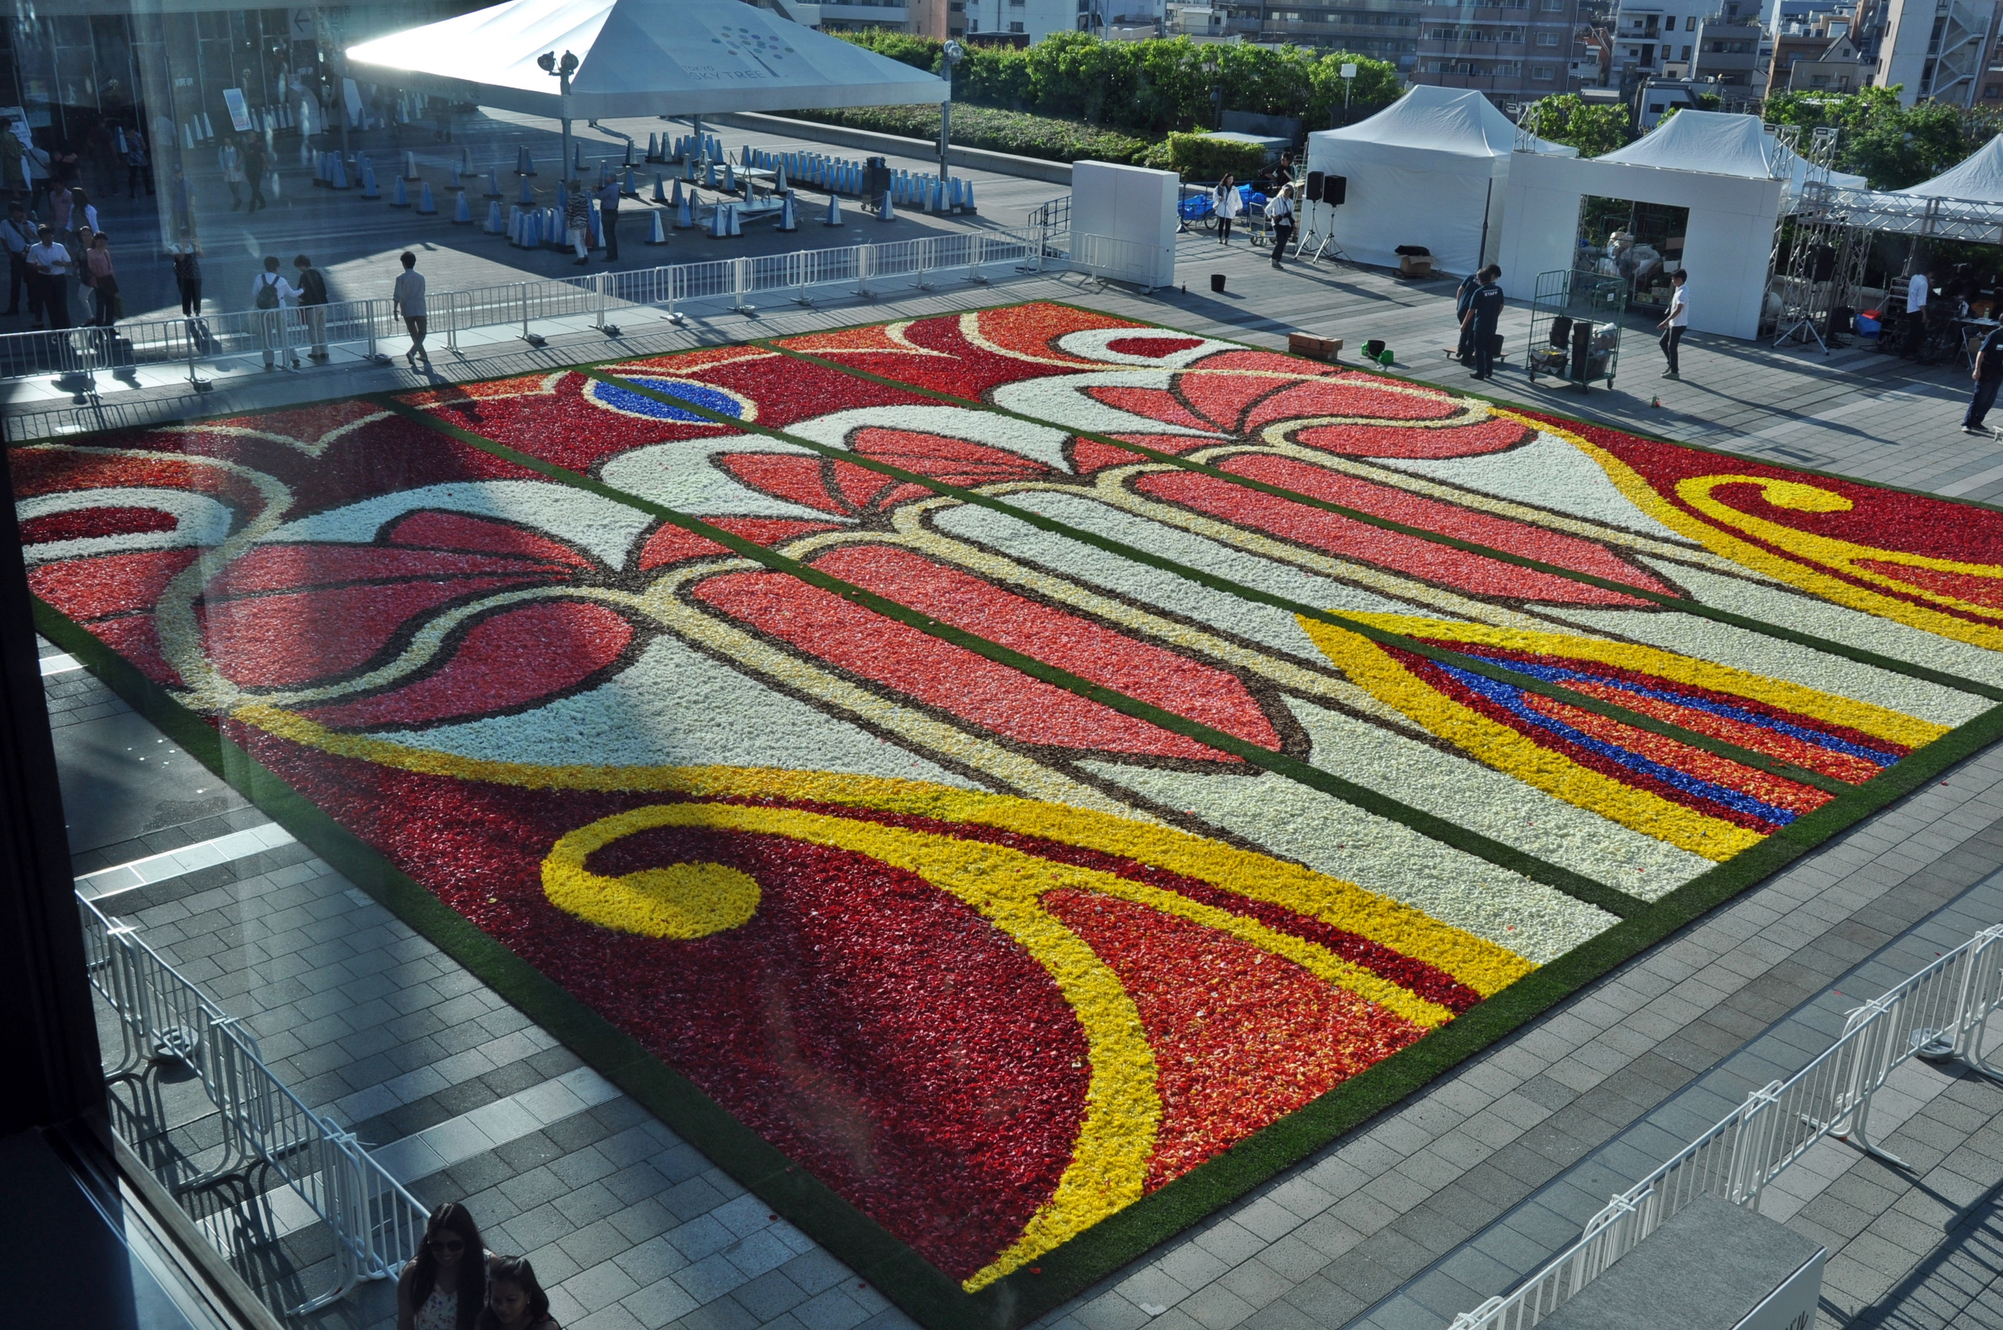

Tokyo Skytree

THE OPENING SHOW, MUSICAL NOTES
The soundtrack for the opening ceremony of the 2016 Flower Carpet has been inspired by the famous Italian opera Madame Butterfly, composed by Giacomo Puccini. The arrangement will tell the story of an idyllic journey through the land of the rising sun from sunrise to sunset. Emerging from a contemplative poem, the music will begin by summoning the break of day through a traditional Japanese air that blends the sounds of the koto zither with the shakuhachi flute. The musical ambiance will build into a more energetic symphonic soundscape embodied by the famous taiko (Japanese drum). Earth, air and water will be cloaked in an abundance of floral colours, culminating in the night sky being lit up by a multitude of multi-coloured fireworks.
The musician-composer Grégoire Dune, responsible for the opening show’s music, studied violin, chamber music and composition at the Royal Music Conservatory of Brussels, where he received his first awards and his higher level diploma. The irrepressible artist, unparalleled multi-instrumantalist (violin, guitar, keyboards) has been on many tours around Europe, the United States and Quebec. He has produced, composed, arranged, performed and collaborated on recording a hundred or so classical, pop and film music albums (various sessions for Alain Souchon, Alain Chamfort, Niagara, Michel Legrand, Aereda, Arthur H, etc.).
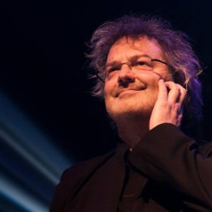

Grégoire Dune

2016 FLOWER CARPET: AGENDA
8, 9, 10 and 11 August 2016: Decoration of the Town Hall in Ikebana style + first preparations on the Grand Place.
12 August 2016: press day – assembly day –afternoon public opening
Upon request: meetings with the organisers throughout the day
5:00 am First flowers laid by 100 volunteers
8:00 am Town Hall opens and visitors can watch the Carpet being made and interview the creators
1:00 pm Flower Carpet open to the general public until 5:30 pm
8:30 pm Official opening at the Town Hall and Museum of the City of Brussels (invitation only)
10 pm Opening ceremony
13, 14 and 15 August 2016: open to the public from 10 am to 10 pm (last entry at 9:30 pm)
10 am to 10 pm Town Hall open to the public: balcony & panoramic view of the carpet
Entry price: €5
Children under 10 get in free.
For more info: www.flowercarpet.be

PRESS CONTACTS
Annette Katz Tel. 0032 2 513 89 40
Email: a.katz@visitbrussels.be
Alexandra Curelea (FR/EN) Tel. 0032 2 340 92 46
Mobile: 0032 487 386 617
Email: Alexandra@voice.be

Laure Vandeghinste (NL/EN) Tel. 0032 2 893 98 76
Mobile: 0032 479 60 45 92
Email: laurev@voice.be
Visual material available on request
Find out more on the website: www.flowercarpet.brussels

ACKNOWLEDGEMENT
The NGO Flower Carpet of Brussels would like to wholeheartedly thank:
Chocolaterie Léonidas
Embassy of Japan in Belgium
Fintro
Hotel Amigo
Interparking
JF Renshaw
L'Avenir
Nomura
Radio 2 (Belgium)
RTBF – La Première and Viva Bruxelles
The AVBS
The Belgian National Lottery
The Brussels-Capital Region
The City of Brussels and its services
The Ghent Floralies
The retailers in and around the Grand Place
Visit Brussels
Wittamer
... And all of the partners who have helped make this event a success.

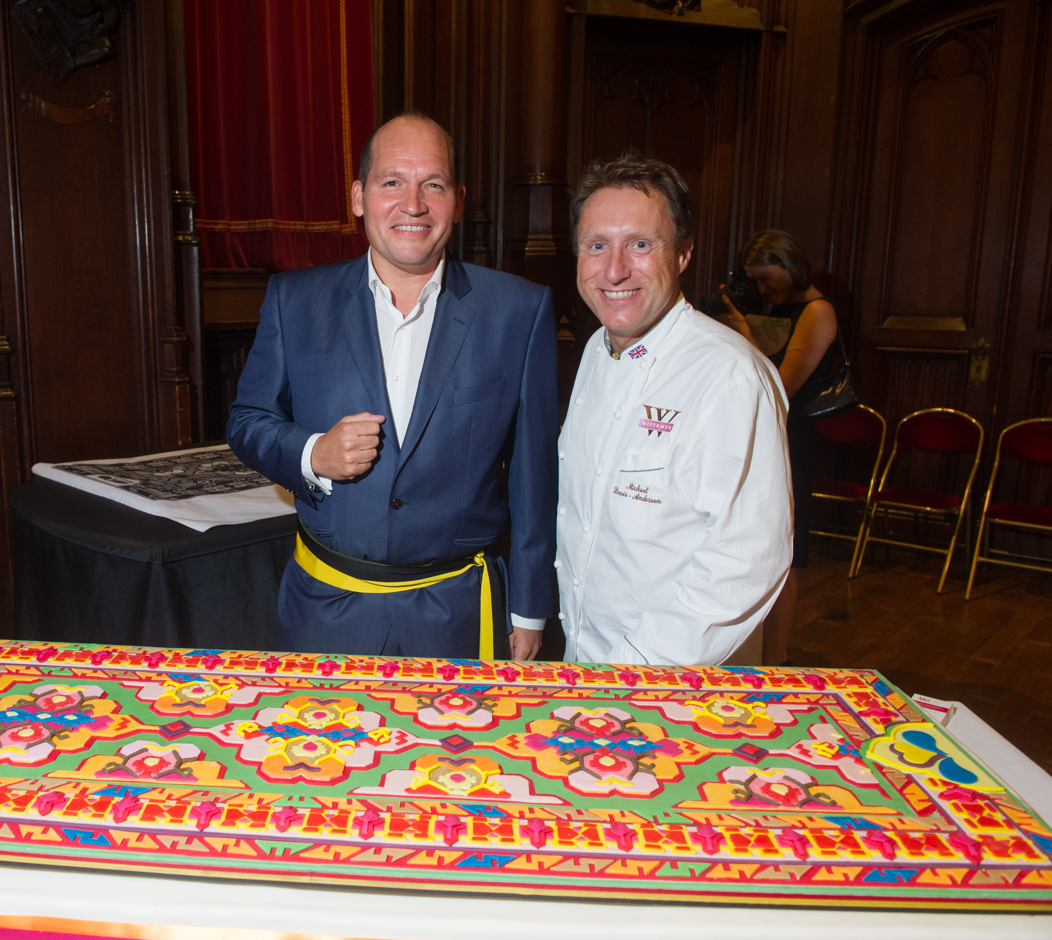
The NGO Flower Carpet particularly thanks La Maison Wittamer, and its sugar supplier JF Renshaw, who will create the 2016 Flower Carpet cake on the occasion of the opening ceremony on August 12, 2016.
Mr Philippe Close &
Mr Michael Lewis-Anderson
© Labo River

Revolution against the feudal system of the Shoguns
Source: http://www.ikenobo.be/stijlen
Source: Sogetsu Azalea Study Group, http://www.sogetsuazaleastudygroup.be/
Source: http://www.ikebana-ohara.be/
Thanks to Bauwens Bonsai: http://www.bauwensbonsai.eu/
Founded in 1892, NOMURA Co., Ltd. is a leading company in the Japanese display industry with more than 120 years of history. NOMURA provides services for the creation of spaces designed to attract visitors to events and installations such as the TOKYO SKYTREE. The company is composed of a talented team of 350 creators, the largest in Japan. NOMURA’s creativity has received acclaim in Japan as well as from overseas. The company has earned more than 100 interior design awards both at home and abroad.
Symbols used to express the Japanese language. Each sign is associated with a sense matrix and pronunciations.

