Glashow Media Gallery Info

The following images are provided for use in coverage about the IceCube Collaboration paper being published in Nature, “Detection of a particle shower at the Glashow resonance with IceCube” (under embargo until 10 March 2021 at 16:00 (London time), 10 March 2021 at 11:00 (US Eastern Time)). Any media used in the gallery must be credited as per the provided credit line. It is a condition of the gallery that anyone using resources from the gallery must include the credit information that accompanies the media.

You can find more information about our gallery usage guidelines here. Please contact press@icecube.wisc.edu with any questions.

File name | Caption | Credit
PEPE_Hydrangea_1.png, PEPE_Hydrangea_1_transparent.png  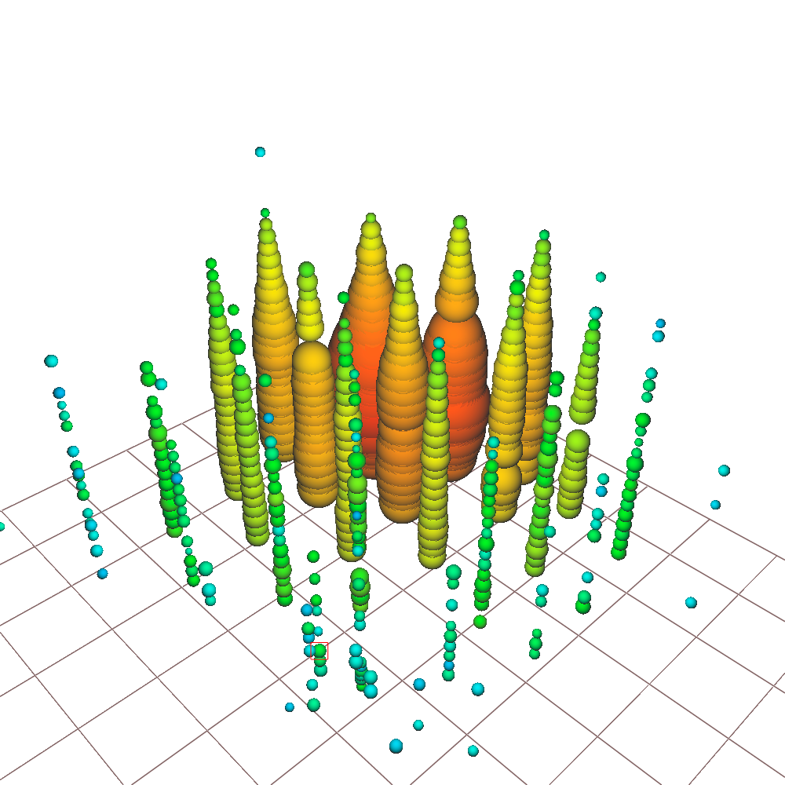 | A visualization of the Glashow event recorded by the IceCube detector. Each colored circle shows an IceCube sensor that was triggered by the event; red circles indicate sensors triggered earlier in time, and green-blue circles indicate sensors triggered later. This event was nicknamed “Hydrangea.” | IceCube Collaboration
Glashow-Resonance_FD.png  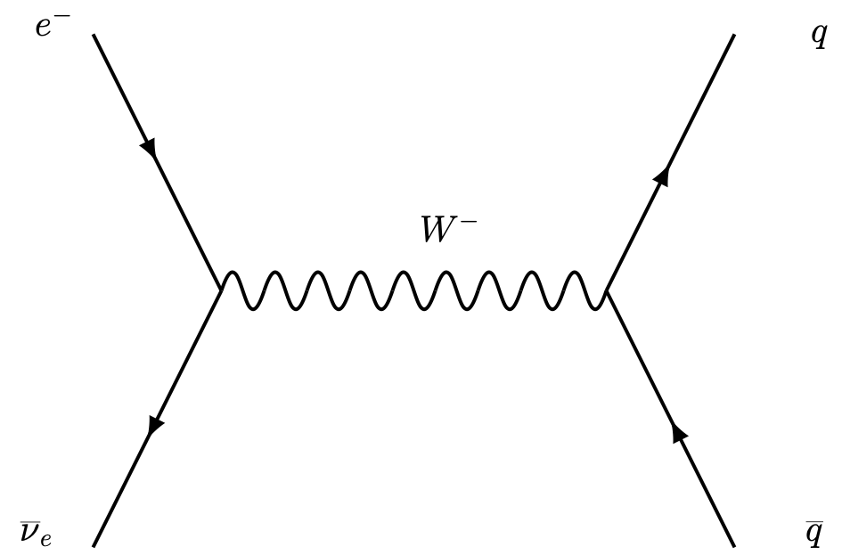 | A Feynman diagram showing the Glashow resonance observed by IceCube: an electron and an electron antineutrino interact to produce a W– boson, which subsequently decays into secondary particles. | IceCube Collaboration
Fig1.JPG  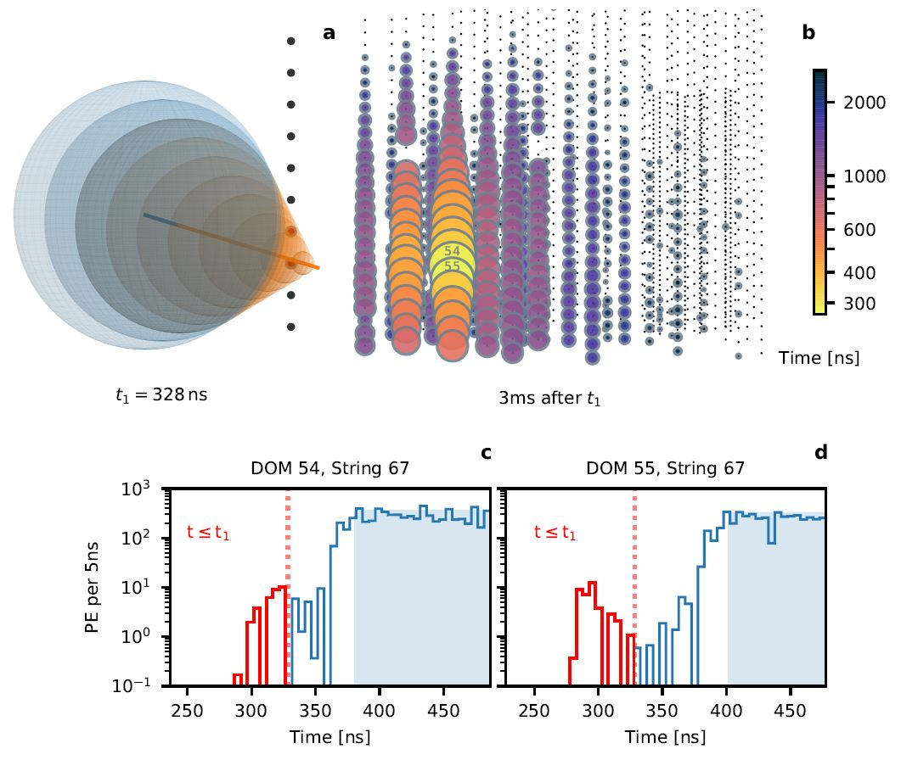 | Visualizations of IceCube data for the Glashow event, adapted from the Nature paper.  The top left is a schematic of an escaping muon traveling faster than the speed that light propagates in ice, resulting in a cone of Cherenkov light (orange). The muons reach the nearest IceCube sensors (DOMs 54 and 55 on string 67, labeled) ahead of the Cherenkov photons produced by the electromagnetic component of the hadronic shower (blue) since these photons travel at the same speed as light in ice.  The top right is an event view showing sensors that triggered across IceCube. Each bubble represents a sensor; its size is proportional to the deposited charge. Colors indicate the time each sensor first triggered.  The lower panels show distributions of the deposited charge over time on the two earliest hit sensors, DOMs 54 and 55. The dotted red line indicates t1 = 328 ns, the instant shown in the top left of the image. The histogram in red and blue shows photons arriving prior to and after t1, respectively. The blue shaded region denotes saturation of the photomultiplier tube in the sensor. | IceCube Collaboration
photon-burst_Glashow.png  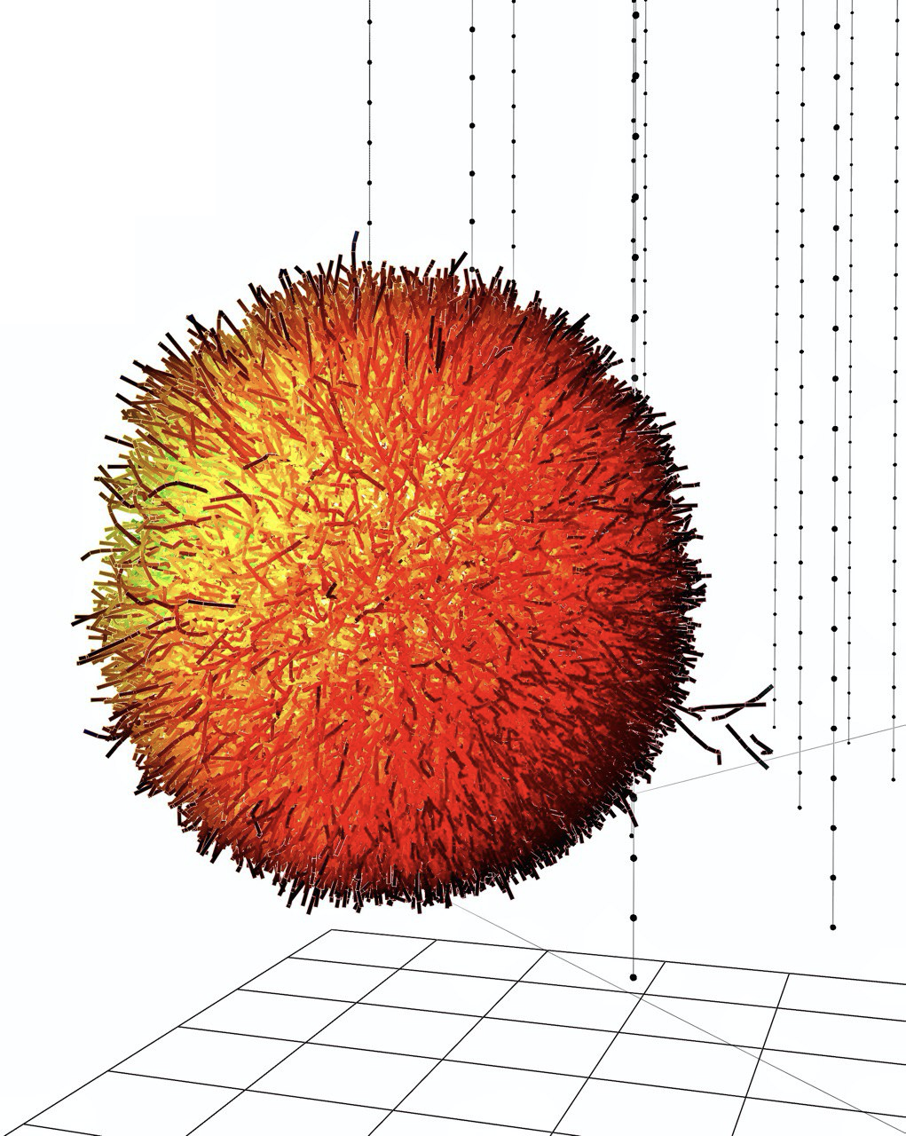 | This simulated image shows the paths traveled by Cherenkov photons from secondary particles after the decay of a W– boson produced in a Glashow resonance event. Each photon travels a random distance in a straight line, then scatters off dust or other impurities in the ice and is deflected in a different direction; the photon continues along that new direction before being deflected again, and so on. The colors correspond to the amount of photon scattering, with yellow changing to darker red after each subsequent deflection. Photons from escaping muons can be seen ahead (lower right) of the main shower. | Lu Lu, IceCube Collaboration
[NEW as of 5 March] Nature-Glashow_Illustration_PMT_Final.jpg  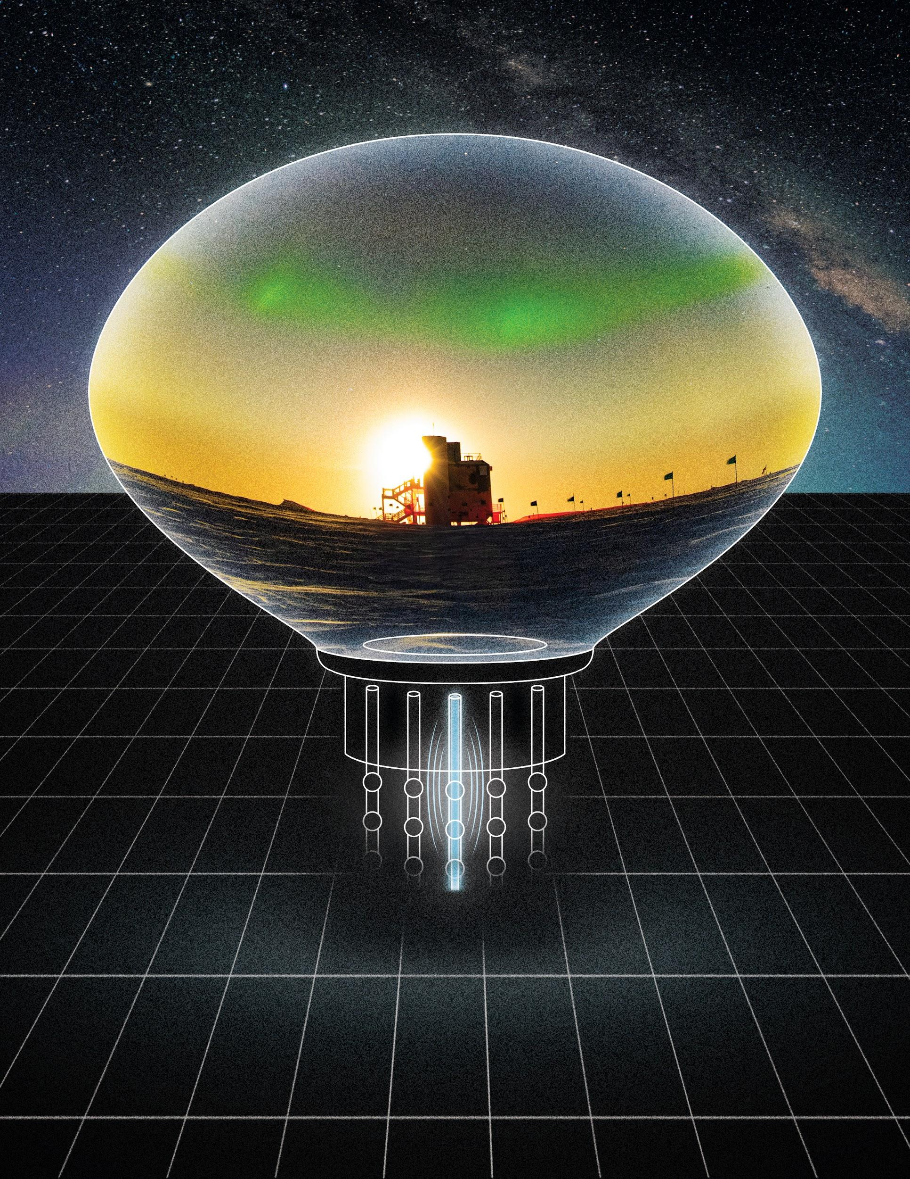 | A South Pole scene of the IceCube Laboratory against a backdrop of auroras displayed inside an artistic rendition of a photomultiplier tube. The resonance is depicted as a glowing blue rod, representing the first string in IceCube to observe early pulses from the event. | IceCube Collaboration (ICL photo by Yuya Makino, IceCube/NSF)
2021_IceCube_Timeline_Final-01 (jpg and pdf)  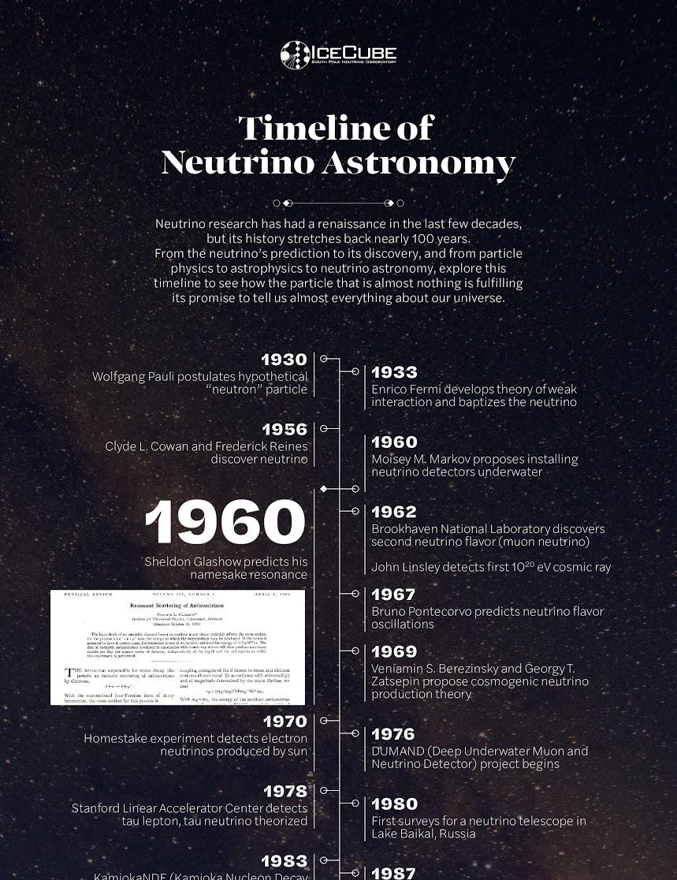 | A timeline of major milestones in neutrino astronomy. | IceCube Collaboration
Glashow-Diagram_Final (jpg and pdf)  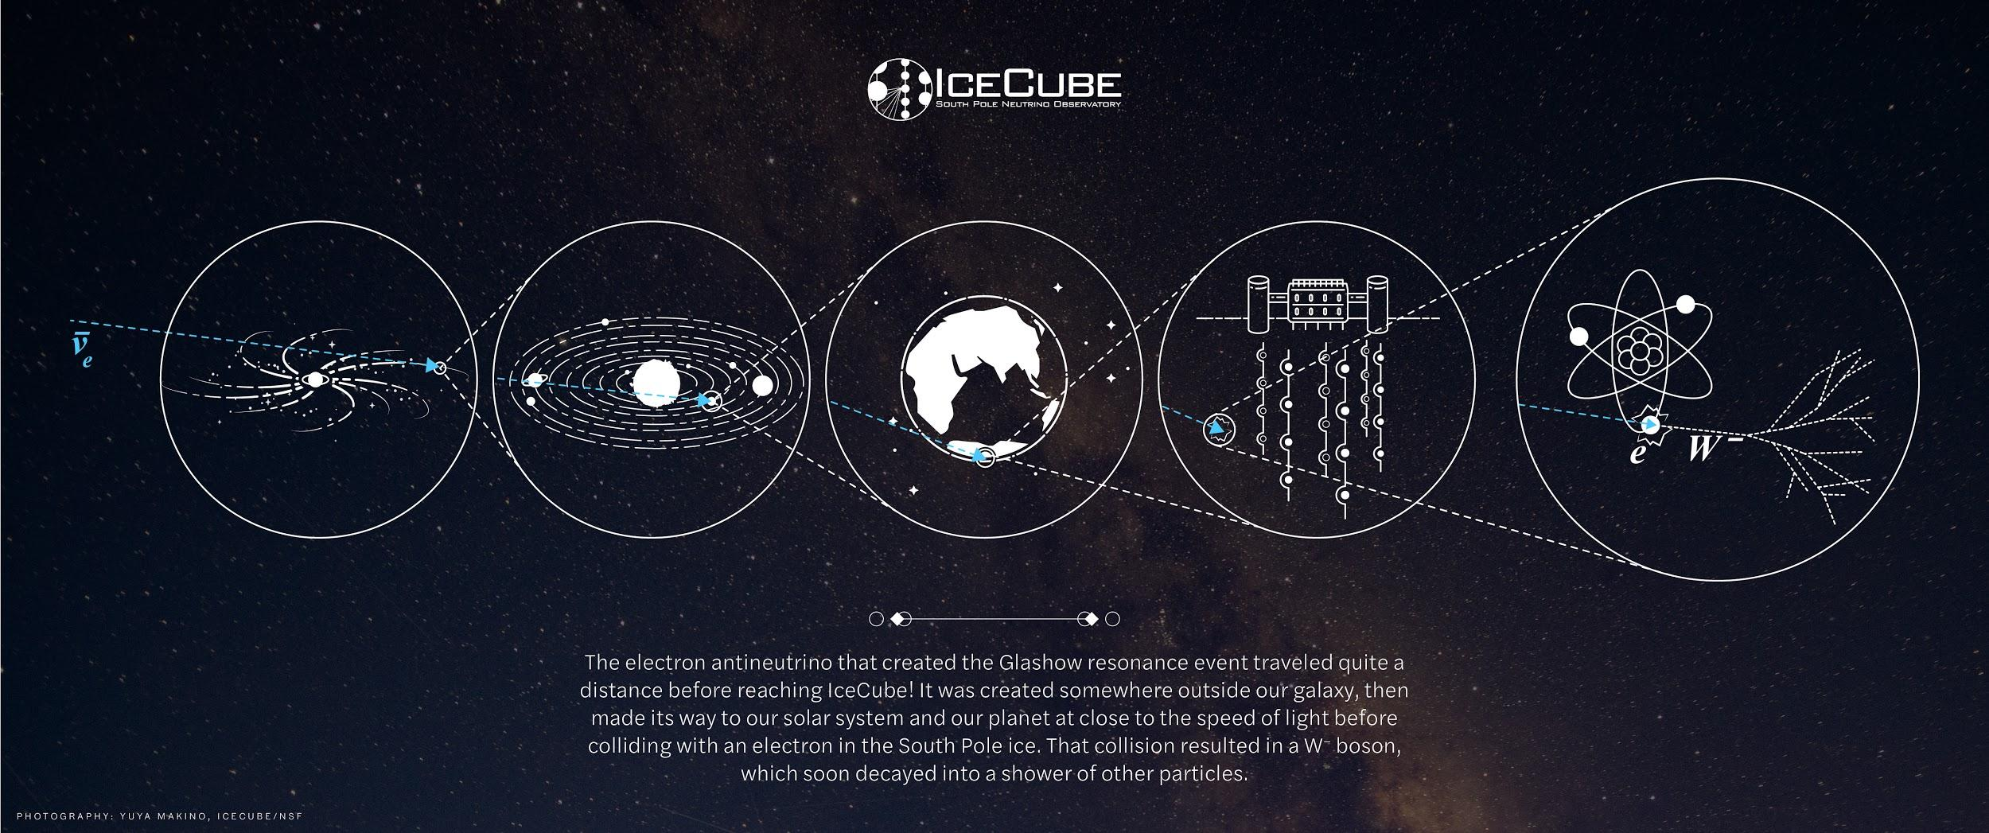 | The electron antineutrino that created the Glashow resonance event traveled quite a distance before reaching IceCube. This graphic shows its journey; the blue dotted line is the antineutrino’s path. (Not to scale.) | IceCube Collaboration
2020week08_icl_jmhardin.jpg  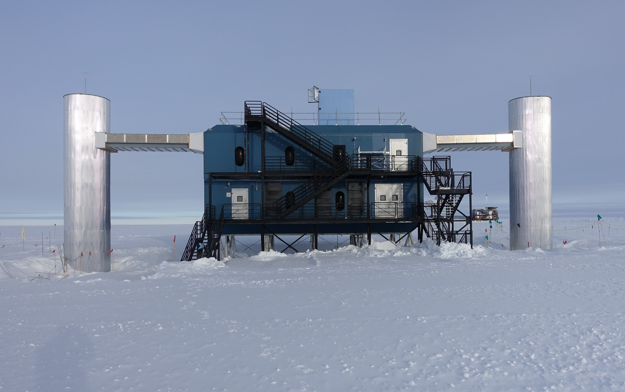 | The IceCube Laboratory at the South Pole. This building holds the computer servers that collect data from IceCube’s sensors under the ice. | John Hardin, IceCube/NSF
IceCube_schematic_wlabels.png  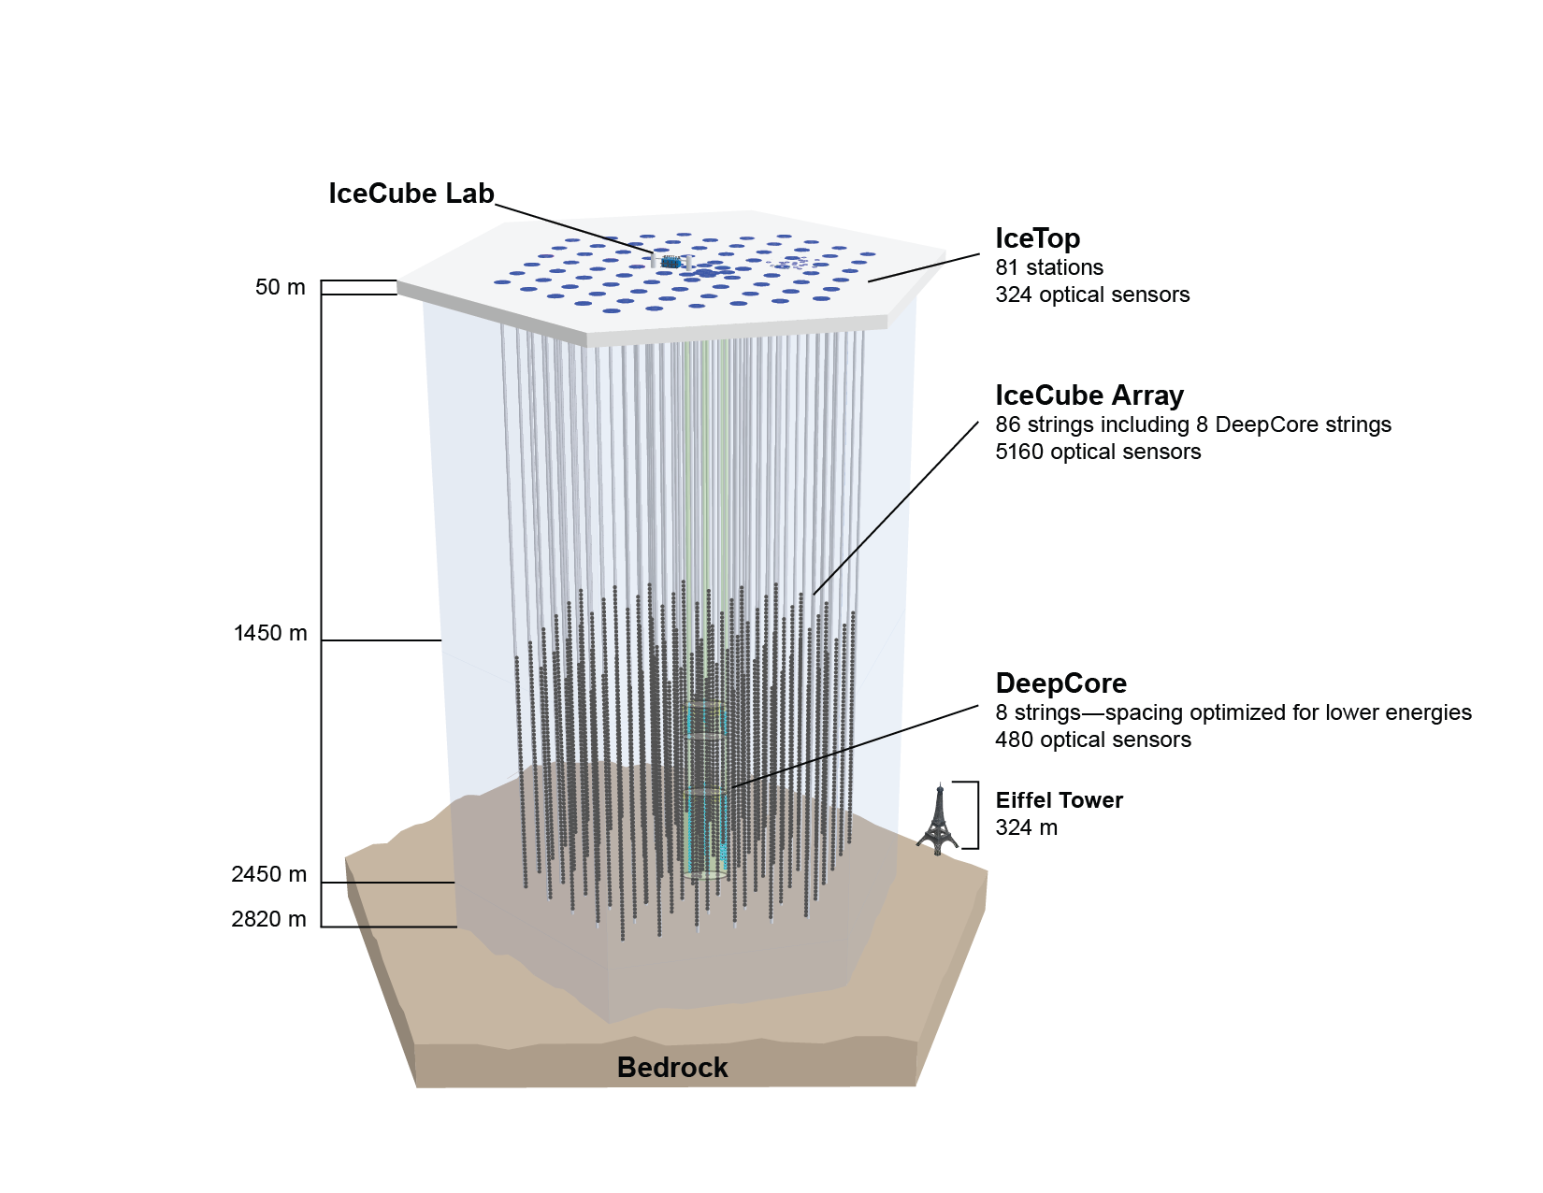 | A schematic of the in-ice portion of IceCube, which includes 86 strings holding 5,160 light sensors arranged in a three-dimensional hexagonal grid. | IceCube Collaboration
collaboration_Chiba.jpg  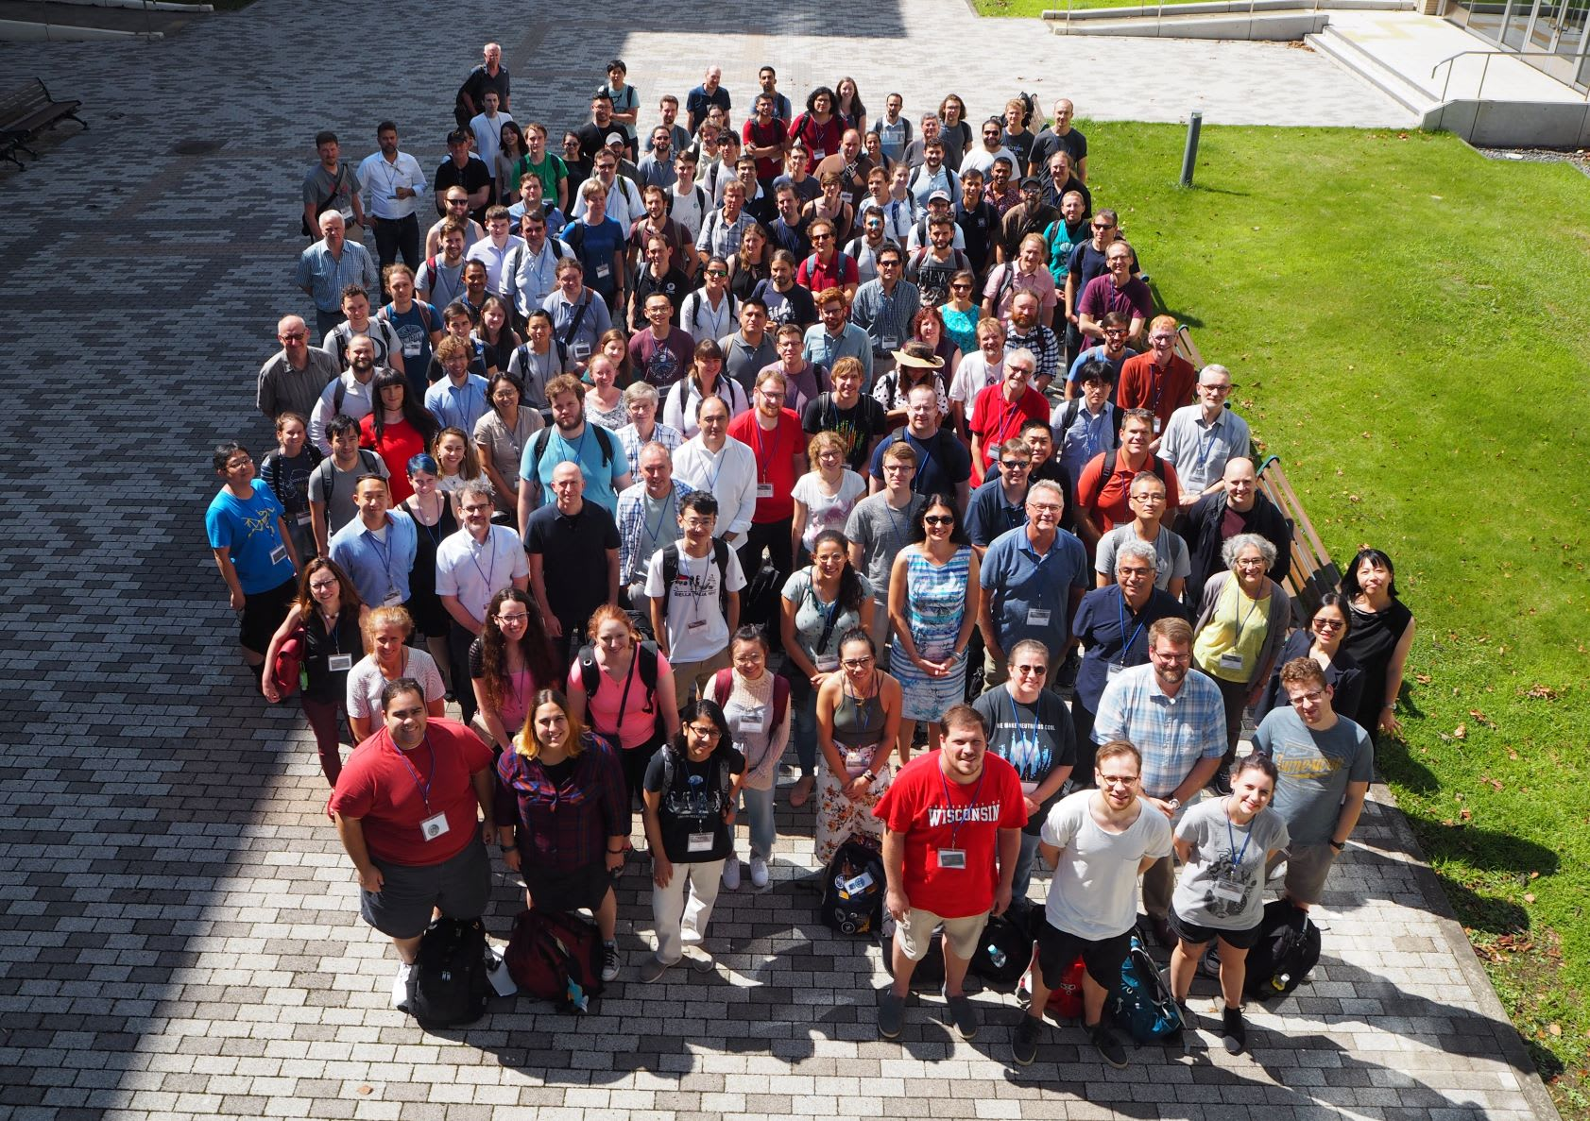 | The IceCube Collaboration is made up of over 400 scientists from 53 institutions in 12 countries around the world. | IceCube Collaboration
2020week45_station_02_ymakino.jpg  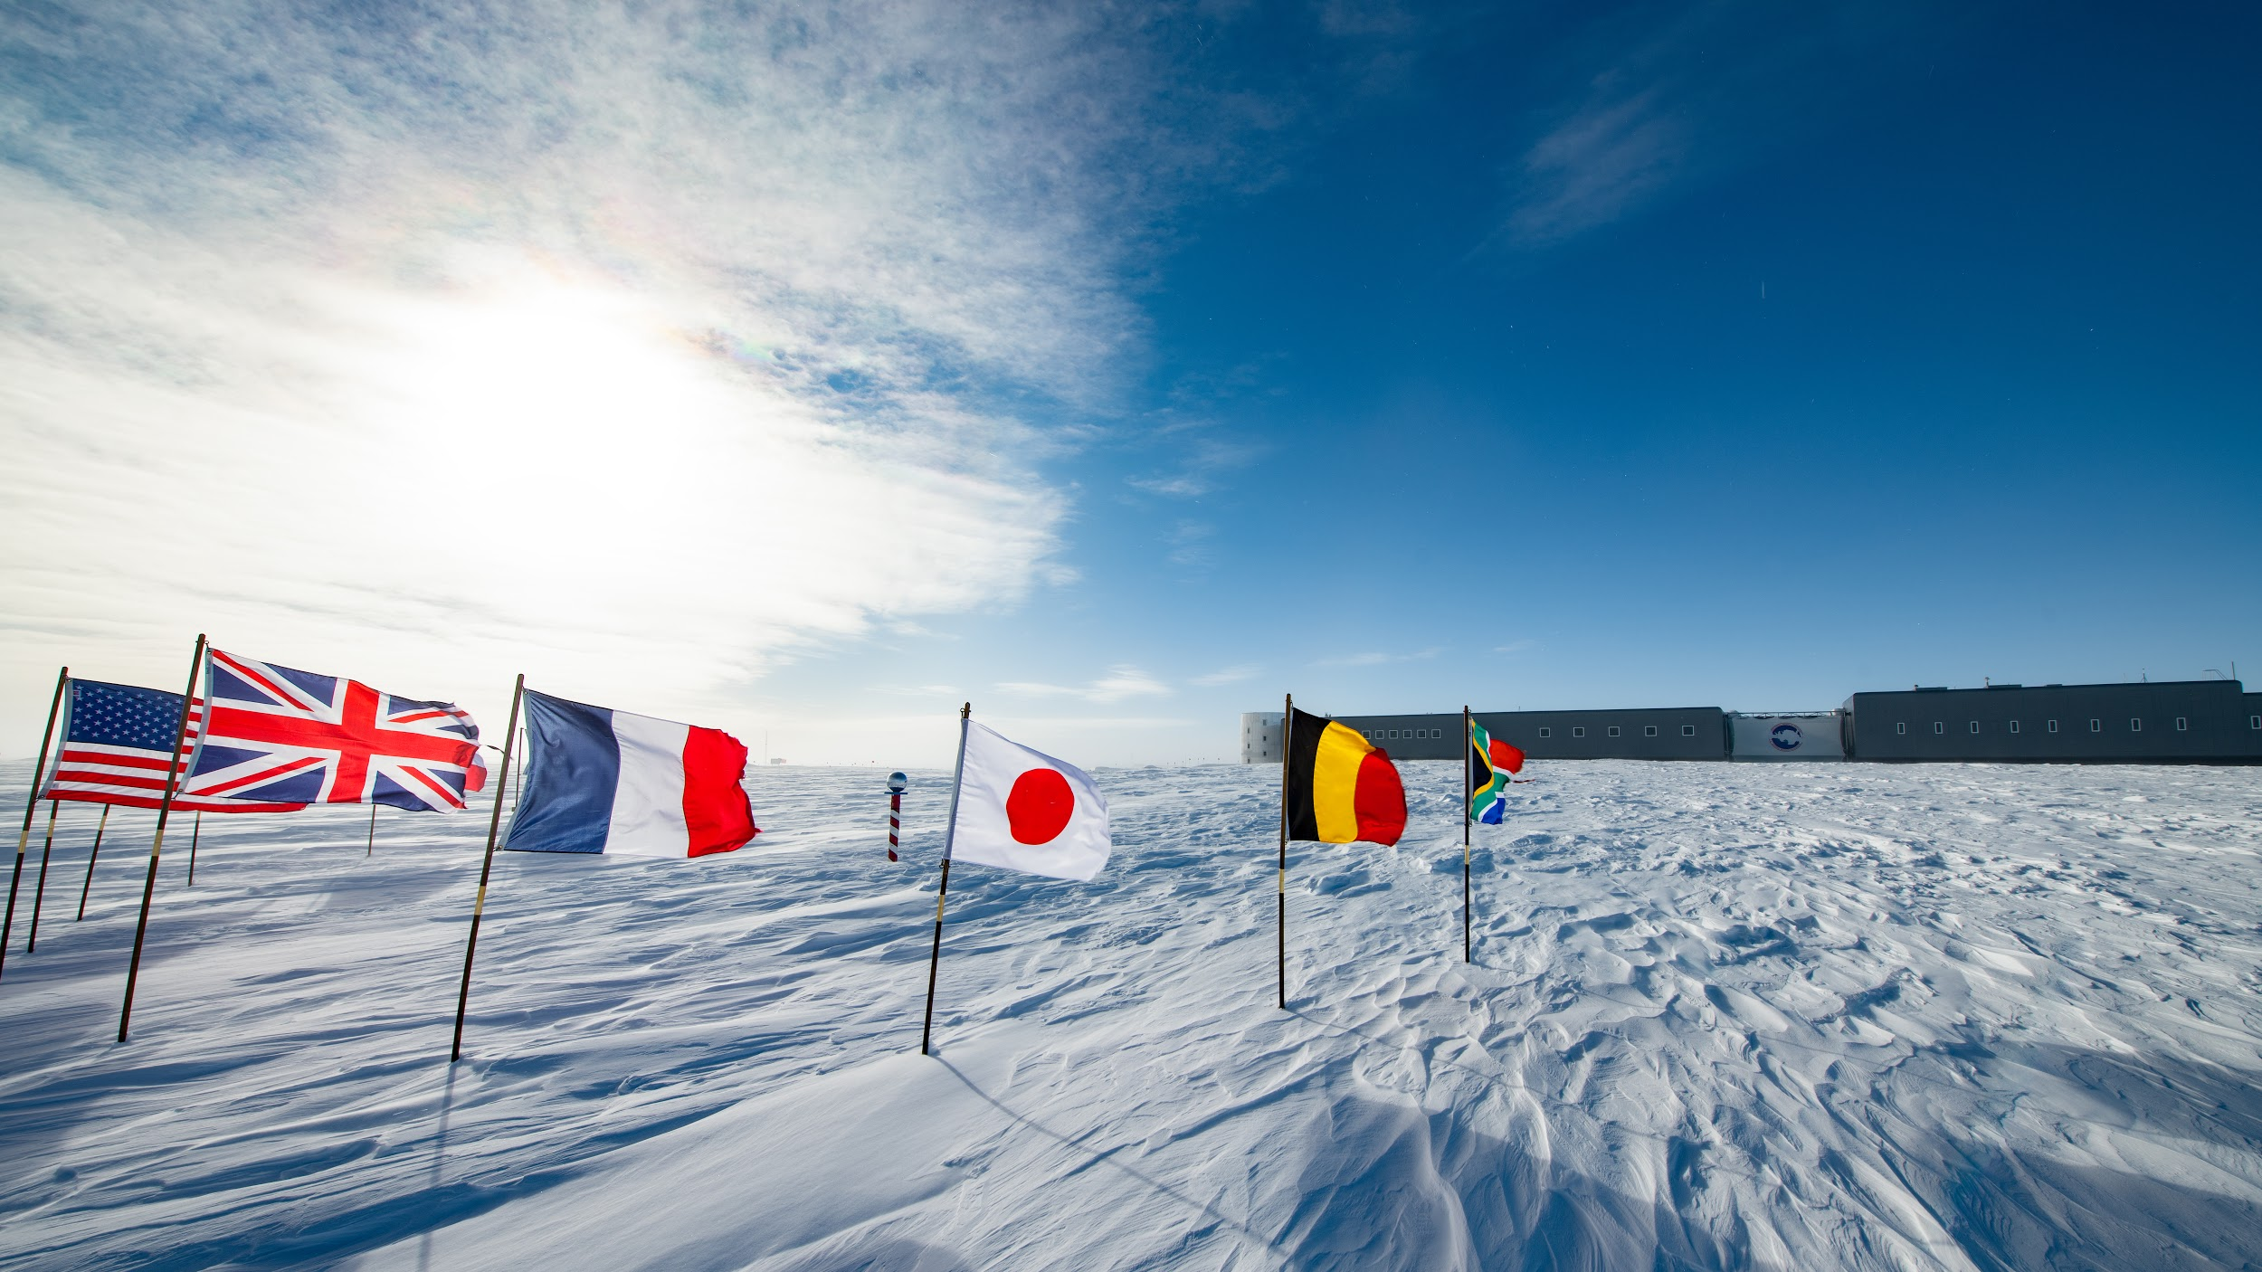 | The Amundsen-Scott South Pole Station is a research center operated by the U.S. National Science Foundation—the only one at the South Pole. Scientists from around the world who work on the South Pole’s various experiments all live at the station, some of them year-round. | Yuya Makino, IceCube/NSF
2019week45_snow_meas_2_ymakino  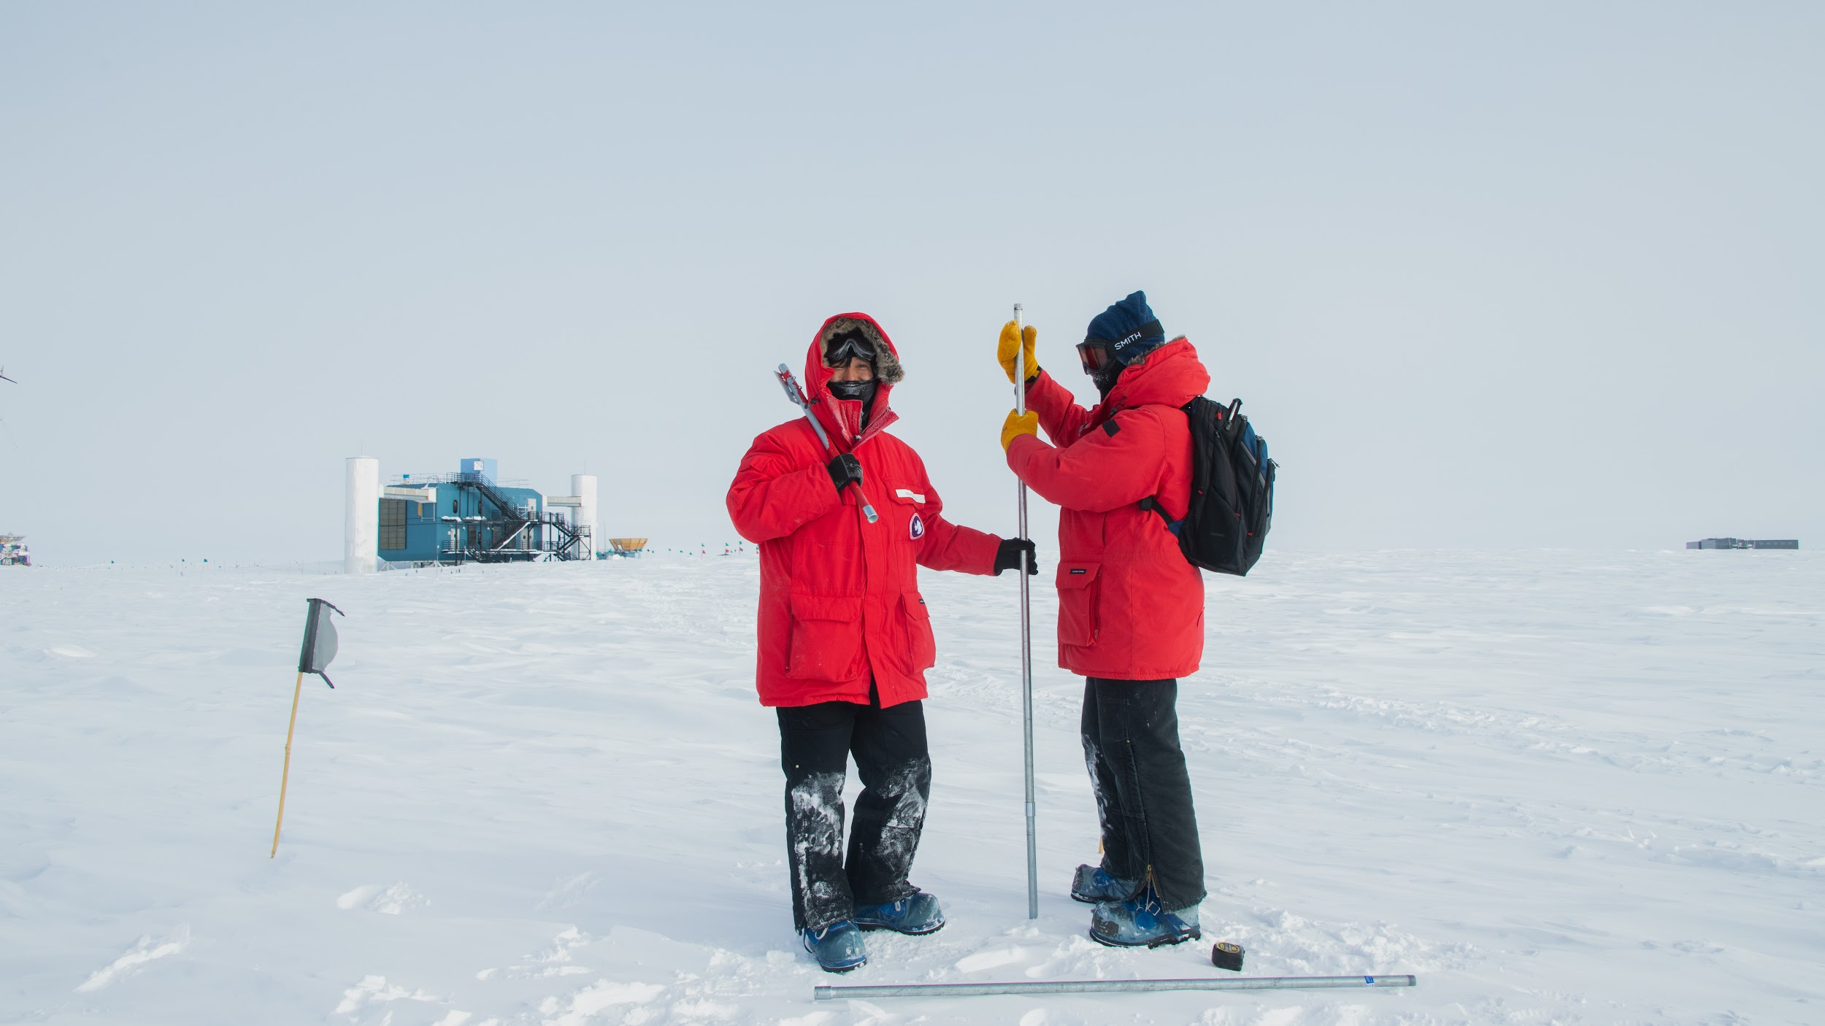 | A couple of IceCube scientists at the South Pole taking snow measurements. The IceCube Laboratory is in the background on the left. | Yuya Makino, IceCube/NSF
2020week16_aurora_03_ymakino  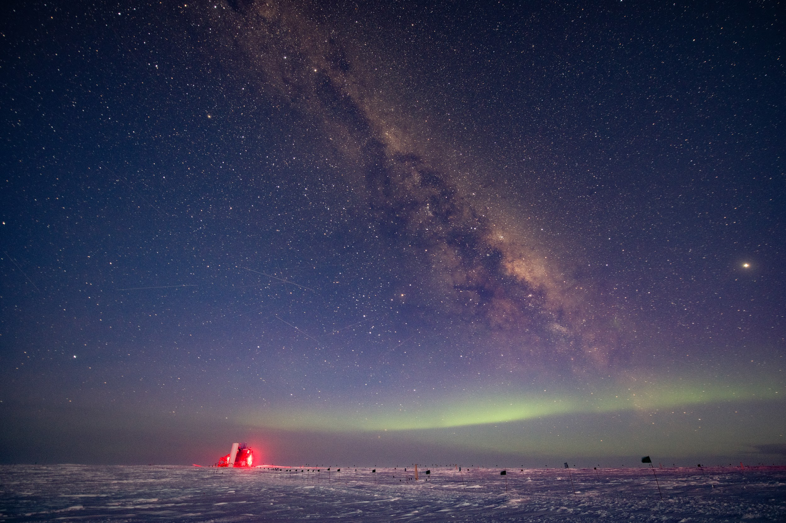 | IceCube is located at the South Pole, which remains in darkness for half the year. Those brave enough to live at the Pole during the long, sunless winter are rewarded with stunning views of the night sky, including the aurora australis, or “Southern Lights.” The building illuminated in red in the lower left is the IceCube Laboratory. | Yuya Makino, IceCube/NSF
ChristianHaack.jpg   | Dr. Christian Haack, Technical University of Munich | Courtesy of Christian Haack
LuLu.jpg  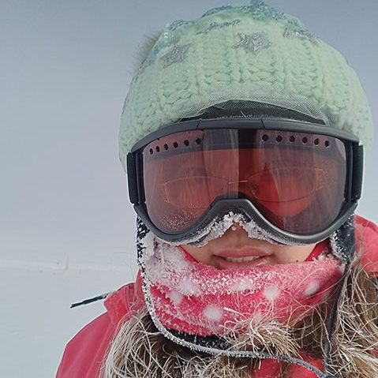 | Professor Lu Lu, Wisconsin IceCube Particle Astrophysics Center/University of Wisconsin–Madison | Courtesy of Lu Lu
TianluYuan.jpg   | Dr. Tianlu Yuan, Wisconsin IceCube Particle Astrophysics Center/University of Wisconsin–Madison | Courtesy of Tianlu Yuan

