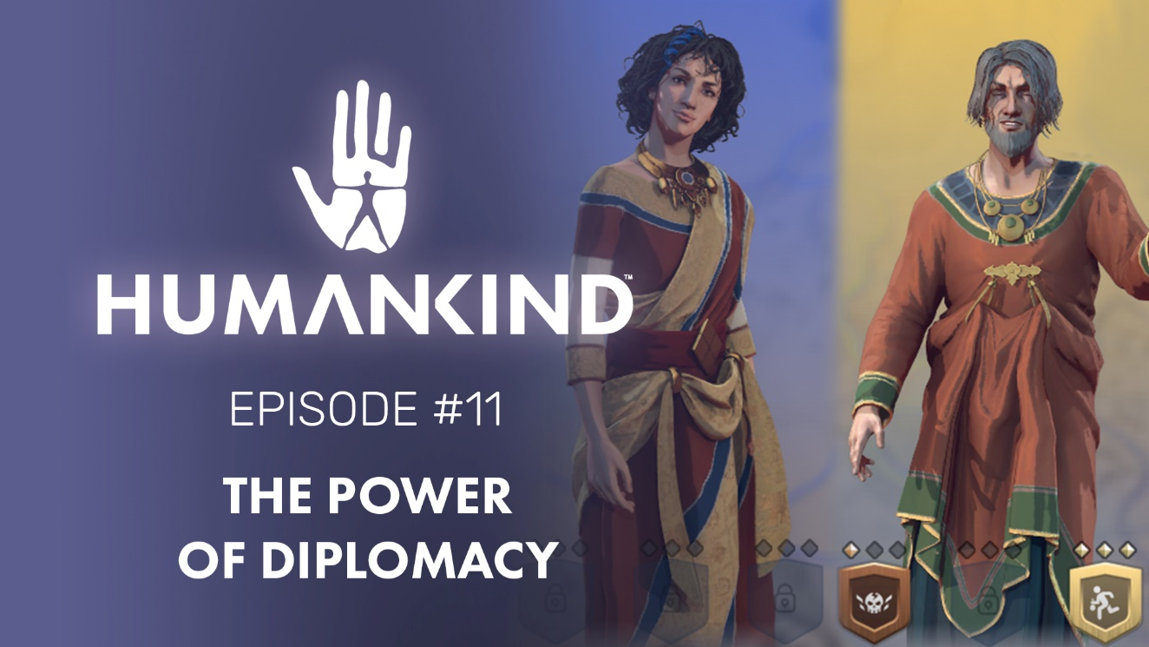

HUMANKIND FEATURE FOCUS #11 – THE POWER OF DIPLOMACY

Diplomacy in HUMANKIND™ will allow players to create meaningful stories and relationships in each game with a multi-faceted system including treaties, grievances, alliances, back-stabbing, demands for compensation, cultural influence, and more.

Paris, April 1st - Battles and war will be important in HUMANKIND, our upcoming turn-based historical strategy game, but they will not happen in isolation. After all, open conflict is just a small part of human history. Rivalries and grudges may have played important roles through time, but so have trade, kinship, and alliances.
The latest episode of our Feature Focus series dives into the methods of conflict and cooperation in HUMANKIND: get ready for trade, treaties, territorial disagreements, and even treason!
HUMANKIND’s diplomacy system is meant to create interesting stories based on a player’s interactions with the map and other opponents. You’ll be able to develop a changing relationship with the other empires and find reasons to love or hate them. Angry at that neighbor who forward settled you? Send them a strongly worded letter to demand they hand it over immediately. Backstabbed by your long-term ally? They’ll have a hard time maintaining that war.
Tools such as treaties, trade, grievances, and demands will be at your disposal to manipulate and enforce these relationships. All of these and more are detailed in the full-length video which is available here, and our dev blog available here.
So, Will you renounce all grudges to make friends and build a global trade network? Or seize every opportunity to demand compensation and make war? How you approach diplomacy in HUMANKIND is up to you, but we certainly look forward to watching the drama unfold!

- The Ampliteam
--
HUMANKIND is available for pre-order on PC & Stadia.
--
For more information about Humankind visit https://humankind.game, or follow us on Facebook, Twitter, & Instagram. Learn more about SEGA at https://sega.co.uk.

