The Qube and Neumann celebrate aspiring and professional talent by opening Neumann-dedicated studio space at West London flagship venue
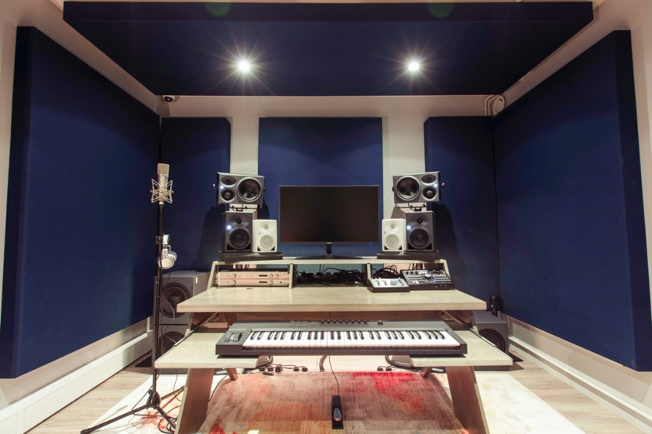
Studio 15 offers three different Neumann KH monitoring setups and is open for bookings from The Qube’s membership

Marlow, UK, December 2021 – As the world’s first members' studio for musicians, artists, managers, labels, and content creators, The Qube is a place like no other. Housed across more than 2000 m², the flagship West London venue is home to 40 creative spaces, including studios for music, podcasts, video and photography, in addition to makerspaces for creative businesses. The facility was founded in 2018 by music producers Amin Hamzianpour and Nicholas Sonuga who wanted to merge the meaningful community of a members' club with the magic of a recording studio and the convenience of a co-working space. With the vision of empowering aspiring and professional creators to fulfil their creative dreams, a partnership between The Qube and Neumann was formed with one of the venue’s rooms, Studio 15, fully equipped with Neumann KH Line monitor loudspeakers, bringing world-class professional monitoring to The Qube’s members.

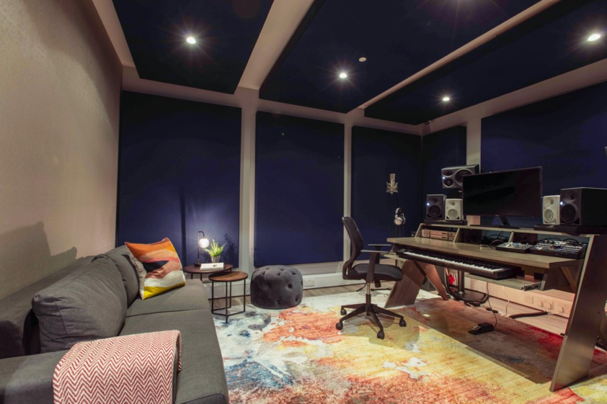
“Building a community of industry-leading music producers and sound engineers, quality of recording and playback has always been at the forefront of our minds, which is why working with Neumann feels like such a natural partnership,” says Hamzianpour. “Their products are synonymous with quality and a household name for most of our members. We're also particularly excited to partner with a brand that's working towards a common mission: to empower music creators and facilitate them in producing their best work.”

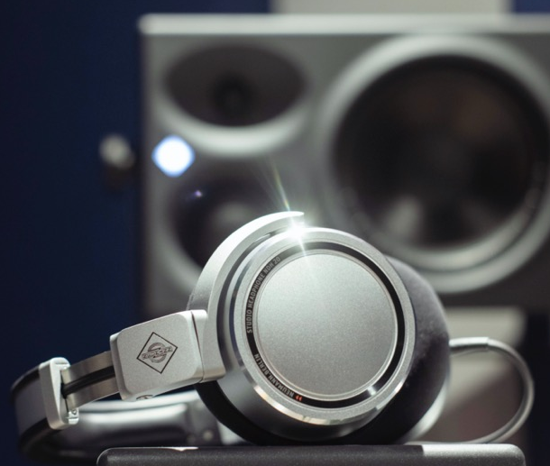
Studio 15 offers three separate 2.1 KH monitoring setups: KH 80 active DSP studio monitors with a compact KH 750 DSP subwoofer; KH 120s with a KH 750 DSP subwoofer; and KH 310 active studio monitors with a KH 750 DSP sub. Additionally, users can take advantage of the Neumann U 87, one of world’s most iconic studio microphones, famous for its warm sound and well-balanced characteristics. The microphone is complemented with V 402, Neumann’s state-of-the art dual channel microphone preamplifier designed to unveil the true character of artist’s voice and instruments. Additionally, Neumann NDH 20 closed-back studio headphones are available for tracking, mixing, and critical listening, offering a delineated sonic image.

“We quickly realised that Neumann having a physical presence at our flagship site in West London would have great value for both brands: for Neumann, to be on the ground in front of hundreds of top-tier professional music creators; and for us to offer our members a taste of the full Neumann experience,” explains Hamzianpour.

The partnership was a success right from the start, with Studio 15 becoming the most booked studio at The Qube between October and November this year, with 211 hours used. “Our members have fallen in love with it!” exclaims Hamzianpour.

Platinum-selling recording engineer, mixer and producer Dukus cannot agree more: "It’s my favourite room! Most of my bookings are going to be in there now. It’s one of the main reasons why I love coming to The Qube."

"It’s a lovely space to work in with an incredible vocal chain ready to go. Also, it’s great to know that you’re hearing all the details with the range of monitoring options," concurs Oli Som, Mix & Mastering Engineer who has worked with Marie-Mai, Louane, James Blunt, Louise Attaque, Newton Faulkner and Robbie Williams amongst others.

Watford-born musician and songwriter Jay Lewn is another fan of the Neumann room: "The Neumann studio is comfortable, perfect for testing mixes and listening back to tunes. It has amazing equipment to get record ready vocals!"
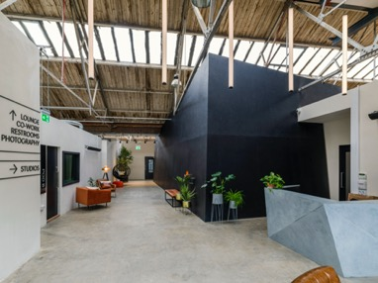
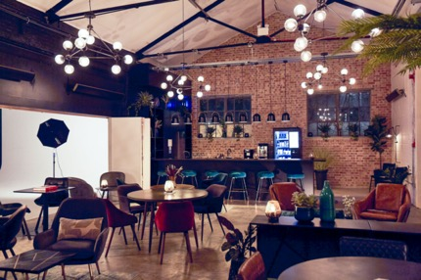

Speaking about The Qube’s future plans and ambitions, Hamzianpour is confident that a partnership with Neumann will bring many more successes to both companies.

“We're expanding to multiple sites in the near future and would love to work closely with the team in designing more bespoke Neumann studios in different territories,” he concludes. “We are also launching an incubator programme to support emerging talent, which is something else we look forward to working with the Neumann team on. In short, there are plenty of great opportunities for both brands to collaborate on and we are thrilled to be working together with such an iconic brand!”

Picture credit: The Qube x Neumann Studio

About Neumann
Georg Neumann GmbH, known as “Neumann.Berlin”, is one of the world’s leading manufacturers of studio-grade audio equipment and the creator of recording microphone legends including the U 47, M 49, U 67 and U 87. Founded in 1928, the company has been recognized with numerous international awards for its technological innovations. Since 2010, Neumann.Berlin has expanded its expertise in electro-acoustic transducer design to also include the studio monitor market, mainly targeting TV and radio broadcasting, recording, and audio production. The first Neumann studio headphone was introduced at the beginning of 2019. Georg Neumann GmbH has been part of the Sennheiser Group since 1991, and is represented worldwide by the Sennheiser network of subsidiaries and long-standing trading partners. www.neumann.com

Local press contacts UK:
Sarah James
sarahj@gasolinemedia.com
+44 1483 223 333

Global press contact:
Andreas Sablotny
andreas.sablotny@neumann.com
+49 (030) 417724-19

