RME Rolls Out Babyface Pro Podcasting Bundle Designed to
Improve Podcasters’ Audio Setups

The all-in-one solution includes the company’s Babyface Pro interface and TotalMix FX software, an Audio-Technica mic and more
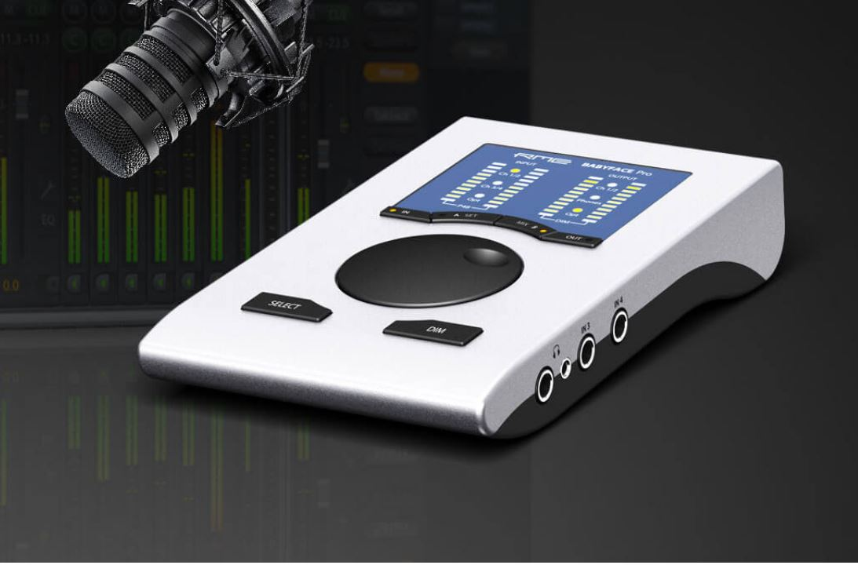
Orlando, FL, June 5, 2019 – Premium German interface manufacturer RME, [InfoComm 2019 booth 5150], has announced an all-in-one audio bundle for professional podcasters looking to take their setups to the next level at an affordable price. Available now, with other configurations rolling out soon, the new Babyface Pro/Audio-Technica Podcast Bundle offers discriminating podcasters broadcast-quality sound and ultimate flexibility by combining RME’s intuitive Babyface Pro audio interface and TotalMix FX mixing software with Audio-Technica’s BP40 Condenser Microphone.
“Podcasting is big business with about 78 million people in the US regularly listening to one podcast per month,” said Derek Badala, Director of Sales for Synthax, RME’s US distributor. “It was high time someone offered the podcasters creating this content an affordable and professional audio setup that takes their show to the next level.”
During the recent podcasting boom, more and more content creators have turned to RME’s Babyface Pro interface while podcasting for its dramatically improved sound and its ability to mix multiple guests easily with no system crashes.
“Additionally, using RME’s TotalMix FX software which comes with all RME interfaces, eliminates the need for additional equipment, saving podcasters hundreds on mixers, cables adapters and software,” Badala said. “We decided to take our offerings one step further and provide podcasters with an all-in-one kit. By partnering with Audio-Technica, On-Stage Stands and the Podcasting Engineering School, we have created a complete, simple and reliable bundle that combines a professional audio interface, education on how to use, software and a microphone that will help podcasters ‘future-proof’ their setups.”
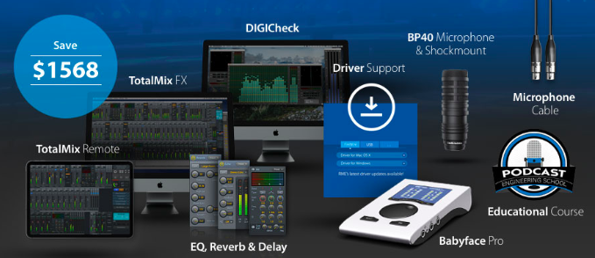
Breaking Down the Bundle
At the heart of the bundle is RME’s Babyface Pro, a “reference-quality” interface with multiple ins/outs allowing for any combination of podcast setups. With two high-precision mic preamps, two headphone outputs for simple host/guest monitoring and the ability to configure a “mix-minus” setup as separate audio sources, the Babyface Pro is the ultimate audio interface for podcasters. The Babyface Pro also allows for independent adjustment of sound settings for every source, individual headphone mixes for up to 6 guests and is compatible with any recording software as well as Mac, Windows and iOS.
As with all RME interfaces, the Babyface Pro comes complete with the free TotalMix FX Remote iPad app which as previously mentioned allows users to configure the “mix-minus” setup as separate audio sources. This allows podcasters to control what guests and listeners hear with no additional cables, mixer or hardware. Users can also mix multiple software applications simultaneously for adding music beds, sound effects and other audio clips to a podcast.
Taking a podcaster’s sound quality to the next level, RME has partnered with Audio-Technica to include the company’s BP40 Condenser Microphone. Optimized for broadcast applications, the A-T BP40 offers a rich, natural sound and the humbucking voice coil prevents unwanted interference. An On-Stage Clamp Desktop Boom Mic Stand is included, leaving a slim and simple look that saves on space. A professional 10-foot microphone cable is also included.
The final piece of the bundle is a Podcast Engineering School Educational Course (a $595 value). This online course provides an overview of the podcast production workflow using a Babyface Pro. The course covers setting up a Babyface Pro, production scenarios and tips, recording online guests, and post-production tips.
With a total value of $2,867, the Babyface Pro/Audio-Technica Podcast Bundle is available now for only $1,299. Offer valid in US only.
For more information on the bundle, visit: https://www.podcast.synthax.com

About Synthax, Incorporated
Synthax Inc. is the exclusive USA distributor for RME digital audio solutions, Ferrofish advanced audio applications, myMix audio products, and ALVA cableware. We supply a nationwide network of dealers with these products for professional audio, broadcast, music industry, commercial audio, theater, military and government applications. For additional information, visit the company online at http://www.synthax.com.

Media Contacts:
Katie Kailus
Public Relations
Hummingbird Media
+1 (630) 319-5226
katie@hummingbirdmedia.com

Jeff Touzeau
Public Relations
Hummingbird Media
+1 (914) 602 2913
jeff@hummingbirdmedia.com

