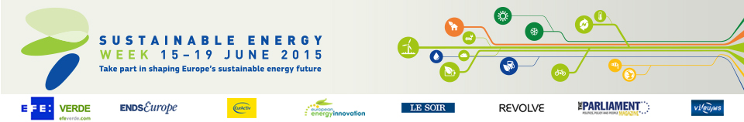

Energy Days in Poland (4)

- Effective support for energy efficiency and development of renewable energy sources by The National Fund for Environmental Protection and Water Management
Date: 30/06/2015
Time: From 11:00 to 16:00
Location: Warszawa

- Siedlce - a sustainable, energy friendly municipality
Date: 14/06/2015 - 19/06/2015
Time: From 10:00 to 14:00
Location: Siedlce

- Creating a Resilient Energy Union: On the way to a sustainable Energy Market
Date: 12/06/2015
Time: From 15:30 to 16:30
Location: Warsaw

- Opolskie Regional Energy Congress
Date: 09/06/2015
Time: From 9:30 to 16:30
Location: Opole

