SENNHEISER TO SHOW TEAMCONNECT CEILING 2 AT 2019 MICROSOFT IGNITE CONFERENCE

Wedemark/Orlando, October 29, 2019 – Audio specialist Sennheiser will be exhibiting its TeamConnect Ceiling 2 microphone at the Microsoft Ignite conference, taking place at the Orange County Convention Center in Orlando between November 4 and 8. TeamConnect Ceiling 2, which is available from Microsoft as a solution for Microsoft Teams Rooms complete with a Microsoft-certified DSP, will be demoed live for attendees of the conference in demo room #W204B.

Sennheiser will also exhibit the TeamConnect Ceiling 2 microphone on the show floor in the partner solution zone (#1937). In addition, attendees can view the TeamConnect Ceiling 2 microphones in the Microsoft Showcase Area in the Microsoft Team Rooms scenario.

The TeamConnect Ceiling 2, Sennheiser's flagship A/V conferencing solution, employs automatic adaptive beamforming technology, providing the speaker with unprecedented freedom to move about the room. Using 28 individual, omni-directional microphone capsules, the system automatically focuses on the voice of the speaker in a meeting, regardless of where they are located. For integrators and AV professionals, it is easy to install and does not require any ongoing maintenance. Several TeamConnect Ceiling 2 can be combined to serve large meeting rooms.

The ceiling array microphone can be used together with existing analogue audio equipment as well as integrated into fully digital systems, where it can be controlled and monitored via the IP network. TeamConnect Ceiling 2 supports Power over Ethernet (PoE), Sennheiser Control Cockpit, Dante Domain Manager and third-party control solutions such as the Crestron control platform.

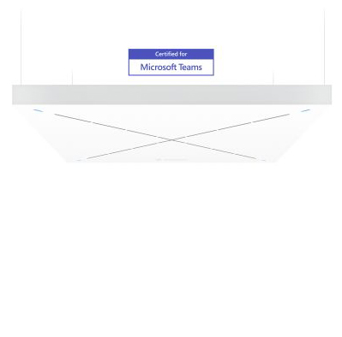 | Visitors to Microsoft Ignite are invited to live demos of Sennheiser TeamConnect Ceiling 2 in W204B

For more information, please visit Sennheiser at the Microsoft Ignite conference on the show floor at booth #1937, in the Microsoft Showcase Area and in the Sennheiser demo room #W204B, or go to www.sennheiser.com/tcc2.

The images accompanying this press release can be accessed here: https://sennheiser-brandzone.com/c/181/3WRocTiS.

About Sennheiser
Shaping the future of audio and creating unique sound experiences for customers – this aim unites Sennheiser employees and partners worldwide. Founded in 1945, Sennheiser is one of the world’s leading manufacturers of headphones, loudspeakers, microphones and wireless transmission systems. Since 2013, Sennheiser has been managed by Daniel Sennheiser and Dr. Andreas Sennheiser, the third generation of the family to run the company. In 2018, the Sennheiser Group generated turnover totaling €710.7 million. www.sennheiser.com

Local press contacts

Jeff Touzeau Daniella Kohan
jeff@hummingbirdmedia.com daniella.kohan@sennheiser.com
+1 (914) 602-2913 +1 (860) 598 7514

