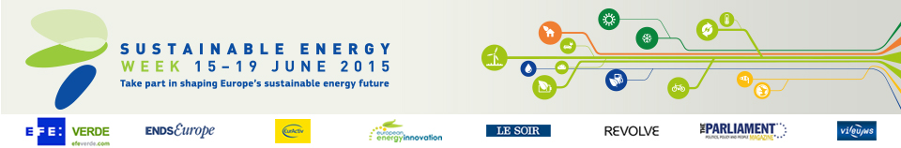

Energy Days in Ireland (6)

- Dundalk IT Wind Turbine open days
Date: 15/06/2015 - 16/06/2015
Time: From 9:00 to 17:00
Location: Dundalk

- Dublin Airport Energy Day
Date: 16/06/2015 - 18/06/2015
Time: From 8:30 to 18:00
Location: Dublin

- Louth County Council Energy Awareness Day
Date: 17/06/2015
Time: From 10:00 to 16:00
Location: Dundalk

- Energy Ireland 2015
Date: 17/06/2015 - 18/06/2015
Time: From 9:00 to 17:00
Location: Dublin

- Launch of 5Cube
Date: 19/06/2015
Time: From 10:00 to 11:00
Location: Dublin

- Renewable Energies - Prosperous Communities
Date: 24/06/2015
Time: From 9:30 to 16:15
Location: Manorhamilton

