For immediate distribution

One for the Road: Sonarworks to Demonstrate Reference 4
and offer Special Discounted Bundles at NAMM 2019
With over 30,000 users and counting, Sonarworks Reference 4 is trusted by CRAS, Pyramind, ICON Collective, IO Music Academy and Grammy winning engineers around the world
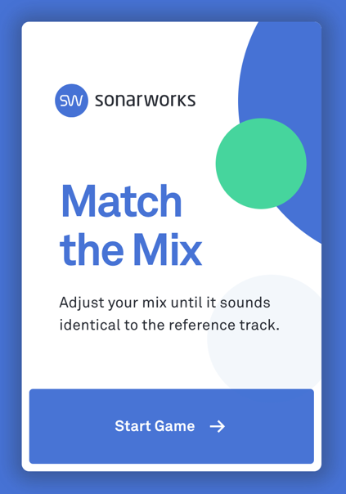
Anaheim, Calif., December 20, 2018 – European audio software developer Sonarworks [Booth ACC North, 19312, Anaheim Convention Center] will be demonstrating its award-winning Reference 4 studio monitor and headphone calibration software during the 2019 NAMM Show next month. Reference 4, the only solution on the market that offers both speaker and headphone calibration, has over 30,000 users around the world and solves the industry-wide problem of sonic discrepancies in monitoring systems. The software is used by industry thought leaders including CRAS, Pyramind, ICON Collective, IO Music Academy and others.

During the 2019 NAMM Show, visitors to the Sonarworks booth will also have the opportunity to play ‘Match The Mix’ and adjust levels until it sounds identical — or as close as possible — to the reference track. Participants who score the best results will be rewarded with a full version of Sonarworks Reference 4 software.
Elements of Successful Monitoring
Reference 4 consists of three primary elements: a DAW plug-in (compatible with AU, AAX Native, RTAS and VST formats), a Systemwide app, and room measurement software. The software utilizes patented technologies and advanced filtering algorithms to establish a common sonic reference point — enabling engineers, producers and other audio professionals to accurately monitor audio sources from any location.

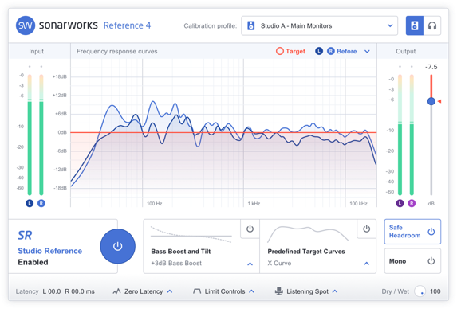
Sonarworks will be offering NAMM attendees in person demonstrations of its revolutionary software, which supports not only loudspeakers but over 200 popular headphone models from AKG, Audio-Technica, Shure, Sennheiser and many other companies. Reference 4 takes less than five minutes to set up and creates unparalleled efficiencies in workflow, enabling users to work faster and with greater confidence – from any location.
For more information about Sonarworks' Reference 4, please visit https://www.sonarworks.com/reference
About Sonarworks
Sonarworks is a Europe-based audio software development company specializing in acoustic calibration and DAW plugins. Accurate sound is our passion. The company was founded in 2013 and entered the pro audio market in 2015. Sonarworks software is relied upon by many Grammy winning artists and engineers around the world.

Media Contact:
Jeff Touzeau
Hummingbird Media
+1 (914) 602-2913
jeff@hummingbirdmedia.com

