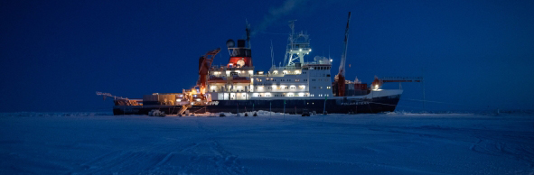
© Alfred-Wegener-Institut/Esther Horvarth (CC-BY 4.0)

Research expedition to the polar ice cap
Teacher documents the MOSAiC expedition with Sennheiser microphones

Wedemark, December 10, 2020 – The MOSAiC expedition (“Multidisciplinary drifting Observatory for the Study of Arctic Climate”) is seen as the largest arctic research voyage of all time and a milestone in climate research. The expedition set sail from Tromsø in Norway on September 20, 2019 and came to an end with the return of the main expedition vessel, the icebreaker Polarstern, to its home port of Bremerhaven, Germany, on October 12, 2020. During the expedition, the Polarstern had docked onto Arctic sea ice and drifted through the Arctic Ocean on a gigantic ice floe. As the ship drifted with the ice, it had contact with a network of measuring stations covering many kilometres. One aim of the expedition was to gain a better understanding of the Arctic’s influence on the global climate in order to make more reliable predictions. One of those taking part in the expedition was Friederike Marie Krüger, a German teacher who had the golden opportunity to exchange the classroom with a research ship for six weeks in order to create teaching materials. In addition to creating a short documentary of the expedition, which she recorded using Sennheiser microphones, her teaching materials are available on the expedition’s education subsite.

Normally, Friederike Marie Krüger works as a geography teacher. “I wrote my dissertation at university on the global melting of glaciers,” said the former geography student. “While I was a student and in the years afterwards, I travelled to Iceland many times. I quickly became fascinated by Nordic regions. But it was entirely by chance that I came across an advertisement for the MOSAiC expedition – they were explicitly looking for teachers to accompany the project. Actually, this is quite common practice in research expeditions, as the aim is to open up additional perspectives to a broader public.”

To record her Arctic impressions, Friederike Marie Krüger borrowed a compact camera with a CMOS sensor and a built-in zoom lens. She also took two Sennheiser microphones along with her.

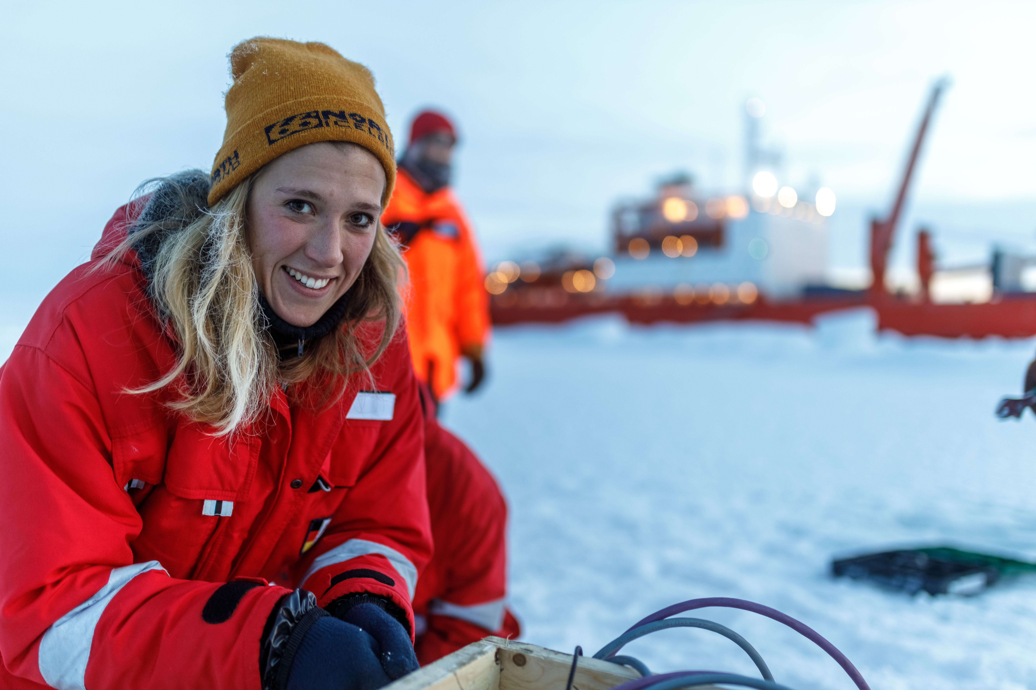 | Friederike Krüger was on board the Akademik Federov to report on the climate research of the MOSAiC expedition  (© Mario Hoppmann)

Heading north with the Akademik Federov
Friederike Marie Krüger set off on board the Russian research vessel Akademik Federov, which accompanied the Polarstern during the first phase of the expedition and carried supplies of marine diesel and additional measuring equipment. Once the Polarstern had docked on a suitable ice floe, a direct ship-to-ship transfer of people and material took place. After that, the two icebreakers deliberately kept a clear distance apart to prevent damage to the ice floe that had been chosen for the drift and to avoid any negative influence on the measurements.

The Polarstern getting close to the Akademik Federov to transfer fuel, staff and scientific instruments  © Alfred-Wegener-Institut/Esther Horvarth (CC-BY 4.0) | 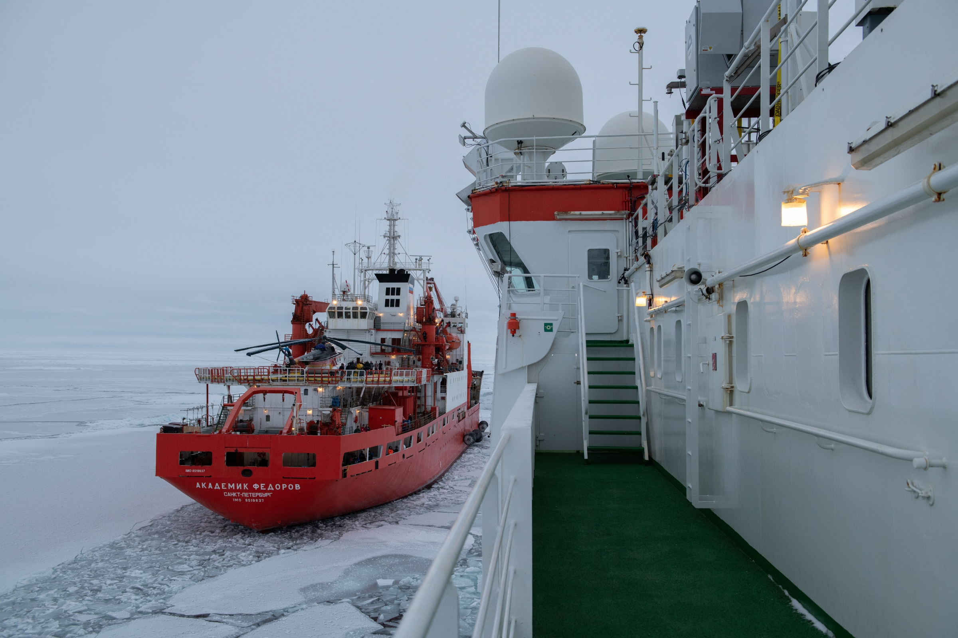

The fifth-year students at Krüger’s school, IGS Bothfeld, were keen to hear about their geography teacher’s exciting adventure, and she kept in contact with them as best she could. Once, a phone call was possible via the ship’s satellite telephone; in addition, she was able to send text messages at specified times using a messaging app. “Of course, the students always asked whether I was going to see some polar bears,” Friederike Marie Krüger recalls with a smile. “But they also asked about more personal things such as whether I felt homesick and the special problems of living on a ship. They also wanted to know what sense it made, from an environmental perspective, to plough through untouched Arctic nature with several icebreakers with powerful diesel engines.”

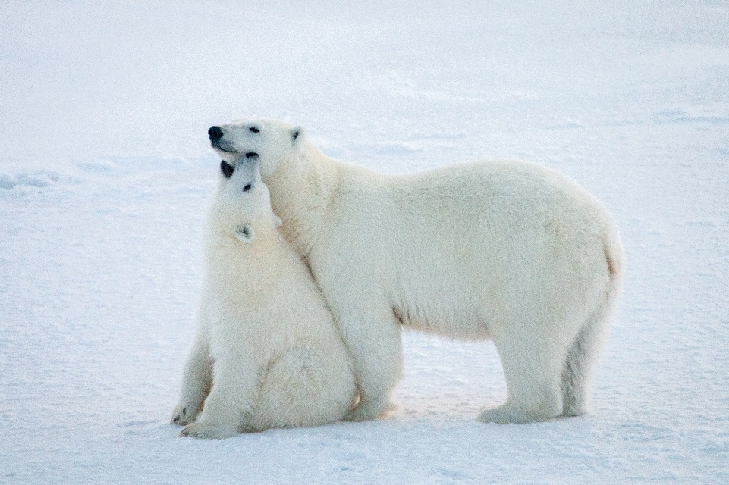 | Friederike Krüger’s students were most interested in polar bears  (© Jan Rohde)

Cool movies at -25 degrees Celsius
Friederike Marie Krüger quickly learned how to master the previously unfamiliar video and audio equipment: “I told myself that it can’t be all that difficult to record my personal impressions in sound and pictures,” is how the teacher described her learning-by-doing approach, which turned out in the end to be a positive one. “The video recordings in 4K and full HD resolution came out really well, and the same is true of the sound,” Krüger said. “At the beginning, I never thought of taking along external microphones and only intended to use the compact camera. But fortunately, just five days before I left, two Sennheiser microphones arrived.”

Most of Krüger’s recordings were made outside and show the spectacular landscape and the scientists at work. As extremely low temperatures are known to have a negative effect on battery capacity, Friederike Marie Krüger had wisely packed additional sets of batteries, which were kept as warm as possible while she was filming outside, and she also took care to hold the compact camera close to her body. “The freezing cold still meant that the camera’s autofocus function stopped working after a short time and I had to go inside the warm cabin for a while before I could continue filming,” said Krüger.

The outside temperatures ranged between -20 and -25 degrees Celsius, and on board it wasn’t possible to mount the camera on a stand because of the movement of the ship. “The cold was pretty unpleasant,” Friederike Marie Krüger admitted. “At such low temperatures, filming is okay for a few minutes, but then your fingers really start to hurt.”

Working on board with the Sennheiser MKE 440
For her sound recordings on the expedition, Friederike Marie Krüger used two proven Sennheiser microphones. For indoor recordings on board the ship, she mainly used an MKE 440 mounted on the camera’s shoe mount. In this compact stereo microphone, two capsules in a V-shaped configuration acoustically cover an area corresponding to the recording angle of a 35 mm camera lens – ensuring homogeneous coverage of the entire area with particularly high speech intelligibility in the image focus.

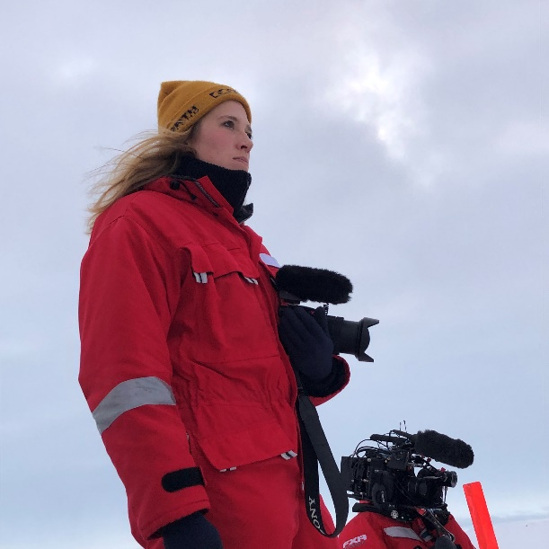 | Despite the brief outdoor trip shown here, the MKE 440 stereo microphone was usually used indoors …  (© Katharina Weiss-Tuider)

With capsules that are elastically suspended inside, it goes without saying that the MKE 440 is protected against structure-borne noise. A fine but extremely sturdy wire mesh made of stainless steel protects the microphone capsules against mechanical damage and also reduces wind noise, but without impairing the high-frequency sound image – which is a problem with foam windscreens. The steel mesh also serves as an effective shield against electromagnetic interference. When outside, Friederike used an MZH 440 fur windshield for the microphone.

Braving the Arctic outdoors: the Sennheiser MKH 416
For outside recordings, Friederike Marie Krüger mostly used a Sennheiser MKH 416, which was protected from wind noise by an MZW 60-1 basket windshield fitted with an MZH 60-1 hairy cover made from long-haired polyester fleece. The short shotgun microphone was mounted on an MZS 20-1 suspension with a pistol grip that made it easy to control. “I quickly learned how important it is in an interview situation to point the shotgun microphone directly at the interview partner…,” Friederike Krüger added.

… while the climate-resistant MKH 416 in its basket windshield and hairy cover was responsible for the majority of outdoor recordings. Friederike Krüger (r.) with Lisa Heusinger and Falk Ebert during the production of Friederike’s mini-documentary

The MKH 416 was connected via an XLR cable to a Sennheiser MZA 14 P 48 U battery power supply unit, which also provided it with phantom power. The microphone signal was recorded with automatic level control through the compact camera’s 3.5 mm stereo mini jack input. The recordings were stored on SD cards inside the camera until Friederike Marie Krüger was able to save them on her laptop and external hard drives when she got back on board the ship.

Sound phenomenon of ice compression: “Creaking steel door times ten!”
So which Arctic sound experience did she think was the most impressive? Friederike Marie Krüger describes in vivid words the haunting sound of ice compression as the ice floe is crushed by sea swell, tides and the wind before being pressed with incredible force against the ship’s hull. “I would compare it to the sound of a creaking steel door in an empty warehouse – but ten times louder! And right next to your bed!” In fact, this natural phenomenon was already described more than 125 years ago by the Norwegian explorer Fridtjof Nansen, whose work is still an inspiration for Arctic expeditions even today.

Stress test successful!
“The Sennheiser microphones did a fantastic job in spite of the harsh Arctic conditions and I never had any problems with either of the models,” Friederike Marie Krüger reported with great satisfaction. “The sound recordings were really successful: the MKE 440 definitely proved itself during the indoor recordings on board, while the MKH 416 showed its strengths as a shotgun microphone during the outside recordings. The basket windshield and protective cover meant that wind noise was never an issue.”

Looking back, Friederike Marie Krüger is certainly glad that she took the microphones with her: “At the beginning, I must admit that I never really thought too much about such things as sound quality and I was simply intending to use the camera’s built-in mini microphone,” the teacher said. “It was only when I got on board the ship that I realised just how important good microphones are if you want to record interviews with intelligible sound and generally if you want to record sound in high quality. The Sennheiser equipment was a tremendous help for me on the expedition.”

First-hand audio-visual impressions
Thanks to vivid first-hand accounts of her experiences accompanied by her own videos and authentic sound recordings, Friederike Marie Krüger has been successful in making a lasting opportunity for education and for wider communication. Ever since she returned home, she has not only conveyed her fascination for the Arctic to students and staff members at IGS Bothfeld but has also given lectures at schools throughout Germany and has developed corresponding classroom activities. She is now planning university seminars for geography teachers as well as preparing projects with museums. Krüger’s video and sound recordings are now available together with other material on the MOSAiC homepage (https://mosaic-expedition.org/education).

Images and graphics of the MOSAiC expedition can be found with the multimedia assets of the Alfred-Wegener-Institut. The additional pictures accompanying this release can be downloaded here.

About Sennheiser
Founded in 1945, Sennheiser is celebrating its 75th anniversary this year. Shaping the future of audio and creating unique sound experiences for customers – this aim unites Sennheiser employees and partners worldwide. The independent family company, which is managed in the third generation by Dr. Andreas Sennheiser and Daniel Sennheiser, is today one of the world’s leading manufacturers of headphones, loudspeakers, microphones and wireless transmission systems. In 2019, the Sennheiser Group generated turnover totaling €756.7 million.
www.sennheiser.com

Global Press Contact

Stephanie Schmidt
stephanie.schmidt@sennheiser.com
+49 (5130) 600 – 1275

