For immediate distribution

Flexibility That Pops: Singer Andy Grammer’s Playback Engineering Team Creates Versatile Rig Centered on Ferrofish
Guitarist Greg Karas and playback tech Joey Muraoka design a unique playback rig that travels easily during North American tour

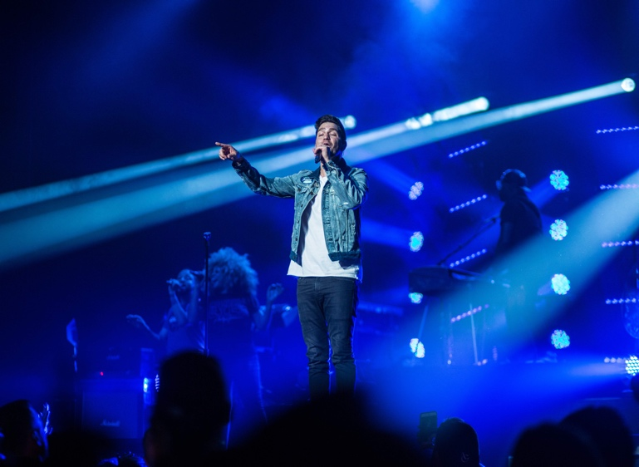
Anaheim, CA, January 14, 2019 — Andy Grammer’s pop music career has been on the rise since the 2011 release of his self-titled debut album, which included the hit singles “Keep Your Head Up” and “Fine By Me.” A few years later, his song “Honey I’m Good” — off his 2014 sophomore effort Magazines and Novels — shot to the top of the pop music charts and has since been certified triple-platinum.
Now, having wrapped up Grammer’s latest tour in support of his third album The Good Parts last November, guitarist Greg Karas and playback technician Joey Muraoka were tasked with upgrading Grammer’s playback rig to the next level flexibility, reliability and portability. Together, with help of FOH engineer Adam Robison, Grammer’s team added a product to their rig worthy of the next stage in the pop star’s career – the Ferrofish A32 AD/DA Converter.
Pioneering the Next Level of Pop
With a background in recording and digital cinema mastering, Karas, who has been Andy Grammer’s guitarist since 2013, depends on the playback rig to ensure his guitar will sound the way it’s supposed to on every song.

“In the past year, we have basically gone through our entire set and programmed all the MIDI changes, so that, as we’re going through the show, all of our presets and patches will automatically change as the songs go on,” Karas said. “That’s extremely important for us because we have a ton of dance moves in our set. In pop music, it’s all about nailing the sounds from a record. When you’re dancing around doing choreography it looks awesome, but it’s really difficult to concentrate on some of the minor details. So, implementing the MIDI switches into our set has been game changer, and now it’s essential.”
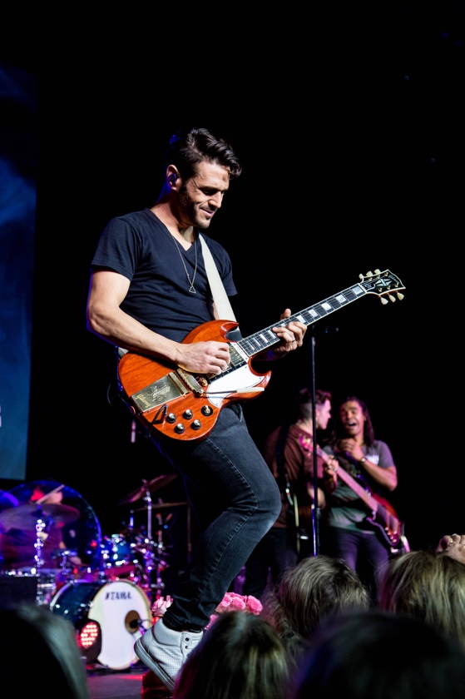
When it came to choosing a converter, Grammer’s playback engineering team had to consider all aspects of their production — in addition to dance moves — that go beyond the music, including for lighting, video and TelePrompTer, with flexible time code applications for different types of productions. Due to the number of television performances that Grammer books in a given year, the Ferrofish A32 affords his playback team the flexibility to work with different production crews without having to change anything in the setup.
“With the TV stuff, it’s really hard for us to travel with a large crew and ship gear out,” Karas said. “Sometimes we’re able to bring our own lighting and video guys, but a lot of times we’re bringing in people that are just tasked to a specific show, and we have to have flexibility on the different types of time code for the different arrangements of our songs.
“Some lighting technicians want to see one frame rate,” Karas continued, “and maybe our system is set up on a different frame rate. And maybe the video guy needs to see something that is slightly different. So, instead of having to redo an entire session and spend all this time and man-hours, one of the reasons that we chose to incorporate the Ferrofish A32 into this rig is that we now have the capability to provide multiple sources of time code at these different branches.”
With their previous system, Muraoka said, “We were pushing it to the limits. We wanted more control over the tracks, better audio quality and a minimum number of cables. Now, by going fully digital with the Ferrofish A32, we’re pushing our rig to the next level, in regards to flexibility with MADI and our consoles, and with the audio quality of our live show.”
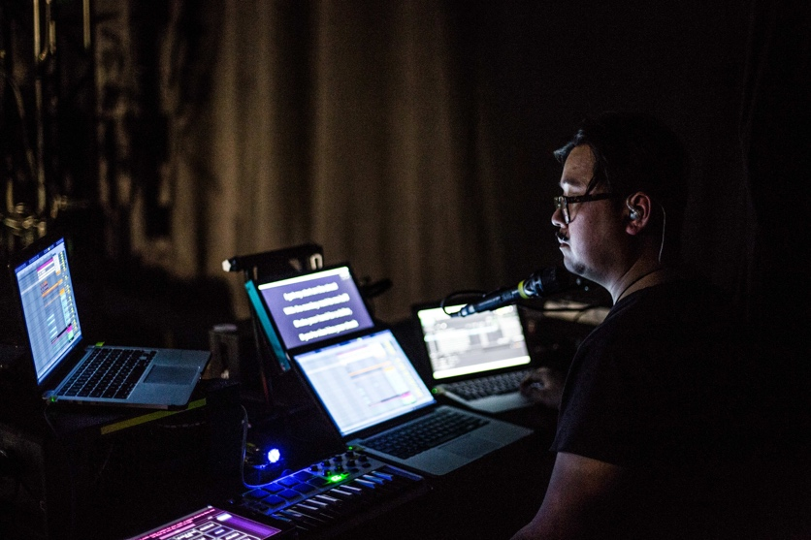
For the past year, Muraoka – who refers himself as a “Hawaiian Swiss Army Knife” – has been in charge of increasing efficiency in all aspects of Grammer’s live show, from production and stage management, to maintaining, organizing, and taking care of drums, keyboards and MIDI instruments. ”I’ve worked with nine different artists,” Muraoka said, “and every camp has their own style of playback rigs. The biggest thing is to be able to fit in any configuration in any situation. With the A32, we have that ability. Whether it is in MADI format with BNC/optical outputs up to 64 tracks or sending out copper with 32 analog outputs, the A32 gives us complete control to send playback tracks to production to be able to give the best mix possible with amazing audio from the A32.”

Ready to Fly from Gig to Gig
When Karas, Muraoka and Robinson began planning upgrades for Andy Grammer’s playback rig last year, one of their biggest concerns was keeping the rig under 50 pounds for fly dates.
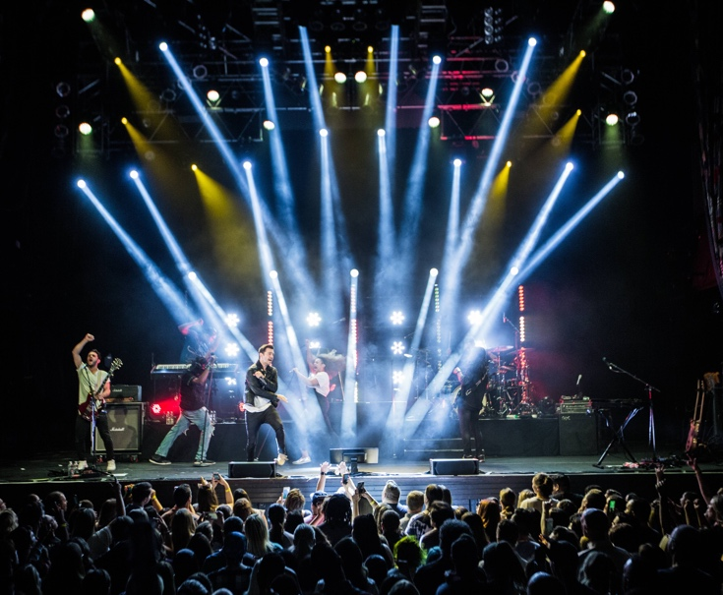
“With this rig, we were trying to build it in such a way that we could carry it on,” Karas said, “so that we would have the ability to keep our eyes on it at all times to reduce the amount of variables you could encounter when you deal with baggage handlers. So, there was lots of emailing and sketching diagrams back and forth, and also asking the equipment companies, ‘How do we shave off and extra two pounds to get this under weight?’ Or, ‘Do we talk about building a custom power supply that will take care of three units with similar power requirements?’”
Having worked with other artists playback teams who used Ferrofish, Muraoka was familiar with the brand’s reputation for making flexible, dependable and lightweight equipment. So, when as they were designing fully digital MADI rig, they kept their eye on the Ferrofish A32 and designed their whole system around it.
Now, with a new playback rig built around the Ferrofish A32, Andy Grammer’s crew is all set up for 2019, and ready to raise the level of their live performances to new heights. “In a lot of ways we’re the ideal candidates to test the A32, because of the high frequency of fly dates we do, and the amount of variables that we encounter,” Karas said. “Most people are doing a tour for months, and they have a lot more control over their situation. With us, we don’t have that luxury often. So, we’re definitely ready to test the new equipment firsthand.”

Karas and Muraoka will be breaking down their playback rig and walking listeners through their workflow during the 2019 NAMM Show on Thursday, Friday and Saturday at 2:30 p.m. at RME’s booth 14702.

For more information, visit ferrofish.com.

About Ferrofish
Known for its precision-engineered German technology, Ferrofish manufacturers high quality, innovative advanced audio applications. From its class-leading A16 MK-II and A32 AD/DA converters to its Verto Series of intuitive Dante converters, Ferrofish is known for its premium conversion solutions that are ideal for a wide range of applications. For additional information, visit the company online at http://www.ferrofish.com.

About Synthax, Incorporated
Synthax Inc. is the exclusive USA distributor for RME digital audio solutions, Ferrofish advanced audio applications, myMix audio products, and ALVA cableware. We supply a nationwide network of dealers with these products for professional audio, broadcast, music industry, commercial audio, theater, military and government applications. For additional information, visit the company online at http://www.synthax.com.

Media Contacts:
Jeff Touzeau
Public Relations
Hummingbird Media
+1 (914) 602 2913
jeff@hummingbirdmedia.com

Katie Kailus
Public Relations
Hummingbird Media
+1 (630) 319-5226
katie@hummingbirdmedia.com

