

**CAMPAIGN STARS SIENNA MILLER AND DOMINIC WEST**

**CELEBRATE ‘THE TALE OF THOMAS BURBERRY’ IN NEW YORK**

London, 14 November 2016

Burberry celebrated its latest holiday campaign, ‘[The Tale of Thomas Burberry](http://www.burberry.com/festive-film/)’, with an event hosted by two of the campaign’s stars, British actors Sienna Miller and Dominic West, in New York tonight.

Over 130 guests attended the event at Burberry’s SoHo store including Sienna Miller, Dominic West, Ben Barnes, Olivia Palermo, Johannes Huebl, Chelsea Leyland, TK Wonder, Cipriana Quann, Shameik Moore, Priyanka Bose, Emma Greenwell, Julia Loomis, Antonia Romeo and Ollie Green. British DJ Mary Charteris performed a live set.

“I have been fortunate enough to have been part of the Burberry family for many years and it never feels like work; Christopher and Asif are incredibly talented and the combination of their talents has materialised in this really special film, which I am honoured to be a part of.”

**Sienna Miller**

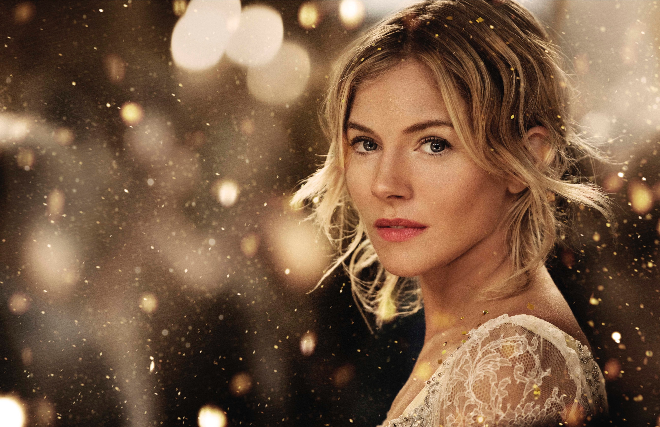

“It’s wonderful that such a great British brand has created such an incredible film, and that I got to be a part of that. Ernest Shackleton has always been a great hero of mine and one of the greatest men of the 20th century, so it was brilliant to play him at last!”

**Dominic West**

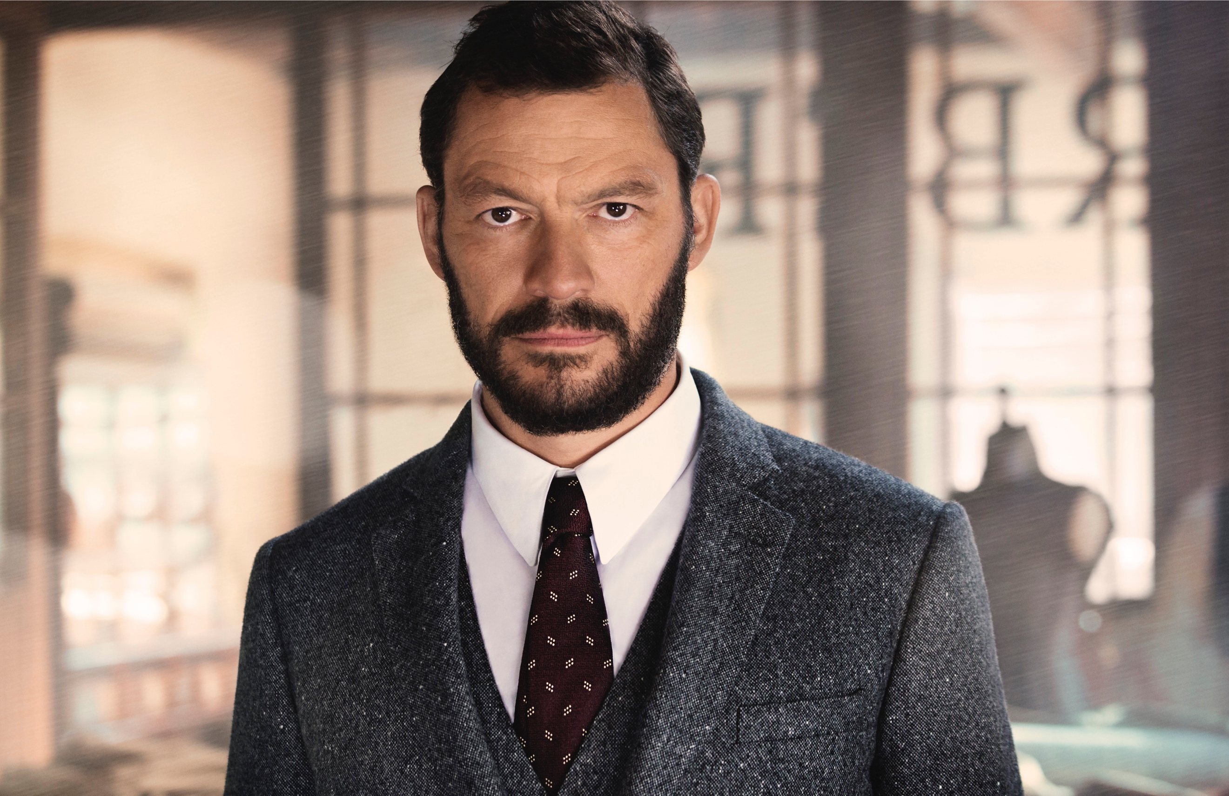

**‘The Tale of Thomas Burberry’**

Premiered earlier this month, ‘The Tale of Thomas Burberry’ comprises a three-minute cinematic [trailer](http://www.burberry.com/festive-film/) directed by Academy Award winner Asif Kapadia, reimagining key events that have shaped the company’s history and values.

The film stars Domhnall Gleeson as Burberry founder [Thomas Burberry](http://www.burberry.com/our-history/), Sienna Miller as Thomas’s fictional first love, Dominic West as Sir Ernest Shackleton, the pioneering polar explorer who wore Burberry gabardine for three Antarctic expeditions and Lily James as pilot Betty Dawson, a fictionalised character inspired by the real-life achievements of Betty Kirby-Green, who broke the world record in 1937 for a return flight from England to Cape Town in an aeroplane named ‘The Burberry’.

**The Story Behind the Tale – New Footage released**

To coincide with the event tonight, Burberry has released footage from the set of the film, revealing details behind the story, alongside interviews with Asif Kapadia, screenwriter Matt Charman and the entire cast.

**This Holiday Season at Burberry**

The Burberry holiday campaign coincides with the launch of dedicated in-store and online experiences, and iconic Burberry [gifts](http://www.burberry.com/gifts/) for [men](http://www.burberry.com/mens-gifts/), [women](http://www.burberry.com/womens-gifts/) and the [home](http://www.burberry.com/womens-gifts/gifts-for-the-home/). For more information on Burberry gifts this holiday season, click [here](http://press.burberry.com/festive/).

Bespoke gifting experiences and personalisation services available selectively throughout the holiday season at the Burberry SoHo store include:

* The monogramming of Scottish-woven cashmere scarves, allowing for personalisation with up to three characters including the choice of ♥ and & symbols, in 45 thread colour options. In addition, an artisan calligrapher will be in store to personalise cashmere scarves with a new calligraphy-style embroidery service.
* Personalisation of a selection of bags with hand-painted initials, from signature designs to seasonal runway styles including The Banner and The Buckle Bag for women, and The Barrow Bag for men.
* Embossing of leather accessories and products from the brand’s gifting collection, available for monogramming in gold or sheer-gloss foil, in small or large font.
* Gift packaging for all Burberry gifts, using the brand’s iconic honey-coloured packaging and a selection of decorative ribbons.

**NOTES TO EDITORS**

**‘The Tale of Thomas Burberry’ – Quotes from the Cast and Crew**

“This Christmas, as we celebrate our 160th anniversary we wanted to tell the story of Thomas Burberry – pioneer, inventor, innovator, and the man behind the iconic trench coat – in our own words. The film we have made is a brief glimpse inspired by his full and extraordinary life, which threaded its way through the history of the twentieth century in all its tumultuous highs and lows.

To do justice to this story, we turned to a team of truly great twenty-first century British talent: Asif Kapadia, a director whose work I admire enormously, and a cast of our brightest and our best actors: Domhnall Gleeson, Sienna Miller, Dominic West and Lily James. We feel very proud to be sharing The Tale of Thomas Burberry this Christmas – his spirit and his vision are still at the heart of everything we do at Burberry today.”

**Christopher Bailey, Burberry Chief Creative and Chief Executive Officer**

“The film is the story of Thomas Burberry – it’s the story of Burberry the man, a person who created a fabric, which created the label, which has become a huge fashion brand. The idea of the film was to show where it all began.

It was a great collaboration and a really fun experience because we worked very closely with Christopher Bailey and the team at Burberry, while being given creative freedom from the very beginning. It was one of the best experiences I have ever had on anything like this.”

**Asif Kapadia**

“Thomas Burberry was a remarkable character. He was intensely gifted and very passionate about the real-world potential of what we wear and how it changes us. What he created has stood the test of time and influenced those who came after him – his work had such an impact and legacy after he was gone. I found that inspiring – it's what most artists dream of. To be integral to the success of so many firsts in aviation, exploration, fashion etc. – it was a very inspiring role to play.

The film also places real emphasis on the value of creativity and of making things which matter, and manages to do so while simultaneously telling the story of a man who achieved many amazing things, all in three minutes – that's not bad!”

**Domhnall Gleeson**

“It’s been so exciting to share the story of Thomas Burberry and everything he has achieved. It’s such a powerful story and to be a part of telling it is something really special.

Asif had this huge undertaking because he was shooting a movie in just a week. Each scene we filmed was like a real scene even if the end product is just three minutes long. He was so brilliant at getting everyone passionate and involved. I’m just so impressed at what he has achieved with this film.”

**Lily James**

**About the Burberry SoHo store**

* The Burberry SoHo store is housed within a landmark building in the SoHo-Cast Iron District, which is listed on the National Register of Historic Places celebrating New York City’s rich architectural heritage.
* The store carries womenswear, menswear, non-apparel and eyewear, as well as the full Burberry fragrance and make-up collections, which are showcased on a new Burberry Beauty counter.
* It also houses the brand’s September collection, first unveiled in full on the runway as part of London Fashion Week on 19 September 2016.
* Burberry SoHo is the seventh Burberry store in New York City, alongside 57th Street, Madison Avenue Menswear, Madison Avenue Womenswear, Bleecker Street, 34th Street Accessories and Brookfield Place. New York City is also home to the brand’s Americas headquarters at 444 Madison Avenue, which opened in 2009.

**About Burberry**

* Established in 1856, Burberry is a global British luxury brand with a heritage of innovation, craftsmanship and design.
* The Burberry business comprises 5 divisions: mens, womens, childrens, accessories and beauty.
* Burberry is headquartered in London and listed on the London Stock Exchange (BRBY.L), Burberry is a constituent of the FTSE 100 index.
* Visit [www.burberry.com](http://www.burberry.com/) for further information