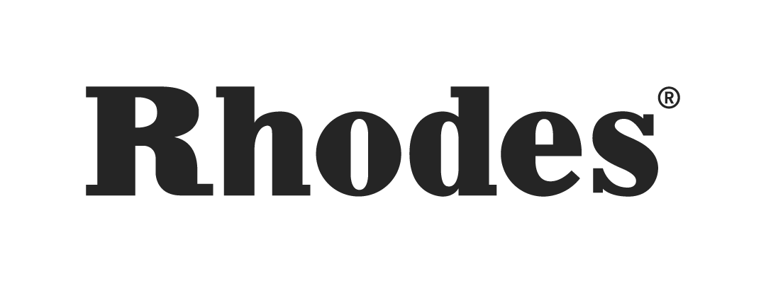

Bill Laurance Showcases Rhodes MK8 Piano in latest 'Rhodes Sessions' recordings

Leeds, United Kingdom, July 17, 2024 — Grammy-winning pianist, keyboardist, and composer Bill Laurance, who got his start with the jazz fusion band Snarky Puppy and has since built a flourishing solo career, presents the latest 'Rhodes Sessions' recordings. In these sessions, Laurance explores the dynamic performance capabilities and diverse sound characteristics of the Rhodes MK8 piano through four original compositions, ranging from swing to indie rock. Recorded at The Nave studio in Pudsey, UK, these live recordings demonstrate the MK8's versatility and appeal to musicians across various styles and genres. View all four sessions on the Rhodes Music YouTube Channel.

Impressions of the MK8
Laurance praised the Rhodes MK8's design and technical prowess, particularly its fluid and responsive action. "The action is unbelievable — so fluid and light. It's like nothing else," he remarked. This responsiveness, coupled with the instrument's Kluge/Steinway keybed, provided an exceptional playing experience. "The MK8 maintains the essence of the original Rhodes sound while offering impressive customization options," Laurance noted. "You can make it sound like a Mark V or VII with more bark, or you can dial it down as you wish. The capacity to tailor the instrument's timbre and appearance is remarkable."

Writing and Composing on the MK8
Laurance's four compositions — spanning indie rock, straight-ahead swing, funk, and a heartfelt ballad — demonstrate the MK8's versatility. "What excites me most about the MK8 is its capacity to accommodate a wider spectrum of styles," he said. Each track in the 'Rhodes Sessions' was crafted to showcase the full breadth of the instrument's capabilities, with Laurance drawing inspiration directly from the MK8 itself. "It's a whole new world," he enthused. "The MK8 is incredibly ambitious, integrating effects and the ability to assign pedals, which takes the instrument to another level."

Laurance was particularly inspired by the specific MK8 piano he used for the sessions, which had been signed by numerous renowned musicians who had tested out the unit previously. "Seeing the MK8 with all the signatures on it was incredible. Knowing that so many amazing musicians had played this instrument was truly inspiring. It felt as if the piano itself was a conduit for creativity, guiding the writing process," Laurance reflected.

The four tracks included in the sessions are:

- Set Piece: An indie rock inspired track where Laurance utilized the MK8's overdrive feature to create powerful riffs.
- Do What You Want: A straight groove piece, enhanced by the MK8's delay effects, allowing Laurance to easily add nuances.
- JuJu: A ballad that came to life with the MK8's tremolo, highlighting its ability to produce rich, emotional tones.
- What It Is: A funk-based song showcasing another unique aspect of the MK8's sound palette.

Laurance expressed his admiration for the Rhodes team, particularly Chief Product Officer Dan Goldman, for their visionary approach to the MK8. With the 'Rhodes Sessions,' Bill Laurance celebrates the legacy of the Rhodes brand and invites audiences to explore the future of music with the MK8. "The MK8 is a testament to remaining respectful of the Rhodes tradition while pushing into the next generation," he stated. "It's about embracing technology and celebrating what these instruments can achieve."

About Rhodes
For Rhodes loyalists around the world, this is a new chapter in Rhodes history; not a new book. With the Rhodes MK8, we’re returning to the principles, aesthetic, craftsmanship and pride of Harold Rhodes’ originals. We’re paying homage to the past with our gaze fixed firmly on what lies ahead.

###
For further information contact:
Jeff Touzeau
+1 (914) 602-2913
jeff@hummingbirdmedia.com

Hunter Williams
+1 (518) 534-9170‬
hunter@hummingbirdmedia.com

