For immediate distribution

Ferrofish A32, A32 Dante Chosen by Mobile TV Group
for Live Sports Broadcasts Across the Country

Premium Dante- and MADI-compatible interfaces selected for their flexibility and ease of use
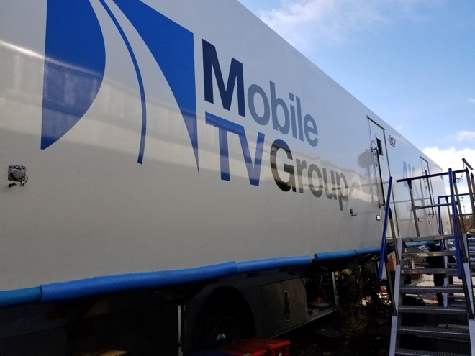
Englewood, CO – November 28, 2017 – Ferrofish’s A32 and A32 Dante, the premium German-manufactured AD/DA converters, have been selected by Mobile TV Group, a broadcast company which deploys mobile units across the nation for the broadcasting of sporting events, including regional and national NBA, NHL, MLB and college football games.
Ferrofish's A32 and A32 Dante are used in three of Mobile TV Group’s mobile units: 39 Flex, 42 Flex and 42 VMU. Mobile unit 39 Flex includes the company’s fiber booth kit which employs two A32s which receive audio from the announce booth in the venue and send it back out to the truck on one fiber. Because of limited space in most venues, Mobile TV Group’s Director of Engineering Peter Wehner was looking for a compact solution for this process, which is frequently used for college football broadcasts.

“Our clients want these fiber booth kits, but we need them to be very compact and small because of the limited space,” Wehner said. “I set out to make the whole booth kit a six rack unit or less. We used the Ferrofish A32 Dante to take all of our 32 channels of analog audio to and from the booth. It goes into the Ferrofish Dante, converts to Dante and then converts to fiber to get the audio back to and from the trucks.”

Dual-Feed Solution
Mobile TV Group also employed Ferrofish’s A32 in mobile unit 42 VMU, which the company dubs its “Shared Resource” unit that handles dual-feed production — a process Mobile TV Group has pioneered. This process is used when the company has two clients or teams each doing individual broadcasts and sharing resources.
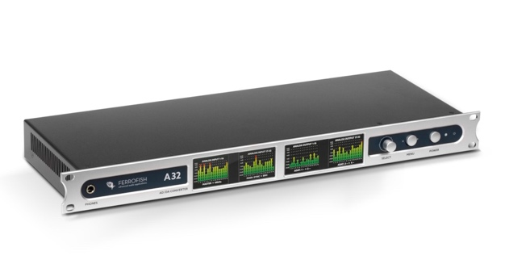
“We have one production switcher, and we spilt it in half,” Wehner explained. “One show has half of the switcher and the other has the other half, and then they share the cameras. There’s a lot of sharing going on which is basically a cost reduction for them, but it requires two distinct shows going on at once.”

Mobile TV Group utilizes two trailers for this process — the main truck, or the A unit, and the second truck, VMU (Visitor Mobile Unit). The Ferrofish A32 is used to move audio via MADI between the two trucks.

“The main truck has all the resources, and we extend everything over to the VMU,” Wehner said. “The A32 is helpful in this instance because it can take a lot of different types of audio in.”

Flexibility & Footprint
One factor that drew Wehner to the Ferrofish interfaces was flexibility and ease of use.

“The thing that stands out about the A32 and A32 Dante is that they’re extremely flexible,” Wehner said “They can take a lot of different types of audio in — Dante, MADI and ADAT — and combine it all into one, and we can route internally in the box. Anything in can be anything out.”
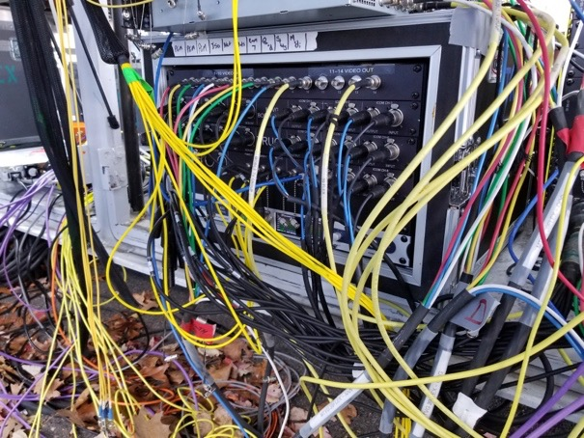
Additionally, Wehner appreciates the interfaces’ redundancy capabilities — a must he said for this type of broadcasting.

“What we really found interesting with the Dante unit is that we can run Dante and MADI at the same time, and if one fails it will automatically change to the other one,” Wehner said. “Redundancy is a big thing with us in broadcasting with these trucks, so that was a huge plus and it’s not available in any other product that I’m aware of. Plus, there are dual-power supplies in them. Everything can be run from the front panel and that was a huge plus for us without having to get a computer out and change settings.”

For more information about the A32 Dante, visit ferrofish.com.
For more information about Mobile TV Group, visit mobiletvgroup.com.

About Ferrofish
Known for its precision-engineered German technology, Ferrofish manufacturers high quality, innovative advanced audio applications. From its class-leading A16 MK-II and A32 AD/DA converters to its Verto Series of intuitive Dante converters, Ferrofish is known for its premium conversion solutions that are ideal for a wide range of applications. For additional information, visit the company online at http://www.ferrofish.com.

Media Contacts:
Jeff Touzeau
Public Relations
Hummingbird Media
+1 (914) 602 2913
jeff@hummingbirdmedia.com

Katie Kailus
Public Relations
Hummingbird Media
+1 (630) 319-5226
katie@hummingbirdmedia.com

