Xytech Showcases New Mobile UI, REST APIs for MediaPulse During NAB Show New York 2018

The company’s new UI enhances the user experience of its leading facility management software MediaPulse

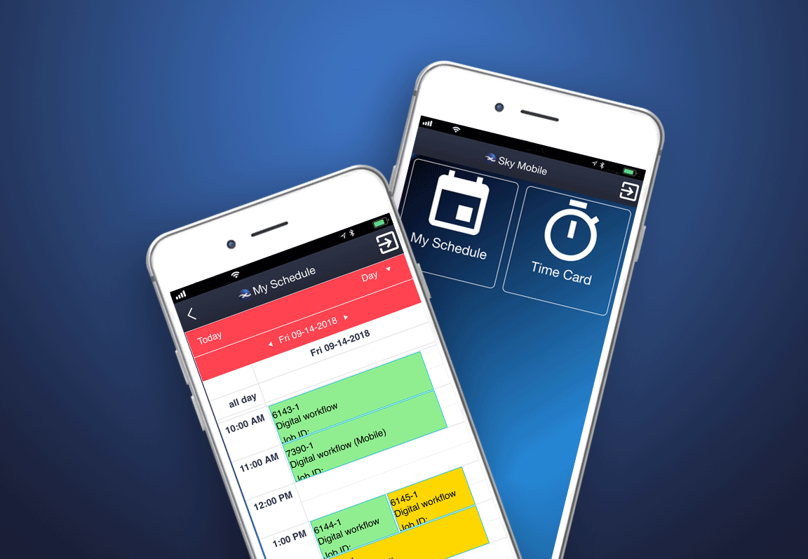
New York, October 15, 2018 — Xytech, the leader in facility management software for the broadcast, studio, media services and video transmission industries, will showcase its new, completely configurable mobile interface for its MediaPulse facility management software system at booth N721 during the NAB Show New York 2018 from October 17-18. This new UI increases flexibility and scalability by extending MediaPulse to all members of a company’s team. MediaPulse Mobile supports all devices with a responsive design.

Thanks to the new UI for MediaPulse, operations staff, producers, facility managers, field crews and freelancers can now use MediaPulse in a screen designed and configured specifically for their needs. The new UI increases efficiency and consistency for the entire organization by delivering exactly what a user needs, when they need it. This streamlines workflows, speeds communication and reduces costly mistakes.

"Designed to provide a personalized interface for all team members, our new MediaPulse Mobile UI allows clients to implement their workflows throughout the entire staff base," explains Greg Dolan of Xytech. "This new Mobile UI is at the center of Xytech’s strategy to expand our technology from operational and financial users to all users in the enterprise. Having an easily adopted UI configured specifically for each end user is a vital step.”

REST APIs: Fast & Flexible Integration
Xytech will also highlight the latest release of the MediaPulse Development Platform. The platform provides simple, fast and flexible integrations with all systems through an API library now supporting REST calls. Triggered messaging, parameter-based alerts and automated report delivery are all included with this release.

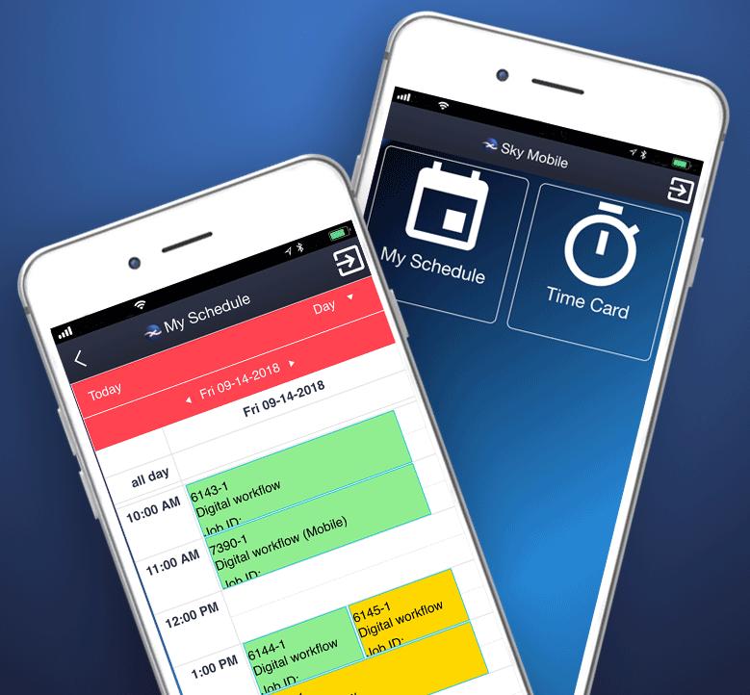
“For 30 years, Xytech’s mission is to adapt the best technology and make it work for our users. To remain essential, we must meet not just today’s challenges, but tomorrow’s as well,” continues Dolan. “While technology and the broadcast industry are moving quickly, these latest updates to MediaPulse further prove our commitment to innovation.”

Xytech will be exhibiting at the upcoming NAB Show New York 2018 from October 17-18, 2018. Located in booth N721, Xytech will demonstrate the new features of its leading facilities management software MediaPulse, along with its latest subscription-based software Dash. Those interested in scheduling an appointment may contact Alexandra Kuipers at akuipers@xytechsystems.com, + 1 (818) 698-4958.

About Xytech Systems: For 30 years, the world’s premiere media companies have depended on Xytech to run their businesses. MediaPulse is the only end-to-end solution for the complete content lifecycle. MediaPulse provides scheduling, automation, asset management, billing and cost recovery for broadcasters, media services companies and transmission facilities in a scalable platform-independent solution.

For more information, visit xytechsystems.com

Media Contacts:

Katie Kailus
Public Relations
Hummingbird Media
+1 (630) 319-5226
katie@hummingbirdmedia.com

Jeff Touzeau
Public Relations
Hummingbird Media
+1 (914) 602 2913
jeff@hummingbirdmedia.com

