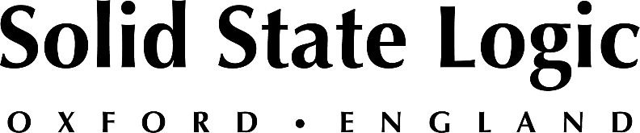

NAB 2022: Solid State System T Broadcast Platform — Breaking Down Barriers in Sports and Entertainment Programming

With powerful remote production features, built-in immersive audio capabilities and more,
no other audio production platform presents such a robust tool kit for professional broadcast

LAS VEGAS, April 13, 2022 — Solid State Logic [Las Vegas Convention Center, Booth C8008] presents its System T production platform at the 2022 NAB Show, scheduled to occur at the Las Vegas Convention Center between April 23 -27. System T — which the company will highlight in demonstrations throughout the show — promises to bring a new level of capabilities to both sports and entertainment production.

As the demands of quality broadcast production continues to evolve in the worlds of sports and entertainment programming, Solid State Logic's System T platform is able to serve live-to-air broadcasters, OTT/streaming services and media production houses alike with powerful, best-in-class capabilities that include sophisticated remote production and support for immersive and next generation audio (NGA) content — which is becoming increasingly common as broadcasters look to distribute higher-value content their audiences.

Solid State Logic's System T platform delivers the ultimate control and redundancy so production environments can operate flexibly, and according to their specific needs. With networked control surfaces, powerful software, intelligent I/O interfaces and sophisticated processing engines, System T can impart a distributed and decentralized workflow — increasing teams' ability to collaborate no matter where they are situated.

Seamless remote production
System T delivers a seamless, remote production experience for production teams:
- Console to console control over any network, including public internet with a VPN
- Virtualised control with SSL's T-SOLSA System T software on a COTS computer hardware or virtual machine
- All control positions utilise the same GUI design for a unified user experience

Immersive and NGA production
For immersive and NGA production, System T offers powerful, best-in-class capabilities such as:

- Native immersive / NGA bus formatting for efficient 3D panning
- Ability to output immersive mixes in parallel to stereo, surround and more
- A 360° transcoder enables user to connect spatial audio microphones — such as Sennheiser's AMBEO microphone — directly to the console
- New TE1 & TE2 engines offer scalable processing packs to accommodate the increase in DSP required for immersive

Interested attendees of the 2022 NAB Show can use SSL guest code LV8385 for free access prior to April 8th. To book an appointment, consultation, or demonstration on System T, please visit the SSL events page at: https://www.solidstatelogic.com/events/nab-show.

Solid State Logic is the world’s leading manufacturer of analogue and digital audio consoles and provider of creative tools for music, broadcast, live and post production professionals. For more information about our award-winning products, please visit: www.solidstatelogic.com.

###
For further information contact:
Jeff Touzeau
+1 (914) 602-2913
jeff@hummingbirdmedia.com

Ross Gilbert
+44 (0) 1865 842300
rossg@solidstatelogic.com

