Wijchen, November 2019

TELETRAILER LONGRUNNER
Nooteboom introduces the latest generation of lightweight extendible flatbed trailers at the Solutrans in Lyon
The TELETRAILER LONGRUNNER is the latest generation of lightweight extendible flatbed Nooteboom trailers with a net maximum payload of 42.5 ton at 80km/h.

The TELETRAILER LONGRUNNER is the latest generation of lightweight extendible flatbed Nooteboom trailers. Available with 2 or 3 hydraulically steered axles and with a single or double extendible load floor, extending up to a maximum length of 30m. The LONGRUNNER is particularly suitable for the transport of long self-supporting loads such as steel and concrete structures, but also for the transport of containers. The latest Nooteboom Longrunner contributes to maximum transport efficiency and minimum running costs. An extendible TELETRAILER LONGRUNNER with a dead weight of just 7,300 kg is now available. At the next Solutrans trade fair in Lyon, held from 19-23 November, this innovation is on display at the Nooteboom stand in Hall 5, stand T132.

Excellent manoeuvrability
The LONGRUNNER is as standard equipped with hydraulically steered axles, including manual steering and the ASA alignment system. Thanks to the large steering angle of more than 50 degrees, the LONGRUNNER offers more transport efficiency, less tyre wear and excellent manoeuvrability. The TELETRAILER LONGRUNNER is available with a choice of tyre sizes, including 245/70R17.5, 435/50R19.5, 275/70R22.5 and 385/65R22.5. The customer can choose to have their trailer equipped with SAF of BPW axles and with drum brakes or disc brakes.
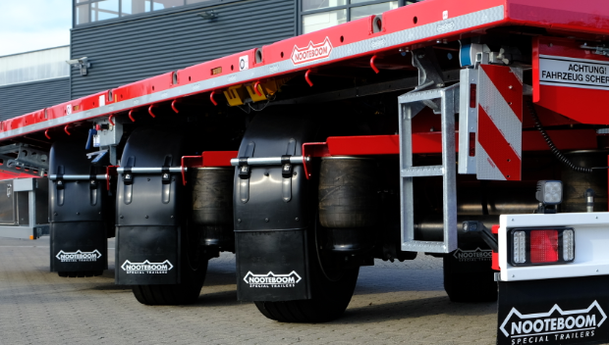
The LONGRUNNER, of which all axles are hydraulically steered, offers excellent manoeuvrability due to the large steering angle of more than 50 degrees.

Highest standard for latest head board
For the LONGRUNNER Nooteboom has developed a completely new TUV-certified head board. There are 9 versions available in different heights, completely closed or with an open frame at the top. These headboards meet the highest standard in the market (NEN-EN 12642 code XL) and are strong enough to stop at least 50% of the load capacity, up to a maximum of 25 tonnes against the head board. Safety first!

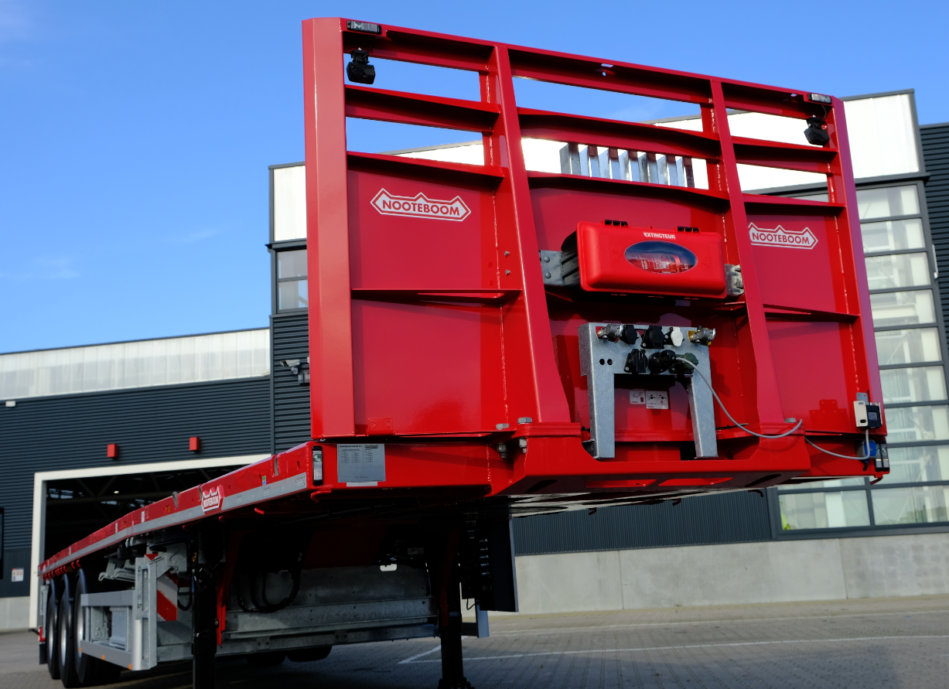
The latest Nooteboom TÜV-certified meet the highest standard in the market (NEN-EN 12642 code XL).
Easy to operate
Nooteboom trailers are internationally renowned for their easy and intuitive operation. This definitely applies to the LONGRUNNER too, which is equipped as standard with electronic air suspension and a manual control. A Wabco lift axle control or Wabco smartboard are available as option. With the smartboard various functions can be controlled, such as raise/lower, axle loads readings, setting 2nd ride height, odometer and operating a lift axle.

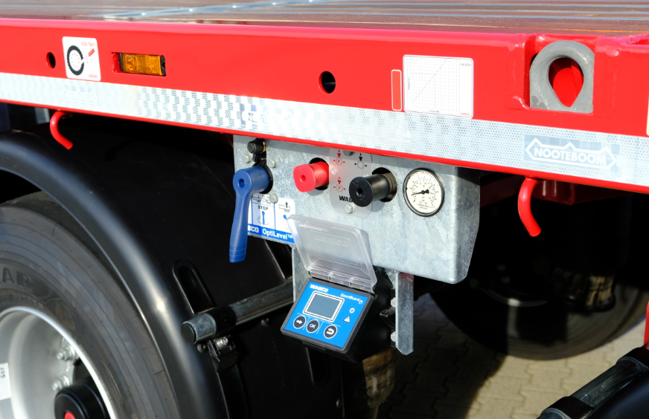
With the smartboard various functions can be controlled, such as raise/lower, axle load readings, setting 2nd ride height, odometer and operating a lift axle.

Materials storage
For the safe and convenient storage of e.g. wheel chocks and loose materials, Nooteboom provides various storage options such as open storage boxes and lockable stainless steel tool boxes. These are mounted underneath the load floor as a substructure. This substructure is available in different sizes, depending on the trailer type and chosen load floor length. Within the dimensions that the customer has opted for he can choose himself where the open storage box, toolbox and/or spare wheel are positioned. For the storage of stakes the Longrunner can be fitted with a detachable galvanised stake storage unit behind the head board. A maximum of 26 stakes can be stored here in vertical position. Alternatively a stake storage unit can be mounted underneath the load floor on the left and right-hand side.

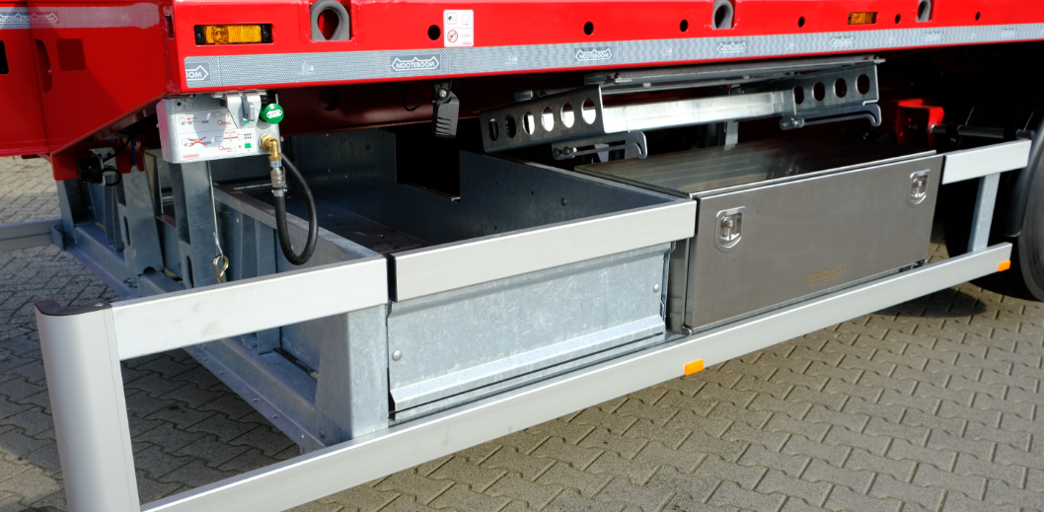
Depending on the trailer type and chosen load floor length, the substructure is available in various sizes and versions.
Road safety
The LONGRUNNER is equipped with LED side-marker lights in the side rave as standard and they can be fitted on the extensions as option. The rear side-marker lights operate synchronously with the flashing of the direction indicators and contribute to increased road safety. Here Nooteboom is anticipating future regulations regarding side-marker lights.

Advantages TELETRAILER LONGRUNNER
- Single and double extendible (max. 30m)
- TUV certified head board in 14 versions
- Electronic air suspension with smartboard control
- Excellent manoeuvrability due to hydraulic turntable steering
- All axles are hydraulically steered including manual steering
- Lightweight chassis due to the use of high-grade steel
- Very low load floor height from 1.145 mm
- Standard equipped with 10t axles
- Fifth wheel load 19t or 23t
- Available with many different tyre types
- Dead weight from 7.300kg
- High payload up to 42.5t at 80km/h

+++++

Note to the editor (not for publication):
Digital photographs in high resolution are attached and free for publication.

