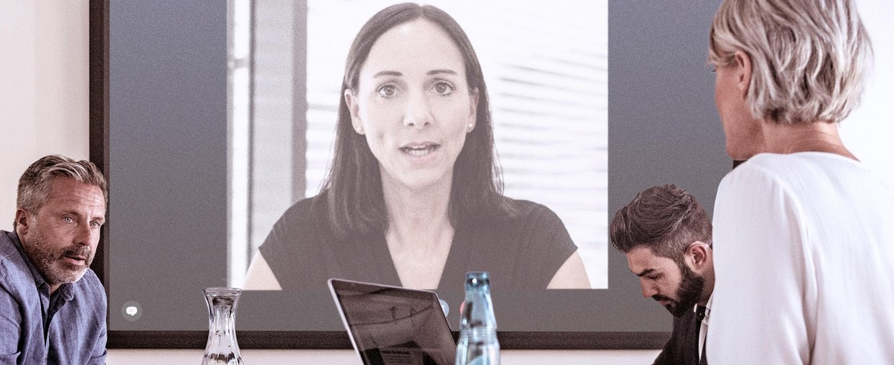Meetings and learning in a world with Covid-19
Sennheiser Essential Guide to Virtual Meetings and Distance Learning

Wedemark, September 17, 2020 – A world in transition: Businesses and higher education institutions worldwide currently find themselves walking a unique tightrope. While the Covid-19 pandemic rages in some regions and has calmed down in others, everywhere organisations of this sort are seeking to resume some form of ‘business as usual’. Even when aiming for partial or phased re-openings, companies and education institutions still need to respect both the relevant pandemic regulations and the health concerns of their employees, customers, students and lecturers. To provide guidance on addressing this challenge, Sennheiser and Audinate have issued an Essential Guide, which can be downloaded free of charge at http://go.audinate.com/resources/assets/sennheiser-distance-learning-covid-wp-f.

The Guide takes a look at the situation in companies and in education institutions around the globe and explores the possibilities that blended learning and remote conferencing offer for bonding with fellow students or business partners and customers in times of social distancing. It discusses both the technical prerequisites and the equally important ‘human factor’, explaining what is required to dispel feelings of separation and loss of connection: How can a blended lecture become as energetic for remote students as for the ones present in the classroom? How can business partners exchange in an authentic way when travelling is not possible?

“Covid-19 has seismically impacted people’s personal, professional and academic lives,” explained Ron Holtdjik, Director Business Communication at Sennheiser. “Sennheiser’s touchless, Dante-enabled audio solutions such as the TeamConnect Ceiling 2 microphone can bring teams and classrooms together emotionally despite social distancing, bridging the gap between on-site and remote while meeting both operational and hygienic needs.”

http://go.audinate.com/resources/assets/sennheiser-distance-learning-covid-wp-f

About Sennheiser
Founded in 1945, Sennheiser is celebrating its 75th anniversary this year. Shaping the future of audio and creating unique sound experiences for customers – this aim unites Sennheiser employees and partners worldwide. The independent family company, which is managed in the third generation by Dr. Andreas Sennheiser and Daniel Sennheiser, is today one of the world’s leading manufacturers of headphones, loudspeakers, microphones and wireless transmission systems. In 2019, the Sennheiser Group generated turnover totaling €756.7 million.
www.sennheiser.com

Global Press Contact

Stephanie Schmidt
Stephanie.schmidt@sennheiser.com
+49 (5130) 600 – 1275

