CEDIA 2022: DALI Introduces PHANTOM K-60 LP and PHANTOM M-675 Custom Installation Speakers

Designed and engineered by DALI in Denmark, new CI solutions allow for seamless integration in both new and existing installations, while providing superior sound quality

Dallas, TX, September 20, 2022— Lenbrook Americas [booth 19048] announces that the latest additions in the DALI PHANTOM Series will be on display at CEDIA 2022. The new PHANTOM K-60 LP and PHANTOM M-675 represent an expansion of the comprehensive range of DALI CI loudspeakers, providing both high-quality sound performance and ease of installation. Both loudspeaker systems are designed and engineered by DALI in Denmark.

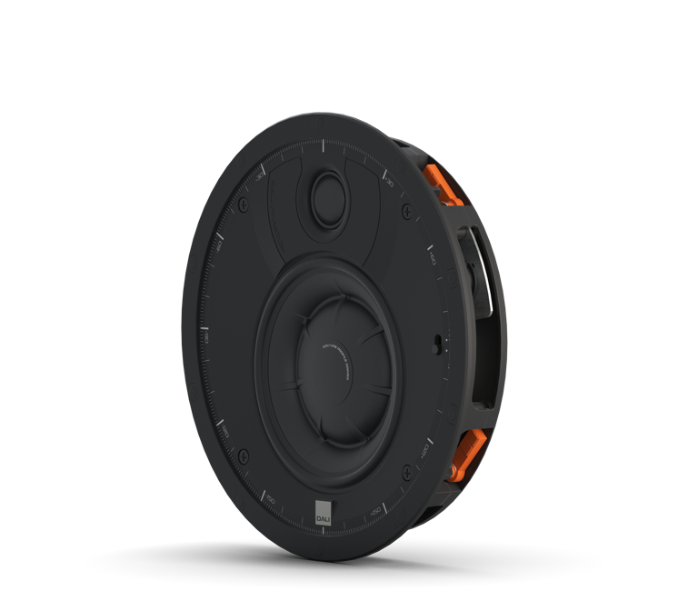

Your Problem Solver: The DALI PHANTOM K60-LP
The DALI PHANTOM K60-LP is an in-ceiling CI speaker that combines class-leading acoustic performance with extreme low profile dimensions. Its shallow form factor makes it a fantastic ‘problem solver’ for a myriad of installation challenges where more conventional installation speakers are sometimes limited. Despite a depth of only 36.5 mm, the sound of the PHANTOM K-60 LP belies its size, offering an impressive acoustic performance — particularly considering its dynamic range and bass response. Sonically, it expresses all the qualities that are to be expected from a DALI speaker — it might just be the best sounding ultra-shallow CI speaker on the market.

The PHANTOM K-60 LP was specifically designed to help installers overcome challenging spaces. Its low-profile form factor and the shallow, innovative design of the K-60 LP can help navigate hurdles that can be caused by pipes, wires, HVAC, vapor barriers or physically shallow ceiling or wall depths. The DALI PHANTOM K-60 LP is priced at $599 each and will be available in October.

Innovative driver design and architecture
The K-60 LP features a newly designed bass/midrange driver derived from the award-winning DALI KATCH G2 wireless Bluetooth speaker. This innovative driver and diaphragm design significantly reduces the speaker's overall depth — without compromising structural rigidity, performance or diaphragm displacement. This new driver architecture makes it possible for the K-60 LP to be extraordinarily slim, while retaining the superior sound quality that DALI is known for — making it the best sounding low profile CI speaker on the market.

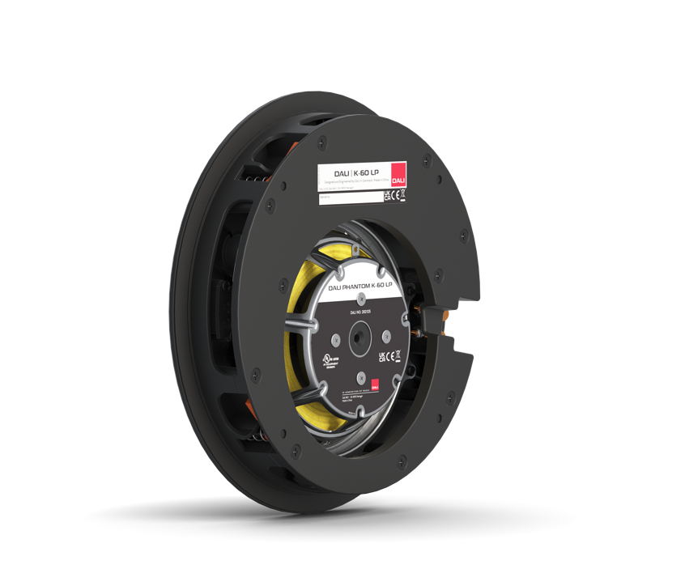

One highly visible and key attribute to the K-60 LP’s performance is the complex 3D form of its pressed and anodized aluminum diaphragm. The selection of this material was necessary in to achieve the necessary rigidity for its low profile driver architecture, which also incorporates seven localized stiffening ribs. These not only provide further rigidity but also provide a channel for the voice-coil lead-out wires, allowing for increased excursion. As a direct result of its
complex geometry, the bass/midrange diaphragm maintains pistonic motion, helping it to perform more efficiently than any other low-profile design on the market.

Your multi-channel solution: The DALI PHANTOM M-675
Meanwhile, the latest multi-channel CI loudspeaker solution from DALI is the PHANTOM M-675. As part of the M-Series, the M-675 is designed to impart spacious, involving sound — whether the listener is listening actively or passively. Like its sibling the M-375, the M-675 utilizes DALI’s unique hybrid soft dome and ribbon tweeter. Also, similar to the M-250 and M-375, the M-675 is developed with multichannel applications in mind and can be mounted in either portrait or landscape orientation and equally suited to front, center or surround channel roles. This makes it extremely flexible in almost any multi-channel listening scenario.

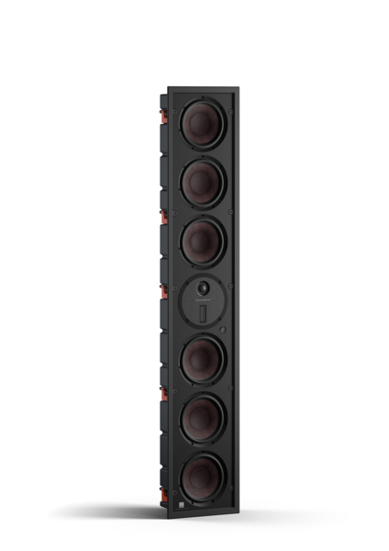

The PHANTOM M-675 features dual 7-inch drivers combined with four 7 inch passive radiators, and the bass/midrange drivers on the M-675 employ a voice-coil made of pure copper. This helps provide a better low-frequency response and higher power handling. The M-675 — as well as all the M-Series speaker models — also incorporate DALI’s patented SMC technology, which minimizes hysteresis and distortion in their magnet systems, while making them operate more efficiently. The DALI PHANTOM M-675 is priced at $2,999 each and will also be available in October.

About DALI
DALI, (Danish Audiophile Loudspeaker Industries), was established in 1983, and grew out of Scandinavia’s leading audio retail chain. Now distributed in 65 countries, and with more than 35 years of experience and global recognition, DALI holds unwavering dedication to sound that has advanced the state of the art, inspiring music and cinema lovers and challenging the competition to catch up. DALI is driven by raw passion for music and an honest reproduction in the domestic environment. Continuous development and refinement of new technologies remains core to DALI’s quest to create the best loudspeakers in the world. For more information, visit DALI-SPEAKERS.com

About Lenbrook
The Lenbrook Group of Companies is a privately held Canadian corporation who are the owners of NAD Electronics, PSB Speakers, Bluesound and Bluesound Professional. Formed in 1978, Lenbrook initially was a national distributor of electronics and communications products in Canada and has grown to become a leading global supplier to over 80 countries around the world.

Lenbrook Americas, a wholly owned subsidiary of Lenbrook International, is responsible for the sales and marketing of NAD Electronics, PSB Speakers, Bluesound and DALI in both the U.S. and Canada. Additionally, it also distributes Tivoli Audio and Master & Dynamic in Canada.

Corporate & Media Contact
Nadia Lildhar
Marketing, Lenbrook International
media@lenbrookamericas.com
PR Contacts
Jeffrey Touzeau
OLEX Communications
jeff@olexcommunications.us
Shelby Coppola
OLEX Communications
shelby@olexcommunications.us

Links:
DALI Website: http://www.dali-speakers.com
DALI Image Library: https://brandfolder.com/dali/press
Lenbrook Americas Website: http://lenbrookamericas.com

