Solutions for Life’s Situations
Sennheiser fills the gaps for both consumers and Hearing Care Professionals with two purpose-built devices that solve the everyday challenge of keeping up with dialogue.
Stäfa, Switzerland June 14, 2023 – New situational hearing products from audio specialist Sennheiser go big on features that enhance listening in the real world. The new TVS 200 and ConC 400 deliver crystal-clear speech in a true wireless form factor, fusing sleek designs with exceptional technology.
Practically everyone has an acquaintance who struggles to follow conversations in noisy environments or TV programs. Similarly, Hearing Care Professionals (HCPs) cater to significantly larger numbers of individuals with these difficulties every day. Many consumers are self-aware of their need to augment speech but struggle to find technology that is as simple to use as a pair of reading glasses. In response, the audio experts at Sennheiser are introducing HCPs to a duo of solutions designed to slot in between the ease of personal sound amplification devices and the power of custom-fitting prescription hearing aids.

For shared television watching spaces like family rooms and bedrooms, the Sennheiser TVS 200 personalizes listening levels with advanced speech clarity to boost the dialogue normally buried in news programs, sports, and movies. Its true wireless design brings a cable-free fit for extended listening without feeling bulky or cumbersome. It comes with a compact “set and forget” transmitter for effortless connection to virtually any TV, while also offering the convenience of connecting to tablets and smartphones using Bluetooth®. TVS 200 lets wearers maintain ambient awareness, link multiple earbud sets to one transmitter, and can even charge the earbuds wirelessly for up to 15 hours of continuous listening per charge. The earbud charging dock doubles as a compact carrying case that stores an extra 1.5 charges for use on the go. A companion app offers further customization and visual feedback from an Android smartphone, iPhone, or tablet.

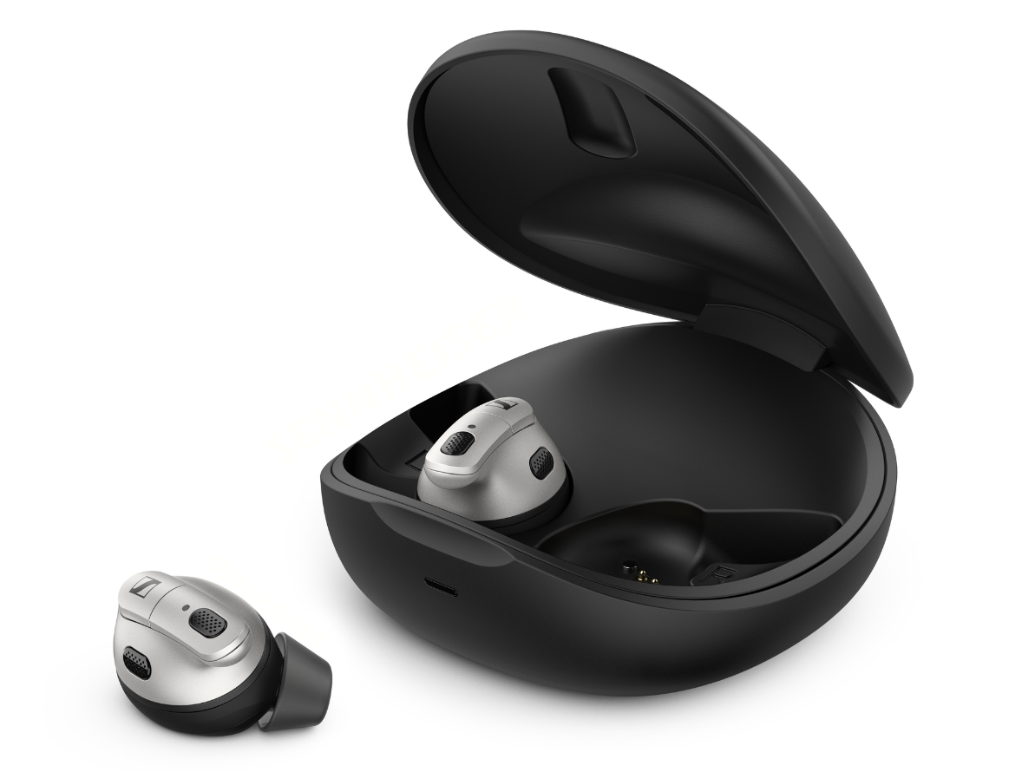

In scenarios with constant din such as restaurants and public transportation, ConC 400 is designed to block distractions while enhancing speech amidst heavy background noise. Specialty beam-forming microphone arrays on each earbud are used to analyze the environment's noise level while automatically optimizing speech intelligibility of the person talking to the ConC 400 wearer. Bluetooth connectivity with multipoint lets wearers focus on the most important conversations, seamlessly switching between in-person chats and smartphone calls or streaming media. It also features Active Noise Cancellation with an Ambient Awareness mode for staying in touch with the world around you. With nine hours of use per charge and a carrying case that stores another 27 hours of usage time, it’s a great companion for all social situations.
Clara Beck, Director of the Consumer Hearing Business Category for Sennheiser added “Our research shows that consumers have common hearing challenges yet require individualized solutions. Sennheiser’s newest situational hearing devices fill in the gaps that exist between average hearing and a hearing aid, leveraging technology and smartphone access to tailor each to personal preferences. By offering Hearing Care Professionals devices from the brand synonymous with sound, their customers can feel confident that the technology inside will be there for them day in and out.”
Availability
TVS 200 will be available starting June 15th, with ConC 400 available starting from the end of June onward, from select Hearing Care Professionals. For more information about Sennheiser Hearing solutions, visit sennheiser-hearing.com/
About the Sennheiser brand
We live and breathe audio. We are driven by the passion to create audio solutions that make a difference. Building the future of audio and bringing remarkable sound experiences to our customers – this is what the Sennheiser brand has represented for more than 75 years. While professional audio solutions such as microphones, meeting solutions, streaming technologies and monitoring systems are part of the business of Sennheiser electronic GmbH & Co. KG, the business with consumer devices such as headphones, soundbars and speech-enhanced hearables is operated by Sonova Holding AG under the license of Sennheiser.

www.sennheiser.com
www.sennheiser-hearing.com

About Sonova Consumer Hearing
Sonova Consumer Hearing offers premium headphones and hearables – primarily in the true wireless segment – as well as audiophile headphones, enhanced hearing solutions and soundbars under the Sennheiser brand. The business is part of The Sonova Group, a global leader in innovative hearing care solutions with headquarters in Switzerland and 17,000 employees worldwide.

Press contact
Sonova Consumer Hearing GmbH
Paul Hughes
Head of PR and Influencers, Sennheiser Headphone and Soundbars
T +49 (0) 162 2921 861
paul.hughes@sonova.com

