First Listen: Mancunian Songsmith Mark Loughman
Finds Droll Humor in New Single/Video 'My Misophonia'

Loughman whimsically recounts personal journey living with
oft-misunderstood medical condition, tortured by 'ordinary sounds'

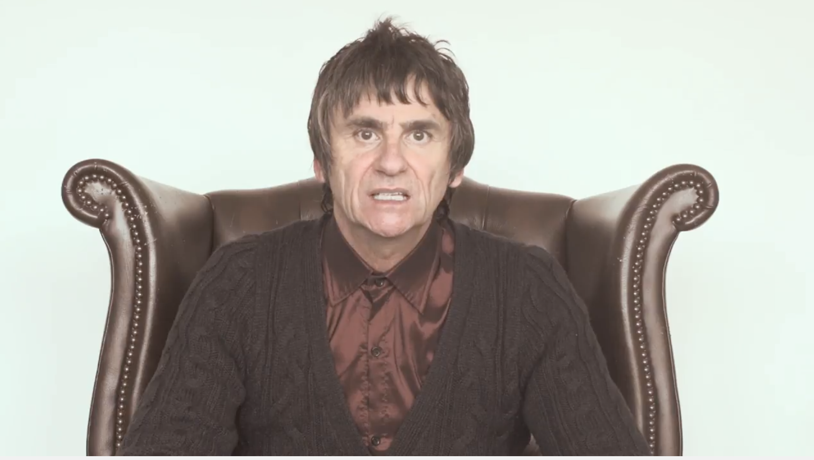
North Hollywood, Calif., September 5, 2017 — Knives on a plate. Open-mouthed chewing. A loud public cell-phone conversation. These seemingly innocuous sounds of everyday life have jolted Manchester, England-born singer-guitarist Mark Loughman like an electric shock. But when Loughman discovered his reactions were a dead-ringer for an obscure medical condition known as misophonia, he was both relieved and inspired. His latest riveting single, ‘My Misophonia’ — accompanied by a hilarious music video co-directed by Daniel Christiansen and edited by Loughman — Loughman finds wry humor in this chronic condition — educating the rest of us while attempting to navigate the often unbearable sounds of ordinary day-to-day life.

According to research by the medical publication Current Biology released in February, "misophonia is an affective sound-processing disorder characterized by the experience of strong negative emotions (anger and anxiety) in response to everyday sounds, such as those generated by other people eating, drinking, chewing, and breathing." Loughman's new single and video call attention to this rare medical condition on a hyper-personal level, while also exhibiting his skills as a talented songsmith and clever lyricist.
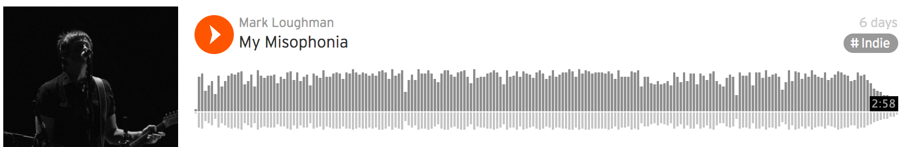
Transforming trauma into art
Loughman sings "My misophonia, well it seems to be going from bad to worse/It’s such a curse, it’s such a curse" at the song’s opening, in his trademark sardonic British snarl atop crunchy guitars and the pounding drums, courtesy of Los Angeles session mate and touring fixture Rodger Carter [Rick Springfield, Glen Campbell]. Seated in what could be a therapist’s chair in the video, Loughman reveals his deepest sonic demons, gazing plaintively into the camera as if searching for an answer to a misunderstood and almost alien medical condition.

Loughman first heard about misophonia when he saw a list of sounds commonly cited as highly irritating to those with misophonia, referred to as 'triggers.' “100% of the triggers they listed were sounds I have a strong response to, so I started doing more research,” he says. While many people may find some of these sounds irritating, the visceral reaction people like Loughman experience to the sounds makes even quotidian situations trying or almost unmanageable.

“I had five siblings growing up, and whenever one of them would make a coughing or sniffling noise I would recoil visibly,” Loughman says. “They’d always wondered what was wrong with me. For most of my life I just had this idea that I was over-sensitive or neurotic, and other people would think I was just looking for excuses to get upset.” Little did he know that he was in good company of other artists sufferering from this condition,
ranging from Kelly Osborne to Franz Kafka and Marcel Proust — who famously covered his bedroom walls in cork to shield him from unwanted noise.

In the first verse, Loughman sings: 'I can’t go to the cinema,‘cause people there like to chew/they sip soda, too, that’s what they do.' Indeed, visiting the movie theater is off limits for Loughman and his wife, who is also coping with his condition by extension. “She has the patience of an angel,” he says, recalling her years of empathetic accommodation to his sensitivities. “She has always been aware that I am very sensitive to certain noises. If she wants to see movies she has to go with her friends, because I can’t handle it.”

Part of the struggle is the fear of what others might think of their reactions to trigger sounds: 'Because it ain’t visible, people write you off as weird/That’s what we feared, that’s what we feared," he sings, referencing the adverse social interactions that can result with people who aren't familiar with his condition. Even when close partners know about the condition, it can exact a toll. “It is often hard on people around you, especially romantic partners,” Loughman says. “Relationships end sometimes over this condition.”

Self-discovery and recovery
Knowing that others share a similar response to these stimuli provides some comfort to Loughman: “Discovering that it was a recognized condition helped me feel that I’m not on my own, that a lot of people deal with this,” he says. He has even connected with communities online dedicated to people suffering from misophonia, where he finds welcome solidarity. “They share stories, triggers, and remedies to allow people to feel that they’re not alone.”

Loughman wants to tap into the power of solidarity with the video and song. In addition to empowering others with misophonia, he hopes his tune will help people around him empathize. “The song has really helped already,” he says. “I’ve had people who have known me for 20 or 30 years reach out and say, ‘Wow, Mark, I always just thought you were an oversensitive jerk!’ So with the song I can just turn it around and say, ‘look, here’s what I’m living with and I can manage it’.”

Encouraged by an active online community, Loughman hopes to continue issuing updates to the song referencing some of the other triggers that he was not able to squeeze into its first iteration. “A lot of the folks in the online support groups have given me some suggestions of different ones to try, so it would be great to have an opportunity to incorporate some of them,” Loughman says.

How is Loughman handling his condition these days? If the last few seconds of the song are any indication he’s managing it well. Loughman mixed the track himself, right up to the sounds of straw-sipping, lip-smacking, and other misophonia triggers that play at the song’s close. “That part was hell to mix,” he says. “But I thought it was important to end with a snapshot of how we experience those sounds!”

To hear ‘My Misophonia’ by Mark Loughman, please view the video on YouTube or visit soundcloud.com/mark-loughman/. For review copies, please contact Hummingbird Media.

Media Contact: |
Jeff Touzeau
Hummingbird Media, Inc.
+1 (914) 602-2913
jeff@hummingbirdmedia.com

