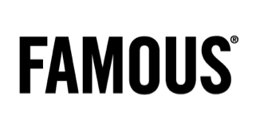
Credits
Famous
Client: Dirk Wouters – Erwin Van der Weerden – Sarah Van Loo
Agency: Famous
CD: Joeri Van Den Broeck , Tim Driesen & Christophe Ghewy
Account team: Mieke Van de Gehuchte – Marieke Michils - Naike Van Hulle
Creative Team: Paul Popelier, Iwein Vandevyver, Tom Jacobs, Gregory Verheyleweghen
Strategy: Luc Libens
Public Relations: Anne Cécile Collignon - Liesbeth Pyck
RTV Producer: Lander Engels – Charlotte Mathias

Brightfish
Concept Double Vision : Peter Forret
Commercieel team : Thierry Jourquin – Roel Vercammen
Marketing Director : Sylvia Van Cauteren

UM
Deputy General Manager: Nathalie l’Hoir
Media Planner: Stéphanie Depaepe, Christel Kerskens
Photography: Renzo de Ceuster
Production: Czar
Director: Koen Mortier
Producer: Eurydice Gysel
Postproducer: Birgit d'hondt
Editing: Manu Van Hove
Camera: Lieven Van Baelen

Online: Nozon
Studio son: Cobra

