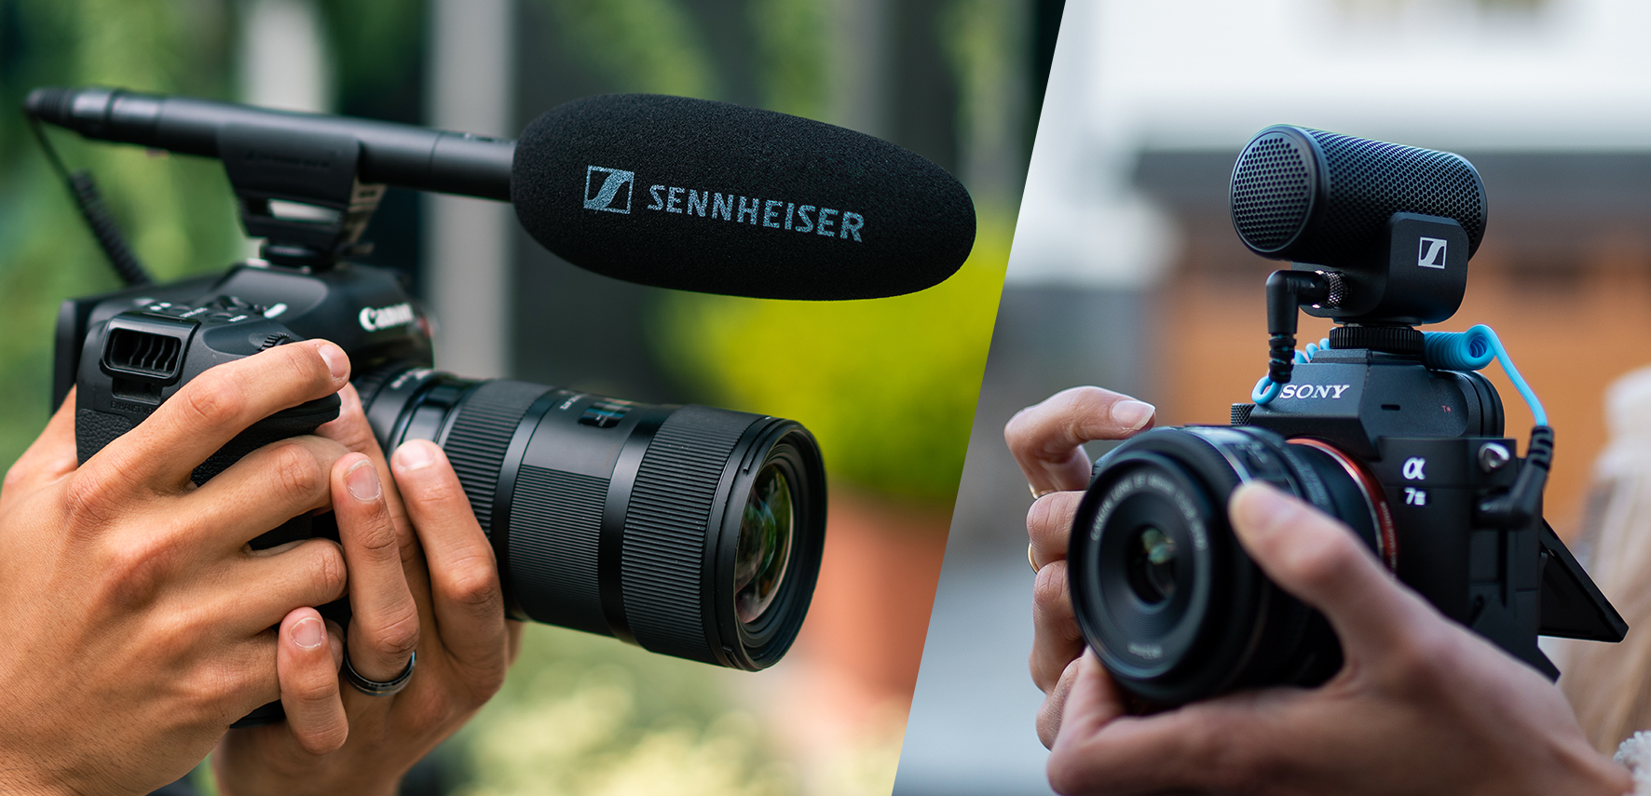Sennheiser A-Cam/B-Cam Promotion
Limited offer provides opportunity to get a free MKE 200

Wedemark, October 2022 – Sennheiser has a special opportunity for all video enthusiasts: At participating retailers (please see sennheiser.com/mke-promo for details), videographers who buy an MKE 600 shotgun mic will get the compact MKE 200 on-camera mic for free. Available throughout Europe, North America and at participating resellers around the world, the promotion is scheduled to run until the end of the year while stocks last.

“When upgrading the audio on your A-cam with an MKE 600 shotgun mic, Sennheiser and their partnering dealers will make sure that your B-cam does not get left behind but receives a shiny new MKE 200 mic for free,” says Robb Blumenreder, Customer & Market Insights Manager, Pro Audio. “We’re very excited about this special promotion, which gives content creators the chance to get two fantastic mics that will add exceptional audio to their videos.”

More about the MKE 600
The award-winning MKE 600 shotgun mic is widely considered to be one of the best mics for content creation. Its super-cardioid/lobar pick-up pattern ensures maximum possible attenuation of unwanted noise from the sides. It allows you to capture a speaker perfectly while keeping the mic out of shot. Wherever dialogue is critical, the MKE 600 is an ideal choice. It will give you excellent voice intelligibility even in acoustically unfavorable environments, coupled with a pleasantly full sound. The easy-to-use microphone has a switchable low-cut filter to reduce structure-borne noise and wind noise. It can be both phantom-powered or battery powered, with a low-batt indicator providing you the reliability you need in the field. Delivery includes a foam windshield, camera shock-mount, XLR3-to-TRS cable, AA battery and a pouch. Available separately are a blimp (fur windshield) and an XLR-3-to-TRRS cable.

The MKE 600 shotgun mic is a perfect tool for ambitious video challenges

More about the MKE 200
The MKE 200 is an award-winning microphone for use on camera or with a smartphone, where it will overcome the poor sound from built-in mics. As your take-anywhere audio upgrade, the MKE 200 is certain to transform your videos and captivate your audiences. To achieve the super-compact form factor, the microphone has built-in wind protection and integrated shock absorption. It’s easy to use and tough enough for your creative adventures. The MKE 200 comes complete with furry windshield, TRS cable for cameras and TRRS cable for smartphones, and a pouch.

The compact MKE 200 is the ideal audio upgrade for vloggers and content creators on the move | 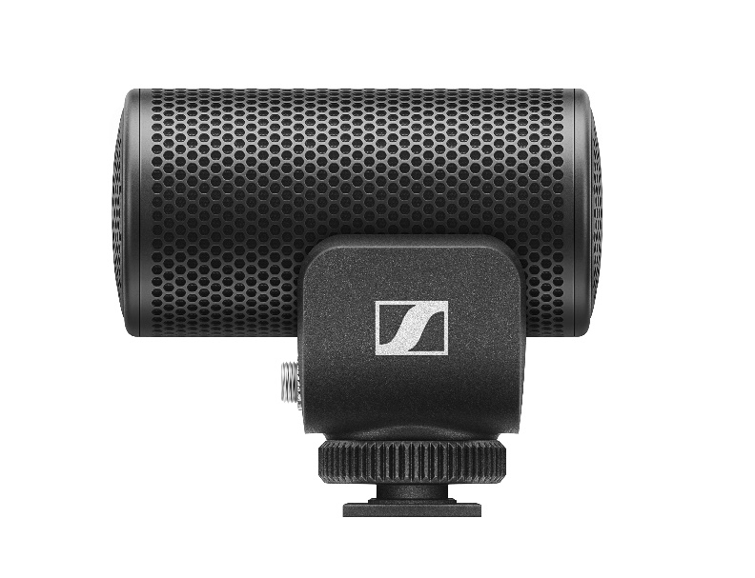

(Ends)

The high-resolution images accompanying this media release and some application shots can be downloaded here.

About the Sennheiser brand
We live and breathe audio. We are driven by the passion to create audio solutions that make a difference. Building the future of audio and bringing remarkable sound experiences to our customers – this is what the Sennheiser brand has represented for more than 75 years. While professional audio solutions such as microphones, meeting solutions, streaming technologies and monitoring systems are part of the business of Sennheiser electronic GmbH & Co. KG, the business with consumer devices such as headphones, soundbars and speech-enhanced hearables is operated by Sonova Holding AG under the license of Sennheiser.

www.sennheiser.com
www.sennheiser-hearing.com

Global Pro Audio Press Contact

Stephanie Schmidt
Stephanie.schmidt@sennheiser.com
+49 (5130) 600 – 1275

