For more information, please contact Marta de Paco
On +34 670 780 664 or email press@comunicahair.com

Important:
These images are only available for editorial content.
Credits must be included.
Notification of their publication is expected.

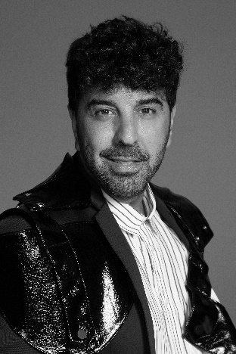
JOSE URRUTIA
CIRCLE Collection

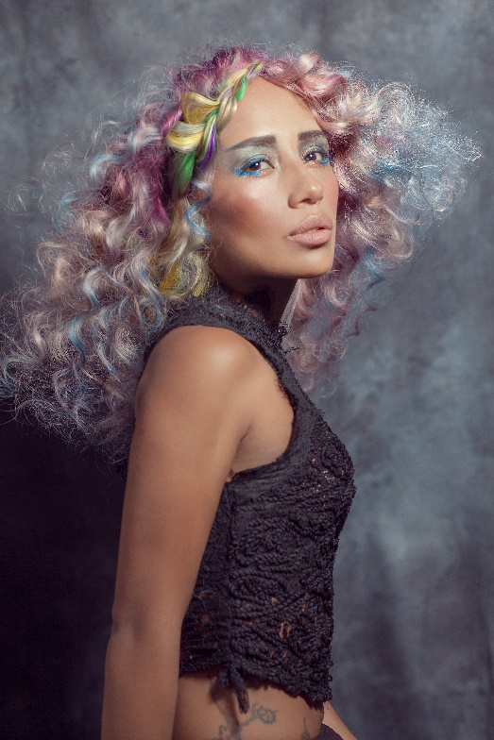
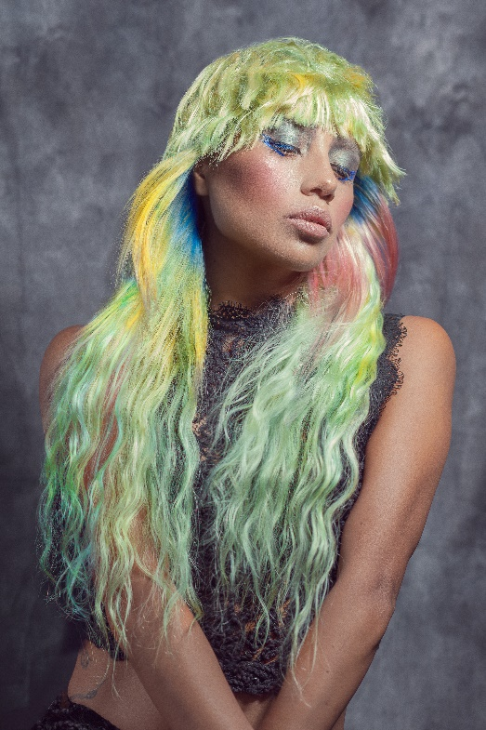
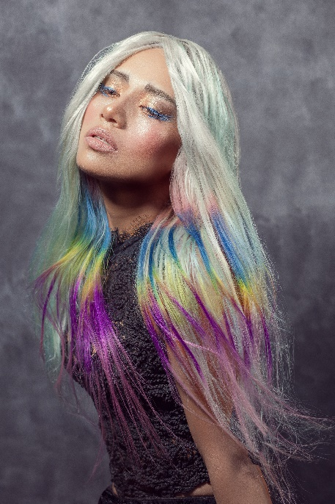
Hair: Jose Urrutia @Peluquería Jose Urrutia
Hair Instagram @pjurrutia
Hair assistant: Belén Naranjo, Karmen Ramírez, Alazne González
Assistant Instagram: @belhair_make_up, @argiakaian1983, @alaznegh
Photography: Jose Urrutia
Photography Instagram @pjurrutia
Retouching: Javier Villalabeitia
Retouching Instagram: @javiervillalabeitia
Make up: Peluquería Jose urrutia
Make up Instagram @pjurrutia
Styling: Veronica Calpa Perugachi
Styling Instagram @calpaperugachi
Products: Revlon Professional
Products Instagram @revlonprofessional_es

JOSE URRUTIA
CIRCLE Collection

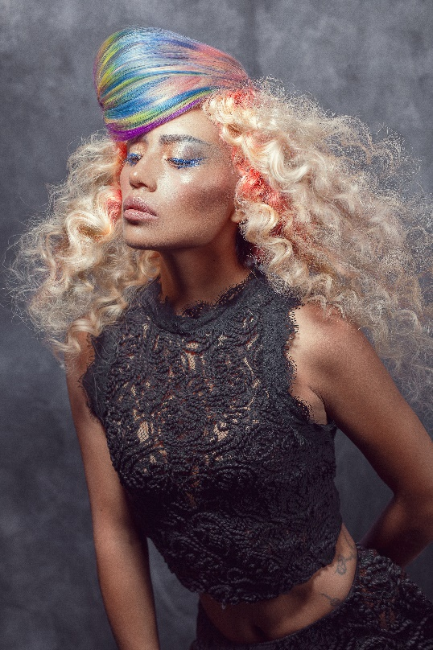

Circle is inspired by the gradient colors of nature, skies at sunset, waves crashing or the seaweed dancing in the sea.
The chromatic richness that surrounds us, with shades that intermingle in an unusual way, although tremendously beautiful and that create a fascination among those who observe it.

On hair, textures are combined with a strong preeminence of waves and curls that acquire even more strength with the application of the different tones. Hair simulates the softness with which algae sway with currents, the fluffiness of the most exotic bird feathers and the palette of colors that appears in the sky when the daylight fades.

