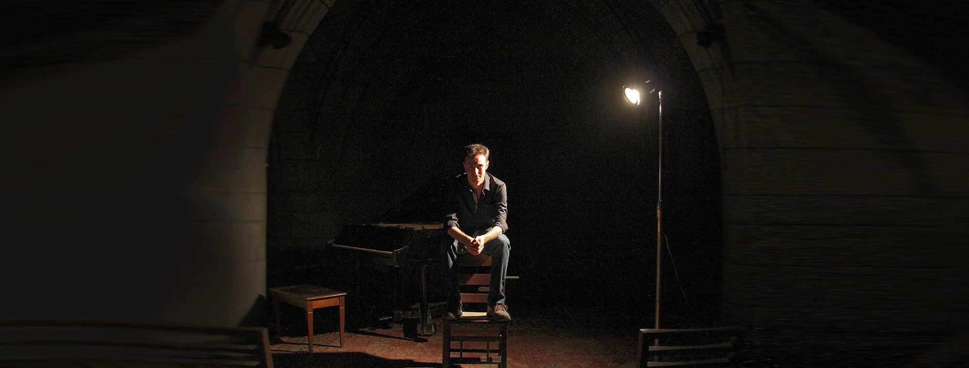

The Crypt Sessions celebrates Halloween with the World Premiere of Gregg Kallor’s dramatic cantata based on Edgar Allan Poe’s The Tell-Tale Heart, October 26 & 28, with mezzo-soprano Elizabeth Pojanowski and cellist Joshua Roman

A collaboration with On Site Opera, the performance will feature a semi-staging by Metropolitan Opera director Sarah Meyers
Kallor will also perform his cello sonata, Undercurrent, with Roman
Gregg Kallor will play Yamaha C7 piano, generously donated by Crypt Sessions sponsor Yamaha

Wednesday, September 21, 2016 — On October 26th and 28th, Unison Media’s performance series The Crypt Sessions will celebrate Halloween early with the world premiere of pianist/composer Gregg Kallor’s dramatic canata based on Edgar Allan Poe’s The Tell-Tale Heart, featuring mezzo-soprano Elizabeth Pojanowski, cellist Joshua Roman, and Kallor himself at the piano. Both concerts will be at 8PM, with a wine & cheese reception from 7-8PM. The piano is generously donated by Yamaha, the official sponsor of The Crypt Sessions.
A collaboration with On Site Opera, the The Tell-tale Heart will have a semi-staged setup by director Sarah Meyers, who has worked with the Metropolitan Opera as stage director for over a decade.
Gregg will also perform his appropriately-named cello sonata Undercurrent with Roman.
“At home in both jazz and classical forms, [Kallor] writes music of unaffected emotional directness.”
-New York Times
The concert is a part of Unison Media’s Crypt Sessions, a concert series in partnership with The Church of the Intercession and sponsored by Yamaha, which most recently featured twin sister piano duo Christina & Michelle Naughton performing Messiaen’s Visions of the Amen.
Tickets are $35 (including a pre-concert wine & cheese reception), with all proceeds going to the church.
Concert Information: http://deathofclassical.com/gregg-kallor/
Tickets: http://cryptsessions.eventbrite.com/
Crypt Sessions Homepage: www.DeathOfClassical.com

LISTING INFO:
The Crypt Sessions Presents: Gregg Kallor - The Tell-Tale Heart
with Elizabeth Pojanowski, mezzo-soprano, and Joshua Roman, cello
A collaboration with On Site Opera directed by Sarah Meyers
October 26th & 28th, 2016 | Wine & Cheese 7PM | Show 8PM
Tickets: $35, including wine & cheese (Direct Link)

CONCERT PROGRAM
Kallor: Undercurrent for cello and piano
Kallor: The Tell-Tale Heart for voice, piano and cello (world premiere)

ABOUT THE CRYPT SESSIONS:
Unison Media's acclaimed Crypt Sessions is a concert series presenting intimate performances in the underground crypt beneath The Church of the Intercession in Harlem. The series, which is sponsored by Yamaha, was launched in 2015 by pianist/composer Conrad Tao, and has featured tenor Lawrence Brownlee, pianist Alexandre Tharaud, the Attacca Quartet, piano duo Christina & Michelle Naughton and more. The series has been featured in The New York Times, The Wall Street Journal, The New Yorker, NPR, WQXR, The Christian Science Monitor, Agence France-Presse, and more.

ABOUT GREGG KALLOR:
Gregg Kallor is a composer and pianist whose music fuses the classical and jazz traditions he loves into a new, deeply personal language. The New York Times writes: “At home in both jazz and classical forms, [Kallor] writes music of unaffected emotional directness. Leavened with flashes of oddball humor, his works succeed in drawing in the listener – not as consumer or worshipful celebrant, but in a spirit of easygoing camaraderie.”
Kallor joined an all-star roster of musicians, including Joyce DiDonato, Anthony Dean Griffey, Isabel Leonard, Susanna Phillips, Yo-Yo Ma, Anthony McGill, actors Sharon Stone and Ansel Elgort, and many more, for An AIDS Quilt Songbook: Sing for Hope. Kallor recorded two songs for the album, with Melody Moore – “One Child,” which Kallor composed for this project – and Matthew Polezani. All profits from the sale of this album will go to amfAR, The Foundation for AIDS Research.

ABOUT UNISON MEDIA:
Unison Media is a classical music company committed to exploring new ways to present and promote music and those who create and perform it. Unison believes in a holistic approach – publicity, social media or marketing on their own no longer have an impact, and it’s only when they are combined in a cohesive, coordinated fashion that you start to get real results. Unison launched the Crypt Sessions in 2015 with the intention of reinvigorating the standard of what a classical music concert should be and to provide a niche venue in the heart of Harlem.

