Powersoft to demonstrate mezzo amplifier platform at cedia EXPO

MEZZO BRINGS UNPARALELLED power, efficiency to residential market

Florence, Italy 22 July 2019
Italian audio innovator Powersoft (CEDIA EXPO: Booth 335] will demonstrate its newest amplifier platform at CEDIA EXPO between 12 and 14 September. Mezzo is a highly reliable and flexible system from one of the leading innovators in amplifier technology – and an ideal fit for integrators working in the home and residential integration markets.

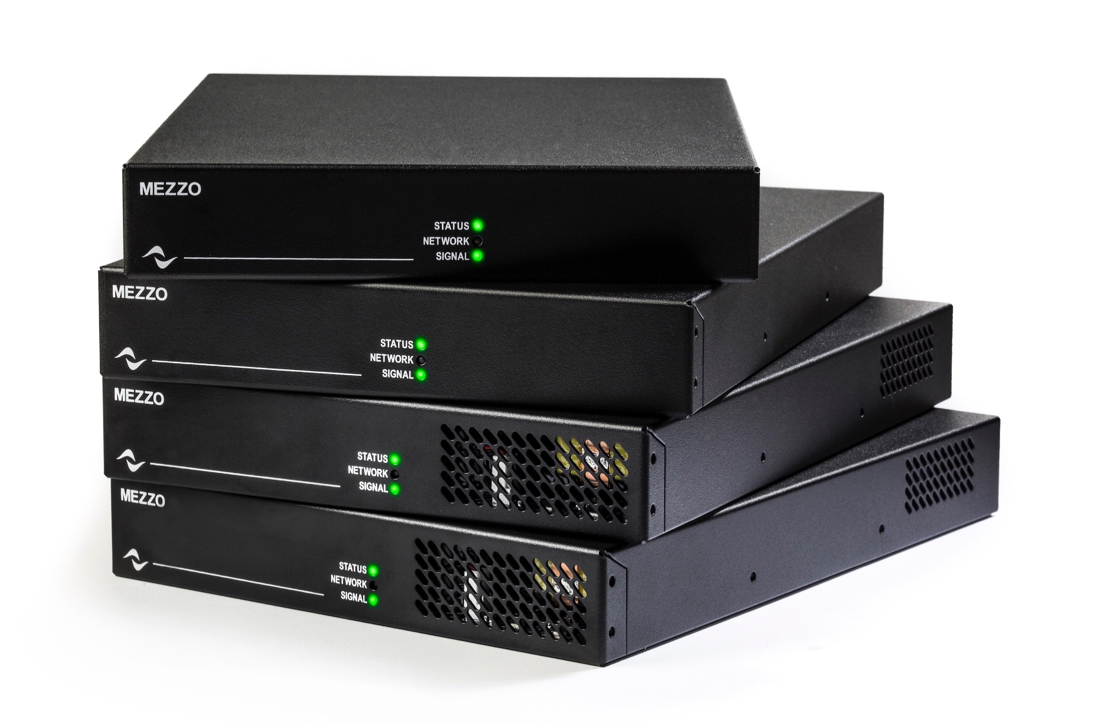
Built in a svelte, half-rack enclosure and sporting plenty of connectivity options, Mezzo is expressly designed for the AV/IT markets, and perfect for home and residential installations. The new line consists of eight amplifier models in all, each offering different power and connectivity options. While Mezzo is capable of delivering an unprecedented degree of power and flexibility in a highly compact design, it is self-configuring and simple to operate. Further, the system can be operated and monitored remotely, making it ideal for integrators seeking reduced installation times and more efficient deployment of A/V staff in the field.

“We are pleased to be introducing such a powerful and compact amplifier solution for the residential market,” commented Klas Dalbjorn, product manager, Powersoft. “Mezzo embraces all the heritage and innovation Powersoft is already known for, but in a form factor that is perfectly suited for fixed installations. Throughout our R&D phase, we listened to the very specific needs of home and residential integrators and we believe Mezzo coveres these needs, while bringing unmatched reliability and ROI.”

Mezzo: power to fit your needs
The eight available models in the new Mezzo line consist of four power sizes, each offering an option with ‘A’ (analog) or ‘AD’ (analog-digital), which adds Dante/AES67. The power sizes include smaller option of 320W in 4 x 80W and 2 x 160W variants, and a larger option of 600W in 4 x 150 or 2 x 300W. All of the eight models are networkable and feature automatic setup for audio parameters, significantly reducing deployment time during installation. Further, all of the units offer load monitoring, so users can monitor system parameters such as temperature, power usage and performance over time. These parameters can be monitored and controlled via Powersoft’s own ArmoníaPlus System Manager, or through an external control system or a plug-in in a DSP matrix platform.
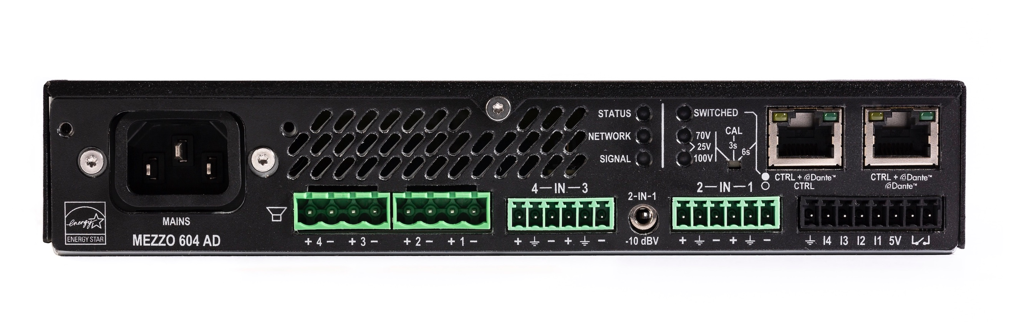

The AD models include Dante and AES67 integration, and also add an internal Gigabit Ethernet switch and a second port, meaning that multiple products can share the same network cable. This feature can convenient in a retrofit, or if the user needs to share a network connection between a projector and an amplifier for instance.

Perhaps most impressive is Mezzo’s overall flexibility and power sharing capabilities. The smaller 320W power sized models are able to deliver 80/160W per channel into 2, 4, 8 or 16 ohms as well as 100, 70 or 25V. Meantime, the larger 600W power sized models can deliver 4 x 150W or 2 x 300W, and can drive two 16 ohm as well as 25, 70 or 100V. While this is impressive in terms of flexibility, each channel has sufficient headroom for power sharing according to the specific installation needs. This means one model can drive zones of varying sizes, and design changes can be accommodated on the fly without having to alter equipment choice.

Flexible installation scenarios to suit your needs
Mezzo also features equally impressive installation options. Each unit comes with rack mount accessories to fit two units into a standard 19” rack, or 1 unit in a 11” compact rack. Alternatively, the unit can stand alone on rubber feet in a credenza or be mounted on the wall - behind a video screen, for instance. The unit is ultra-quiet and requires no ventilation and can therefore be used in dusty environments, under a desk or in locations where an audio closet may not available. Further, in terms of performance, Mezzo also delivers enough power to drive many subwoofers. This potentially means a significant space savings in locations that will no longer require 19” racks.

For more information and full specifications, please visit http://www.powersoft-audio.com/en/

For further information

Francesco Fanicchi  POWERSOFT FIRENZE  francesco.fanicchi@powersoft.com  +39 339 6381206 | Jeff Touzeau  HUMMINGBIRD MEDIA, INC.  jeff@hummingbirdmedia.com  +1 (914) 602-2013

ABOUT POWERSOFT:
Powersoft is the world leader in lightweight, high power, single rack space, energy efficient amplifiers for the professional audio market. Founded in Italy in 1995, headquartered in Florence, Italy, with offices in New Jersey, Powersoft couples the experience and precision of its production department with exceptional components to deliver products with perfect audio response and high-performance reliability. Its state-of-the-art amplifiers can be found in an array of markets, ranging from stadiums, sporting arenas, theme parks, performance venues and airports to convention centers, churches, and clubs, and are used by the world's leading tour sound companies. For more information, visit the Powersoft website: www.powersoft.com

