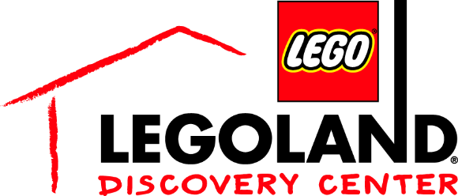
For More Information:
McKenzie Riley
BRAVE Public Relations
404.233.3993
mriley@bravepublicrelations.com
FOR IMMEDIATE RELEASE

The Ultimate LEGO® Ninjago Experience at LEGOLAND® Discovery Center to kickoff March 24
For a limited time, guests are invited to explore their inner ninja with the new LEGO Ninjago Training Camp and LEGO NINJAGO 4D Movie Short

ATLANTA (March 5, 2018) – LEGO® fans of all ages are invited to join their favorite ninjas – Lloyd, Jay, Kai, Cole, Zane and Nya – during The Ultimate LEGO® Ninjago Experience, featuring two new attractions at LEGOLAND® Discovery Center Atlanta. Guests will be able to experience The Ultimate LEGO® Ninjago Experience at a special event the weekends of March 24 and March 31.

Event weekend special programming:

Mystery mosaic build
Throughout event weekends

LEGO® Ninjago Training Camp Reaction Game Tournament
for a chance to win a LEGO® trophy and LEGO® Ninjago swag bag
Noon and 3 p.m.

LEGO® Ninjago Miniland takeover and scavenger hunt
Throughout event weekends
Little ones can compete to win an annual pass to LEGOLAND Discovery Center

Character Meet and Greets with Kai
11 p.m., 2 p.m. and 5 p.m.

LEGO® Ninjago giveaways
Throughout event weekends

An all-new LEGO® Ninjago 4D short movie is launching at LEGOLAND® Discovery Center Atlanta! In LEGO NINJAGO – Master of the 4th Dimension, the ninjas will show off their awesome LEGO® Ninjago moves in a super-cool and explosive 4D adventure. Enter the Dojo with Master Wu and train with the ninjas to learn the teachings of the Scroll of the 4th Dimension. Guests will experience the totally-awesome world of Ninjago as they’ve never seen, smelled or felt it before. LEGO Ninjago 4D premieres March 24. For more information, including ticket prices, visit bit.ly/LEGONINJAGO4D.

The LEGO® Ninjago Training Camp is making its return to LEGOLAND® Discovery Center Atlanta! Families can put their ninja skills to the test to see if they have what it takes to become a true LEGO ninja and defeat the bad guys in this fun, action-packed play-zone. Children can test their agility in the laser maze and master their building skills at the Ninjago build table to go on a LEGO adventure that’s bigger and better than they can do at home.

About the LEGO Group
The LEGO Group is a privately held, family-owned company with headquarters in Billund, Denmark, and main offices in Enfield, USA, London, UK, Shanghai, China, and Singapore. Founded in 1932 by Ole Kirk Kristiansen, and based on the iconic LEGO® brick, it is one of the world's leading manufacturers of play materials. Guided by the company spirit: "Only the best is good enough”, the company is committed to the development of children and aims to inspire and develop the builders of tomorrow through creative play and learning. LEGO products are sold worldwide and can be virtually explored at www.LEGO.com.
For more news from the LEGO Group, information about our financial performance and responsibility engagement, please visit www.LEGO.com/aboutus.

About Merlin Entertainments
MERLIN ENTERTAINMENTS plc is the leading name in location-based, family entertainment. Europe’s Number 1 and the world’s second-largest visitor attraction operator, Merlin now operates 111 attractions, 12 hotels/4 holiday villages in 23 countries and across 4 continents. The company aims to deliver memorable and rewarding experiences to its almost 63 million visitors worldwide, through its iconic global and local brands, and the commitment and passion of its managers and estimated 26,000 employees (peak season). Among Merlin’s attractions are - SEA LIFE, Madame Tussauds, LEGOLAND, DreamWorks Tours SHREK’s Adventure, The London Eye, Dungeons, Gardaland, LEGOLAND Discovery Centres, Alton Towers Resort, Warwick Castle, THORPE PARK Resort, Blackpool Tower, Heide Park Resort, Sydney Tower Eye and SKYWALK. All brands which are distinctive, challenging and innovative – and which have great potential for growth in the future. Visit www.merlinentertainments.biz for more information.

###

