MEDIA ALERT: Synthax Adds to Weekly Webinar Lineup with New Sessions on Audio Networking, Babyface Pro iOS Integration

The two new webinars will be added to the list of free weekly webinars announced last month
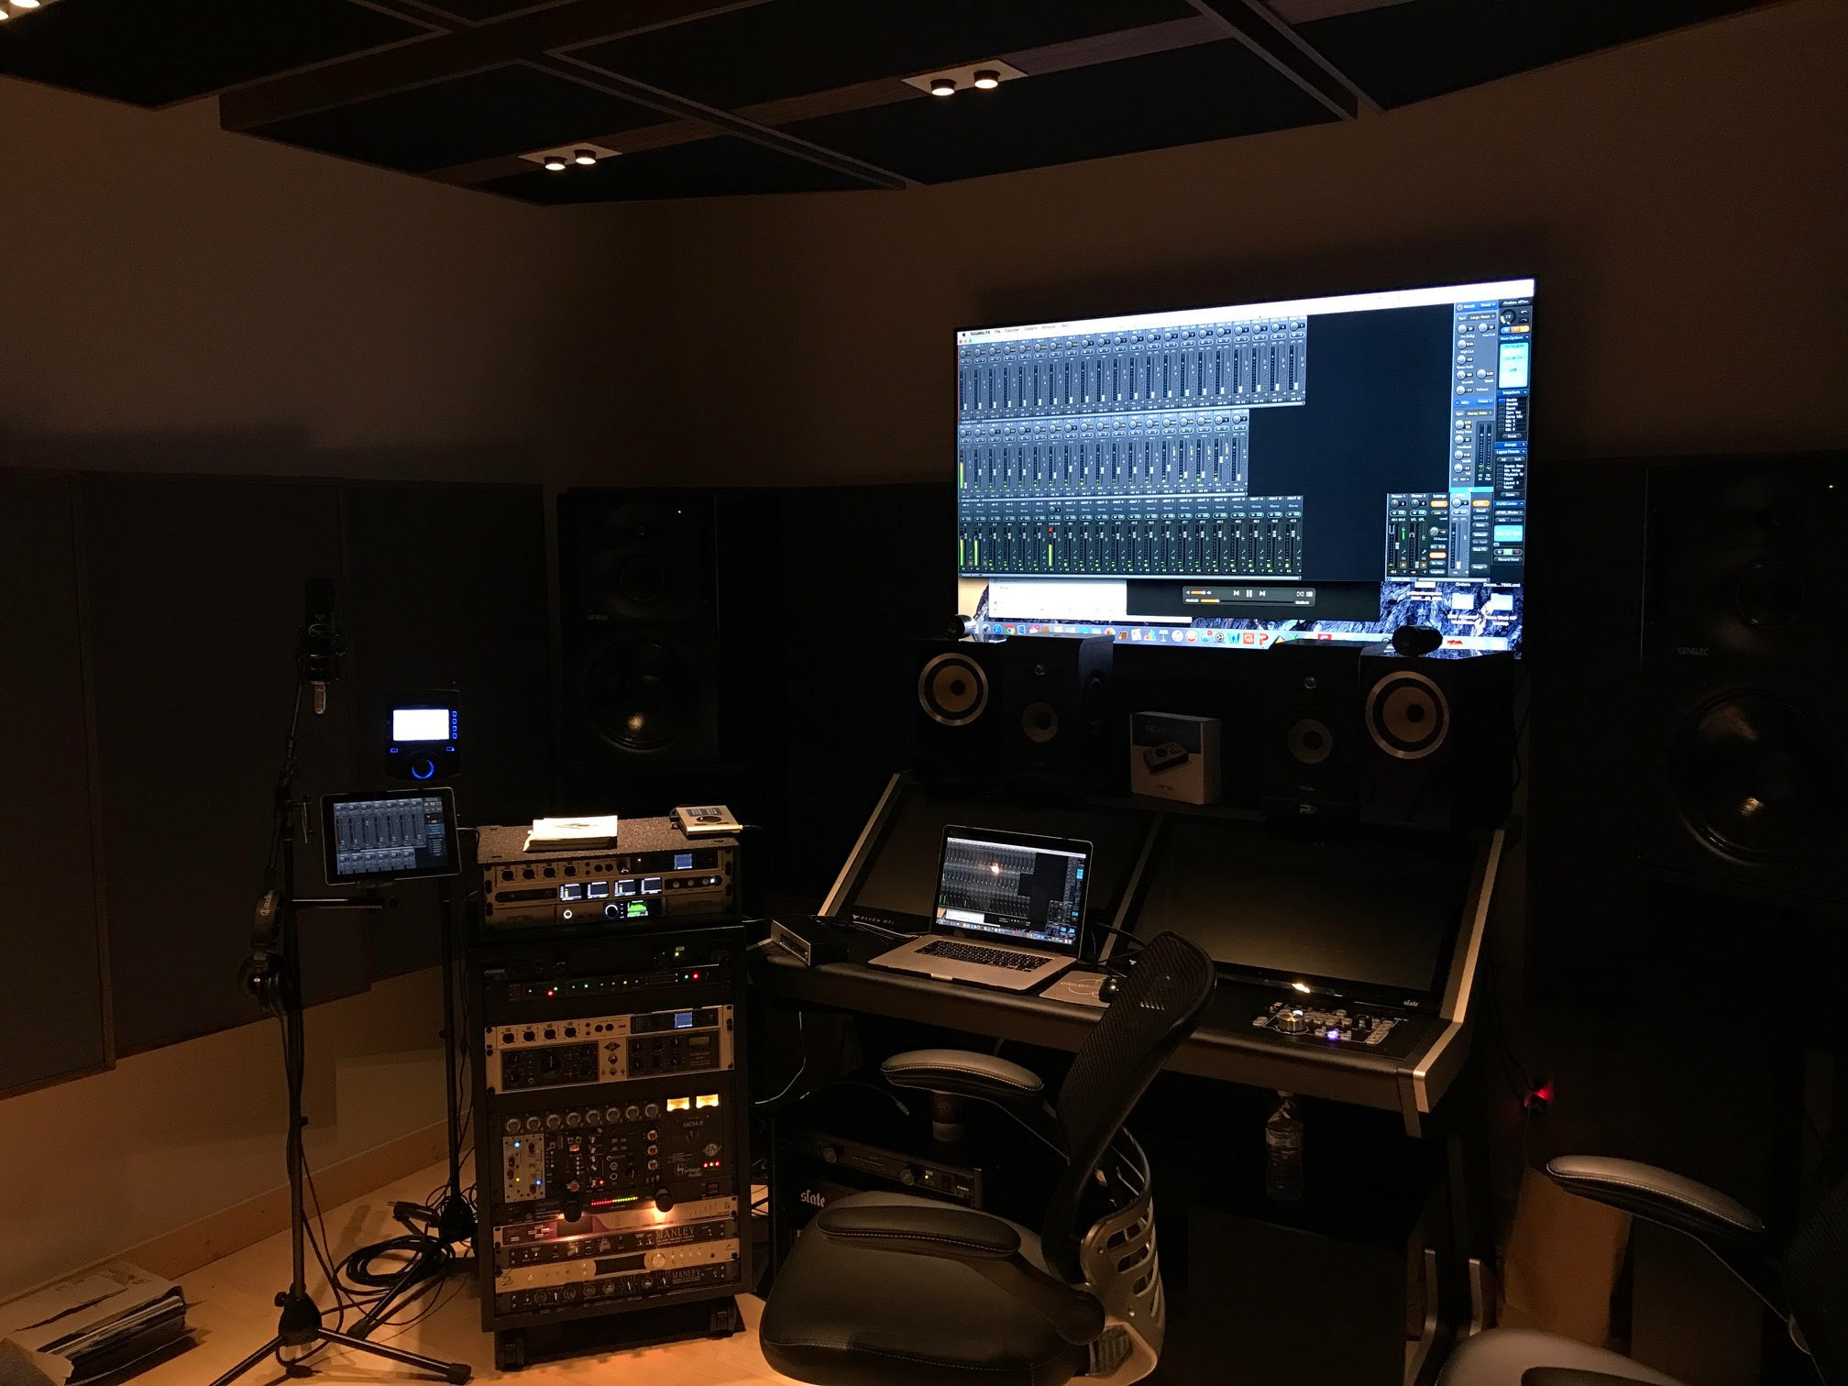
Fort Lauderdale, Florida, May XX, 2020 — During the disruptions in the market caused by Covid-19, Synthax — distributor of RME audio solutions, Ferrofish audio converters, Digigram broadcast and streaming solutions, Appsys digital audio tools, and myMix personal monitor and mixer — has been holding a series of free weekly webinars covering a variety of industry topics, from breaking down audio networking systems to the psycho-effects of IEM usage.
This week, Synthax has announced it will add two new webinars to its weekly lineup: “Audio Networking Mic Preamps & Converter Solutions” and “Using the Babyface Pro with iOS I iPad.” These new additions are in response to popular demand from dealers and customers.
Hosted by Synthax’s Director of Sales Derek Badala along with several of Synthax’s key technical experts, the new webinar “Using the Babyface Pro with iOS I iPad” will be held every Wednesday at 11am EST throughout the month of May, while “Audio Networking Mic Preamps & Converter Solutions” will be held every Thursday at 2pm EST through May.
The webinars are targeted to those who work in the live sound, broadcast and audio production markets. Those interested can register and find a full schedule with available times at: https://www.synthax.com/webinars/.
Attendees can receive (2) CTS RU credits during two of the webinars: the 11am EST “Reliable Audio Over Unreliable Networks” and 1pm EST “Unravelling Audio Networking: Dante, AVB & MADI” webinar which discusses the go-to networking systems and delves into the advantages each has to offer, while explaining how to best employ them in a user’s workflow.
To register for any of the free webinars, visit: https://www.synthax.com/webinars/
For more information on Synthax, visit: https://www.synthax.com/
About Synthax, Incorporated
Synthax Inc. is the exclusive USA distributor for RME digital audio solutions, Digigram broadcast audio systems, Appsys digital audio tools, Ferrofish advanced audio applications, myMix personal monitoring systems and ALVA cableware. We supply a nationwide network of dealers with these products for professional audio, broadcast, music industry, commercial audio, theater, military and government applications. For additional information, visit the company online at http://www.synthax.com.
About Digigram
For over 30 years, Digigram has developed innovative digital systems that make modern broadcasters rapidly evolving operations more efficient, more reliable and more effective. Used by thousands of journalists, broadcasters and industrial users all over the world, Digigram’s sound cards, audio processing software and pioneering IP audio technologies are designed with a consistent attention to quality and reliability. Digigram (DIG) is publicly listed on the NYSE Euronext Paris stock exchange. More information is available at http://www.digigram.com/.

Media Contacts:
Katie Kailus
Public Relations
Hummingbird Media
+1 (630) 319-5226
katie@hummingbirdmedia.com

Jeff Touzeau
Public Relations
Hummingbird Media
+1 (914) 602 2913
jeff@hummingbirdmedia.com

