Synthax Focuses on Expansion in Broadcast Market with Appointment of Brittany Hilton
Hilton has been named Broadcast Sales Manager and tasked with extending the Synthax brands’ reach in the market across the Americas
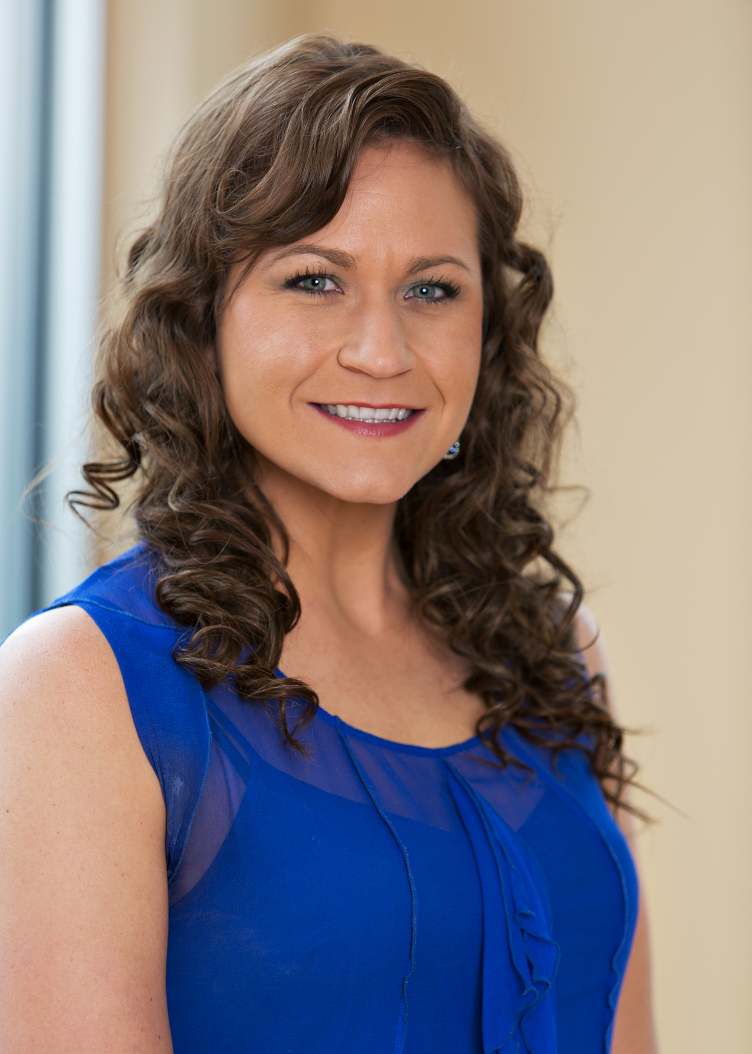
Fort Lauderdale, FL – August 11, 2020 — Synthax, US distributor of RME, Ferrofish, Digigram, Appsys and myMix, has announced Brittany Hilton has been named Broadcast Sales Manager, effective immediately. She will report directly to Derek Badala, Synthax’s Director of Sales, The Americas.
“Brittany is a consummate professional and has almost a decade of experience in the industry,” Badala said. “Over the last few years, Synthax has put forth a strong focus on the future of broadcasting and how its portfolio of brands can improve broadcasters’ processes. Brittany will be a very valuable team member as we continue to expose new markets across the Americas to the Synthax brands’ state-of-the-art solutions.”
Hilton has worked in the broadcasting industry since 2012, spending the majority of her career in broadcast sales, most recently at the Broadcasters General Store in Ocala, Florida. Before this, she worked with Broadcast Depot as a national account manager, DoubleRadius as an outside sales rep, and worked lighting and sound at the House of Blues in Myrtle Beach, South Carolina. Her extensive background in the industry will help her target the right products to broadcasters, allowing them to streamline their processes and obtain the highest quality audio available.
“I’m so excited to join the Synthax team and use my background to introduce Digigram’s broadcast solutions to new companies across the U.S. and Latin America,” Hilton said. “Digigram is an amazing brand with a great team, and one that I’ve been lucky to work with for years now. I’m looking forward to working for this forward-thinking company and showing broadcasters all the amazing ways Digigram’s solutions can improve their workflow.”
Key to her new role will be increasing Digigram’s reach and brand awareness. Hilton will also focus on sharing how Digigram — and fellow distributed brands RME and Ferrofish — can streamline and not only broadcasting processes, but also those in hospitality, house of worship and live sound markets, as well as those working in the timely distance learning field.
For more on Synthax, visit http://www.synthax.com.

About Synthax, Incorporated
Synthax Inc. is the exclusive USA distributor for RME digital audio solutions, Digigram broadcast audio systems, Appsys digital audio tools, Ferrofish advanced audio appliations, myMix personal monitoring systems and ALVA cableware. We supply a nationwide network of dealers with these products for professional audio, broadcast, music industry, commercial audio, theater, military and government applications. For additional information, visit the company online at http://www.synthax.com.
Media Contacts:
Katie Kailus
Public Relations
Hummingbird Media
+1 (630) 319-5226
katie@hummingbirdmedia.com

Jeff Touzeau
Public Relations
Hummingbird Media
+1 (914) 602 2913
jeff@hummingbirdmedia.com

