Water, waste, and vaccination: Fighting cholera and typhoid in Harare, Zimbabwe
In Zimbabwe’s capital Harare, recurring outbreaks of cholera and typhoid fever are a pressing health concern. In many of the city’s suburbs, public water supply is unreliable, and leaking sewage pipes, pit latrines, and poor waste management contaminate the groundwater. Using innovative borehole technology and empowering communities to manage their own water points, Doctors Without Borders (MSF) has developed a highly effective environmental health toolkit.
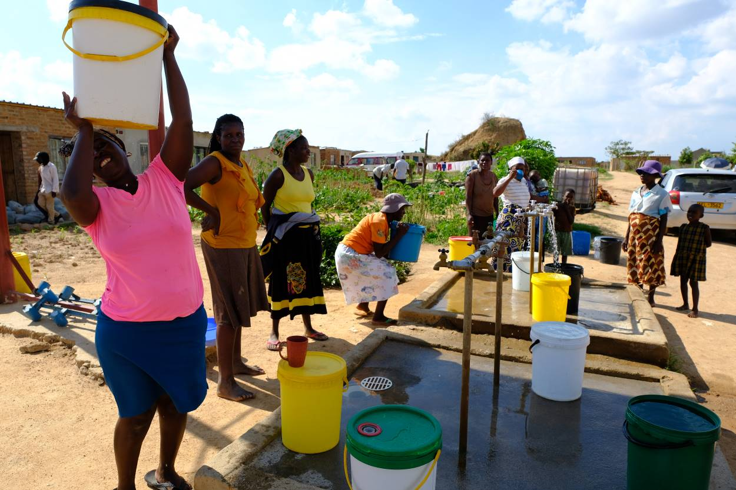
Women fetching water at a water point in the informal settlement of Stoneridge in Southern Harare. MSF drilled the solar-powered borehole and trained the local community health club, who is now maintaining the site. Photo: Samuel Sieber/MSF
A small, dimly lit entrance leads into the dozen rundown apartment blocks of Mbare flats in southern Harare. Satellite dishes and laundry lines clutter the weathered building facades, and small groups of children play between rain puddles in the courtyard. In front of the adjacent building, a congested waste container spills into a large field of household waste and plastic.
The barrack-like buildings date back to pre-independence, built for single male migrant labourers working in the nearby city centre. Today, over 20’000 people live in these flats, and up to four families share a single room. Unreliable fresh water supply, clogged and leaking sewage pipes, and virtually no public garbage collection make Harare’s high-density suburbs prone to recurring outbreaks of waterborne infectious diseases like cholera and typhoid.
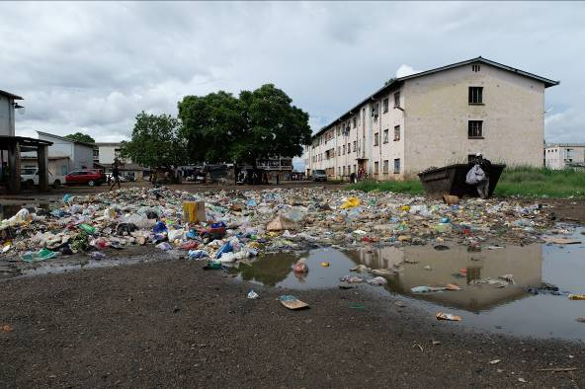
Waste management remains notoriously challenging in Harare’s densely populated suburbs like Mbare. Household waste is known to contaminate shallow groundwater and causes diarrheal disease outbreaks. Photo: Samuel Sieber/MSF
“We know the sewage and waste puts our health at risk”, said Jane Masanga, a mother of three who lives in one of the buildings right next to the vast waste pile. “But we currently depend on one single borehole with a hand-pump right next to the main road, and have no means to dispose or recycle our household waste”, she added.
On this cloudy December morning, the roaring of a large mobile drilling echoes through the buildings. Next to the old hand pump by the main entrance, Médecins Sans Frontières is drilling a new borehole with the help of a local drilling company, with pipes leading to a water point with taps.
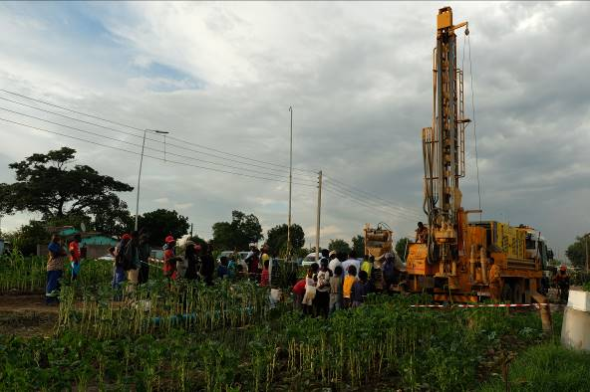
Using innovative rehabilitation and drilling technologies, MSF has been drilling over 70 new boreholes in Zimbabwe. Photo: Samuel Sieber/MSF
“We are drilling 80 meters deep into the ground, and are installing a sanitary seal that we have perfected over the last years to avoid any contamination from waste, sewage or shallow groundwater”, explained Danish Malik, MSF coordinator for the regional environmental health hub in Harare.
The new drilling technique is part of a comprehensive set of environmental health tools developed by MSF. Where possible, a specially fitted vehicle is used to rehabilitate existing boreholes instead of drilling new ones, which is often more cost efficient. For new boreholes like the one in Mbare, electromagnetic siting technology helps choose the best drill site. Since 2016, 50 water points were rehabilitated and 12 new boreholes drilled using the toolkit.
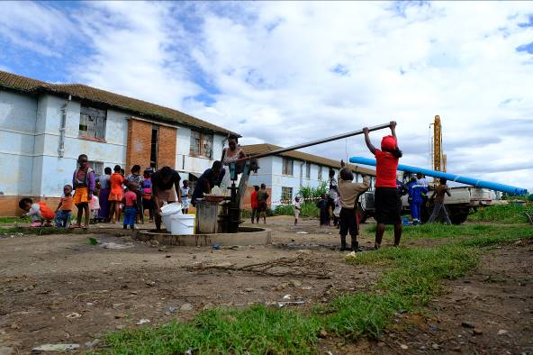
Over 20’000 people depend on this hand pump for drinking water at Mbare flats. Now, MSF is drilling a borehole with a pump and water taps, and is training a local community health club to maintain the water point and engage in community surveillance. Photo: Samuel Sieber/MSF
The true driving force of the toolkit are however the communities of Harare’s suburbs. After drilling or repairing a borehole, MSF’s outreach team trains a small group of local facilitators to establish and run a community health club. These health clubs then manage and maintain the water point site independently, ensure water quality, and pass on vital health and hygiene messages to their communities.
“For one US dollar a month, we provide over 250 families in our neighbourhood with clean water every day, buy the needed chlorine, maintain the pump, and invest into making our water point accessible and safe for everyone”, said Nyarai Dzingai, a community health club member in Kuwadzana, another suburb in the western outskirts of Harare.
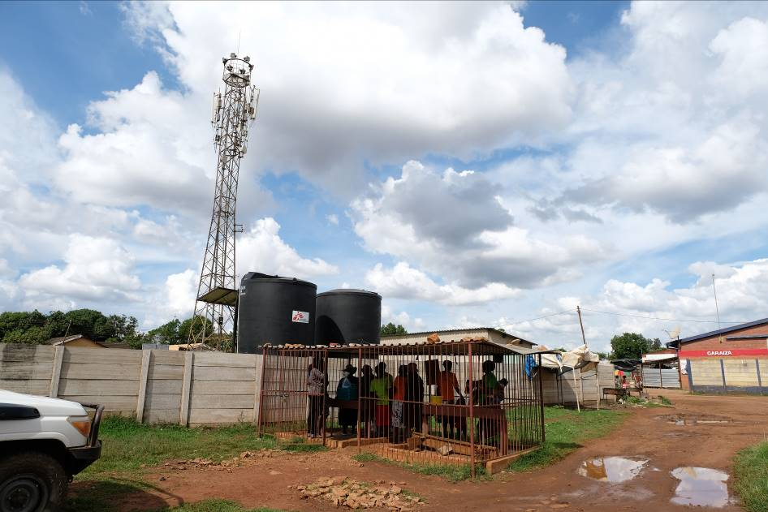
A community health club meeting in Kuwadzana. Here, MSF drilled and rehabilitated several boreholes in response to a typhoid outbreak around shallow boreholes and hand-dug wells in 2017. Photo: Samuel Sieber/MSF
Here, MSF repaired and drilled several boreholes in 2017, in response to a typhoid fever outbreak with clusters of cases around old boreholes and hand-dug wells. The clubs also help pass on important health messages for minor ailments. “Sometimes we are nurses, too, and explain to mothers how to prepare salt or sugar solutions for a child or husband with diarrhoea”, added Nyarai.
The strong participatory approach is the main ingredient in the community health clubs’ recipe for lasting success. “We train and encourage clubs to be autonomous right from the start, so they can continue their work with or without MSF”, said MSF health promoter Kudakwashe Sigobodhla. Over 70 health clubs are currently active in Harare, and many managed to invest into additional fencing or decorating their water points.
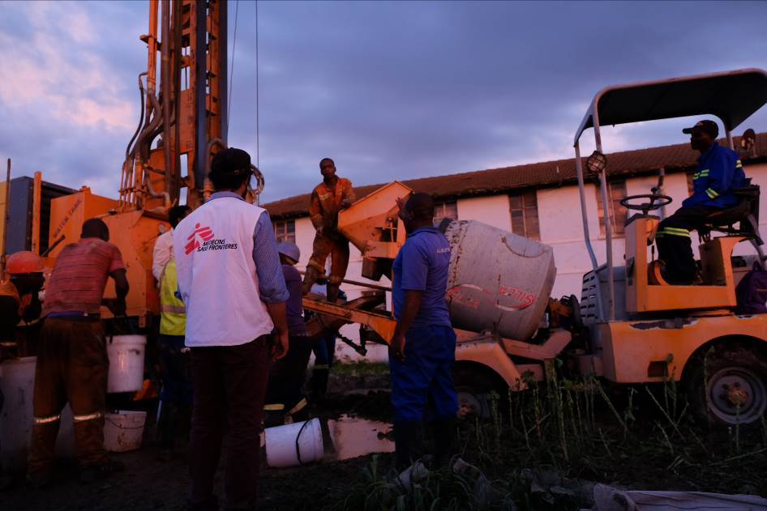
Cementation of the sanitary seal at the drill site in Mbare, Harare. Photo: Samuel Sieber/MSF
This year, Nyarai and her fellow health club members in Kuwadzana will receive additional training on community-led surveillance. “We are strengthening the health clubs’ capacity to notify cases of severe diarrheal diseases”, said Reinaldo Ortuño Gutierrez, MSF’s medical coordinator in Zimbabwe. “At the same time, we are supporting a study testing the effectiveness of a new typhoid vaccine, an additional tool to fight outbreaks of the waterborne infectious disease.
The combination of technical, medical, and community-empowering elements in a modular kit allows upscaling environmental health interventions beyond Zimbabwe too. Over the course of 2019, MSF’s regional environmental health team and local partner organisations have set up 19 water points with health clubs in Malawi, and an additional six in Mozambique. Other MSF projects in West Africa and South America are next on the pilot list.
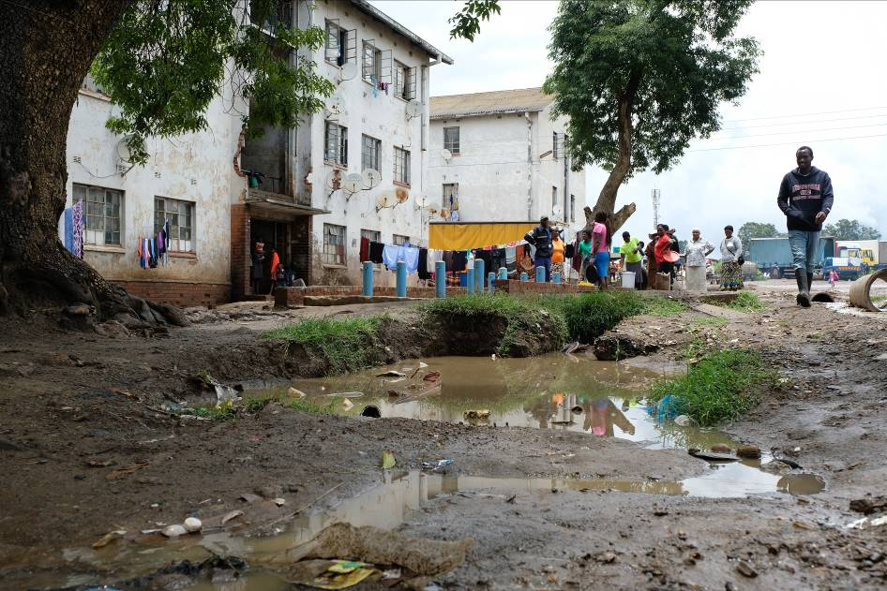
Water point in Matapi, Mbare. Improving waste management and wastewater recycling are next on MSF’s environmental health hub agenda. Photo: Samuel Sieber/MSF
At the drill site in Mbare, night is falling as the team starts cementing the 20-meter long plastic pipe that seals the upper part of the borehole. Once this borehole is up and running, two new toolkit elements will shortly be available to tackle the waste piles and leaking sewage contaminating the shallow groundwater.
Together with local companies buying recyclable materials from communities at several collection points across Mbare, MSF is about to launch a new scheme for managing solid waste. In Stoneridge, an informal settlement in the outskirts of Harare, a pilot with local company Jojatis has just fitted ten households with a decentralised system to clean and recycle household wastewater using earthworms.
“We are evaluating these waste management innovations with local research partners like the University of Zimbabwe. Once proven successful, we will include them in our environmental health toolkit and keep scaling them regionally,” Danish Malik added.

