Under embargo until 9am AEST / 11am NZST, April 26, 2022
Inspired by Sound
Sennheiser introduces the MOMENTUM True Wireless 3 – redefining the limits of possibility
Sydney, Australia, 26 April, 2022 – The multi-award-winning MOMENTUM series from Sennheiser introduces a new member to the family. The MOMENTUM True Wireless 3 sets new standards when it comes to sound quality, adaptive noise cancellation (ANC), and wearing comfort. Encased in a design that was defined using high-quality materials and precise workmanship, the earbuds offer a range of technologies and features that take the listening experience to a new level.
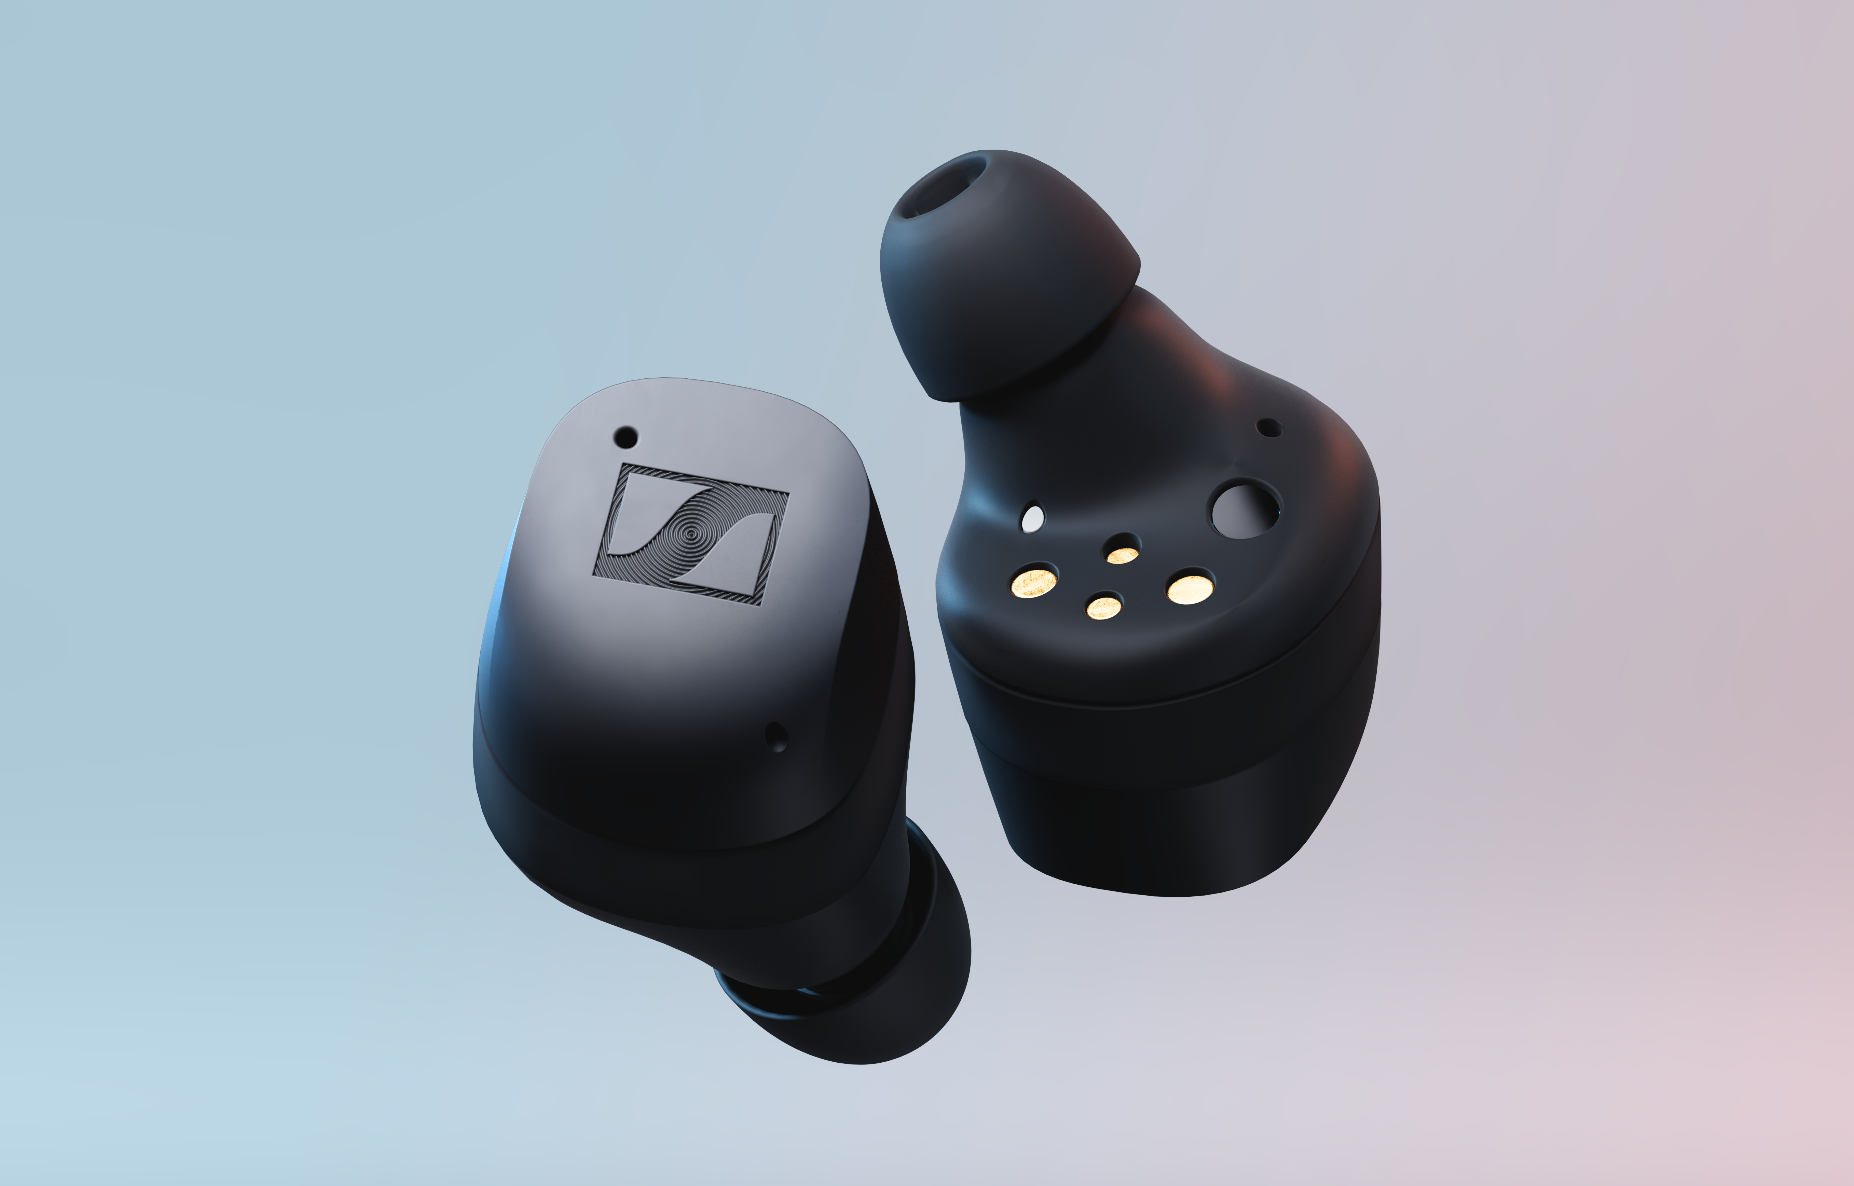

"Our MOMENTUM series continuously succeeds in redefining the boundaries of possibility," said Frank Foppe, Sennheiser True Wireless Product Manager. "The MOMENTUM True Wireless 3 builds on a powerful heritage. With the Sennheiser Signature Sound, TrueResponse technology, next-level adaptive noise cancellation and an even better fit, these earbuds are the natural successor of the MOMENTUM series."

A superior sound experience
Just like its predecessors, the MOMENTUM True Wireless 3 delivers outstanding sound quality, centred around Sennheiser's True Response transducer. Based on dynamic 7mm drivers manufactured in Germany, it produces an immersive stereo sound with deep bass, natural mids and detailed highs. The new Sound Personalisation feature provides an enhanced sound experience via a guided listening test to setup the perfect sound for each user’s individual hearing. In addition, the Smart Control App offers a choice of presets and an equaliser feature to tailor the sound to the user’s taste.

Since the MOMENTUM True Wireless 3 was created for everyday life, especially on the go, Sennheiser has specifically improved the earbuds with Adaptive Noise Cancellation which automatically adjusts to your environment. The system continuously observes ambient noise to suppress it in real time. Users who want to be aware of their surroundings to hear things such as train announcements, for example, can deactivate the noise cancellation at the touch of a button, or switch to transparency mode.

For the best possible synchronisation between audio and visual content, the MOMENTUM True Wireless 3 also supports a wide range of audio codecs such as AAC, SBC and aptX™ Adaptive, which reduce latency to a minimum. In addition, each earbud now features three microphones that promote crystal-clear call quality, enabling smooth and easy-to-follow video calls. The intuitive touch control of the MOMENTUM True Wireless 3, which users can tailor to their personal preferences, makes it easier to navigate the audio and access voice assistants.
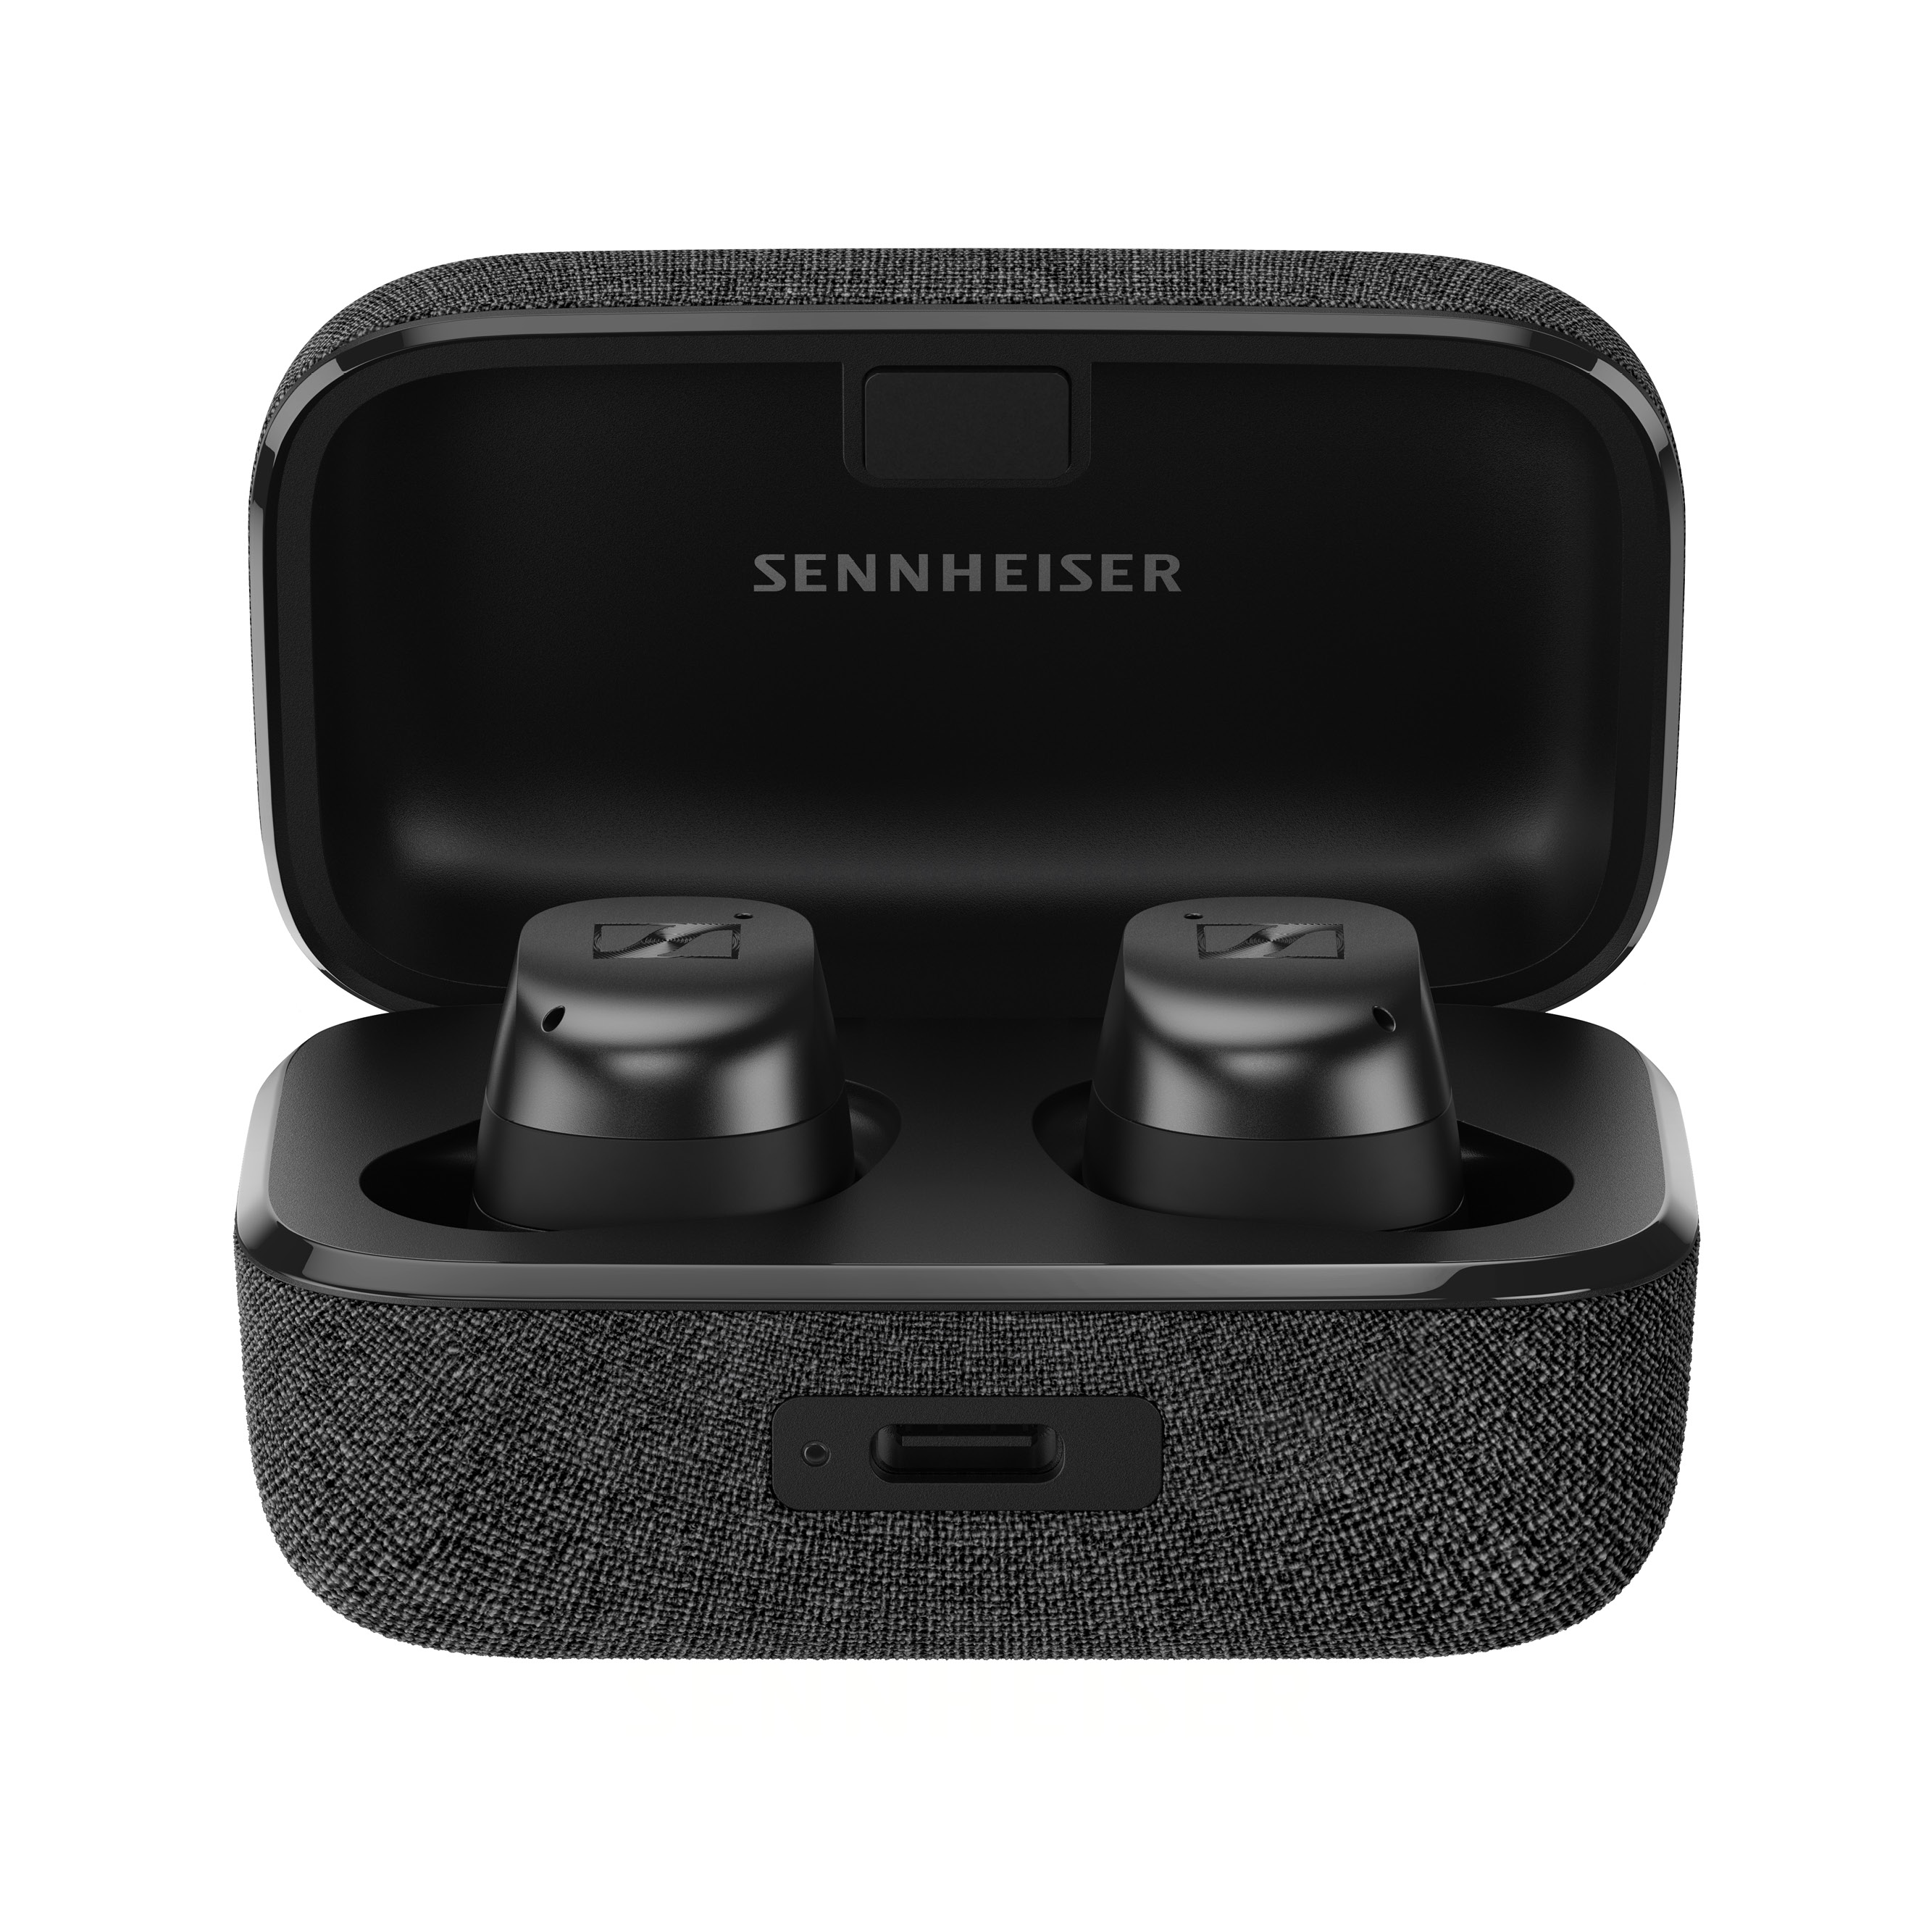
Exceptional design and extraordinary comfort
Winner of a 2022 Red Dot Design Award, the new stylish and futuristic ergonomic design enables a long-lasting comfortable fit. The MOMENTUM True Wireless 3 also comes with several silicone pads in different sizes that are designed to fit all ear shapes and sizes. Thanks to its IPX4-certified splash-resistant casing, the MOMENTUM True Wireless 3 is made for almost any adventure. Whether it's running in the rain or a strenuous fitness session, the new Sennheiser earbuds deliver a top-class listening experience even under adverse conditions.

No matter where users of the new MOMENTUM True Wireless 3 may be, a battery life of seven hours – which can be extended to 28 hours using the case – means that users no longer have to worry about finding a power source nearby. And because the high-quality case supports wireless charging, the process itself is easy as it can be.

Pricing and availability
The Sennheiser MOMENTUM True Wireless 3 can be pre-ordered from today and will be available from 10 May, 2022 for $399.95 AUD / $424.95 NZD in black, white and graphite.

About the Sennheiser brand
We live and breathe audio. We are driven by the passion to create audio solutions that make a difference. Building the future of audio and bringing remarkable sound experiences to our customers – this is what the Sennheiser brand has represented for more than 75 years. While professional audio solutions such as microphones, meeting solutions, streaming technologies and monitoring systems are part of the business of Sennheiser electronic GmbH & Co. KG, the business with consumer devices such as headphones, soundbars and speech-enhanced hearables is operated by Sonova Holding AG under the license of Sennheiser.

www.sennheiser.com
www.sennheiser-hearing.com

Press contact
Sennheiser Consumer Audio GmbH
Paul Hughes
Head of PR and Influencers
T +49 (0) 162 2921 861
paul.hughes@sennheiser-ce.com

