For immediate distribution
Multi-Dimensional Live Sound: PK Sound Releases Trinity 10
Trinity 10 advances PK Sound’s robotic line array offering, providing end-users with the same voicing
and directivity as the full size Trinity in a mid-size module
Calgary, Alberta, October 23, 2018 — PK Sound, the company that revolutionized the loudspeaker industry with its Trinity Advance Robotic Line Array's three-dimensional wavefront technology, has released Trinity 10 — the first mid-size, three-dimensionally controlled sound system of its kind.
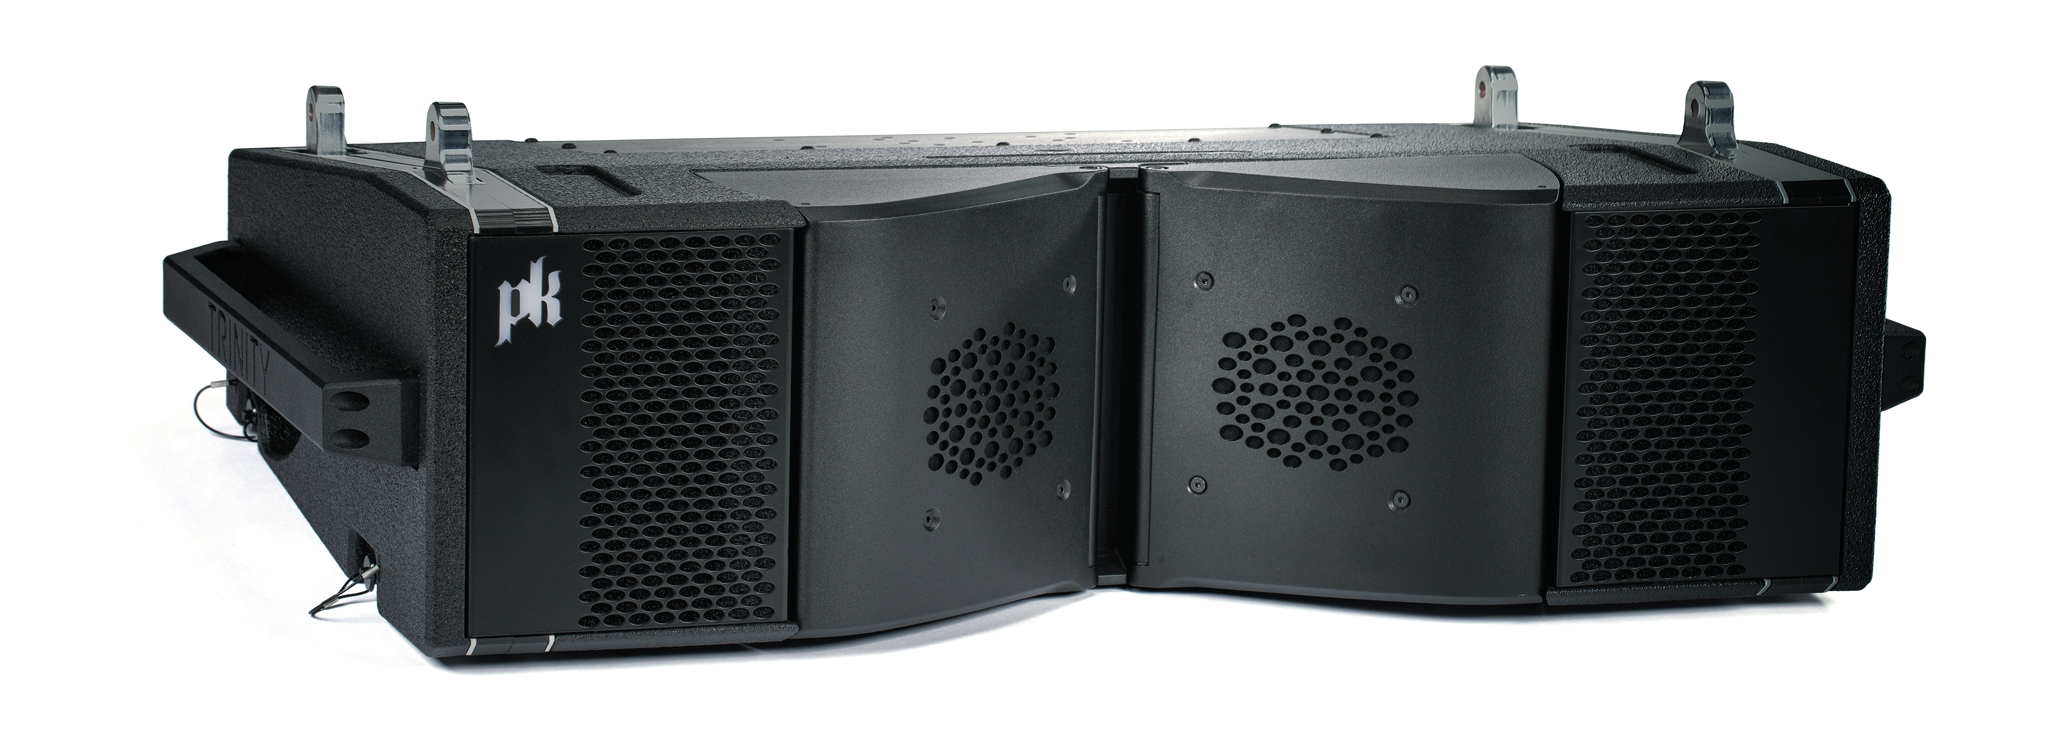
Trinity 10 features the identical voicing as the full-size Trinity module. Like the larger version, the Trinity 10 is configured remotely, providing advanced users with a completely new set of tools and unparalleled control over the vertical and horizontal polar directivity of the entire array, while bringing world class sound field control to mid-size class line arrays. In addition, Trinity 10 is powered by a 3000 W Class D amplifier to maximize headroom while maintaining crystal clear audio and providing exceptional output.
"Trinity 10 is the next evolution in robotic line array technology and provides unparalleled sound field control in a mid-size solution," said Jeremy Bridge, President and CEO of PK Sound. "By giving users the ability to sculpt the sound field in all three dimensions, precision and accuracy previously unobtainable can now be achieved. This vastly increases both traditional and creative applications for both artists and engineers."

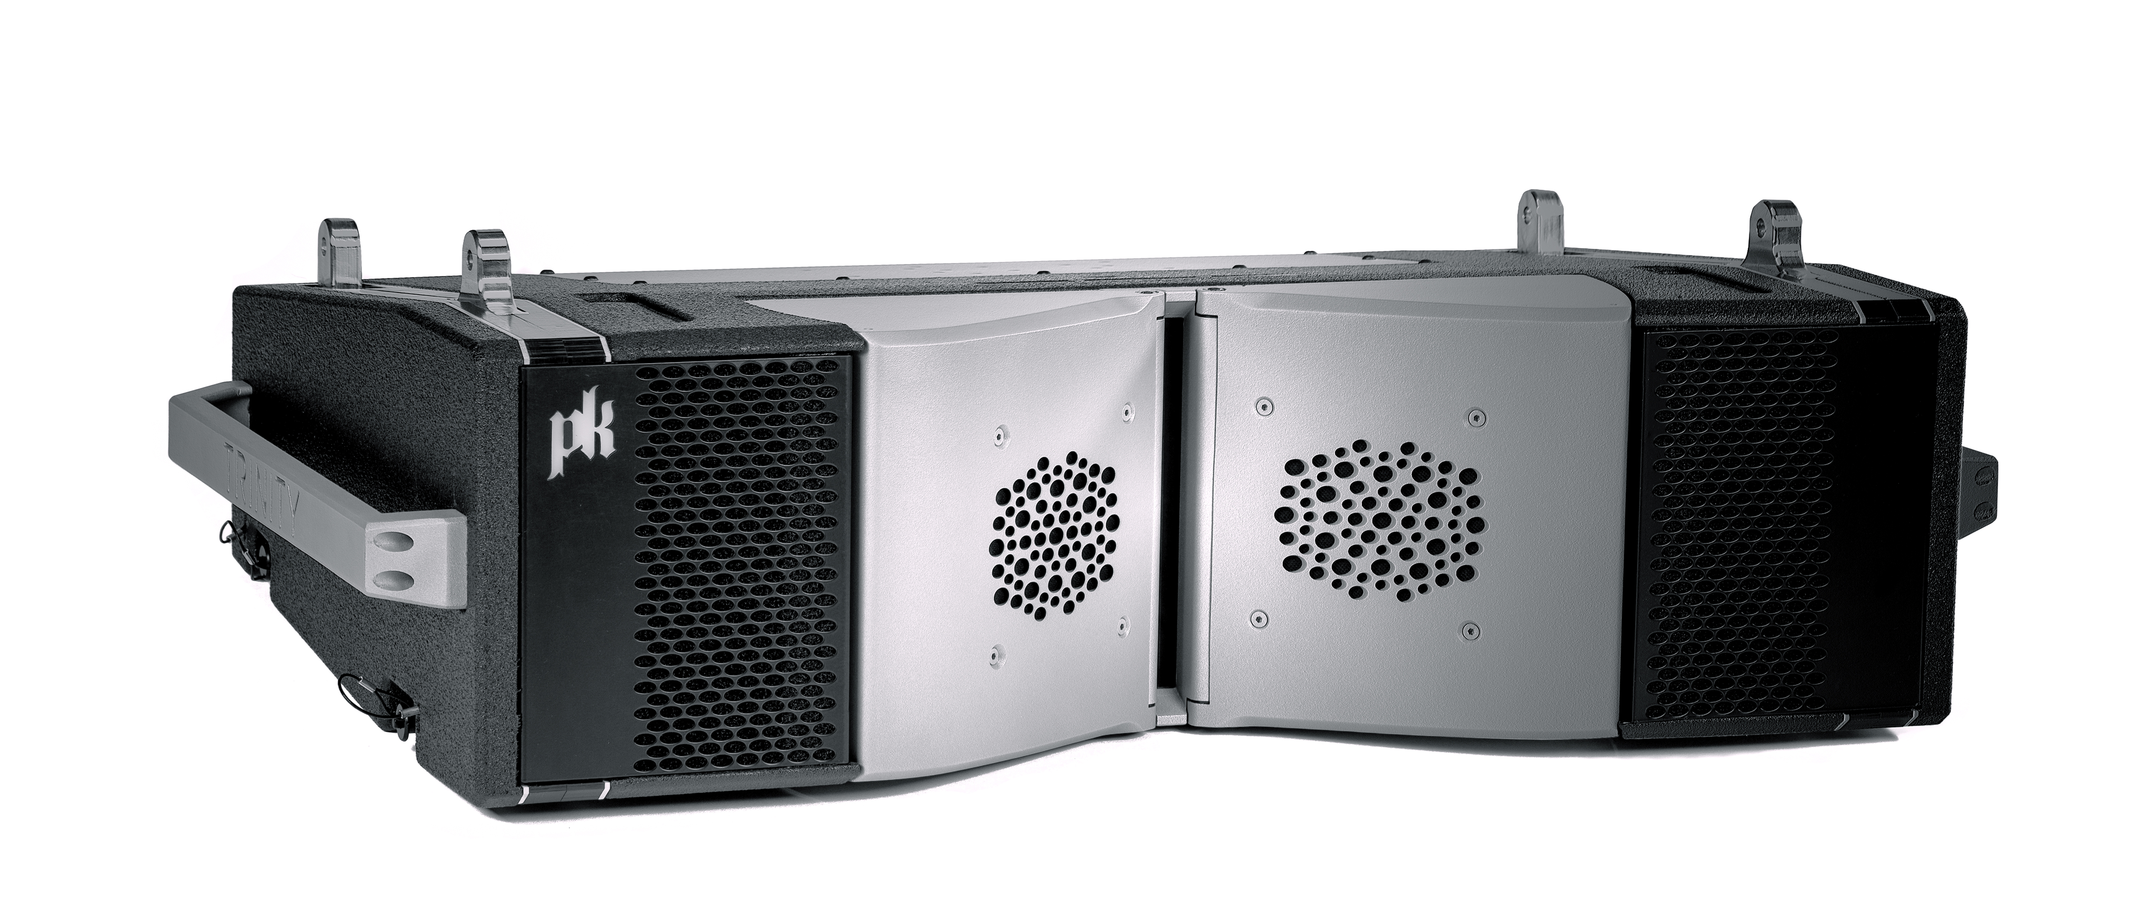
Unprecedented Precision in a Mid-size Module
Voiced exactly the same as the larger Trinity module, the Trinity 10 uses the same high and mid frequency components and waveguide design, ensuring seamless integration when both models are used together.
Each Trinity 10 module features a Coherent Midrange Integrator (CMI) to combine mid high range frequencies, as well as precisely spaced low frequency apertures for smooth and controlled directivity. The CMI waveguide is variably adjustable from 50 to 120 degrees, both symmetrically and asymmetrically, giving engineers the ability to focus the sound field and increasing the loudspeakers's long throw capabilities by increasing its sensitivity.
Trinity 10 is equipped with dual bandpass loaded, 10-inch transducers to provide greater accuracy and output than traditional front-loaded designs, plus two 6.5-inch midrange transducers coupled to a CMI waveguide through phase plugs specifically designed to increase sensitivity and ensure seamless integration with high frequencies. Trinity 10 also features a dual driver high frequency compression device coupled directly to an integrated planar waveguide, dramatically reducing the overall length and internal diffraction and significantly reducing distortion across the entire high frequency band.
Remote Control in Three Dimensions
PK Sound's Kontrol™ software lets users access the internal functions of each module remotely – including safety and DSP – so that each array can be flown straight and adjusted in the air. PK Sound’s Kontrol™ Auto-Array feature communicates with each module and automatically arranges modules into the proper position in each array, removing the need for time-consuming manual arrangement.
Trinity 10 also uses Auto-Align, a unique rigging system that is remotely adjustable from 0 degrees to 12 degrees in 0.1-degree increments. Auto-Align removes the need for cumbersome rigging links, significantly reducing setup time and increasing safety. To further reduce setup time, the Trinity 10 system stacks efficiently on carts four or six high with a fly bar that remains attached during transport.
In addition to vertical directivity, Trinity 10 provides 25 individual horizontal directivity options that can be arranged in any order in the array and fine-tuned on the fly, giving users the flexibility to change the directivity of the system to suit any number of audience configurations in a multitude of different venues.
"Trinity 10's patented technology provides engineers with a new set of sound field control tools to overcome the challenges they face on a daily basis without compromising acoustic integrity,” Bridge added. “Trinity 10 combined with Kontrol™ loudspeaker management software lets engineers instantly adjust every aspect of the sound field remotely without the need for drastic DSP.”
Each Trinity 10 module also includes local control functions, giving users access to key loudspeaker functionality and providing additional setup flexibility. Trinity 10 modules also feature a weatherproof amplifier plate and interconnects to ensure consistent performance in demanding outdoor conditions.
For more information, please visit PK Sound’s website at: https://www.pksound.ca/

About PK Sound
At PK Sound we are passionate about providing a powerful connection between artist and fan. We believe that every audio experience should be exceptional. Our loudspeakers are well known for their transparent, full bodied, powerful sound; a result of new technologies created by people who love music, focusing on the evolving demands of artists, engineers and fans.

Media contacts
Jeff Touzeau
Public Relations
Hummingbird Media
+1 (914) 602 2913
jeff@hummingbirdmedia.com

