JULIEN BAKER ANNOUNCES NEW ALBUM TURN OUT THE LIGHTS
OUT OCTOBER 27, 2017 VIA MATADOR RECORDS
PRE-ORDER NOW HERE

LISTEN TO NEW SINGLE “APPOINTMENTS” HERE

FALL NORTH AMERICAN HEADLINING TOUR BEGINS OCTOBER 12TH

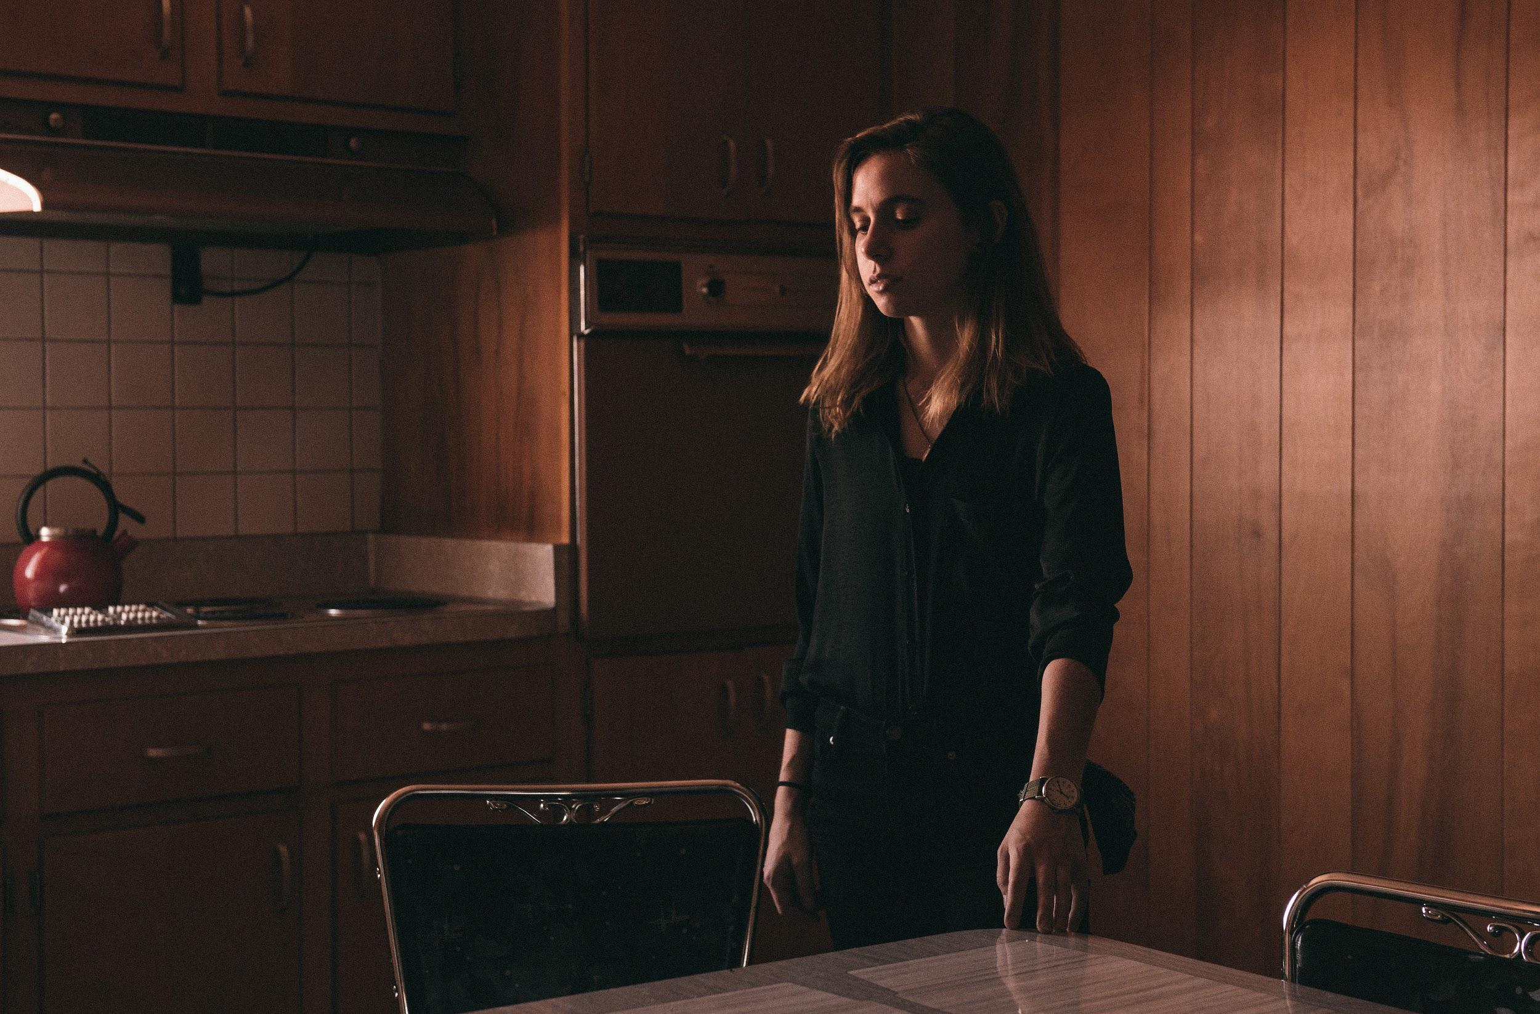
Credit: Nolan Knight

Julien Baker will release her highly anticipated second album Turn Out The Lights on October 27th, 2017 via Matador Records. An early preview can now be heard in first single “Appointments,” a viscerally moving track that culminates in a swell of Baker’s voice, guitar, and piano. Turn Out The Lights will arrive nearly two years to the day after her debut LP, Sprained Ankle -- which was widely acclaimed by outlets including The New York Times, NPR Music, Pitchfork, RollingStone.com, Noisey, and The AV Club, among others -- and is now available for pre-order HERE.

Recorded at the legendary Ardent Studios in Baker’s hometown of Memphis, TN, Turn Out The Lights expands upon the sound and vision of Sprained Ankle while retaining the haunting, confessional songwriting style for which she has become known. Throughout the album, she reflects on experiences of her own and those closest to her, exploring the internal conflicts that wrestle inside us all: how we deal and cope with our struggles, and how it all impacts both ourselves and our relationships of all kinds. The result is a deeply empathetic album that embraces the grays and complex truths of humanity and mental health. Turn Out The Lights was written and produced by Baker, and mixed by Craig Silvey (The National, Arcade Fire, Florence & the Machine).

Baker -- following a handful of dates this month and next that include shows supporting Belle & Sebastian and Ben Folds, as well as a stop at the Pygmalion Festival -- will head out on a massive North American headlining tour beginning October 12th in Atlanta, GA. The first leg will wrap up on the 29th in Philadelphia, PA and, following a three week run throughout the UK and Europe that includes an already sold out show at London’s Union Chapel, the second leg will pick back up on November 29th in Knoxville, TN. The tour will wind down in Dallas, TX on December 20th and includes an October 27th show at New York’s storied Town Hall as well as a December 14th show at Los Angeles’ landmark Palace Theatre. A current itinerary is below.

Read Julien Baker’s full bio HERE.

Turn Out The Lights track listing:

- Over
- Appointments
- Turn Out The Lights
- Shadowboxing
- Sour Breath
- Televangelist
- Everything That Helps You Sleep
- Happy To Be Here
- Hurt Less
- Even
- Claws In Your Back

Turn Out The Lights cover artwork:

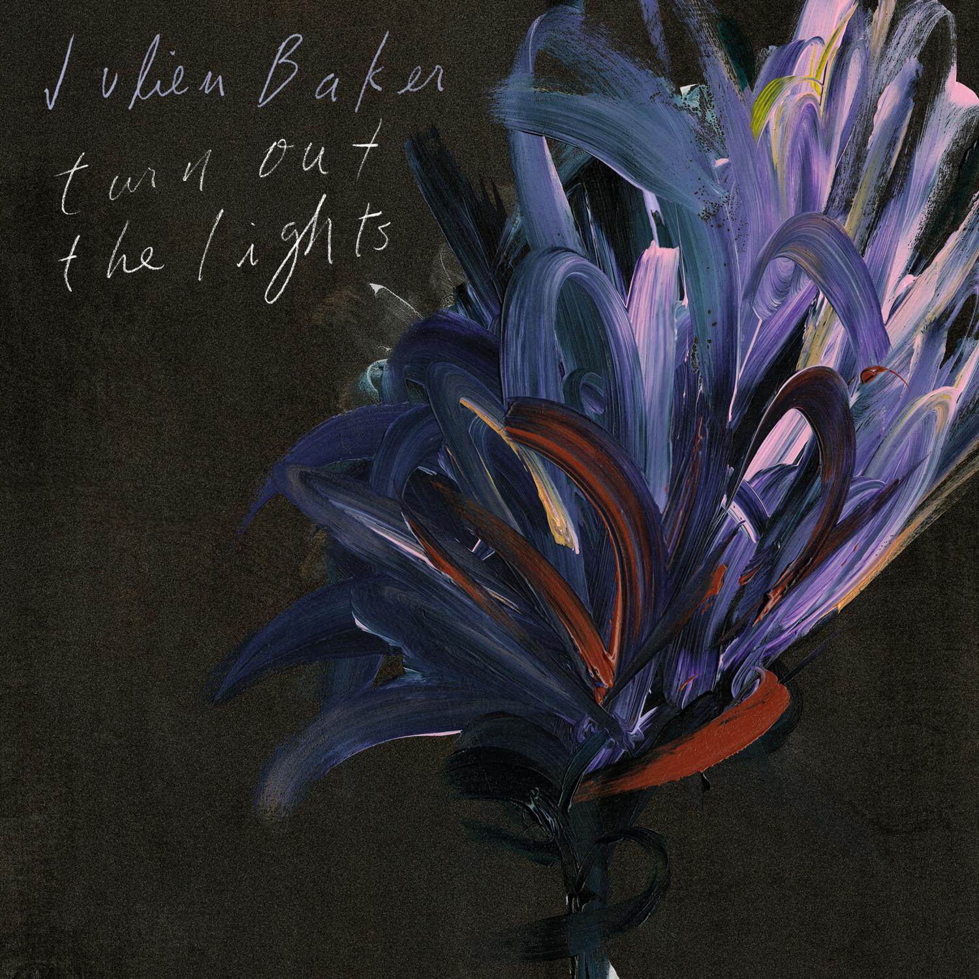

Julien Baker tour dates:

08/17 Louisville, KY @ Iroquois Amphitheater*
08/26 Davenport, IA @ Adler Theatre#
09/20 Chicago, IL @ Amnesty International & Sofar Sounds Give A Home show
09/21 Champaign, IL @ The Pygmalion Festival 2017
10/12 Atlanta, GA @ Masquerade +
10/13 Saxapahaw, NC @ Haw River Ballroom +
10/14 Asheville, NC @ The Grey Eagle +
10/15 Charlottesville, VA @ Jefferson Theater +
10/17 Washington, DC @ 9:30 Club +
10/18 Millvale, PA @ Mr. Smalls Theatre +
10/20 Madison, WI @ Majestic Theatre +
10/25 Montreal, QC @ Theatre Fairmount +
10/27 New York, NY @ Town Hall +
10/28 Somerville, MA @ Somerville Theatre +
10/29 Philadelphia, PA @ Union Transfer +
11/03 The Hague, NL @ Crossing Border Festival
11/04 Utrecht, NL @ Ekko
11/06 Bristol, UK @ The Lantern
11/07 Leeds, UK @ Brudenell Social Club
11/08 Glasgow, UK @ CCA
11/09 Dublin, IE @ Whelans
11/10 London, UK @ Union Chapel (SOLD OUT)
11/12 Brussels, BE @ Autumn Falls
11/14 Berlin, DE @ Heimathafen Neukolln
11/15 Hamburg, DE @ Uebel & Gefahrlich
11/16 Düsseldorf, DE @ New Fall Festival
11/17 Madrid, ES @ El Sol
11/18 Braga, PT @ Theatro Circo
11/19 Barcelona, ES @ La De Apolo
11/29 Knoxville, TN @ Bijou Theatre
11/30 Nashville, TN @ Marathon Music Works
12/01 Memphis, TN @ 1884 Lounge
12/02 St. Louis, MO @ Delmar Hall +
12/07 Spokane, WA @ The Bartlett +
12/08 Seattle, WA @ Neptune Theatre +
12/09 Vancouver, BC @ Rickshaw Theatre +
12/10 Portland, OR @ Aladdin Theater +
12/12 San Francisco, CA @ The Fillmore +
12/14 Los Angeles, CA @ Palace Theatre +
12/15 San Diego, CA @ The Irenic +
12/16 Phoenix, AZ @ The Crescent Ballroom +
12/18 Austin, TX @ Emo's +
12/19 Houston, TX @ The Heights Theater +
12/20 Dallas, TX @ The Kessler Theater +
* supporting Belle & Sebastian
# supporting Ben Folds
+ Half Waif supports

www.facebook.com/julienrbaker
www.twitter.com/julienrbaker
www.instagram.com/julienrbaker
http://mat-r.co/TurnOutTheLights
www.chromaticpublicity.com

###

For more information on Julien Baker, please contact Amanda Pitts (ap@chromaticpr.com) // For more information on Matador Records, please contact Shira Knishkowy (shira@matadorrecords.com).

