Mammut Core Protect Rope: A MILESTONE FOR CLIMBING SAFETY
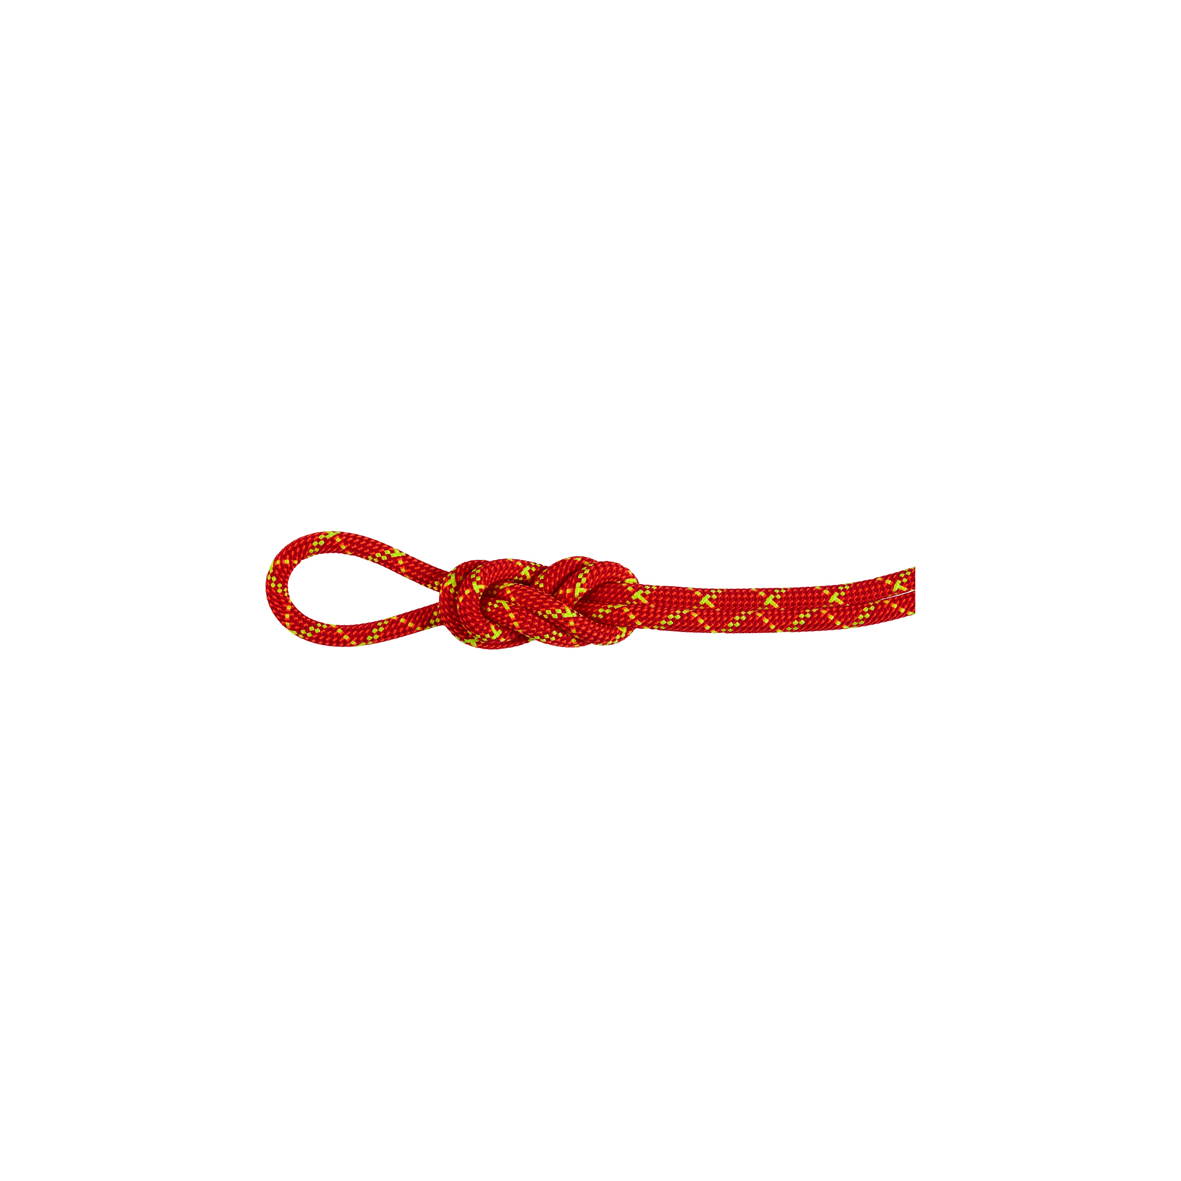
Photo: ©Mammut Sports Group AG

Introducing the Core Protect Rope, Mammut unveils a revolutionary climbing rope that epitomizes the pinnacle of safety and innovation. Featuring Mammut's patented Core Protect technology, augmented with an additional aramid protective layer, this rope offers significantly enhanced cut resistance without compromising on weight, dynamics, or handling compared to standard climbing ropes.

Despite the high quality of modern climbing ropes, accidents involving severed ropes can still occur, particularly on Alpine climbing tours, around sharp edges, or when navigating cracks. Even on sport climbing routes with aged, fixed carabiners, sharp edges pose a potential risk to the rope. The Core Protect Rope represents Mammut's response to these risks, marking a significant advancement in climbing rope technology.

"Every year, accidents occur due to rope failures and breaks. With Core Protect, we've developed a product that can mitigate these risks and enhance the safety of our sport."
– Magnus Raström, Senior Product Manager Climbing Gear
Technological breakthrough with market-leading comfort
The primary focus of the Mammut product team was to craft a climbing rope prioritizing lives saved through heightened cut resistance, while maintaining conventional rope behavior and performance. The Core Protect Rope not only upholds the standards of safety but also elevates climber performance and safety. Mammut's Core Protect Rope has life-saving benefits and redefined the standard for safety in mountain sports.
An additional protective layer of aramid, known for its heat resistance and strength, surrounds the core of the rope. This layer is strategically positioned between the outer shell and the core, both made of polyamide 6, known for its dynamic properties. The aramid sheath is braided with excess length, allowing it to fully unfold under tension over sharp edges to protect the core without exposing it to maximum fall energy. Positioned beneath the sheath, it shields the aramid from UV radiation and reduces wear on carabiners and safety devices.

"The primary challenge in working with more cut-resistant materials is preserving the rope's dynamic behavior. Aramid lacks natural stretch, but thanks to the hybrid yarn construction, we've managed to integrate cut-resistant fibers into a dynamic climbing rope." – Adriana Stöhr Textile Engineer, Climbing Equipment

Mammut invested twelve years in the development and testing of the Core Protect Rope to ensure its performance in realistic fall scenarios. Test results demonstrate the rope's ability to withstand falls over sharp granite edges, surpassing standard ropes and providing climbers with an unprecedented level of safety. Designed and developed in Switzerland, the Core Protect Rope underwent rigorous testing by mountain guides and professional athletes like Stephan Siegrist and Jonas Schild. Its construction ensures the rope behaves like any other Mammut Dry climbing rope, delivering a familiar and dependable climbing experience.

The rope, which won the OutDoor by ISPO Award 2024, is now available in two versions.

- 8.0 Alpine Core Protect Dry Rope
- 9.5 Alpine Core Protect Dry Rope

See also:
- The Last Unsolved Problem of Climbing Ropes – Hard is Easy

About Mammut

Mammut is a Swiss outdoor company founded in 1862 that offers mountain sports enthusiasts worldwide high-quality products and unique brand experiences. For 160 years, the world's leading premium brand has stood for safety and pioneering innovation. Mammut products combine functionality and performance with contemporary design. With its combination of hard goods, footwear, and clothing, Mammut is one of the complete suppliers in the outdoor market. Mammut Sports Group AG is active in around 40 countries and employs approx. 800 people.

mammut.com

