

Sennheiser Education Solutions
Optimal assistive listening experience for university students
Sennheiser launches redesigned MobileConnect App

Sydney, 26 November 2019 – In education, the ability to clearly hear and understand every detail and nuance is essential. MobileConnect, Sennheiser’s WiFi-based system for assistive listening ensures that educational institutions can provide this optimal learning experience for everyone. With the launch of the latest version of the MobileConnect App, the audio specialist is further improving learning conditions for hearing impaired students by making the app effortlessly intuitive to use and even simpler to integrate into lectures. With MobileConnect, students no longer have to sit in dedicated seats in the lecture hall and thanks to the solution’s BYOD (Bring Your Own Device) philosophy, can easily participate in lectures via the app on their own smart device.

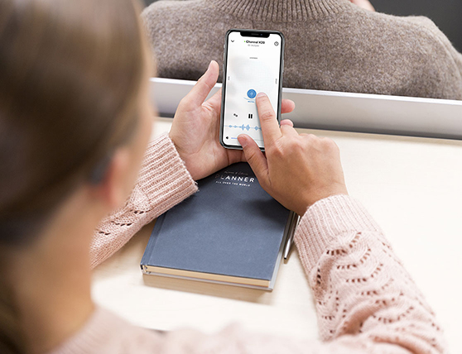 | Improved audio handling and stream stability: The new MobileConnect App improves learning conditions for hearing impaired students due to simple integration into lectures and intuitive user experience

The new version of the MobileConnect App features improved audio handling and stream stability, while maintaining uncompromised low latency. For a better user experience and usability, the app’s interface has been updated with a new look and feel. For the visually impaired, the MobileConnect App now features voice-over captions and a dark mode, which makes it easier to adapt the app to their personal needs.

The heart of the app, the personal hearing assistant, now opens immediately when the app has been started. To make channel selection as easy as possible for the user, the MobileConnect App lets them either enter a channel ID or use the integrated QR code scanner, depending on what the university offers. When the lecturer pauses, a waveform animation will signal to users that they are still linked up with the transmission channel.

“The new MobileConnect App is an ideal tool for use at universities,” says Jakub Kolacz, Product Manager for Mobile Connect. “In academic education, hearing is a significant part of learning. By transmitting whole lectures in real-time via WiFi directly to students’ own devices, no matter where they are seated, academic institutions are able to offer true inclusion.”

The installation setup of a MobileConnect system is simple: A Sennheiser ConnectStation is linked to the university’s existing audio infrastructure and connected to the same WiFi network. All that students need to do is download the free MobileConnect App, which – due to the unique Unicast Mode – is compatible with all iOS and Android devices as well as hearing aids, Cochlea implants and headphones. Students use their own smartphones, so no additional hardware is necessary.

MobileConnect is compatible with all iOS and Android devices as well as hearing aids, Cochlea implants and headphones | 

“The MobileConnect system doesn’t require maintenance or operating costs and by including the students’ own devices there is no need for any headphone hygiene or battery management. This means the investment in MobileConnect is quickly amortized,” explains Jakub Kolacz.

The Christian Albrechts University in Kiel is an example of the groundbreaking impact Sennheiser’s assisted listening system has on the academic lives of hearing-impaired students. The university’s event technology team integrated four ConnectStations into the existing WiFi, thereby covering many different lecture halls across the campus. For the students it is now much easier to follow lectures, as they don’t need to sit in the front row and close to the loudspeakers or resort to lip-reading. “Barrier-free access to learning resources such as lectures or courses is a right that all students should expect and that every academic institution should provide,” says Jakub Kolacz.

To learn more, please visit the Sennheiser MobileConnect landing page at https://en-de.sennheiser.com/mobileconnect-smartphone-hearing-system-app.

The high-resolution images accompanying this press release can be accessed here: https://sennheiser-brandzone.com/c/181/P1HuS44J.

About Sennheiser
Shaping the future of audio and creating unique sound experiences for customers – this aim unites Sennheiser employees and partners worldwide. Founded in 1945, Sennheiser is one of the world’s leading manufacturers of headphones, loudspeakers, microphones and wireless transmission systems. Since 2013, Sennheiser has been managed by Daniel Sennheiser and Dr. Andreas Sennheiser, the third generation of the family to run the company. In 2018, the Sennheiser Group generated turnover totaling €710.7 million. www.sennheiser.com

Global Press Contact Local Press Contact

Stephanie Schmidt Heather Reid
stephanie.schmidt@sennheiser.com heather.reid@sennheiser.com
T +49 (5130) 600 – 1275 T +61 448 119 609

