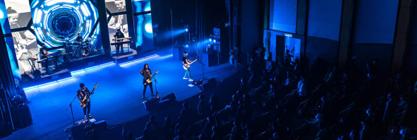Digital 6000 is Hujan’s wireless system of choice
Malaysian indie band electrified their audiences with their Hujan 16 Tahun series of concerts

Petaling Jaya, Malaysia, 13 December 2021 – After a two-year hiatus due to the Covid-19 pandemic, popular Malaysian indie band Hujan made a comeback with a series of virtual concerts entitled ‘Hujan 16 Tahun’ that were transmitted live from the Petaling Jaya Performing Arts Centre to their large fanbase. The concert was held on four nights – 20, 21, 23 and 24 October – with different genres and themes, showcasing a cross-section of the band’s 16-year career, their struggles, ups and downs and fantastic successes. It was also the very first time that Hujan used Sennheiser’s Digital 6000 System, which lifted their stellar performance to a new level in audio tech. Wireless monitoring was done via evolution wireless and 2000 Series IEMs, and the backline included several Sennheiser and Neumann microphones. Neumann KH 310 monitors helped to finetune the mix for the live streams.

Hujan performing on the final day of their special four-day concert

Photo credit: @ehhafishah

In planning this very special concert series, the band wanted to ensure that their shows came as close as possible to a real-world performance to reignite the Indie music spirit in their dedicated fans – commonly known as the “Raingers” – who had to wait such an unusually long time for a performance from their favourite band. The newly constructed hall of the Petaling Jaya Performing Arts Centre was chosen as the ideal location for “Hujan 16 Tahun”, which incidentally inaugurated the centre.

The sold-out Petaling Jaya Performing Arts Centre

Photo credit: @ehhafishah

For vocals, Hujan relied on a four-channel Sennheiser Digital 6000 system plus additional wired mics. Vocalist Noh used an SKM 6000 with Neumann KK 205 head, lead guitarist AG Coco an SKM 6000 with Neumann KK 105 capsule and Azham an SKM 6000 with MM 445 capsule. Bassist Izzat relied on a wired MD 435 microphone, while backing vocals were picked up by an e 935 and e 945

Lead singer Noh with his Sennheiser SKM 6000 and Neumann KK 205 head

Photo credit: @ehhafishah

Recording engineer Bijan FX was thrilled about the audio performance of Digital 6000: “It was band vocalist Noh’s first time on the D 6000 system, and it felt as if it was not wireless at all! Its latency is so low that it seemed like a wired microphone. On the mixing side, the Neumann KH 310 monitors helped me in making critical decisions – their precision was fantastic.”

FoH engineer Ahmad Syafiq, who looked after the sound for the limited number of live guests, added: “I liked how the sound felt coming out of the SKM 6000 handheld and the KK 205 super-cardioid capsule; complemented with the Neumann V 402 pre-amplifier, it sounded much smoother for the vocalist’s rock nature. With the lead guitarist singing into a super-cardioid KK 105 and the bassist into a super-cardioid MD 445, we were able to bring studio sound onto the stage.” Ahmad Syafiq had patched the V 402 in-line between the EM 6000 receiver and the sound console – for the benefit of the engineers at FoH, monitor and recording – and the audience.

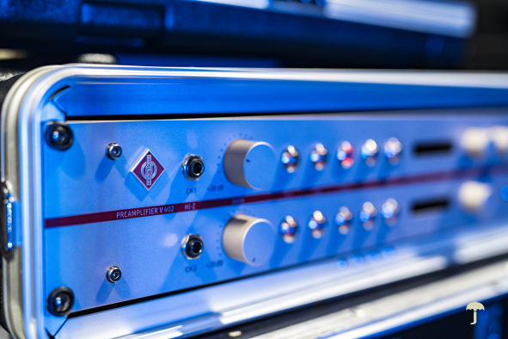 | The Neumann V 402 was looped in between the wireless system and the mixing desk  Photo credit: @ehhafishah

Guitar and bass used wireless instrument systems from the evolution wireless and Evolution Wireless Digital series, while the drumkit was miked with various Sennheiser and Neumann models. Syafiq had a special solution for the snare top: “The evolution 900 series drum mics are my go-to microphones without a doubt; they give me the ability to tailor the music. For the snare top, we took an unorthodox path and used the super-cardioid MD 445, which sounded excellent as its polar pattern helps to eliminate hi-hat bleed. I would strongly recommend everyone to give this a try. Tyler Tan of Sennheiser told me about this application; it was a wonderful idea, and I’m sure that the drum world will benefit from it.” In addition to the e 901 and e 902 for the kick drum, the toms and the snare bottom were picked up by e 904s. For the hi-hat and ride, Syafiq had chosen the Neumann KM 184. Ambience was picked up by two MKE 600.

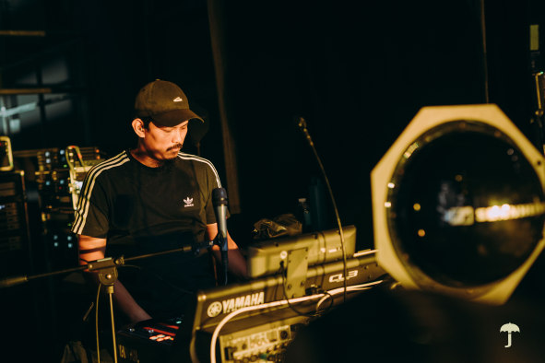 | Monitor engineer Zunnun Zolaznan  Photo credit: @ehhafishah

The sell-out crowd in the convention centre was joined by 1400 fans who watched the four-day concert online, making Hujan 16 Tahun the most successful virtual concert in Malaysia.

Band Manager Epain Ahmad was equally enthusiastic: “Thank you, Sennheiser, for the amazing collaboration, especially for the on-site support from Zoul and Tyler. The equipment made us sound better and made the fans feel better. It was a dream come true for us to collaborate with Sennheiser. We’re looking forward to our next shows.”

(Ends)

The high-resolution images accompanying this press release plus additional photos can be downloaded here.

About Sennheiser and Neumann
Shaping the future of audio and creating unique sound experiences for customers – this aim unites Sennheiser employees and partners worldwide. The independent family company, which is managed in the third generation by Dr Andreas Sennheiser and Daniel Sennheiser, is today one of the world’s leading manufacturers of headphones, microphones and wireless transmission systems. As part of the Sennheiser Group, Georg Neumann GmbH, known as “Neumann.Berlin”, is the world’s leading manufacturer of studio microphones. Since 2010, the company has expanded its expertise in electro-acoustic transducer design to also include the studio monitor market, and added studio monitoring headphones to its portfolio in early 2019. In 2020, the Sennheiser Group generated turnover totaling €573.5 million. www.sennheiser.com | www.neumann.com

Global Press Contacts

Andreas Sablotny Stephanie Schmidt
Andreas.sablotny@neumann.com stephanie.schmidt@sennheiser.com
+49 (30) 41 77 24 - 19 +49 (5130) 600 – 1275

