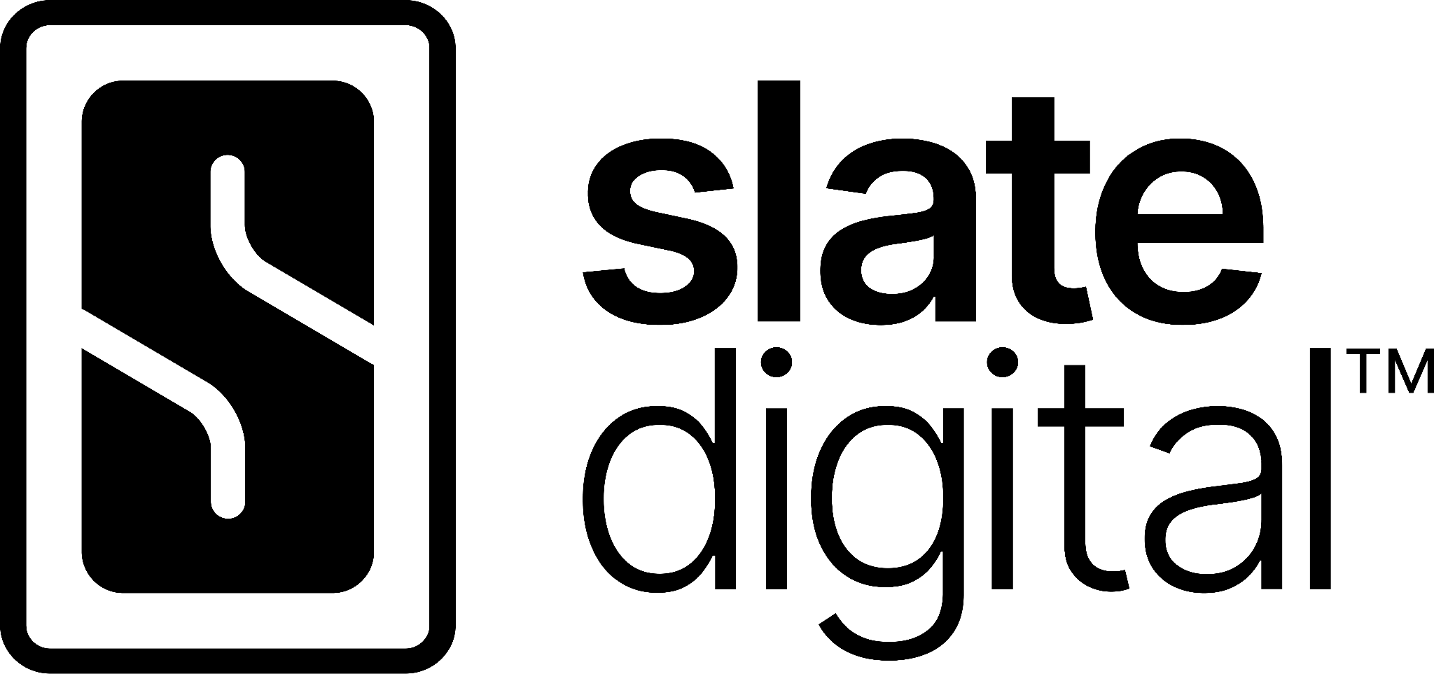

sonible Added to Complete Access — at No Extra Cost
Complete Access subscribers gain sonible's full line of intelligent, AI-assisted mixing and mastering plug-ins alongside Slate Digital, Solid State Logic and Harrison Audio tools, with no change to subscription pricing.

Los Angeles, CA, October 15, 2026 – Slate Digital announces that sonible is joining Complete Access, the brand’s robust, subscription-based plugin library and recording tool service. The addition of the Austrian developer of AI-assisted audio plugins marks one of the biggest expansions in the services’s history, which already includes industry-standard tools from Solid State Logic and Harrison Audio. All subscribers will now have access to sonible's intelligent processing tools at no additional cost. For more information and to subscribe, please visit: https://slatedigital.com/complete-access/

A major leap in value, at the same price
Complete Access brings together mixing, mastering, effects, and other production tools from Slate Digital, Solid State Logic and Harrison Audio to provide engineers and producers with a versatile palette for modern audio production. With the addition of sonible, subscribers now have access to a complimentary set of tools with content-aware processing that can take a mix or master from first analysis all the way to a finished result, with deep, advanced controls at every step.

This mix of professional-grade EQs, compressors, reverbs, delays, saturation and analog-inspired processors and intelligent, AI-assisted mix and master tools creates an incredible value proposition for producers and engineers working at every level, from industry professionals, to passionate DIYers, to recording students making their first inroads into recording and production. Substantially more options and flexibility for the same, low subscription price. Existing subscribers will receive the sonible collection automatically, and new subscribers get it from day one.

- More tools, same subscription: sonible's catalog of intelligent plug-ins joins the full Slate Digital, Solid State Logic and Harrison Audio lineup.
- No extra cost: no add-on tier, no upgrade fee, no change to monthly or annual pricing.
- Nothing to opt into: current subscribers get access automatically through their existing account, all managed through Complete Access Hub.
- Two workflows in one toolbox: intelligent processing with deep, advanced control and hands-on, analog-inspired sound shaping now live side-by-side.

Intelligent processing meets creative character
sonible has spent more than a decade building AI-assisted audio technology for music production. Its plug-ins analyze incoming audio and use what they hear to deliver source-specific processing and intelligent starting points. From there, the smart range in particular offers deep, sophisticated control for users who want to shape every detail. For many producers, sonible covers the whole job on its own.

Inside Complete Access, that approach joins a much larger creative environment. Producers can rely on sonible for anything from a quick fix to a fully detailed mix or master, and reach for award-winning analog-modeled processors and creative effects from Slate Digital, SSL and Harrison Audio to add color and character. Precise problem solving, fast workflows and distinctive sound shaping no longer have to be separate purchases or separate choices.
For producers new to sonible, Complete Access is the easiest way yet to discover intelligent audio processing, with no separate purchase required.

“Adding sonible is one of the biggest steps forward Complete Access has ever taken. Our subscribers now get an entirely new category of intelligent tools alongside the Slate Digital, Solid State Logic and Harrison Audio plug-ins they already rely on, and they don't pay a cent more for it. That's the kind of value we want Complete Access to stand for.”

— Jon Hillman, Director Commercial Strategy, Slate Digital

“Complete Access is a great environment for discovering what different approaches to audio processing can bring to a production. Adding our intelligent tools to such a broad collection of creative processors gives producers an enormous amount of freedom. You can get to a solid starting point quickly, experiment with completely different colors and characters, and ultimately decide where you want to take your sound.”

— Ralf Baumgartner, CEO and co-founder, sonible

Pricing and availability
sonible plug-ins are available to all Complete Access subscribers starting October 15, 2026. Subscription pricing is unchanged.

For Plans and additional details, please visit: http://www.slatedigital.com/complete-access.

About Slate Digital
Slate Digital makes audio processing plugins, virtual instruments, modeling microphones, sample packs, and production tutorials for content creators, music producers and engineers. Founded in 2010 with the goal of empowering audio producers at all levels of experience to create great-sounding music, their innovative products and industry-leading Complete Access subscription have been recognized throughout the recording industry.

About sonible
From mixing engineers, FOH engineers and music producers to AI experts, software developers, DJs and musicians, the sonible team is an eclectic mix of highly skilled engineers and creative individuals. sonible develops AI-assisted audio plug-ins, designs and implements 3D audio systems, and builds audio hardware. Its tools are known for their sound, intuitive interfaces and workflow-enhancing features. sonible is based in Graz, Austria.

