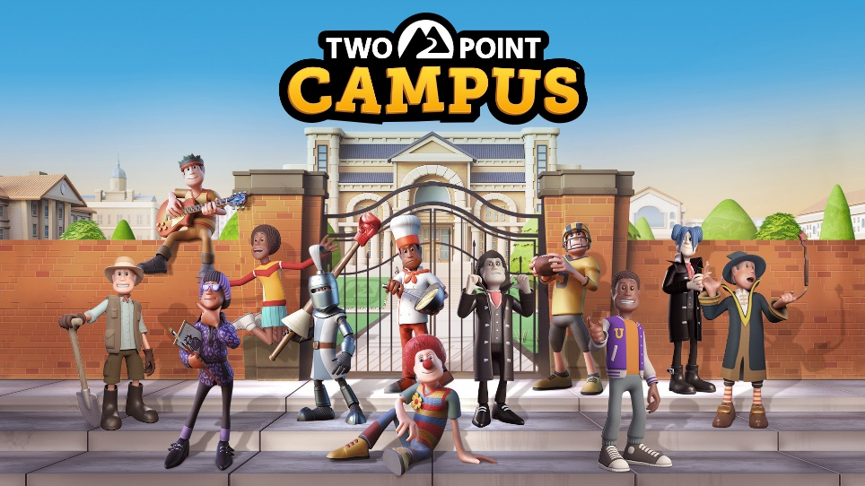

TWO POINT CAMPUS | BACK-TO-SCHOOL WITH A NEW LAUNCH TRAILER
London, England – 4 August 2022 – It’s almost back-to-school season, so what better way to celebrate than throwing the wildest milkshake keg party in Two Point County history! If dairy doesn’t agree with you, we’ve also got this brand-new launch trailer to celebrate Two Point Campus releasing on August 9th.
You can throw your own parties in Two Point Campus™, complete with laser lights, over-flowing red cups, and some killer tunes, it’s sure to keep your students happy – or at least distracted. And if a typical student shindig isn’t enough, as administrator of your very own campus, you have the power to schedule live gigs from definitely 100% real bands like Helium Baboon, Alchemical Friendship, or Boogie Knights. So, build yourself a Student Union and get the party started, and yes, the floor is supposed to be sticky.
Maybe you want to take things a little slower? Hopefully not too slow since the local Speed-Walking Club is looking for new recruits. Clubs are the perfect way to avoid thinking about your studies, whether it’s powerwalking around campus, scoring some mid-lecture Zs with the Power-Napping Club, or taking up gardening in the Nature Club. Feel the earth beneath your feet, the sun on your face and the wind… wherever it is you feel that.
Two Point Campus is a charming university management simulator that lets you live out your dreams of running your very own campus environment – complete with wild and wacky courses like spell-casting wizardry, dragon-slaying knight school, or top-secret spy school.
You can be the college party champion when Two Point Campus releases on PC, PlayStation 4|5, Xbox One, Xbox Series X|S, and Nintendo Switch on August 9th. Two Point Campus will also be available with Xbox Game Pass for console and PC on day one. If you’re after a physical copy, then check out our special Enrolment Edition, which comes with an awesome foldout campus map, a stylish University Prospectus, and exclusive packaging. You can pre-order a physical or digital copy of the game here and receive some awesome in-game items for both Two Point Campus and Two Point Hospital™.
For more information about Two Point Campus head to www.twopointcampus.com, where you can sign up for County Pass today, which unlocks the most sought after free in-game item at launch: The Golden Toilet! You can follow the game on Instagram, Facebook, YouTube, and Twitter.

About Two Point Studios Limited
Two Point Studios Limited is a British game developer, based in Farnham, Surrey (UK) and was founded in 2016. Two Point Studios’ small, but dedicated and passionate team have worked on some of the most recognisable brands in gaming, including Fable and Black and White. Drawing on that experience, Two Point Studios released a brand-new IP in the sim genre called Two Point Hospital, which launched for PC in August 2018. For more information about Two Point Studios visit www.twopointstudios.com.
About SEGA Europe Limited
SEGA Europe Limited is the European Distribution arm of Tokyo, Japan-based SEGA CORPORATION, and a worldwide leader in interactive entertainment both inside and outside the home. The company develops and distributes interactive entertainment software products for a variety of hardware platforms including PC, wireless devices, and those manufactured by Nintendo, Microsoft and Sony Interactive Entertainment Europe. SEGA wholly owns the video game development studios Two Point Studios Limited., Creative Assembly, Relic Entertainment, Amplitude Studios, Sports Interactive and HARDlight. SEGA Europe’s website is located at www.sega.co.uk

