Toyota Motor Corporation

Tommi Mäkinen Sees Promising Future for
Toyota GAZOO Racing’s WRC Project

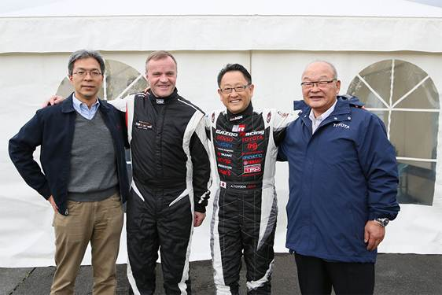
Toyota City, Japan, December 4, 2015―In November, key representatives of the Toyota GAZOO Racing* World Rally Championship (WRC) team met at Fuji Speedway, Japan, to discuss current progress and future prospects. With production of the team’s competition vehicle, the Yaris WRC, about to start, Team Chairman Akio Toyoda, Team Principal Tommi Mäkinen, Team Vice President Koei Saga, and Toyota Motorsport GmbH President Toshio Sato reaffirmed their shared goals and strengthened their commitment to making the project a success.
Left to right: Toshio Sato, Tommi Makinen, Akio Toyoda and Koei Saga

“When developing a rally car, it’s absolutely essential to remember to take the characteristics of the roads into account. You can’t just build a car on paper. Learning that lesson will really help us make ever-better cars, and it’s an area where we can learn a lot from Tommi. He’s practicing that philosophy every day,” said Akio Toyoda, expressing his high hopes for the project under Mäkinen’s guidance.

Toyota GAZOO Racing’s appointment of Tommi Mäkinen as team principal, announced in July, is based on a strong belief in his ability to form a solid, experienced team and to provide a winning car. Alongside Team Chairman Akio Toyoda, Mäkinen is leading the works team that will represent Toyota in WRC. He is currently putting together a team to lead this project, and has surrounded himself with a strong group of experienced, enthusiastic professionals, who are working relentlessly to make a success of this new challenge. At this point, Tommi Mäkinen Racing has more than 40 dedicated team members working 24/7.

“I understand that this project may have seemed difficult to pull off given the relatively short amount of time we have to set it up. However, we have worked hard to build a structured, professional and responsive team. The efficiency of the people involved in the project has made it possible to stick to the initial schedule and meet our objectives. Obviously, there is a lot of work still to do but we are more than ready for that,” explained Mäkinen, team principal.

Tommi Mäkinen is a four-time WRC world champion with 24 wins to his name. Toyota GAZOO Racing hopes to leverage the experience of Tommi Mäkinen Racing and take the Yaris WRC to the upper reaches of the sport’s top-flight category.

The next important stage will be testing for the Yaris WRC, which is scheduled to start during the spring 2016.

Q&A with Toyota GAZOO Racing Team Principal Tommi Mäkinen

Has assembly of the Yaris WRC started?
Right now, we are in the process of designing the car. Our team of engineers and designers, along with our suppliers, have worked tirelessly to meet the schedule and develop a car that could be a winner. Assembly of the Yaris WRC will therefore begin very soon.

Is Toyota Motorsport GmbH (TMG) involved in this project?
Yes, TMG is a key partner for us. It is responsible for designing and producing the Yaris WRC’s engine, which will be an exclusively Toyota unit. We will therefore be working very closely together to make the Yaris WRC a formidable car.

Where will the Toyota GAZOO Racing team be based?
The team will be based in Finland and registered as a Japanese team. The workshops and design offices needed for our operations in 2016 are currently set up in Puuppola, where Tommi Mäkinen Racing is based. Our colleagues from Japan have been visiting Finland regularly in order to ensure that communication is frequent and effective. We are delighted to be running this project in a country where rallying is considered a national sport and a genuine source of pride. It is also an ideal place to develop our car, with many options for testing. However, we are looking at different options to accommodate a works team and its required facilities for 2017.

What do you think will determine whether this project succeeds?
Although Toyota is the biggest car manufacturer in the world at the moment, it’s also well-known for lean and efficient operation. I want our team to be the same. I want to have the same conquest feeling as we had with our small Mitsubishi team. You don’t need to have the biggest budget or team in order to win. The most important thing is relaxing and enjoying the experience, and sharing it with people who feel the same way. We want to show everybody that we love cars, and we also have fun working together—we want to do things the Toyota way.

When will testing start?
Testing is due to start during spring 2016. An extensive schedule has already been drawn up in order to hold tests in Finland and around the world.

Have you finalized your team?
Our team is developing gradually, and several positions have yet to be filled. We are looking for people who are ready to work hard on this project and join a team that works like a big family. We will all work together, hand in hand. We are looking for people with strong characters and individual strengths, who at the same time are able to fit into the team.

Who will be driving for you in 2017?
We are in discussions with various drivers for 2017, bearing in mind that we hope to enter at least two, if not three vehicles into the championship.

Who are the key members of your team at this stage?
The team’s operations director is Lauri Riipinen, and our sporting director is Jarmo Lehtinen.

In our Technical Team, which is responsible for design and development, we have Michael Zotos, Tom Fowler, Mikko Ruoho, and Simon Carrier.

*Toyota GAZOO Racing is the general name given to Toyota’s activities aiming to train team members and build ever-better cars by engaging in motorsports.

contact

