EMBARGOED UNTIL WEDNESDAY, NOVEMBER 23RD, 2022 AT 10:00AM EST

Moog Announces New Plug-in Effect & End-of-Year Software Specials
The MF-109S Saturator, a brand new software offering from Moog, is now available as a free gift for all Moogerfooger Effects Plug-ins owners. Plus, Moog’s iOS and macOS apps are all 50% off for a limited time.

Download hi-res images here

Meet the New MF-109S Saturator Plug-in
This brand new Moogerfooger effect is now free for a limited time with the Moogerfooger Effects Plug-in bundle.

Last month, Moog Music released the Moogerfooger Effects Plug-ins, a re-invention of Bob Moog’s classic analog effects modules, to bring the legendary performance and musicality of the original hardware effects to your digital music production environment. Today, the storied synthesizer company releases the MF-109S Saturator, a free addition to the powerful effects suite.

The MF-109S Saturator is a new creative audio processor that emerged out of the Moogerfooger Effects Plug-ins development. A major component of the classic Moogerfooger functionality is the input drive stage, which adds warmth, distortion, and crunch to any given sound. The MF-109S allows users to have dynamic control over this drive circuit, opening up a new way for artists to interact with the unique saturation tool.

The Saturator is able to move from tight, distorted overdrive and analog saturation to smooth compression. Further, it models the noise generator circuit of the Minimoog Model D and allows for control of both noise generator level and noise tone with a switchable filter type.

All parameters of the MF-109S are able to be played, tweaked, automated, and modulated to create lively and truly musical performances. Adding a Moogerfooger effect to your sound invites exploration and experimentation to bring your musical expressions to life.

Download the MF-109S Saturator Here

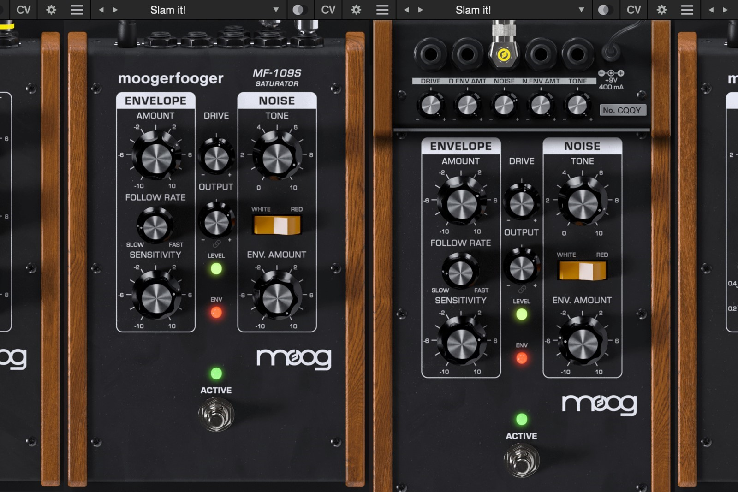

A Free Gift for Moogerfooger Effects Plug-ins Owners
The MF-109S Saturator is available as a free gift with the purchase of the Moogerfooger Effects Plug-ins suite. This limited-time offer is also free to everyone who has previously purchased the Moogerfooger Effects Plug-ins since the collection was released in October.

Take advantage of Moog’s introductory special: the complete bundle of all seven Moogerfooger Effects Plug-ins based on the original Moogerfooger pedals, now with the additional Saturator, for only $149 USD.

To get started with these powerful sound design tools, visit Moog’s website here.

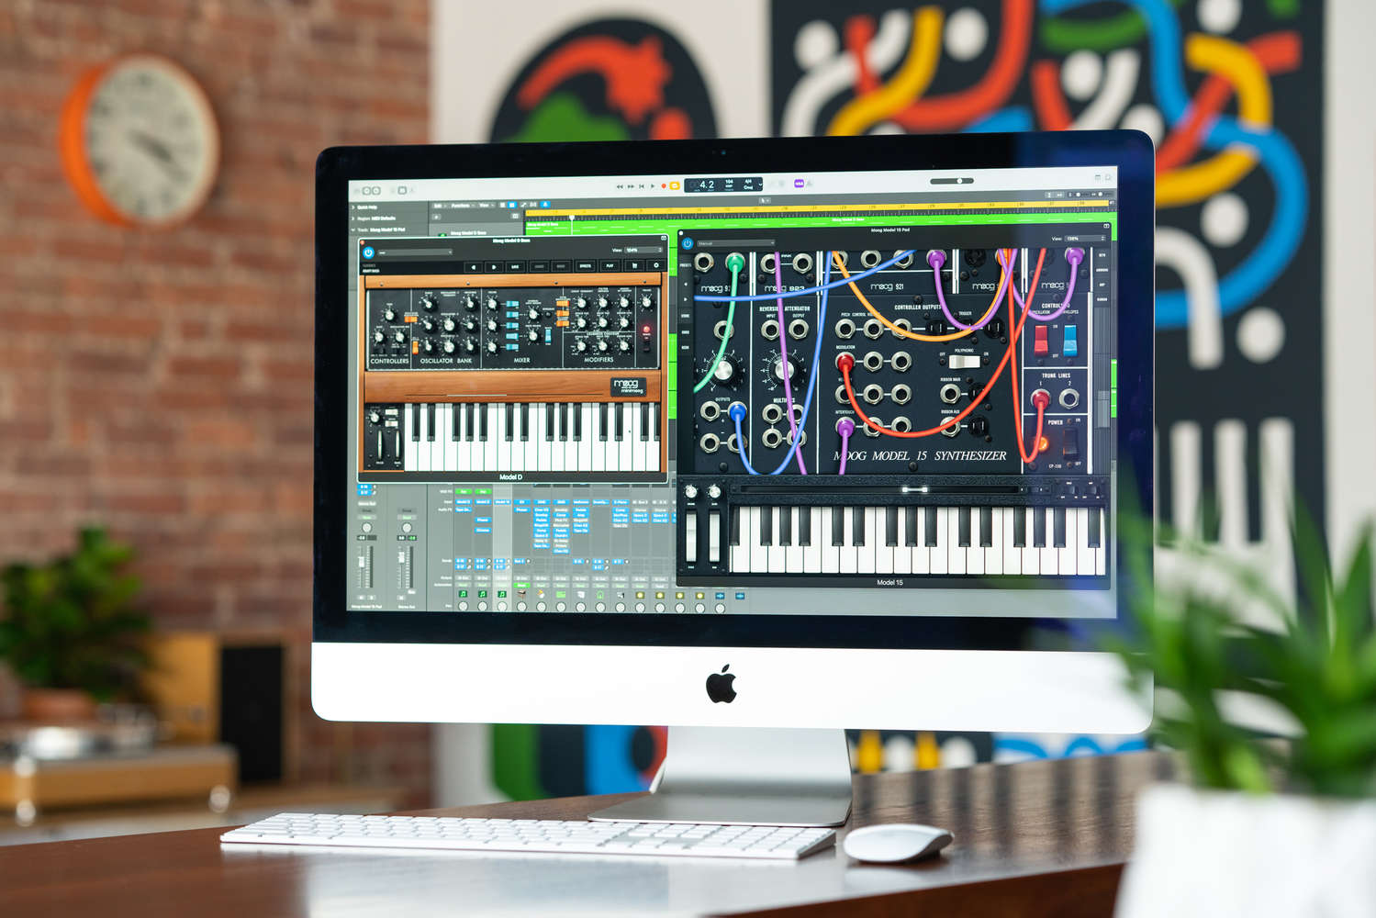

Moog Music iOS & macOS Apps Now 50% Off
Explore the sound and workflow of three powerful Moog synthesizers from your iOS or macOS device.

Moog iOS and macOS apps are on sale in the App Store for a limited time. Each app offers a completely unique synthesis experience; read on to learn which is the best fit for your sound, style, and use—or download and explore them all.

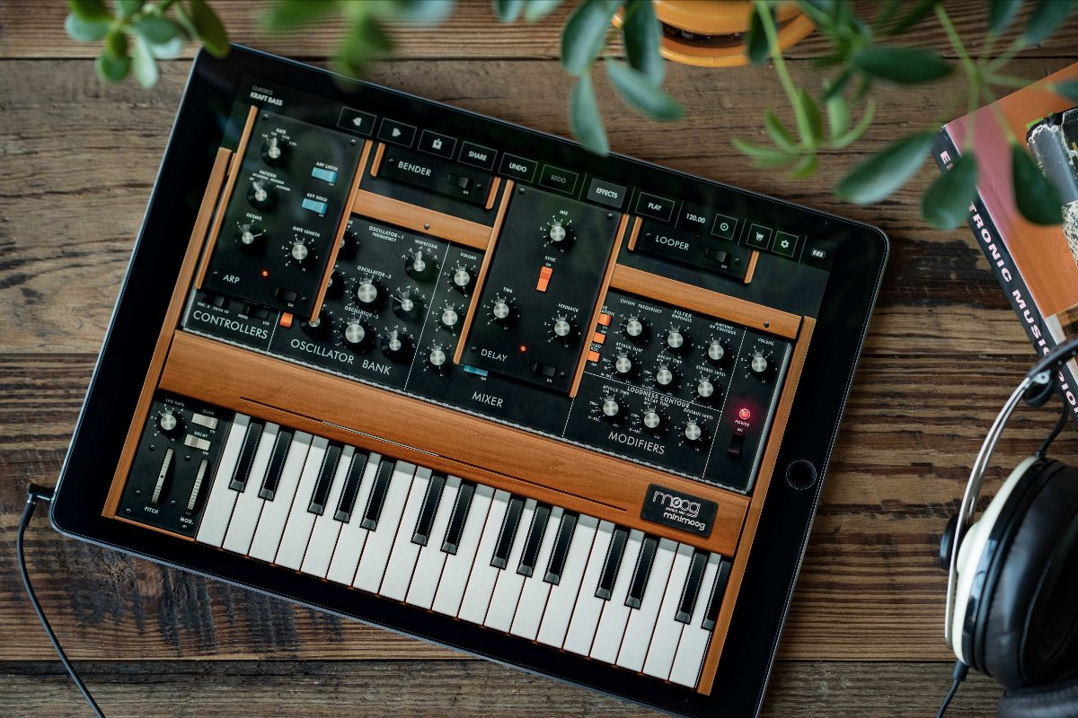

Minimoog Model D
A mobile transmutation of the legendary Model D

Introduced in 1970, the Minimoog Model D served as the archetype for all synthesizers that followed. This version of the instrument includes more than 160 built-in presets and features like stereo ping-pong delay, MIDI CC mapping, and AUv3 compatibility for integration with tools like Ableton Link and GarageBand. Recreate the sounds of your favorite songs with this inspiring standalone synth.

Download the Model D App Here

Model 15
Modular exploration—no patch cables required

Enter the world of modular or hone your patching skills and synth know-how. Model 15 allows you to replicate the sounds and workflow of the classic all-analog Model 15 modular synthesizer from your mobile device or computer! Simple swipes and taps provide instant access to features like a traditional Moog keyboard, 1150 ribbon controller, and eight-step sequencing arpeggiator. Use it as an AUv3 plugin for seamless integration with Logic, GarageBand, and MainStage; as an effect for your existing audio chain; or as a single, dynamic sound design tool. Perfect for studio use and live performance environments alike.

Download the Model 15 App Here

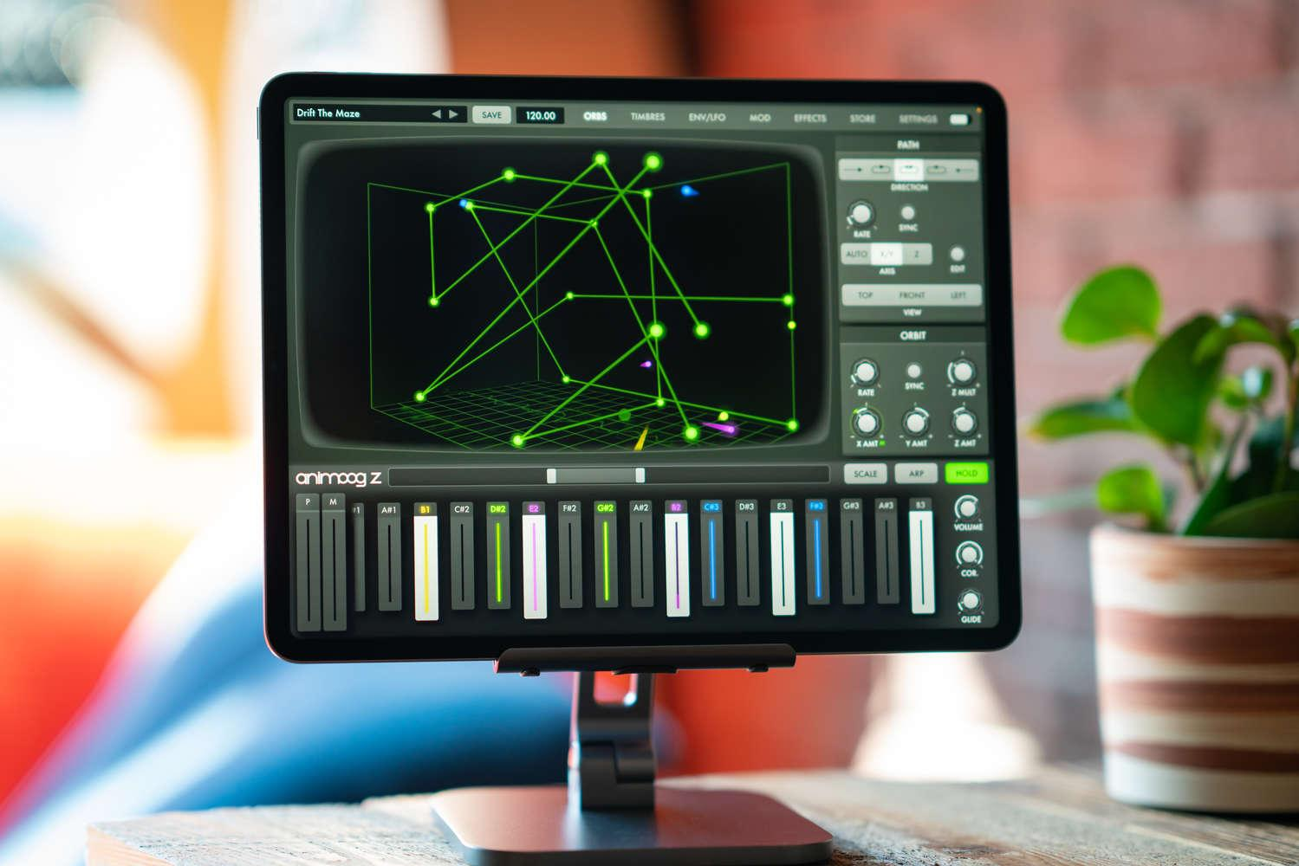

Animoog Z
An immersive and unique approach to wavetable synthesis

Getting started with this fun and expressive 16-voice polyphonic synthesizer is immediate and intuitive: simply select and drag the orbit path to create endless sonic configurations as your patch travels through an array of timbres. Experiment with dynamic effects, create your own timbres, and discover new concepts of multidimensional sounds design. Use Animoog Z’s built-in configurable keyboard to control pitch and pressure per voice (or send MIDI out), or connect your favorite MPE controller to explore Animoog Z’s MPE-compliant sound engine.

Download the Animoog Z App Here

More about Moog Music
Moog Music is the world’s leading producer of theremins and analog synthesizers. The employee-owned company and its customers carry on the legacy of its founder, electronic musical instrument pioneer Dr. Bob Moog. All of Moog’s instruments are assembled by hand in its factory in downtown Asheville, North Carolina. Learn more here.

