Roundtable Post is Set for the Future with Xytech’s MediaPulse

Renowned post production company says ‘yes’ to MediaPulse as part of its major facility upgrade plan

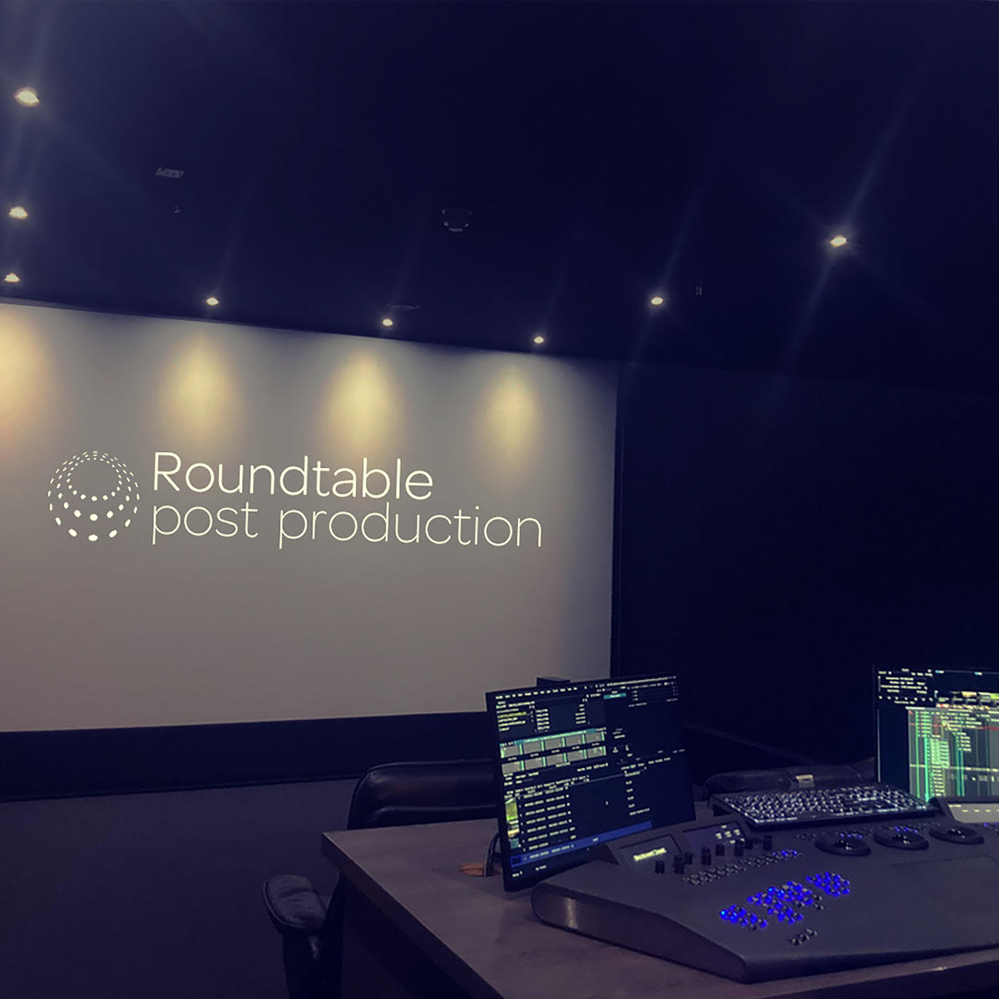
London, UK, December 7, 2021 — When Ben Coulson, Managing Director of Roundtable Post, knew it was time to source a professional solution to manage the company’s expanding resources he turned to Xytech’s MediaPulse resource management software. Established in 2008, Roundtable Post, an independent post production facility, solidified its name in the genre of high-end documentary with acclaimed productions such as Finding Jack Charlton, Last Man Standing, and Andy Murray: Resurfacing under its belt.

“With our business growing, it was on my mind to find a fully scalable resource management solution to help us avoid bottlenecks of information arising from an increase in assets and staff,” said Coulson.

MediaPulse was recommended by a number of producers at Roundtable with positive past experience and found it to be the industry’s most user-friendly option.

“The feedback from my team was a great starting point. I had researched various options, but their enthusiasm for MediaPulse made me look closely to understand what the system could offer. It ticked all our boxes in providing operational mastery and financial controls,” Coulson explained.

From humble beginnings to post-production stars
“When I started the company, it was just me with an occasional assistant offering two offline suits to the people who needed support with their post production edits,” reminisced Coulson.

Now, Coulson has a business partner and a 25-strong team of permanent staff plus adhoc freelance support, necessitating extra layers of management and planning. “Before MediaPulse, we used a rather rudimentary scheduling software, but it’s unwieldy,” he explained. “The MediaPulse system will be able to address a full spectrum of challenges the team currently faces. From flexible resource scheduling to asset management, effective quoting to billing, we’re looking forward to getting the most out of MediaPulse’s functionality to help us streamline our internal processes.”

Coulson also plans to replace the company’s archaic log system with the ease and efficiency of MediaPulse. “Logging things in and out is still a very manual process for us. MediaPulse will make things more accurate, and we’ll be able to track our resources better,” he added.

With around one million pounds spent on upgrading facilities, investing in different areas and increasing its capabilities, Roundtable recently doubled its capacity.

“That’s why a good quality resource management system is imperative,” Coulson noted. “I have really enjoyed the support I’ve experienced from Xytech, and I know the time will come when my team will look back and say, ‘How did we manage without a system like this?’”

Roundtable Post recently hired Post Producer Amy Gilkerson to be the MediaPulse super user and help roll out the system across the company.

“I am very excited to help implement MediaPulse here at Roundtable Post,” Gilkerson said. “Having used MediaPulse numerous times throughout my career, I believe it to be the most well-rounded software in terms of media asset management, scheduling, billing and invoicing. As we are going through an exciting time of team growth and business development, MediaPulse is a perfect system that will not only help streamline our internal workflows but also support us with improving the business significantly as we set our course for the future.”
“Managing internal processes such as scheduling, resource management and billing is very time consuming, especially when multiple assets and stakeholders are involved,” concluded Aurore Gilewicz, Account Manager at Xytech.

“At Xytech, our MediaPulse solution is completely configurable and we look at an individual client’s needs to create a custom fit product to address their unique workflows. This allows customers like Roundtable to automate their operational processes, making them more efficient. We are excited to work with Roundtable to deliver an integrated Cloud-based solution as an essential part of their internal infrastructure and support the team with future expansion and business growth.”

About Xytech
For more than 30 years, the world’s premiere media companies have depended on Xytech to run their businesses. MediaPulse is the only end-to-end solution for the complete content lifecycle. MediaPulse provides scheduling, automation, asset management, billing and cost recovery for broadcasters, media services companies and transmission facilities in a scalable platform-independent solution. For more information, visit xytechsystems.com.

About Roundtable Post
Roundtable Post is an independent, cutting edge, full service post production facility based in central London. Established in 2008, the company solidified its name in the genre of high-end documentary with acclaimed productions such as Finding Jack Charlton, Last Man Standing, and Andy Murray: Resurfacing under its belt. Roundtable team understands the unique challenges that documentary filmmakers face, whether that's the challenge of tracking master archives, managing the dramatic schedule shifts or getting the absolute most out of their archive so that it holds up on the big screen, and uses its specialist ways to offer a completely bespoke service that empowers the client to tell a story. https://roundtablepost.co.uk/

Media Contacts:

Sarah James
Gasoline Media
+44 7702 421635
sarahj@gasolinemedia.com

Victoria Chernih
Gasoline Media
+44 7881 091687
victoria@gasolinemedia.com

